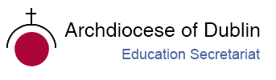
Post-Primary Diocesan Adviser R.E. News Blog
November 2020 / Mí na Samhna, Mí na Marbh

Welcome to the November issue of the R.E blog! I hope you all had a lovely, restful midterm break and are ready to face the challenges of a new term. This month is dedicated to the faithful departed and is known as Month of the Holy Souls. You will find some resources below including prayer services in Irish, which could be used with your students through-out the month.
We hope to begin a process of contacting schools and offering ways of ‘meeting’ virtually so we can continue to support teachers and chaplains, offer resources and ascertain how we can put structures in place to continue our service to schools in these times. We hope that schools can arrange a suitable time to meet and chat via a virtual platform. Letters will be sent out to schools this month. If you would like to arrange a meeting please feel free to contact us, or if you have any suggestions for how we can best support you please don’t hesitate to let us know.
We are delighted to welcome 12 new Ember teams who have successfully trained as Faith Leaders for their schools. Four of these are part of our new ‘Ember Ignite’ initiative with the Loreto Trust. Our new online training manual was a great success! We will continue to support our new faith leaders through some new initiatives. If you wish to know any more about our Ember programme, please feel free to contact us.
As you are aware, each year, the Holy Father asks for our prayers for a specific intention each month. You are invited to answer the Holy Father's request and to join with many people worldwide in praying for this intention each month. For November, the Pope’s intention is Artificial Intelligence “We pray that the progress of robotics and artificial intelligence may always serve humankind.”
Details can be found at http://popesprayerusa.net/popes-intentions/
Please contact me if you want to include your name/school on our mailing list to receive the blog. We will continue to add resources as Gaeilge with the assistance of Sr. Mairéad Ni Bhuachalla.
Le gach dea-ghuí,
Lily Barry
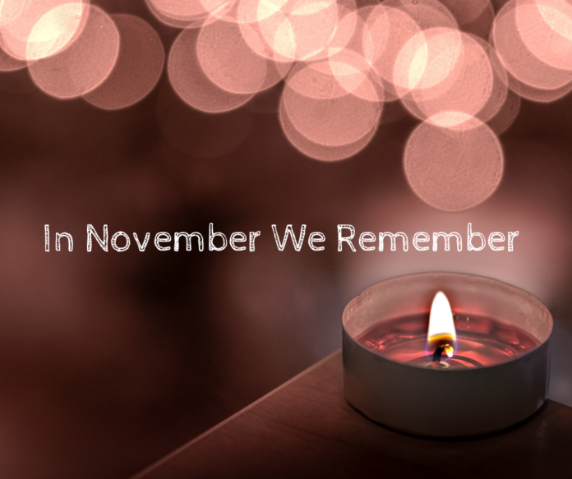
November/ Mí na Samhna
The Month of the Holy Souls / Mí na Marbh

November 1st marks the month of the Holy Souls with the Solemnity of All Saints. During the year, the Church celebrates one by one the feasts of the saints. Today she joins them all in one festival. The feast of All Saints should inspire us with tremendous hope when we recall to us Jesus’ promise that those who believe will never die but be born into new life in Christ. During this month we pray especially for our departed friends and loved ones on the last great journey towards the eternal light of God.
‘Have you not read what was said to you by God, “I am the God of Abraham, the God of Isaac, and the God of Jacob?” He is God not of the dead, but of the living.’ (Matt 22:31-32)
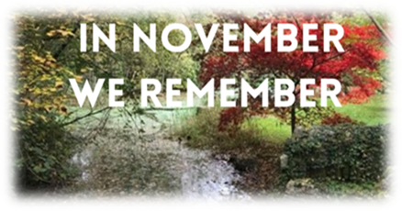

Ní imithe uainn atá siad, ach imithe romhainn.
They are not gone from us but gone before us.

On Sunday 1 November, the eve of All Souls’ Day, the bishops and priests of Ireland will lead a short service of prayer at 3.00pm to dedicate the month of November to ‘Remembrance of the Dead and Prayer for the Bereaved’. Bishops invite the whole country to unite in this moment which will be followed by parish liturgies throughout the month of November, reaching out as much as possible to those who cannot be physically present.
For details of how to participate in this service of prayer online, please check in with your local diocese or parish. ‘We will reach out in November, a month we traditionally pray for our dead, to offer spiritual support to the bereaved’ – Bishops
For further resources see:
https://www.catholicbishops.ie/2020/10/27/in-november-we-remember-2/

November 2nd
All Souls’ Day / Cuimhneachán na Marbh

All Souls' Day commemorates the faithful departed. November is a time for remembering and praying for our loved ones who have gone before us and whose loss we feel. It is a time when we are particularly conscious of those in our parishes who are grieving and all those families who have lost loved ones in the past year. More than most years, this November will be especially poignant as we remember all those who have died during the COVID-19 pandemic.

Families and the month of November

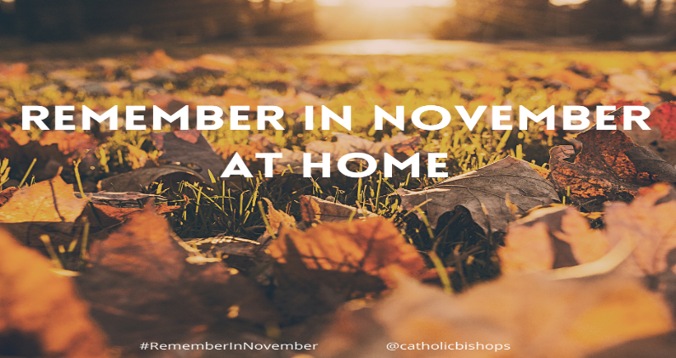
The Catholic Bishops of Ireland are particularly conscious of families who have lost loved ones in the past year. They offer a beautiful prayer resource for families to use at home. “As families are not able to attend remembrance services in person this year, we offer this prayer resource for use at home. We would suggest that the prayer service be used for the first time on the evening of Sunday 1 November, the eve of All Souls’ Day and then throughout the month of November as a way to remember our loved ones who are no longer with us”.
https://www.catholicbishops.ie/wp-content/uploads/2020/10/Family-Prayer-Service-at-Home-in-November.pdf

Catholic Schools and the Month of November. The theme for Catholic Schools Week 2021
‘Catholic Schools: Communities of Faith and Resilience’.

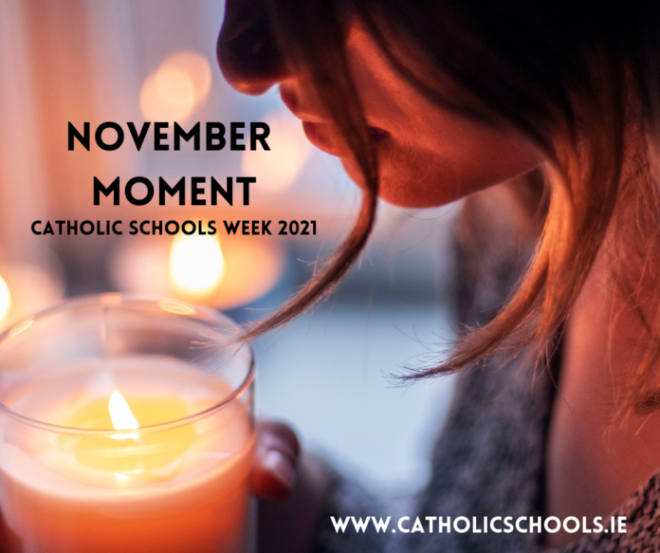
Traditionally preparations for celebrating Catholic Schools Week begin in November. The Catholic Schools Moment of November recalls to us God’s love for us, a love that conquers all things, even death. Catholic schools.ie invite Catholic schools to engage with the resources which are available as part of preparations for Catholic Schools Week 2021. “These resources aim to assist Catholic school communities with their reflections during the month of the Holy Souls as they prepare for their celebration of CSW2021.

https://www.catholicschools.ie/resources-for-use-in-catholic-schools/

November 3rd
St. Malachy / Naomh Maolmhaodhóg

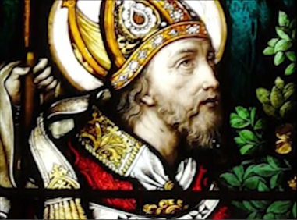
St. Malachy was Archbishop of Armagh and was the first Irish saint canonised by a Pope. St Malachy is the patron of the dioceses of Down & Connor. As well as being a committed monk, Malachy struggled heroically to wrest control of the Church from lay dynasties and give bishops effective authority in their dioceses in 12th century Ireland.

Let us ask for the intercession of St Malachy, that we may grow in the grace of God as our parish grows in the family of God.
https://www.catholicireland.net/saintoftheday/st-malachy-maol-maedhog-ua-morgair-1094-1148-patron-of-down-and-connor-diocese/

November 3rd
St. Martin de Porres / Naomh Máirtín de Porres

Today the Church celebrates the optional memorial of St. Martin de Porres, who lived a life of fasting, prayer, and penance as a Dominican lay brother. Martin was praised for his unconditional care of all people, regardless of race or wealth his life reflected his great love for God and all of God's gifts. Martin fed, sheltered, and doctored hundreds of families his charity that made him the patron saint of social justice. St. Martin died on November 3rd, 1639 and is buried in the Convento Santo Domingo in Lima, Peru.
https://www.catholicculture.org/culture/liturgicalyear/calendar/day.cfm?date=2020-11-03
https://www.youtube.com/watch?v=sowGAJQAyho&autoplay=1&list=PL58g24NgWPIzvBk2IQVES_xC4WTm6-CDI&ab_channel=CatholicOnline
November 4th
Memorial of St. Charles Borromeo, Bishop / N. Seárlas Borromeo, Easpag
St. Charles Borromeo (1538-1584) was a member of a noble family and a nephew of Pope Pius IV. He was made a Cardinal at the age of 23 and assisted the Pope in administering the affairs of the Holy See and in governing the Church. Soon thereafter he was made Archbishop of Milan. “Great was Charles' love of neighbour and liberality toward the poor. When the plague raged in Milan, he sold his household furniture, even his bed, to aid the sick and needy, and thereafter slept upon bare boards. He visited those stricken by the disease, consoled them as a tender father, conferred upon them the sacraments with his own hands. A true mediator, he implored forgiveness day and night from the throne of grace”. He died on November 3, at the age of 46. He was beatified on May 12, 1602 by Pope Paul V and his feast day is celebrated on November 4th.
https://www.catholicculture.org/culture/liturgicalyear/calendar/day.cfm?date=2020-11-04
November 6th
All the Saints of Ireland / Lá Fhéile Naomh na hÉireann
The early Irish Martyrologies and the Stowe Missal give a firm basis to devotion to the saints of Ireland. The feast celebrates the gifts and the glory of God in his saints, their sharing in the paschal mystery of Christ, our communion with them in Christ, their example and their intercession for us, the pilgrim Church, the sustaining power of the Eucharist, the hope of eternal life. Only four saints, St Malachy (1094-1148), St Lawrence O’Toole (1128-80) and St Oliver Plunkett (1625-81) and St Charles of Mount Argus (1821-93), have been officially canonised. All the other Irish saints, such as Ss Patrick, Brigid, and Colmcille, are saints, as it were, by acclamation of the local Church, before the official papal canonisation process was established. https://www.catholicireland.net/saintoftheday/all-the-saints-of-ireland/
November 14th
St Laurence O'Toole / Lorcán Naofa Ó Tuathail
St Laurence O'Toole was born in Castledermot, Co. Kildare in 1128. He became Abbot of Glendalough in 1153 and Archbishop of Dublin in 1162. He died in Normandy on November 14th, 1180 and was canonised in 1225. His eventful life can be summarised under eight headings: Hostage, Monk, Archbishop, Contemplative, Mediator, Traveller, Legate and Saint. For further information including a power point presentation, worksheets and prayers, please see: http://education.dublindiocese.ie/st-laurence-otoole/
A prayer to St. Laurence
St. Laurence O’Toole, man of peace, you were in the middle of family and political conflict from your earliest days. Give the gift of peace and hope to all who experience the trauma of division in families, in communities and among nations. St. Laurence O’Toole, man of faith, you had the openness to accept a position of leadership in your community at an early age. Bless our young people with a spirit of generosity to offer themselves in the service of the Gospel. Amen.
https://www.catholic.org/saints/saint.php?saint_id=365
November 14th
World Diabetes Day / Lá Domhanda Diabaetas

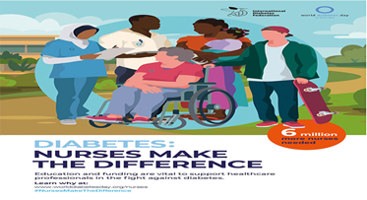
In 2020, the World Diabetes Day campaign focuses on promoting the role of nurses in the prevention and management of diabetes. Diabetes: nurses make the difference campaign, aims to raise awareness around the crucial role that nurses play in supporting people living with diabetes. Nurses currently account for over half of the global health workforce. They do outstanding work to support people living with a wide range of health concerns. People who either live with diabetes or are at risk of developing the condition need their support too. People living with diabetes face a number of challenges, and education is vital to equip nurses with the skills to support them. As the number of people with diabetes continues to rise across the world, the role of nurses and other health professional support staff becomes increasingly important in managing the impact of the condition. Healthcare providers and governments must recognise the importance of investing in education and training. With the right expertise, nurses can make the difference for people affected by diabetes.
https://worlddiabetesday.org/about/theme/

November 18th World Day of Remembrance for Road Traffic Victims /
Lá Cuimhneacháin Domhanda ar Íobhartaigh Timpistí Bóithre
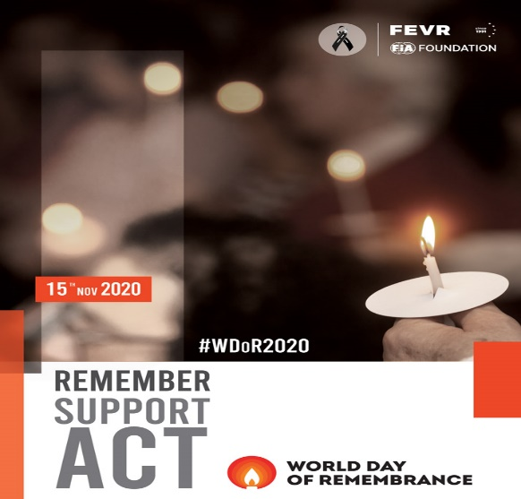
The World Day of Remembrance for Road Traffic Victims (WDR) is commemorated on the third Sunday of November each year.
It is a high-profile global event to remember the many millions who have been killed and seriously injured on the world’s roads and to acknowledge the suffering of all affected victims, families and communities – millions added each year to countless millions already suffering: a truly tremendous cumulative toll.

It is 25 years ago this year since a day dedicated to remembering road traffic victims began to be observed internationally – for the first ten years by the European Federation of Road Traffic Victims (FEVR) and its many member organizations, including RoadPeace (UK), who introduced the day in 1995. With strong support from WHO and UNRSC members, UN Member States adopted UN General Assembly Resolution 60/5 on 26th October 2005, calling for an annual World Day of Remembrance for Road Traffic Victims as an “appropriate acknowledgement for victims of road traffic crashes and their families”.
https://worlddayofremembrance.org/#about

November 20th
Universal Children’s Day / Lá Uilíoch na Leanbh
World Children’s Day was first established in 1954 as Universal Children's Day and is celebrated on 20 November each year to promote international togetherness, awareness among children worldwide, and improving children's welfare.
“Around the world, children are showing us their strength and leadership advocating for a more sustainable world for all. Let us build on advances and re-commit to putting children first. For every child, every right”. UN Secretary-General António Guterres
https://www.un.org/en/observances/world-childrens-day
November 21st
The Presentation of Mary / Toirbhirt na Maighdine Muire
The Feast of the Presentation of Mary is celebrated in both the Eastern and Western Churches. It recalls the day in the life of the Jewish girl named Mary (Maryam) when her parents, Joachim and Anne, presented her to the Lord in the temple and dedicated her life to Him. Mary had already been chosen by God, preserved by a singular grace as a chosen vessel through whom the Incarnate Word would be given for the salvation of the whole world.
Today's Feast emphasises our response to God's gifts. We remember the response of Mary's mother and father in their decision to present her in the temple for dedication to the Lord. All parents are called to imitate their response by presenting their children for Baptism.

https://www.catholicculture.org/culture/liturgicalyear/calendar/day.cfm?date=2020-11-21
https://www.catholic.org/news/hf/faith/story.php?id=43754

The Presentation Sisters and Friends of Nano Nagle, all over the world, celebrate the Feast of the Presentation of Mary in the Temple on the 21st November each year. The Presentation Sisters were founded by Nano Nagle in Cork, Ireland in 1775. Nano was a woman of great courage who established secret schools (hedge schools) for Catholic children barred from education by oppressive British law. She taught long days, and at night she carried her lantern among Cork’s attics and alleyways, bringing comfort and hope to the city’s poor, sick, and elderly.
https://www.presentationsisters.org/who-we-are/nano-nagle/

November 25th

Solemnity of Our Lord Jesus Christ, King of the Universe /Sollúntas Chríost Rí na nUile

The Solemnity of Our Lord Jesus Christ, King of the Universe, formerly referred to as "Christ the King," was established by Pope Pius XI in 1925 as an antidote to secularism, a way of life which leaves God out of man's thinking and living and organises his life as if God did not exist. The feast is intended to proclaim in a striking and effective manner Christ's royalty over individuals, families, society, governments, and nations.
This is a tremendous feast with which to end the liturgical year because it turns upside down all the pre-conceived ideas we have about hierarchy, kingship and what it means to be in authority. Jesus’ power comes from God and it is a power that builds people up rather than diminishes them. He does not deny that he is a king, but it is not the word he would use. The only thing that matters to him is the truth and that truth is God.

http://education.dublindiocese.ie/feast-of-christ-the-king/ https://www.catholicculture.org/culture/liturgicalyear/calendar/day.cfm?date=2020-11-22

November 25th
International Day for the Elimination of Violence against Women / Lá Idirnáisiúnta in aghaidh Foiréigin ar Mhná
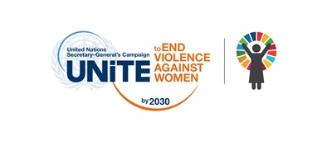

"Orange the World: Fund, Respond, Prevent, Collect!"
The UN System’s 16 Days of Activism against Gender-Based Violence activities, from 25 November to 10 December, will take place under our 2020 global theme: "Orange the World: Fund, Respond, Prevent, Collect!"

As the world retreated inside homes due to the lockdown measures introduced to curb the COVID-19 pandemic, reports showed an alarming increase in the already existing pandemic of violence against women.
“Accompanying the crisis has been a spike in domestic violence reporting, at exactly the time that services, including rule of law, health and shelters, are being diverted to address the pandemic,” stated the UN Secretary-General's report, “Shared Responsibility, Global Solidarity: Responding to the socio-economic impacts of COVID-19".
You can make a difference during the ongoing COVID-19 pandemic and protracted state of crisis it has generated across the world. You can support women and girl survivors of violence to stay safe and free of violence. Take action during this year’s 16 Days of Activism to End Gender-Based Violence.
https://www.unwomen.org/en/about-us
November 27th
Feast of the Miraculous Medal / Féile an Bhoinn Míorúilteach
Today marks the Feast of Our Lady of the Miraculous Medal. On this day, we commemorate the apparition of Our Blessed Mother to Saint Catherine Laboure (whose feast day is tomorrow, 28 November) and celebrate the vision Our Lady revealed to the young saint- the Miraculous Medal.
It was in Paris, in the year 1830, part of a period when the Catholic Church was under attack from its many enemies, when “times are evil in France and in the world,” as Our Lady said. While doing silent meditation, Saint Catherine had a striking vision of the Blessed Virgin, her beauty indescribable, standing on a globe. Rays of light shone forth from the precious gems on the Blessed Mother’s hands symbolizing the graces that she bestows upon us. Catherine saw an oval frame formed around her, bearing the words “O Mary conceived without sin, pray for us who have recourse to Thee.” A voice then said to Catherine, “Have a medal struck after this model. Persons who wear it will receive great graces, especially if they wear it around the neck.”

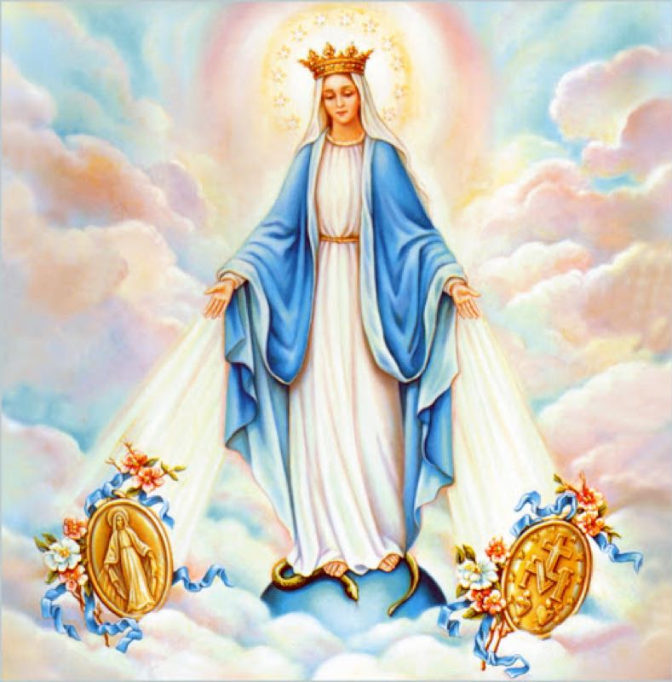
On the front, the medal shows Our Mother Mary standing on the globe (Mary, assumed into heaven, is the Queen of Heaven and Earth), as her feet stand on the head of the serpent (Mary is our protection). The oval-shaped medal is circled with the signature, “O Mary, conceived without sin, pray for us who have recourse to thee.” At the back of the medal, twelve stars (12 Apostles who formed the first Church) surround a large “M” from which a cross (Jesus’ Cross and Redemption) arises. And below the “M” there are two flaming hearts (the burning love of Jesus and Mary for us). The left hearts are circled with thorns, which represents Jesus (the Sacred Heart who died for our sins). The right heart, pierced by a sword (her sorrows), symbolizes Mary (the Immaculate Heart who intercedes for us).
https://www.catholicculture.org/culture/liturgicalyear/calendar/day.cfm?date=2020-11-27

November 28th
St. Catherine Laboure / Naomh Caitríona Laboure
Traditionally today is the feast of St. Catherine Laboure who is associated with the miraculous medal devotion. For forty-five years from the time of her visions in 1831 until her death in 1876 she led an outwardly uneventful life as a Daughter of Charity in Paris. The Blessed Virgin Mary appeared to her, a member of the Daughters of Charity, three times in 1830 and commissioned her to have made the Miraculous Medal and to spread devotion to it. She was canonized in 1947. The Daughters’ Motherhouse in Paris marks the location of St. Catherine Labouré’s apparitions of Our Lady of the Miraculous Medal. https://daughters-of-charity.com/history/

November 29th
First Sunday of Advent / An Chéad Domhnach den Aidbhint
The new Liturgical Year commences with the first Sunday of Advent. In this new liturgical year, the Church not only wishes to indicate the beginning of a period, but the beginning of a renewed commitment to the faith by all those who follow Christ, the Lord. This time of prayer and path of penance that is so powerful, rich, and intense, it endeavours to give us a renewed impetus to truly welcome the message of the One who was incarnated for us. The Season of Advent is therefore a season of vigilant waiting, that prepares us to welcome the mystery of the Word Incarnate. As Blessed John Henry Newman reminded us in a homily for the Advent Season: “Advent is a time of waiting, it is a time of joy because the coming of Christ is not only a gift of grace and salvation but it is also a time of commitment because it motivates us to live the present as a time of responsibility and vigilance”. The entire Liturgy of the Advent season, will spur us to an awakening in our Christian life and will put us in a ‘vigilant’ disposition, to wait for Our Lord Jesus who is coming:
‘Awaken! Remember that God comes! Not yesterday, not tomorrow, but today, now! The one true God, "the God of Abraham, Isaac and Jacob", is not a God who is there in Heaven, unconcerned with us and our history, but he is the-God-who-comes.’
Do not lose heart – a message in the context of the Covid-19 pandemic from the Irish Catholic Bishops’ Conference
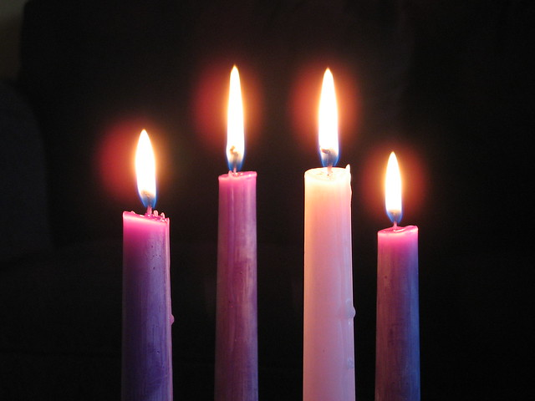
Advent and Christmas are likely to be very different this year. Advent, as a time of patient, hopeful waiting, and longing, will have a particular resonance in these times, while the much- needed joy of Christmas may well be tempered by the impact of restrictions. We encourage parish communities to explore creatively ways in which the hope of Advent and the joy of Christmas can be realised and safely celebrated.

https://www.catholicbishops.ie/2020/10/08/do-not-lose-heart-a-message-in-the-context-of-the-covid-19-pandemic/

November 30th
Day of Remembrance for all Victims of Chemical Warfare / Cuimhneachán orthu siúd a cailleadh de bharr Cogaí Ceimiceacha
This commemoration provides an opportunity to pay tribute to the victims of chemical warfare, as well as to reaffirm the commitment of the Organisation for the Prohibition of Chemical Weapons (OPCW) to the elimination of the threat of chemical weapons, thereby promoting the goals of peace, security, and multilateralism.

https://www.opcw.org/

November 30th
St. Andrew the Apostle / Féile Naomh Aindriú, Aspal
Andrew, Peter's brother, and John were the first disciples to follow the Lord. With tender delicacy the Gospel (John 1:35-42) describes their first meeting with Jesus. Andrew did not belong to the inner circle of the apostles, Peter, James and John, and the evangelists narrate nothing extraordinary about him (John 6:8); but tradition extols his great love of the Cross-and of the Saviour.
https://www.catholicculture.org/culture/liturgicalyear/calendar/day.cfm?date=2020-11-30

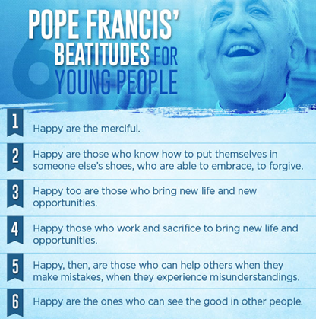

In the words of Pope Francis to our young People…
I leave you with words of encouragement and hope for evangelisation…
Let us proclaim the ‘Good News’ with great Joy to all the young people we meet in our schools and parishes!

Other Dates/Information (Dataí Eile/Eolas):

Archdiocese of Dublin / Ard-Dheoise Bhaile Átha Cliath

See the Archdiocese of Dublin website for information on events, which take place throughout the diocese.
http://www.dublindiocese.ie/ or follow the Diocese on Facebook.
https://www.facebook.com/DublinDiocese/photos/a.336758473023201/2786129244752766/?type=3

Teen Hope is a parish-based programme for faith outreach to teens led by the youth evangelisation team in St Paul’s, Arran Quay. Its aim is to help the young person discover their true value and worth, inspired by Jeremiah 29:11 @I know the plans I have for you, declares the Lord, plans for your peace, not disaster, reserving a future full of hope for you”
We are launching Teen Hope Online. Teen Hope is a space where teens can be themselves – a pressure free zone. It is a space where through fun and engaging activities you can build friendships, and encounter an experience of welcome, belonging and discipleship. While we physically cannot gather due to Covid 19, the Young Church Dublin is offering the Alpha Youth Series online as a way to reach out to Teens (4th, 5th and 6th Years) during this time. For more information email st.pauls@dublindiocese.ie

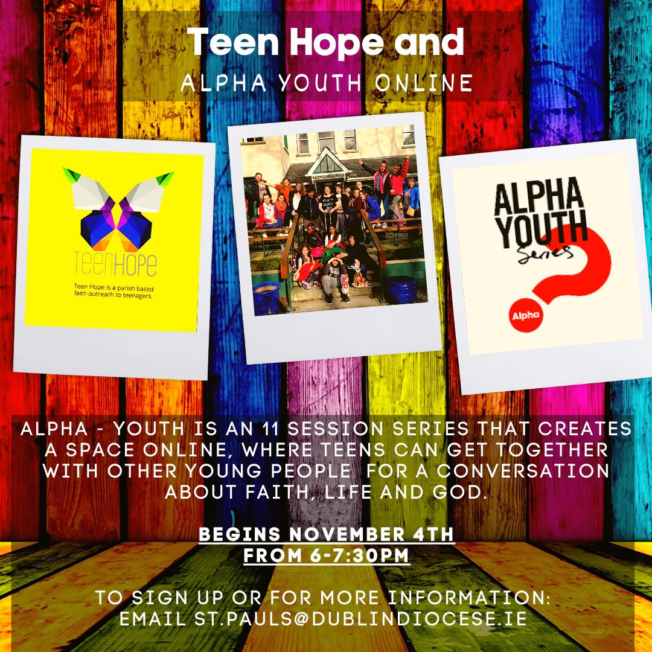

Nutrition for the Soul / Cothú don Anam
Excellent resources available from Pat Murphy, including reflections, posters, and badges for your students. See https://patsnutritionforthesoul.blogspot.com/

Nua Film Series / Scripture Union Ireland
Scripture Union Ireland just over three years ago launched a unique faith formation resource called Nua Film Series. NUA is a very high-quality faith-based film series produced, directed and hosted by Irish people and is all about exploration and encourages questions, acknowledges doubt, and offers young people aged 15 + years, and older, an engaging perspective on the Christian faith. It adopts a conversational approach to the questions raised about the Christian faith that is less intimidating and more inviting, as well as being contemporary and relevant. Scripture Union are now launching a very exciting new initiative called Nua Origins a Film Series for 1st Years.
“Why Origins? – Because of the cultural fascination today’s young people have with Superheroes origins stories and films that go back to the ‘beginnings’ of their heroes’ life and answer the question, how did this person become who they are? So Nua Origins goes back to the ‘beginnings’ and explores ‘Where faith begins! We wanted to ensure that this resource was totally accessible and ‘user friendly’ to ensure that any Parish Worker (Facilitator), Teacher, Parent, Pastoral or Youth Ministry worker could use it with the minimum of skill and ease. We have therefore provided some additional resources including a very useful Journal resource for personal reflection by each participant. This Journal was developed in collaboration with Paula Mc Keown and Caren Collins from the Down and Conor Living Church office. In addition, there are a USER Introduction Guide, a Session Guide, and a technical information sheet with simple instructions on downloading the videos and links and passwords etc We are planning on developing a short Training Video to support Facilitators, Parents, Teachers etc to deliver this resource with the utmost of ease”. https://scriptureunion.ie/
If you would like to get involved in this programme, please contact myself or Sr. Bernadette for further information. lily.barry@dublindiocese.ie Bernadette.carron@dublindiocese.ie
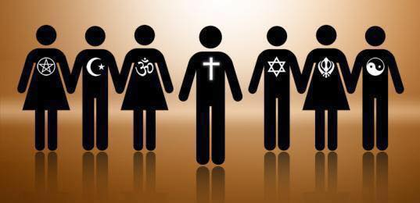
RTAI- Religion Teachers’ Association of Ireland / Cumann Múinteoirí Reiligiúin na hÉireann
Private group for teachers of Religious Education in Ireland to share ideas.
For members who have paid membership for school year 2020-2021 and would like to be part of private group see:
https://www.facebook.com/groups/246145419333367
Acmhainn i nGaeilge

Samhain-Tugaimid-chun-cuimhne.ppt
http://education.dublindiocese.ie/november-resources-as-gaeilge/

21st-century Religious Education

This is a new and exciting initiative, the first dedicated RE podcast for students and teachers. It will be a great resource for senior cycle R.E. Each 20-minute weekly episode offers a podcast on religion, ethics, and philosophy. “And deals with some of the most topical, important, and interesting questions you can think of. Is religion evil, how did we get here, what happens when we die, is there right or wrong, and even the mother of all big questions - what is the meaning of life? This is a podcast that deals with these questions in a simple way, but also in a way that will hopefully make you think”.
​
Each episode is twenty minutes long and will offer stories, statistics, religious teaching, and opinions on a specific topic. We will also interview people from some of the world's major religions (and perhaps even those that have opinions on religion, without being religious themselves). Who knows, you might even find it entertaining, too!
​In an uncertain teaching climate, these could also be an invaluable resource for distance learning! Louisa Jane Smith
https://www.buzzsprout.com/1295498
https://www.therepodcast.co.uk/

