Post-Primary Diocesan Adviser R.E. News Blog
September 2020 / Meán Fómhair 2020

Dear R.E Teacher/Chaplain,
Welcome to a new academic year and September’s issue of the R.E blog! I am writing this blog as we continue through these challenging times. It remains a time of deep uncertainty for everyone. However, we have already learnt much from the past few months on how to stay safe while also leading a normal life. We have realised that it is impossible to respond to the pandemic alone; it is only through solidarity that the virus can be defeated. Arturo Sosa SJ, the superior general of the Jesuits, reminds us of some silver linings to the situation we find ourselves in, and as I share them with you I hope they will serve as a reminder to you in times of doubt and challenge this month as we begin a very different journey in our schools:
- The global reach of the pandemic reminds that we share one world, one humanity.
- The courage and generosity of the "frontline workers" and the progress towards a vaccine by scientists shows all that can be done when humanity is mobilised to fight for a good cause.
- The pandemic has brought about much soul-searching, reflection and pause-for-thought. It has renewed the search for meaning which is the prerequisite for religious faith.
- The Church has made much better use of social media than heretofore, building new channels for communicating the Gospel.
Currently, like so many, the Education Secretariat are adapting to the changes in our work practices. We are trying to find best practice for staying in touch with schools and supporting teachers and our Ember teams in whatever way possible. If you have any suggestions or would like to make contact, please feel free to do so. I will continue with the monthly blog and provide resources linked to important dates from international justice, peace and environmental calendars as well as important dates/feast days from the liturgical calendar in the hope that they will continue to be of some help.
Let us remember that as Christians we are a people of hope and in the words of Pope Francis, we are reminded that “All of us can live but we cannot live without Hope.” We look forward to continued collaboration as we stay hopeful and work together to promote the faith of the young people in our care.
We will continue to add resources as Gaeilge with the assistance of Sr. Mairéad Ni Bhuachalla.
Le gach dea-ghuí,

Lily Barry
Post-Primary Diocesan Adviser

Pope's September prayer intention: Respect for the Planet’s Resources
“We pray that the planet’s resources will not be plundered but shared in a just and respectful manner”.
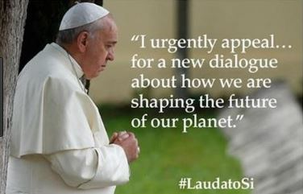
“The Spirit of life dwells in every living creature and calls us to enter into relationship with him” (Laudato Si’, 88)
See: http://popesprayerusa.net/2020/09/01/september-pope-video-respect-planets-resources/ for a short video for September from Pope Francis about ‘Respect for the Planet’s Resources’. Other resources and a short video clip on LaudatoSi, is available at:
https://youtu.be/KIVuISZGdug https://www.youtube.com/watch?v=IcP5E2trsX4&feature=youtu.be https://laudatosiweek.org/prayer/
Season of Creation – Irish Bishops’ Conference is a compilation of rich and varied resources prepared by the Catholic Communications Office, the Bishops’ Council for Justice and Peace, the Laudato Si’ Working Group, Trócaire, and the Vatican’s Dicastery for Promoting Integral Human Development. There are inspired reflections also from Bro. Richard Hendrick OFM Cap. See: www.litmus.dublindiocese.ie for sample prayer services on this topic inspired by Laudato Si.
Archbishop Diarmuid Martin circulated to priests and parishes (1 September 2020) Pope Francis' Message for the World Day of Prayer for the Care of Creation & the Season of Creation. This can also be read on the website of the Irish Bishops’ Conference – www.catholicbishops.ie
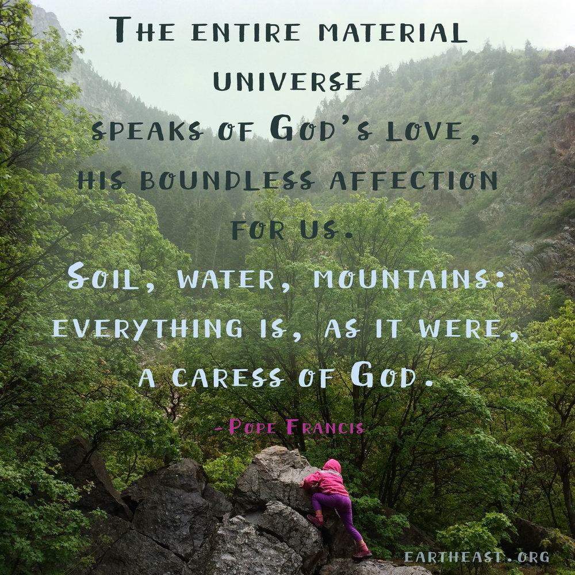

September 5th Remembering St. Teresa of Calcutta / Cuimhneachán ar Mother Theresa
“Not all of us can do great things. But we can do small things with great love.”
― Mother Teresa
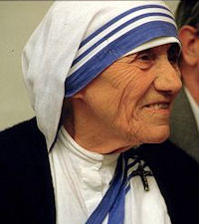
Today the Missionaries of Charity and their friends will be celebrating the feast day of St. Teresa of Calcutta. September 5th is the anniversary of her death and is established as her liturgical feast. Mother Teresa left a testament of unshakable faith, invincible hope and extraordinary charity. Her response to Jesus' plea, "Come be My light," made her a Missionary of Charity, a "mother to the poor," a symbol of compassion to the world, and a living witness to the thirsting love of God. Mother Teresa was beatified by Pope John Paul II on October 19, 2003. See the following websites for further information and resources:
https://www.youtube.com/watch?v=E0wwF1Emn7o https://www.catholicculture.org/culture/liturgicalyear/calendar/day.cfm?date=2019-09-05

September 5th The International Day of Charity / Lá Idirnáisiúnta Tiomanta don Charthanacht

“Charity can alleviate the worst effects of humanitarian crises, supplement public services in health care, education, housing and child protection.”

The General Assembly of the United Nations designated the 5th of September, the anniversary of the death of Mother Teresa, as the International Day of Charity.
Originally a Hungarian civil society initiative to commemorate Mother Teresa’s death, International Day of Charity on September 5 took off worldwide in 2012 when the UN declared it an international holiday. Besides honouring Mother Teresa’s tireless work to help others overcome poverty and suffering, the holiday provides a platform for charitable opportunities to take place. Overall, this day reminds us that simple acts of charity can alleviate the worst effects of humanitarian crises and create more inclusive and resilient societies. Use this day with your students to explore the idea of volunteering and why it is a valuable way of contributing to their community. See the following for ideas and resources:
https://nationaltoday.com/international-day-charity/
https://www.un.org/en/observances/charity-day

September 8th International Literacy Day / Lá Idirnáisiúnta Tiomanta don Litearthacht

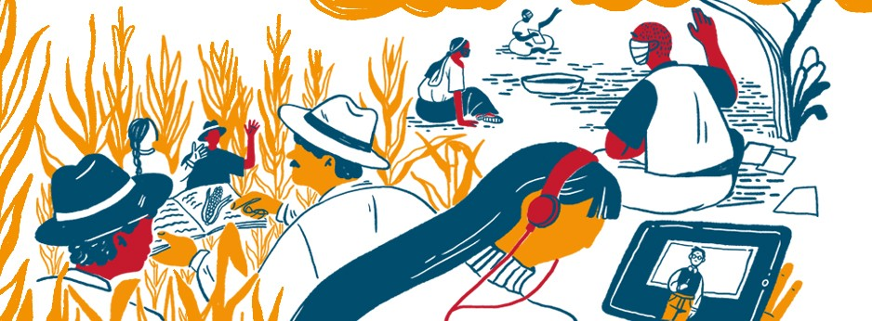

Literacy teaching and learning in the COVID-19 crisis and beyond
International Literacy Day (ILD) 2020 will focus on Literacy teaching and learning in the COVID-19 crisis and beyond with a focus on the role of educators and changing pedagogies. The theme will highlight literacy learning in a lifelong learning perspective and therefore mainly focus on youth and adults. The recent Covid-19 crisis has been a stark reminder of the existing gap between policy discourse and reality: a gap that already existed in the pre-Covid-19 era and is negatively affecting the learning of youth and adults who have no or low literacy skills and therefore tend to face multiple disadvantages. During Covid-19, in many countries, adult literacy programmes were absent in the initial education response plans, so the majority of adult literacy programmes that did exist were suspended with just a few courses continuing virtually, through TV and radio, or in open air spaces. What is the impact of the Covid-19 crisis on youth and adult literacy educators and teaching and learning? What are the lessons learnt? How can we effectively position youth and adult literacy learning in global and national responses and in strategies for the recovery and resilience-building phase?
By exploring these questions, International Literacy Day 2020 will provide an opportunity to reflect on and discuss how innovative and effective pedagogies and teaching methodologies can be used in youth and adult literacy programmes to face the pandemic and beyond. The Day will also give an opportunity to analyse the role of educators, as well as effective policies, systems, governance and measures that can support educators and learning. Through a virtual conference, UNESCO will initiate a collective global discussion to reimagine the literacy teaching and learning of youth and adults in the post-Covid-19 era towards the achievement of the SDG4.
https://en.unesco.org/commemorations/literacyday

September 8th Birth of the Blessed Virgin Mary / Saolú na Maighdine Muire
On Our Lady's birthday the Church celebrates the first dawning of redemption with the appearance in the world of the Saviour's mother, Mary. The Blessed Virgin occupies a unique place in the history of salvation, and she has the highest mission ever commended to any creature. We rejoice that the Mother of God is our Mother, too. Let us often call upon the Blessed Virgin as "Cause of our joy", one of the most beautiful titles in her litany.
For Pope Francis, Mary is an icon of wisdom, strength, courage and joyful hope. Her unconditional “yes” to God encourages modern believers to say “yes” to God’s call today. We must turn to Mary often, he says, for she is a mighty intercessor and a faithful companion on our spiritual journey. The writings, homilies, prayers, talks, and even tweets of Pope Francis on Mary are available in this book, “Mother Mary” and it gathers his most important and inspiring words about Mary.
https://www.franciscanmedia.org/nativity-of-the-blessed-virgin-mary/
http://education.dublindiocese.ie/september-8th-our-ladys-birthday/

September 8th Feast Day of Blessed Frederic Ozanam

The Church throughout the world, the Society of St. Vincent de Paul (SSVP) and the Vincentian Family celebrate on 9th of September the feast of the blessed Frederick Ozanam, principal founder of the SSVP, whose feast day was established by the Vatican as the date of his death (8 September) was the feast of the birthday of the Blessed Virgin Mary.
Frédéric Ozanam always respected the poor while offering whatever service he could. Each man, woman, and child were too precious to live in poverty. Serving the poor taught Frédéric something about God that he could not have learned elsewhere. A man convinced of the inestimable worth of each human being, Frédéric served the poor of Paris well, and drew others into serving the poor of the world. Through the Saint Vincent de Paul Society, which he founded, his work continues to the present day. These words, spoken in 1834 by Frederic Ozanam, remain accurate in today’s world:
"The question which is agitating the world today is a social one. It is a struggle between those who have nothing and those who have too much. It is a violent clash of opulence and poverty which is shaking the ground under our feet. Our duty as Christians is to throw ourselves between these two camps in order to accomplish by love what justice alone cannot do".
For a short video on his life and other resources see: https://famvin.org/en/2018/09/08/fecha-liturgica-del-beato-federico-ozanam/ https://www.franciscanmedia.org/blessed-fr-d-ric-ozanam/
September 10th World Suicide Prevention Day/ Working Together to Prevent Suicide
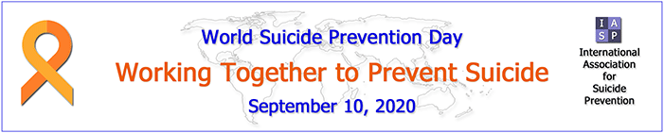
Cosc ar Fhéin-ghortú
The International Association for Suicide Prevention (IASP) is dedicated to preventing suicide and suicidal behaviour, alleviating its effects, and providing a forum for academics, mental health professionals, crisis workers, volunteers and suicide survivors. IASP have launched a Cycle Around the Globe Campaign from September 10th-October 10th.
ABOUT CYCLE AROUND THE GLOBE 2020 CAMPAIGN
Every 40 seconds someone takes their life, almost 800,000 people a year around the world. For each suicide approximately 135 people suffer intense grief or are otherwise affected resulting in 108 million people, annually, are profoundly impacted by suicidal behaviours. For every suicide, 25 people make
a suicide attempt and many more have serious thoughts of suicide.
IASP's Cycle Around the Globe Campaign supports community-based suicide prevention activities in lower- and middle-income countries. Activities that aim to help communities recognize suicidal feeling and support those in distress to seek help and avert a tragedy. This campaign is about finding mechanisms to spread the message exponentially into areas where there is limited knowledge of these
life/death issues. We want our global community to engage with each other and to join to spread awareness of suicide prevention. So please, cycle any distance on any road, track or gym and help us work together to prevent suicide.
Register now and plan your cycling for 10th September - 10th October when miles/kms will be logged here to go towards our collective goal. https://www.charityfootprints.com/eventdetails?id=450
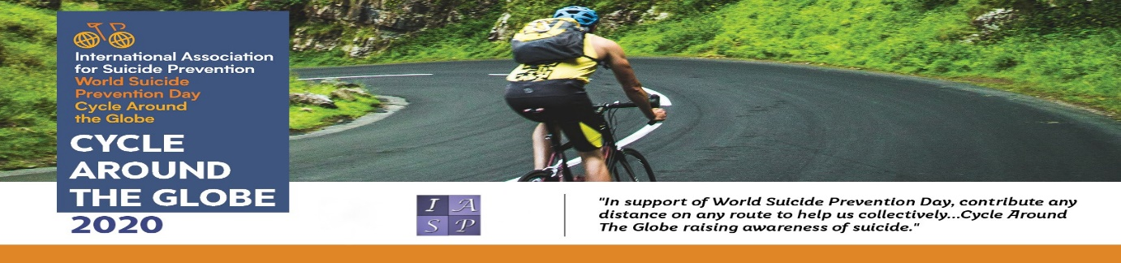
https://www.youtube.com/watch?v=MfZ6AB1R3Sg&feature=youtu.be
https://www.iasp.info/ Pieta House https://www.pieta.ie/
September 11th 9/11 R.E. Resources /Acmhainn
A reminder that the 9/11 Memorial & Museum is committed to providing ongoing resources for students, teachers, families, and the general public. They provide a host of educational resources—and a variety of free public programs, the Museum strives to foster a deeper understanding of the continuing impact of 9/11 and terrorism on America and the world at large. Recognising that it can be difficult for parents and teachers to talk about terrorism with young people, the 9/11 Memorial & Museum remind us that these conversations are crucial to help future generations understand the events that shaped their world.
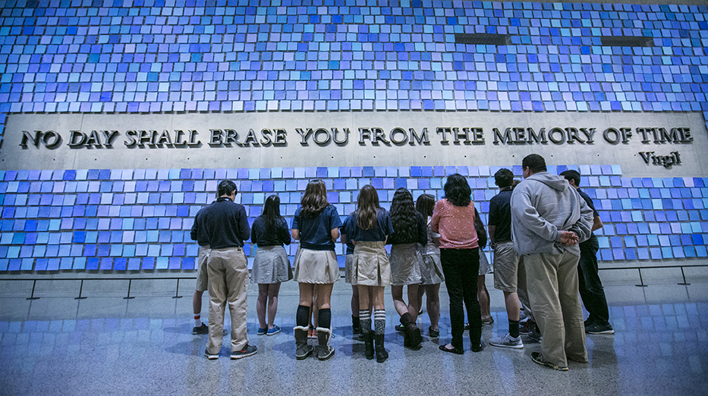
Teach + Learn Information, context and resources exploring the attacks of 9/11, including excellent education programmes, lesson plans and interactive timelines are available at:
https://www.911memorial.org/teach-learn
http://education.dublindiocese.ie/september-11th-911-r-e-resources/

September 12th Memorial of the Most Holy Name of the Blessed Virgin Mary
Cuimhneachán ar Ainm ró- Naofa na Maighdine Beannaithe Muire.
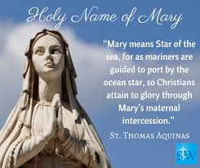
The feast of the Most Holy Name of Mary began in Spain in 1513 and in 1671 was extended to all of Spain and the Kingdom of Naples. In 1683, John Sobieski, king of Poland, brought an army to the outskirts of Vienna to stop the advance of Muslim armies loyal to Mohammed IV of Constantinople. After Sobieski entrusted himself to the Blessed Virgin Mary, he and his soldiers thoroughly defeated the Muslims. Pope Innocent XI extended this feast to the entire Church. Mary always points us to God, reminding us of God’s infinite goodness. She helps us to open our hearts to God’s ways, wherever those may lead us. Honoured under the title “Queen of Peace,” Mary encourages us to cooperate with Jesus in building a peace based on justice, a peace that respects the fundamental human rights of all peoples.
https://www.franciscanmedia.org/mosaint-holy-name-of-the-blessed-virgin-mary/
September 14th Feast of the Exaltation of the Holy Cross / Féile Ghlórú na Croise Naofa

The Feast of the Exaltation of the Holy Cross, celebrated every year on September 14th, recalls three historical events: the finding of the True Cross by Saint Helena, the mother of the emperor Constantine; the dedication of churches built by Constantine on the site of the Holy Sepulchre and Mount Calvary; and the restoration of the True Cross to Jerusalem by the emperor Heraclius II. But in a deeper sense, the feast also celebrates the Holy Cross as the instrument of our salvation. This instrument of torture, designed to degrade the worst of criminals, became the life-giving tree that reversed Adam's Original Sin when he ate from the Tree of the Knowledge of Good and Evil in the Garden of Eden.
https://www.learnreligions.com/feast-exaltation-of-the-holy-cross-542472
https://www.catholicculture.org/culture/liturgicalyear/calendar/day.cfm?date=2019-09-14
September 15th Our Lady of Sorrows

Devotion to the Seven Sorrows of Our Lady has its roots in Sacred Scripture and in Christian piety, which always associates the Blessed Mother with her suffering Son. Today's feast was introduced by the Servites in order to intensify devotion to Our Lady's Sorrows. In 1817 Pius VII — suffering grievously in exile but finally liberated by Mary's intercession — extended the feast to the universal Church. The title "Our Lady of Sorrows" focuses on Mary's intense suffering during the passion and death of Christ. "The Seven Dolors," the title by which it was celebrated in the 17th century, referred to the seven swords that pierced the Heart of Mary. The feast is like an octave for the birthday of
Our Lady on September 8th. As Mary stood at the foot of the Cross on which Jesus hung, the sword of sorrow Simeon had foretold pierced her soul. Below are the seven sorrows of Mary:
- The prophecy of Simeon (Luke 2:25-35)
- The flight into Egypt (Matthew 2:13-15)
- Loss of the Child Jesus for three days (Luke 2:41-50)
- Mary meets Jesus on his way to Calvary (Luke 23:27-31; John 19:17)
- Crucifixion and Death of Jesus (John 19:25-30)
- The body of Jesus being taken from the Cross (Psalm 130; Luke 23:50-54; John 19:31-37)
- The burial of Jesus (Isaiah 53:8; Luke 23:50-56; John 19:38-42; Mark 15:40-47)
https://www.catholicculture.org/culture/liturgicalyear/calendar/day.cfm?date=2020-09-15
https://www.franciscanmedia.org/our-lady-of-sorrows/

September 18th-20th Jewish New Year: Rosh Hashanah / Aithbhliain na nGiúdach
Rosh Hashanah celebrates the Jewish New Year, the anniversary of the creation of Adam and Eve, a day of judgment and coronation, and sounding of the shofar. It is considered the birthday of the universe, and it’s celebrated as the head of the Jewish year. It begins at sundown on the eve of Tishrei 1 (Sept. 18, 2020) and ends after nightfall on Tishrei 2 (Sept. 20, 2020).
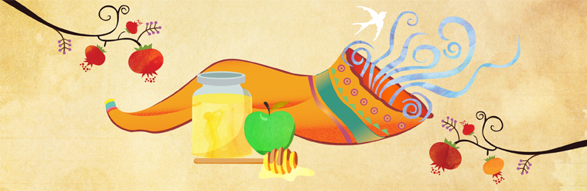
https://www.chabad.org/library/article_cdo/aid/4762/jewish/What-Is-Rosh-Hashanah.htm

September 21st International Day of Peace / Lá Idirnáisiúnta Tiomanta don Síocháin

Each year the International Day of Peace is observed around the world on 21 September. The General Assembly has declared this as a day devoted to strengthening the ideals of peace, both within and among all nations and peoples. This year the 2020 Theme is: Shaping Peace Together https://www.un.org/en/observances/international-day-peace

September 21st Matthew the Evangelist / Maitiú, Soiscéalaí
At the time that Jesus summoned him to follow Him, Matthew was a publican, that is, a tax-collector for the Romans. His profession was hateful to the Jews because it reminded them of their subjection; the publican, also, was regarded by the Pharisees as the typical sinner. St. Matthew is known to us principally as an Evangelist. He was the first to put down in writing our Lord's teaching and the account of His life. His Gospel was written in Aramaic, the language that our Lord Himself spoke. Matthew’s Gospel makes clear that Jesus is the fulfilment of everything said by the prophets in the Old Testament. His book is the first of the four Gospels in the New Testament. The Church established St. Matthew's feast day as September 21st.
https://www.catholic.org/saints/saint.php?saint_id=84
http://www.stmatthewcr.org/parish/who-was-st-matthew/
September 23rd St. Padre Pio / Naomh Padre Pio

St. Padre Pio was an Italian priest who was known for his piety and charity, as well as the gift of the stigmata, which has never been explained. Padre Pio was hearing confessions when he felt pain in his hands and feet. He noticed the stigmata, the wounds of Christ, appearing on his hands and feet. The experience was painful. Bleeding occurred. The wounds smelled of roses, and although they continued to weep, they never became infected. Doctors who later examined the stigmata were amazed at their perfectly round shape. By 1919, word began to spread about Padre Pio's stigmata and people came from far away to examine him. Padre Pio died on September 23, 1968. His funeral was attended by over 100,000 people. Pope John Paul II recognized Padre Pio as a saint on June 16, 2002. His feast day is September 23rd.
Prayer of St. Pio
Stay with me, Lord, for it is necessary to have You present so that I do not forget You. You know how easily I abandon You.
Stay with me, Lord, because I am weak and I need Your strength, that I may not fall so often.
Stay with me, Lord, for You are my life, and without You, I am without fervor.
Stay with me, Lord, for You are my light, and without You, I am in darkness.
Stay with me, Lord, to show me Your will.
Stay with me, Lord, so that I hear Your voice and follow You.
Stay with me, Lord, for I desire to love You very much, and always be in Your company.
Stay with me, Lord, if You wish me to be faithful to You.
https://www.catholic.org/saints/saint.php?saint_id=311
https://padrepiodevotions.org/prayers-of-padre-pio/

September 25th St. Finbarr
Born in the second half of the 6th century AD, in Achaid Duborcon near Crookstown, Co. Cork, to a slave girl and her metalworker husband from Connacht, who had moved to Munster to find work, St
Finbarr (also known as Barra) is the patron saint of Cork. As an adult, Finbarr left home with three unidentified ascetics and spent time in Scotland, including on the Isle of Barra, before establishing various hermitages in his native area, notably at Kilclooney and on the island here in Gougane Barra. St Finbarr died at Cloyne in 633 AD and his remains were taken to Cork to be enclosed in a silver shrine in what is now St Finbarr’s Cathedral. https://corkcathedral.webs.com/

September 27th Feast Day of St. Vincent de Paul / Féile Naomh Uinseann de Pól
The name of Vincent de Paul is synonymous with compassion and practical help for the needy. As a young priest Vincent was deeply moved by the misery in which many of the people in city slums and remote country areas in France lived. The poor were neglected both spiritually and materially, while the rich lived in luxury. He felt urged to do something to change the situation. Alone he could do very little, so he enlisted the help of many willing volunteers, mostly women, and in 1617 formed them into groups to help the poor in their local areas. These groups became known as the Confraternities of Charity. Concerned about the spiritual poverty of the country people, four years later, in 1625 he gathered another group around him and the Congregation of the Mission, better known in Ireland as the Vincentian Fathers, came into being. Then in 1633, together with St Louise de Marillac, he co-founded the Daughters of Charity, who would have “for cloister the streets of the city.” For more information on St. Vincent see: https://www.famvin.org/wiki/Vincent_de_Paul
The Society of St. Vincent de Paul (SVP)
The Society of St. Vincent de Paul (SVP) was founded in Ireland in 1844. It is the largest voluntary charitable organisation in Ireland. The Society of St. Vincent de Paul (SVP) charity is a Christian voluntary organisation, working with people experiencing poverty and disadvantage. Inspired by their principal founder, Frederic Ozanam, and patron, St. Vincent de Paul, they seek to respond to the call every Christian receives to bring the love of Christ to those in need: "I was hungry and you gave me food" (Matthew 25). No work of charity is foreign to the Society. They are involved in a diverse range of activities: See https://www.svp.ie/home.aspx for further information.
http://education.dublindiocese.ie/september-27th-st-vincent-de-paul/
https://www.svp.ie/about-us/history-spirituality.aspx

September 29th Feast of the Archangels / Féile na nArdaingeal

Today is the feast of St. Michael, St. Gabriel and St. Raphael which is superseded by the Sunday Liturgy.
The Feast of the Archangels is traditionally celebrated on the 29th September. The liturgy celebrates the feast of these three archangels who are venerated in the tradition of the Church. Michael (Who is like God) was the archangel who fought against Satan and all his evil angels, defending all the friends of God. He is the protector of all humanity from the snares of the devil. Gabriel (Strength of God) announced to Zachariah the forthcoming birth of John the Baptist, and to Mary, the birth of Jesus. His greeting to the Virgin, "Hail, full of grace," is one of the most familiar and frequent prayers of the Christian people. Raphael (Medicine of God) is the archangel who took care of Tobias on his journey.
http://education.dublindiocese.ie/2012/02/21/feast-of-the-archangels/
https://www.catholicculture.org/culture/liturgicalyear/calendar/day.cfm?date=2020-09-29
Other Dates/Information: Dátaí eile/Eolas

Archdiocese of Dublin / Ard-Dheoise Bhaile Átha Cliath
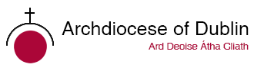
See the Archdiocese of Dublin website for information on events, which take place throughout the diocese.

http://www.dublindiocese

The Combined Catholic Parishes of Clondalkin.
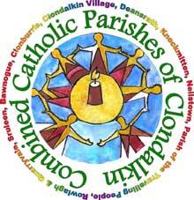
Excellent resources for September are available from Frank Brown Parish Pastoral Worker from The Combined Catholic Parishes of Clondalkin.
https://www.facebook.com/TheCCPCDublin/

https://dublindiocese-my.sharepoint.com/:f:/g/personal/frank_brown_dublindiocese_ie/EiL6olVXpJRHir7ytKzOJlcBfMtp8dP3bC3s1g_Tio0P-w?e=PD4V2E

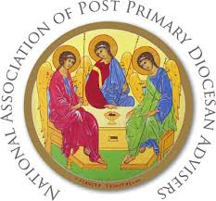
National Association of Diocesan Advisers (NAPPDA)
NAPPDA are continuing to work together to collate resources from around the country for teachers and chaplains to use with their schools and parishes during these unprecedented times. Below are some we feel will be particularly useful to keep a faith element present for ourselves and those to whom we are called to minister. We continue to hold you all in our prayers.

- R.E. Today is the British Association of R.E. teachers and includes lots of helpful material.
https://clicks.retoday-email.co.uk/email_content.php?token2=3nXeT2F1sSJUPafLcgVioh-VFqbB4X1JjZQm6MuPueM1oTuVDqpEI7sfzpZkqRo0lFMCdSCq41JJG4xE7M4vCQ..

- Actor Morgan Freeman has an excellent Netflix series called ‘Story of God.’
https://www.netflix.com/ie/title/80178897
- Ann Lehane’s Life Coaching for young people
https://www.instagram.com/tv/B-W0Zx7JiZb/?igshid=1h5u2q2p0hlkh
- Dynamic Catholic is a site designed to re-energize the Catholic Church by developing world-class resources that inspire people to rediscover the genius of Catholicism. https://dynamiccatholic.com/

- Brendan McManus Ten Ignatian Tips for Coping with Coronavirus: A spirituality for strange times: https://www.jesuit.ie/news/a-spirituality-for-strange-times/
- On-Line Prayer: https://www.sacredspace.ie

- This daily 3-Minute Retreat is a short prayer break at your computer that can give you 24 hours of peace. You’ll find this specifically on https://www.loyolapress.com/3-minute-retreats-daily-online-prayer

A Teacher's Prayer / Paidir do Mhúinteoirí
Help me to be a fine teacher, to keep peace in the classroom, peace between my students and myself, to be kind and gentle to each and every one of my students.
Help me to be merciful to my students, to balance mercy and discipline in the right measure for each student, to give genuine praise as much as possible, to give constructive criticism in a manner that is palatable to my students.
Help me to remain conscientious enough to keep my lessons always interesting, to recognise what motivates each of my students, to accept my students' limitations and not hold it against them.
Help me not to judge my students too harshly, to be fair to all, to be a good role model, but most of all Lord help me to show your love to all of my students.
Amen.

Paidir do Mhúinteoirí
Cuir ar mo chumas múineadh le heagna mar cabhraímse i múnlú na haigne.
Ullmhaigh mé chun múineadh le fírinne mar cabhraímse i múnlú coinsiasa.
Spreag mé chun múineadh le fís mar cabhraímse i múnlú na todhchaí.
Cuir ar mo chumas múineadh le grá mar cabhraímse i múnlú an domhain.
“Dealróidh na saoithe mar loinnnir na spéire, agus iad siúd a theagasc an fhíréantacht do mhórán mar reanna neimhe ar feadh na síoraíochta.”
(Leabhar Dhainéil 12: 3)

Táimid go léir Bainteach lena Chéile
Póstaer ag léiriú samplaí den chruthaíocht: clocha, plandaí, ainmhithe, daoine
Cinnire: Táimid bailithe le chéile anseo chun “amharc le súile nua” ar an gcruthaíocht agus chun tuiscint níos
fearr a fháil ar an ngaolmhaireacht atá idir gach dúil bheo.
Guth 1: Léiríonn an póstaer seo éagsúlacht na cruthaíochta atá le feiceáil timpeall orainn.
Guth 2: “Fógraíonn na spéartha glóir Dé agus foilsíonn an fhirmimint saothar a lámh.” (Salm19:1)
Guth 3: “Chonaic Dia gach a ndearna sé agus, féach! bhí sé go sármhaith.”(Geineasas 1:31)
Guth 4: Mar sin tá sé de dhualgas orainn urraim a thabhairt don chruthaíocht agus an mhaitheas atá inti a aithint.
Guth 5: Bhí na daoine a scríobh cuntas faoi chruthú na cruinne i leabhar Geineasas an-bheacht nuair a
shamhlaigh siad gur chum Dia an duine daonna “de chré na talún.” (Geineasas 2:7)
Guth 6: Mar tá gach adamh carbóin inár gcorp agus gach adamh iarainn inár gcuid fola bainteach leis na réaltaí
a tháinig ón “Ollphléasc” i dtosach ama.
Guth 7: Is é an t-aer céanna ón atmaisféar a choimeádann beo sinn.
Guth 8: Nuair a scriostar gné amháin den chruthaíocht, bíonn tionchar ag an scrios sin ar gach gné eile.
Gach Uile Náisiún ar an Domhan *

Gach uile náisiún ar an domhan, mol an Tiarna a chruthaigh dúinn
An réalta is mó, an bláth is lú, Alleluia.
Moladh na Flaithis an Tiarna, Alleluia.
Gealach is réaltaí, mol an Tiarna, Alleluia.
Sléibhte faoi shneachta, mol an Tiarna, Alleluia.
Cnoic is gleannta, mol an Tiarna, Alleluia.
Duibheagán aigéin, mol an Tiarna, Alleluia.
Brádán éadrom, mol an Tiarna, Alleluia.
Leoin ag búiríl, mol an Tiarna, Alleluia.
Éin ag cantain, mol an Tiarna, Alleluia.
Ríthe is prionsaí, mol an Tiarna, Alleluia.
Óg is aosta, mol an Tiarna, Alleluia.
Kevin Mayhew
Aistrithe ag Máire Ní Mháille
Cinnire: Nuair a bhí Íosa Críost ag labhairt faoi “Ríocht Dé”, ní aonad polaitíochta a bhí i gceist, ná fiú flaitheas
Dé ar Neamh. Samhlaoid a bhí in úsáid aige chun cur in iúl conas mar a bheadh an saol nuair a bheadh
gaolmhaireacht chóir, chothrom idir dhaoine agus an t-imshaol agus i measc an chine daonna féin, de
réir mar a bhí leagtha amach ag Dia.
Guth 9: Scríobh Naomh Pól chuig na Rómhánaigh: “Is aon chorp amháin sinn i gCríost agus gach duine againn
ina mbaill dá chéile.” (Rómh. 12:5)
Guth 10: Bhí an tuiscint sin ag ár sinsear romhainn mar dúirt siad: “Is ar scáth a chéile a mhaireann na daoine,”
agus “Ní neart go cur le chéile.”
Guth 11: Tá sé de dhualgas orainn an ghaolmhaireacht seo a chothú agus a chur chun cinn mar tá síocháin ar
talamh agus todhchaí na cruinne ag brath ar ár n-iarrachtaí.
Cinnire: A Dhia, cabhraigh linn meas a bheith againn orainn féin, ar dhaoine eile, agus ar an imshaol, agus
gaolmhaireacht chóir, chothrom a chothú agus a chleachtadh pé áit ina mbeimid.

Sin é ár nguí chugat trí Chríost ár dTiarna. Áiméan.
* Tá ceol an iomainn seo ar an dlúth-dhiosca a théann le Beo go Deo 8.

