Post-Primary Diocesan Adviser R.E. News Blog
May 2020/Bealtaine 2020

Dear R.E Teacher/Chaplain,
I am writing the final blog of the school year as we continue through these challenging times. It is a time of deep uncertainty for everyone. Around the world, all eyes are on the spread of the COVID-19 virus. The pandemic is challenging families, communities, health care systems, and governments in a way that we have never experienced before. But, we are a people of hope. Pope Francis reminds us that “All of us can live but we cannot live without Hope.” And in this month of May Pope Francis has turned to Our Lady as a sign of hope. Pope Francis’ Prayer to Mary during the coronavirus pandemic calls out to Mary as a sign of our hope and salvation:
O Mary,
you always shine on our path
as a sign of salvation and of hope.
We entrust ourselves to you, Health of the Sick,
who at the cross took part in Jesus’ pain, keeping your faith firm. Under your protection, we seek refuge, Holy Mother of God. Do not disdain the entreaties of we who are in trial, but deliver us from every danger, O glorious and blessed Virgin.
https://www.catholicbishops.ie/2020/03/16/prayer-resources-for-use-during-the-coronavirus-pandemic/
Although school and class times are very different for each of us, I will continue to offer resources linked to important dates from international justice, peace and environmental calendars as well as important dates/feast days from the liturgical calendar in the hope that they will continue to be of some help. As May is traditionally the month for graduation there are a variety of further resources on graduation available on our website:
http://education.dublindiocese.ie/2012/06/22/graduation-resources/ http://education.dublindiocese.ie/graduation-prayer-service-2018/ I am sure some of you will find ways to involve your students in ceremonies to mark the ending of their school year.

I would like to take this opportunity to say thank you to all who welcomed us into their schools, and invited us to various events through-out the year. I have been privileged to be part of many special occasions this year. I would also like to thank the Ember teams and teachers for their continued work and as they witness to their faith in our school communities.
I hope that we will return to some normality in the new academic year, and look forward to continued collaboration as we work together to promote the faith of the young people in our care.
We will continue to add resources as Gaeilge with the assistance of Sr. Mairéad Ni Bhuachalla.
Le gach dea-ghuí,

Lily Barry
Post-Primary Diocesan Adviser
May 1st / Lá Bealtaine
Month of Mary the Mother of our Lord / Mí na Maighdine Muire

Mary said, "Behold, I am the handmaid of the Lord. May it be done to me according to your word." Then the angel departed from her. Mary's profound Prayer, her "Fiat" (Let it be done) in response to the visitation from the messenger of heaven, the angel, provides a pattern of prayer and a way to live for every Christian. It issues forth in her song of praise, her "Magnificat." This song begins with the words "Magnificat anima mea Dominum" "My soul doth magnify the Lord" (Luke 1:46-55). However, the "Fiat" is more than a prayer and the "Magnificat" more than a hymn of praise. Together they reveal the Way of the first disciple, Mary, and together they constitute a guide, for this journey of life that we all walk.
Our lives, so real and human, with all of the blessings and all of the pain, can be packed with meaning, purpose and destiny, if we have eyes to see, ears to hear and hearts to respond with the kind of voluntary surrender that was so beautifully expressed by the Virgin of Nazareth in her continuing surrender to God's invitation. https://www.catholic.org/mary/disc.php
It is a Catholic tradition to honour the Blessed Virgin Mary during May, with churches and homes erecting a May Altar with a statue of Mary, flowers, a candle and a picture of Mary. In a short pastoral letter, Pope Francis is encouraging families to rediscover the Rosary at home and has offered two new prayers to recite at the end of the Rosary. See https://www.catholicbishops.ie/2020/03/16/prayer-resources-for-use-during-the-coronavirus-pandemic/ and for further resources on Our Lady see http://education.dublindiocese.ie/may-the-month-of-mary-resources/

The Holy Father's Intentions for the Month of May 2020:

For Deacons
We pray that deacons, faithful in their service to the Word and the poor, may be an invigorating symbol for the entire Church.

Pope Francis' special video to pray for an end to the pandemic
In a special edition of “The Pope Video”, the Holy Father asks us to pray for the sick and the suffering, while thanking all those who, united and regardless of their religious tradition or convictions, pray for those affected.
https://clicktopray.org/pray-with-the-pope/ http://popesprayerusa.n
May 1st
Feast of Saint Joseph the Worker / Naomh Iosef, Oibrí
May is the Feast of St Joseph the Worker, a day on which the Church encourages us to celebrate the value of work, and the dignity and rights of workers. "May Day" has long been dedicated to labour and the working man. It falls on the first day of the month that is dedicated to the Blessed Virgin Mary. Pope Pius XII expressed the hope that this feast would accentuate the dignity of labour and would bring a spiritual dimension to labour unions. It is eminently fitting that St. Joseph, a working man who became the foster-father of Christ and patron of the universal Church, should be honoured on this day. For more resources see:
http://education.dublindiocese.ie/2014/04/22/may-1st-feast-of-saint-joseph-the-worker/
May 3rd
Feast of Saint Philip and James, Apostles / Naomh Philib agus Naomh Séamus, Aspail

We celebrate both saints on the same day because their relics were brought to Rome together on the same day in early May. They rest there still, in the Basilica of the Holy Apostles. They are considered two of the favoured witnesses of our Beloved Jesus' Resurrection. Saints’ Philip and James, bear testimony to us that their Master is truly risen from the dead, that they have seen Him, that they have touched Him, that they have conversed with Him (1 John 1: 1), during these forty days.
https://www.catholicireland.net/saintoftheday/saints-philip-and-jamesapostles/

May 3rd
World Press Freedom Day / Lá Domhanda Saoirse na Meán Cumarsáide

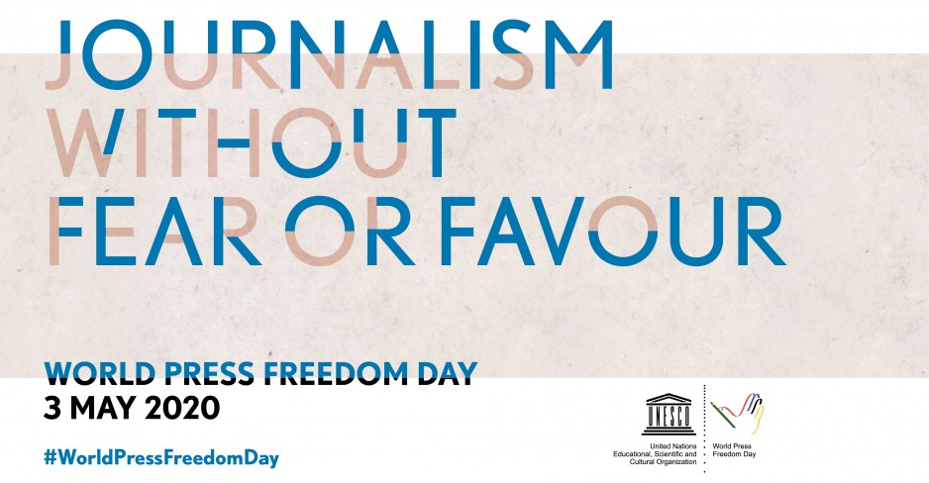
May 3rd acts as a reminder to governments of the need to respect their commitment to press freedom and is also a day of reflection among media professionals about issues of press freedom and professional ethics. Just as importantly, World Press Freedom Day is a day of support for media which are targets for the restraint, or abolition, of press freedom. It is also a day of remembrance for those journalists who lost their lives in the pursuit of a story.
On World Press Freedom Day, on 3 May, UNESCO calls on governments, media and civil society to join us in a global online movement to draw the world's attention to these issues which are essential to the survival of our democracies. Together, we will ensure that our response to the crisis is effective. This unprecedented health crisis has the potential to rebuild citizens' trust in the media. https://en.unesco.org/commemorations/worldpressfreedomday/2020/mediaresources
May 5th
Blessed Edmund Ignatius Rice / Naomh Iognáid Rís Beannaithe

“Let us do ever so little for God, we will be sure He will never forget it, nor let it pass unrewarded."
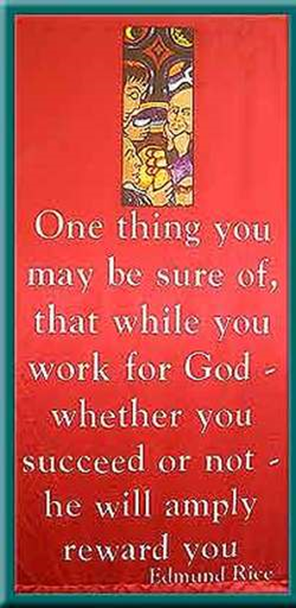
Blessed Edmund Rice, religious (1762-1844) came from Callan, County Kilkenny. After his young wife’s early death, he sold his possessions and dedicated his life to the education of the poor. To advance the work, he gathered other like-minded men who took religious vows to work for the Catholic education of boys. He is a model of patient and cheerful acceptance of the sufferings God sends, a true lay apostle and a deeply committed religious.
His Holiness John Paul II beatified Edmund Ignatius Rice on October 6, 1996, in St. Peter's Square. Speaking of Blessed Edmund Rice, the Pope stated, "Here we have an outstanding model of a true lay apostle and a deeply committed Religious. ... Today, his spiritual sons, the Christian Brothers and the Presentation Brothers, continue his mission: a mission, which he himself described in this simple and clear intention: 'Trusting in God's help, I hope to be able to educate these boys to be good Catholics and good citizens.’" For more information on his life see: https://www.erst.ie/about-us/who-is-edmund-rice/
http://edmundricemsm.weebly.com/legacy-of-edmund-rice.html
Care of the Earth & the Story of Creation PowerPoint is a wonderful resource shared by Br. Anthony Mark McDonnell and may prove useful in linking the story of caring for the earth to Blessed Edmund and the work of the brothers today.

May 5th
African World Heritage Day / Lá Domhanda Oidhreacht na hAifrice
Proclaimed by the 38th session of the General Conference of UNESCO (November 2015), African World Heritage Day (5 May) is an opportunity for people around the world, and particularly Africans, to celebrate the Continent’s unique cultural and natural heritage.
Some other International days which may be of interest to you are:
May 3rd World Portuguese Language Day
May 16th International Day of Light and International Day of Living Together in Peace
May 21st World Day for Cultural Diversity for Dialogue and Development
May 22nd International Day for Biological Diversity
https://en.unesco.org/commemorations/international-day

May 7th
The Festival of Wesak / Féile Wesak

For those who are teaching Buddhism as a major world religion for the Junior Cycle this might be a good opportunity to explore one of its most important festivals which occurs this year on 7 May.
Wesak is the most important of the Buddhist festivals and is celebrated on the full moon in May. Wesak (Vesakha) is an annual holiday observed traditionally by Buddhists and sometimes informally called "Buddha's Birthday". It actually encompasses the birth, enlightenment and passing away of Gautama Buddha. For further resources see:
https://www.lucistrust.org/resources/wesakbooklet#wesak
http://education.dublindiocese.ie/2013/05/06/buddhism-resources/

May 13th
Our Lady of Fatima / Féile Mhuire Fatima

Today, the 13th day of May, is the feast day of Our Lady of Fatima. It was on this day that the Blessed Virgin Mary started her series of apparition to three shepherd children in the small village of Fatima in Portugal in 1917.
Between May 13 and October 13, 1917, three Portuguese children–Francisco and Jacinta Marto and their cousin Lucia dos Santos–received apparitions of Our Lady at Cova da Iria near Fatima, a city 110 miles north of Lisbon. Mary asked the children to pray the rosary for world peace, for the end of World War I, for sinners, and for the conversion of Russia.
Mary gave the children three secrets. Following the deaths of Francisco and Jacinta in 1919 and 1920 respectively, Lucia revealed the first secret in 1927. It concerned devotion to the Immaculate Heart of Mary. The second secret was a vision of hell. When Lucia grew up she became a Carmelite nun and died in 2005 at the age of 97.
Pope John Paul II directed the Holy See’s Secretary of State to reveal the third secret in 2000; it spoke of a “bishop in white” who was shot by a group of soldiers who fired bullets and arrows into him. Many people linked this vision to the assassination attempt against Pope John Paul II in St. Peter’s Square on May 13, 1981. The feast of Our Lady of Fatima was approved by the local bishop in 1930; it was added to the Church’s worldwide calendar in 2002.
https://www.franciscanmedia.org/our-lady-of-fatima/

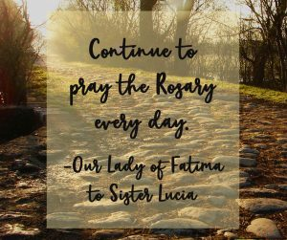

May 14th

Feast of St. Matthias, Apostle and Martyr / Féile Naomh Maitias

After the death, resurrection and ascension of Jesus and in the wake of the death of Judas, Matthias was chosen as an apostle to replace him (Acts 1:15-26).
The criteria set by Peter for the replacement among the apostles after the suicide of Judas were that he should be “someone who has been with us the whole time that the Lord Jesus was travelling around with us from the time when John was baptising until the day when he was taken up for us and he can act with us as a witness to his resurrection” (Acts 1:21-22).
They nominated two candidates, “Joseph known as Barsabas, whose surname was Justus, and Matthias”. They drew lots and as the lot fell to Matthias, he was listed as one of the twelve apostles. He is not mentioned elsewhere in the New Testament.
Tradition says he worked first in Judea and later in Cappadocia and at Colchis in present-day Georgia, where he is said to have died, but another tradition locates him in Ethiopia. Still another tradition says he died in Judea. His supposed relics were brought to Rome by the empress Helen, the mother of Constantine; they are now venerated in the Benedictine Abbey Church of St Matthias in Trier, Germany. https://www.catholicireland.net/saintoftheday/st-matthias-1st-century-apostle/

May 22nd
St. Rita / Naomh Ríta

May 22nd is the feast day of St. Rita, an Augustinian nun from 14th century from Cascia, Italy. She is the patroness of impossible causes and hopeless circumstances because of her difficult and disappointing life. Through her trials, God used her in remarkable ways, not only while she lived, but now from heaven she assists those who plead for her intercession for their own seemingly impossible and hopeless circumstances.
https://www.catholic.org/saints/saint.php?saint_id=205

May 24th

The Ascension of the Lord / Déardaoin Deascabhála

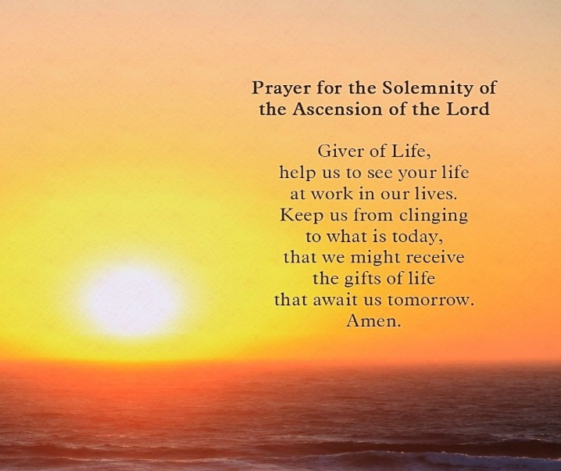
The image we have of the Ascension is that of departing, going away, disappearing; but our belief as Christians is that it represents the silent presence of Christ everywhere in the universe. He is no
longer limited by earthly conditions — to be in one place at one time in his presence to his followers — but now dwells in the heavens with the Father: present in every gathering of his people — so he is present among us now, present whenever his people are in need, present in hearts calling us to be
disciples and to be his hands, and feet, and voice in our lives.
To celebrate this feast today is not to recall a past event — that day long ago ‘when he went up to heaven’ — but to rejoice that Jesus is our living Lord, with us now, leading and guiding us, because he is not tied down to a moment in earthly history. By meditating on the story, we discover similar moments in our own relationship with God, with a cause, or with people who have touched our lives. https://www.catholicireland.net/?s=The+ascension+ https://www.catholic.org/lent/ascension.php

May 27th
St. Augustine of Canterbury / Agaistín Canterbury

St. Augustine was born in Rome and died in Canterbury, England, in 604. When Pope Gregory I heard that the pagans of Britain were disposed to accept the Christian Faith, he sent the prior of St. Andrew, Augustine, and forty of his Benedictine brethren to England. Despite the great difficulties involved in the task assigned to him, Augustine and his monks obeyed. The success of their preaching was immediate. King Ethelbert was baptized on Pentecost Sunday, 596, and the greater part of the nobles and people soon followed his example. St. Augustine died as the first Archbishop of Canterbury.
https://www.franciscanmedia.org/saint-augustine-of-canterbury/

May 31st
Pentecost / Domhnach Cincíse
‘The world is charged with the splendour of God’
(Gerard Manley Hopkins)

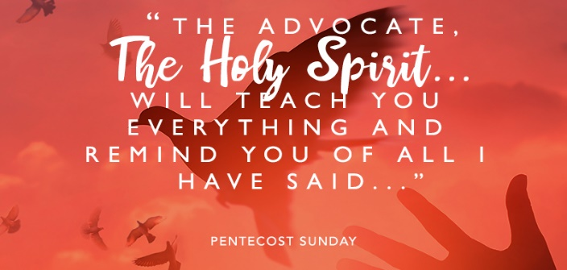

The word Pentecost is Greek and it means "50th day." Fifty days after Easter Sunday, we celebrate the coming of the Holy Spirit upon the Apostles and their followers, and the beginning of their Earthly ministry to make disciples of all nations. The Resurrection of Jesus reaches its powerful climax with an out pouring of life, light and energy for his followers. After Jesus’ crucifixion this small group of men and women were hiding. They were afraid and had lost all heart and hope. But through the gift of the Holy Spirit they are filled with courage, enthusiasm and determination. Given new life and hope, they went out into the streets and market places and loudly without fear, proclaimed the good news of the Resurrection; the missionary church is born as they were charged with the splendour of God.

Lord, we thank you for this Easter season which we have now completed.
We thank you for the times when we have to stand hopefully
before an empty tomb,
times when we see you and live with you
and then have you vanish from our sight
and have to wait for you in Jerusalem for what seems an interminable time,
until eventually your promised Spirit comes on us and we can live again.
Amen.

Other Dates/Information: / Dátaí Eile/ Eolas

Archdiocese of Dublin /Ard-Dheoise Bhaile Átha Cliath
The diocesan website contains information on various activities happening throughout the diocese. Please check http://www.dublindiocese.ie/ for up to date information.

Where to find Mass On-Line:
A comprehensive list of Churches with scheduled Mass times is available from:
https://www.dublindiocese.ie/list-of-churches-with-webcams-to-watch-listen-to-daily-mass/
www.procathedral.ie and: https://www.dublindiocese.ie/watch-listen-live/

“God speaks to the Church and to the world through the young “
Young people have a huge amount to offer the Church, especially in helping us to remember the newness of the Gospel and the ongoing renewal this calls us to.
At the 2018 Synod hundreds of bishops and cardinals, as well as female religious and young people had a foretaste of what could happen if we could open ourselves up to the action of the Holy Spirit more effectively across all generations, especially with the young.
This project hopes to unpack some of the richness of the Synod documents as well as Christus Vivit, and learn from the process that created them so as to help the process of implementation in our Church.
We want to share the fruits of the Synod so that the Church can continue to both preach the Gospel and engage the modern world with integrity and authenticity.
Do you share this vision? Get in touch, work with us and if you’re able please think of giving to help us reach more people! https://www.synodfruits.org.uk/get-involved/
This is one project amongst others developed by a group of young adults working under the banner ‘Forming Missionary Disciples’
Young adults have a huge amount to offer the Church, in how it lives the Gospel authentically in the modern world and as it looks for new ways to challenge today's social and ecological problems.
We want to unlock this potential by building community, creating more opportunities for intergenerational relationships, and forming and empowering the next generation of leaders.
“I dream of a ‘missionary option’, that is, a missionary impulse capable of transforming everything, so that the Church’s customs, ways of doing things, times and schedules, language and structures can be suitably channeled for the evangelization of today’s world rather than for her self-preservation” Pope Francis, Evangelii Gaudium #27
https://www.formingmissionarydisciples.org.uk/

SCHOOL CHAPLAINS' ASSOCIATION OF IRELAND

The School Chaplains’ Association have a number of lovely ideas for graduation which can be found in their April newsletter. Contact them on: https://schoolchaplaincy.ie/ Here is one example:

Ceremony of Light- Graduation Mass
‘A Journey to Remember’
Entrance Procession: Laudate Dominum
INTRODUCTORY RITE:
Gathering Ritual
Celebrant:
This night/evening/day marks a very special time for these young people who are leaving school. It is an ending, but it is also a beginning. We tell the story of ending and beginning now using the Easter light, the symbol of Christ, the Alpha and Omega, the beginning and the End.
Teacher:
On behalf of the school, I offer you the light of Wisdom. Carry this light from this place to a world that stands in need of wisdom: A world that faces decisions and choices never dreamed of in times past.
Remember that everything you have learned in this school was learned in the company of others.
Be open to the learning that is ahead that is ahead of you. May you be a light of wisdom for others and may you grow in a wisdom that will inspire you to find the good and the true. May this light of wisdom that will inspire you to find the good and the true. May this light of wisdom guide you during your exams and in the future life on the road ahead.
Parent:
On behalf of the parents I offer you the light of love. This is a light we lit for you a long time ago. It is the light you depended on in those early days, the light you ran to when things went wrong.
The light that was left on for you because you were afraid of the dark, the light that dressed you for the first day at school, for your First Communion, for your Confirmation. This is the light that waited up for you if you were late home… And the light that was always there even though sometimes, just sometimes, you wished it wasn’t.
Carry this light of love into a world where real love is rare and precious. Use it to light the path in your search to love and be loved. And when you find that the light is flickering, blown by the storm of pain and rejection. Remember that there will always be a light burning for you in that place called home.
Student (Not a 6th Year):
On behalf of all the students that you leave behind, I offer you the light of memory. Carry the light of these days out into the world. Remember those of us who remain to carry on the story of the school. Remember us, and we will remember you.

Trustee’s Representative:
On behalf of the trustees of this school, I offer you the light of faith. Carry this light of faith out into the world. Remember to be part of the Christian community wherever you find it, and to be a light for the world.
Penitential Rite
A Thiarna déan Trócaire,
A Chríost déan Trócaire,
A Thiarna déan Trócaire,
Opening Prayer
LITURGY OF THE WORD:
First Reading: A Reading from the Book of Micah
Listen to what the Lord says: "Stand up, plead your case before the mountains; let the hills hear what you have to say. I brought you up out of Egypt and redeemed you from the land of slavery. I sent Moses to lead you, also Aaron and Miriam This is what the Lord asks of you, only this to act justly, and to love tenderly, and to walk humbly with your God.
The word of the Lord. All: Thanks be to God.
Responsorial Psalm:
Refrain (All): I HAVE LOVED YOU WITH AN EVERLASTING LOVE, I HAVE CALLED YOU AND YOU ARE MINE. (X2)
Second Reading: A reading from the Second Letter to the Thessalonians
But we ought always to thank God for you, brothers and sisters, loved by the Lord, because from the beginning God chose you to be saved through the sanctifying work of the Spirit and through belief in the truth. He called you to this through our gospel, that you might share in the glory of our Lord Jesus Christ. So then, brothers and sisters stand firm and hold to the teachings we passed on to you, whether by word of mouth or by letter. May our Lord Jesus Christ himself and God our Father, who loved us and by his grace gave us eternal encouragement and good hope, encourage your hearts and strengthen you in every good deed and word.
The word of the Lord. All: Thanks be to God.
Alleluia: Seinn Alleluia
Gospel: The Road to Emmaus
Let us acclaim the Gospel in Song
Homily
Prayers of the Faithful:
Lord Hear us Response: Lord Graciously Hear us.
A Thiarna éist linn Response: A Thiarna bí ceannsa agus éist linn.
Offertory procession: B’Íosa Im Chroise
LITURGY OF THE EUCHARIST:
Sanctus: Is Naofa tú.
Memorial Acclamation. (Sung)
Great Amen (Sung)
COMMUNION RITE
Agnus Dei:
Communion Hymns:
Instrumental
Ave Verum
The Lord bless you and keep you
THE BLESSING AND DISTRIBUTION OF GIFTS
Communion Reflection: May the Road rise to meet you
Refrain: May the road rise to meet you, may the wind be at your back. May
the sun shine warm upon your face, upon your face. May the rain fall softly on your
fields, and until we meet again, may you keep safe in the gentle loving arms of God.
Concluding Rite
Greeting
Priest: The Lord be with you
All: And with your spirit.
Blessing
Priest: May almighty God bless you,
the Father, and the Son, and the Holy Spirit.
All: Amen
Dismissal / Recessional (Stand) Dominican Magnificat
Refrain: Magnificat, magnificat, anima mea Dominum. (2)
To praise, my soul rejoices in God.
To praise, my soul shall glorify the Lord.
He who is mighty has done great things for me,
behold the servant of god. R.
To bless, to bless the people of God.
To bless, to bless the name of the Lord.
All generations shall call her blessed.
Behold the servant of God. R:
To Preach, to preach the word of our Lord.
To preach, to preach his truth to the earth.
Teach us to follow him and show us his way.
For Holy is his Name. R:
GRADUATION BLESSING

LOVING GOD,
LOOK UPON OUR GRADUATES AND THEIR FAMILIES WITH LOVE.
WE PRAY THEY MAY THEY BE AWARE OF YOUR CARING PRESENCE
THROUGHOUT THEIR LIVES. BLESS AND STRENGTHEN THEM SO
THEY MAY PUT THE GIFTS YOU HAVE GIVEN THEM TO GOOD USE.
WE ASK YOU TO WALK BESIDE THEM, GUIDING THEIR
FOOTSTEPS ON THE ROAD AHEAD. MAY THEY FIND FRIENDS
WHO WILL ALSO WALK BESIDE THEM AND MAY THEY BE
COMFORTED IN THE DARKER MOMENTS OF LIFE’S JOURNEY.
AMEN

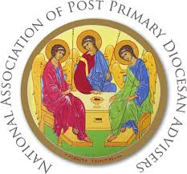
National Association of Diocesan Advisers (NAPPDA)
NAPPDA are continuing to work together to collate resources from around the country for teachers and chaplains to use with their schools and parishes during these unprecedented times. Below are some we feel will be particularly useful to keep a faith element present for ourselves and those to whom we are called to minister. We continue to hold you all in our prayers.

- This is a list of services that have been made available for free for the duration of the COVID-19 pandemic and is being continuously updated.

Twitter: @ShaneHastingsIE Email: giveback@shanehastings.eu

https://covid19.shanehastings.eu/giveback/?fbclid=IwAR2aXv6PMsc_NVIBONZz18o4whJs9CpIz729NxIU4KqEkpz0rfo-eN-X6L4
- R.E. Today is the British Association of R.E. teachers and includes lots of helpful material.
https://clicks.retoday-email.co.uk/email_content.php?token2=3nXeT2F1sSJUPafLcgVioh-VFqbB4X1JjZQm6MuPueM1oTuVDqpEI7sfzpZkqRo0lFMCdSCq41JJG4xE7M4vCQ..

- The Department of Education and Skills have helpful material on Wellbeing – https://www.education.ie/en/Education-Staff/Services/Employee-Assistance-Wellbeing- Programme/Employee-Assistance-Wellbeing-Programme.html

- Actor Morgan Freeman has an excellent Netflix series called ‘Story of God.’
https://www.netflix.com/ie/title/80178897

- Ann Lehane’s Life Coaching for young people – https://www.instagram.com/tv/B-W0Zx7JiZb/?igshid=1h5u2q2p0hlkh

- Dynamic Catholic is a site designed to re-energize the Catholic Church by developing world-class resources that inspire people to rediscover the genius of Catholicism. https://dynamiccatholic.com/

- Check the website of the National Episcopal Conference for relevant prayers for this time at: https://www.catholicbishops.ie/2020/03/16/prayer-resources-for-use-during-the-coronavirus-pandemic/

- Brendan McManus Ten Ignatian Tips for Coping with Coronavirus: A spirituality for strange times.
https://www.jesuit.ie/news/a-spirituality-for-strange-times/

- On-Line Prayer
https://www.sacredspace.ie All you need is a phone!

- This daily 3-Minute Retreat is a short prayer break at your computer that can give you 24 hours of peace. You’ll find this specifically on https://www.loyolapress.com/3-minute-retreats-daily-online-prayer

Rosmini School
Rosmini TY Young Social Innovators Team have created a short survey as part of their Kindness to the Elderly Counts project.

They are inviting people who are older and cocooning at home to complete a survey to find out how they are coping with social distancing & cocooning and what young people can do to help.

If you can, I would be very grateful if you could share the survey link below. I would love for our students to get as many responses as possible. It would really help with their great work.

https://www.surveymonkey.com/r/XF7QQKZ

Thank you for your support.

Kind regards,
Chris

