**

**Post-Primary Diocesan Adviser R.E. News Blog**

**February 2020**

Dear R.E Teacher/Chaplain,

Welcome to February’s issue of the R.E blog. This month’s blog continues with a calendar of events for February with a selection of resources linked to important dates from international justice, peace and environmental calendars as well as important dates/feast days from religious calendars. There is also a variety of further resources on our website <http://education.dublindiocese.ie/post-primary/> under classroom and general resources.

We continue to promote **Pope Francis’ monthly intentions** which we encourage you to introduce and use with your students. We will continue to highlight the Holy Father’s request for prayers for a specific intention each month and invite you to answer the request and join with many people worldwide in praying for this intention each month. For **February** the Pope’s intentionis **Listen to the Migrants’ Cries:** We pray that the cries of our migrant brothers and sisters, victims of criminal trafficking, may be heard and considered. For further resources see <http://popesprayerusa.net/popes-intentions/>

We would encourage you to download the blog and share it with other teachers in your school. If you would like to be added to our mailing list, please let us know. Finally, if there is any way we can help/assist you in your work as Religious Educators, please feel free to contact us with any queries at [lily.barry@dublindiocese.ie](mailto:lily.barry@dublindiocese.ie) / [bernadette.carron@dublindiocese.ie](mailto:bernadette.carron@dublindiocese.ie) May you continue to be guided by the Holy Spirit in the work you do with young people.

We will also continue to add resources as Gaeilge with the assistance of Sr. Mairéad Ni Bhuachalla. This month we include three prayer services as Gaeilge, which you can use with your students to mark the important feast days of lá Fhéile Bríde, lá Fhéile Naomh Bláisias agus Naomh Vailintín.

Le gach dea-ghuí,

Lily Barry,

Post-Primary Diocesan Adviser.

**January 26th-3rd February**

**Catholic Schools Week 2020/ Seachtain na Scoileanna Caitliceacha**

**‘Living in Harmony With God’s Creation’/ Maireachtáil go Sítheach Le Gach ar Chruthaigh Dia.**

**Catholic Schools Week** takes place from **26th January to the 2nd February 2020**. This year the theme is ‘Living in Harmony With God’s Creation’. Pope Francis’ encyclical **Laudato Si** is the foundation on which the theme is based upon, and it calls on all of us to protect our common home and to bring the whole human family together to seek a sustainable and integral development, for we know that things can change’ (LS, 13). Pope Francis challenges us to look at our lifestyles. We must become aware of the impact our lives have on the lives of others. The hope of Catholic Schools Week 2020 is that we realise how powerful each and every one of us is and that even the smallest changes can have the biggest impact.

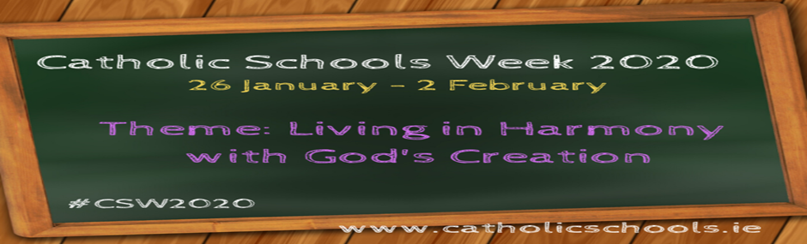

Again, this year, resources for Catholic Schools Week will be available online. All lessons have resources for both Junior and Senior Cycle. Each lesson contains practices which support the national Literacy and Numeracy Strategy, as well as self-reﬂective practices as a way of supporting assessment in the classroom. They also provide extension exercises as an option for your students.

Log on to [www.catholicschools.ie](http://www.catholicschools.ie) to download the CSW 2020 resources.

[**January 30th**](http://education.dublindiocese.ie/st-aidan-of-ferns/) **St Aidan (St Mogue) first Bishop of Ferns**

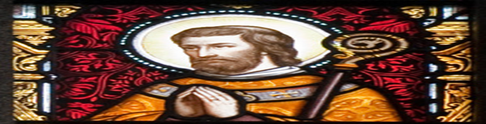

Just a reminder to those who may have celebrated the feast day of St. Aidan of a lovely story and further information from Mary Colleary of Templeport, who sent in this information to shed light on our Christian heritage.

Naomh Máedócas Cavan people know him was born in my native parish of Templeport in west Cavan (550AD). Each year on Naomh Máedóc's feast day, the 31st of January, we commemorate his life with a pilgrimage to "Inish Island also known as St Mogues island" on Templeport lake opposite my home. Pilgrimages recite prayers walking anti-clockwise within the ruins of the church there. It is believed Naomh Máedóc was born on this Island. Visitors take home clay from the corner of the church ruins with the belief that those who have it in their homes or on their person while travelling by car, plane or boat will not be harmed. Locals credit the belief in the power of the clay to the saving of a local lady from drowning on the Titanic.

For over 100 years up until the early 1980 the Island was a graveyard in which so many local deceased family members were buried including my own. My Grandfather was the oars man for 50 yrs. of the “Cot boat" that took the remains of each deceased for burial on the island. Families can still visit their family graves each summer, on August bank holiday Monday.

As parishioners of Templeport we treasure the connection with the Diocese of Ferns where we believe Naomh Máedóc served the final years of his ministry as Bishop there among its people.

***Knowing the Christian commitment of the other saints whose feasts day we celebrate, we have the privilege as educators in faith, of preserving and nourishing young people’s faith in this rich heritage.*** Mary Colleary (Mc Govern)

**February   1st       St. Brigid’s Day***/* **Lá Fhéile Bríde**

Brigid is one of the great saints of Ireland. Irish people have prayed to her for many hundreds of years. St. Brigid was Abbess of the monastery at Cill Dara (the Church of the Oak in the 6th century. Tradition tells us that as Brigid explained the passion and death of Christ to the dying pagan chieftain she took some rushes from the floor of the bothán and fashioned a cross. The Old Irish custom of placing a St. Brigid’s cross over the doors of dwelling houses and animal shelters thus began. People believed that in so doing Brigid would look after their households and stock and that full and plenty would be theirs in the year ahead. Later the custom of sprinkling the cross with holy water and invoking the following blessing began: “May the Father, Son, Holy Spirit and St. Brigid bless this cross and all who look upon it.” People ask her blessing on themselves, their families and their work. They use her name in prayer. "Brid agus Muire dhuit" was one old Irish blessing. For further resources and a short video on how to make St. Brigid’s day crosses see:

<http://education.dublindiocese.ie/2012/02/21/ppsaintbrigid/> <https://www.icatholic.ie/how-to-make-st-brigid-cross/> <https://www.catholic.org/saints/saint.php?saint_id=453>

**Féile Bríde – Brigid’s Festival is a week- long series of events commencing on the eve of St. Brigid’s Day, the first day of February.**

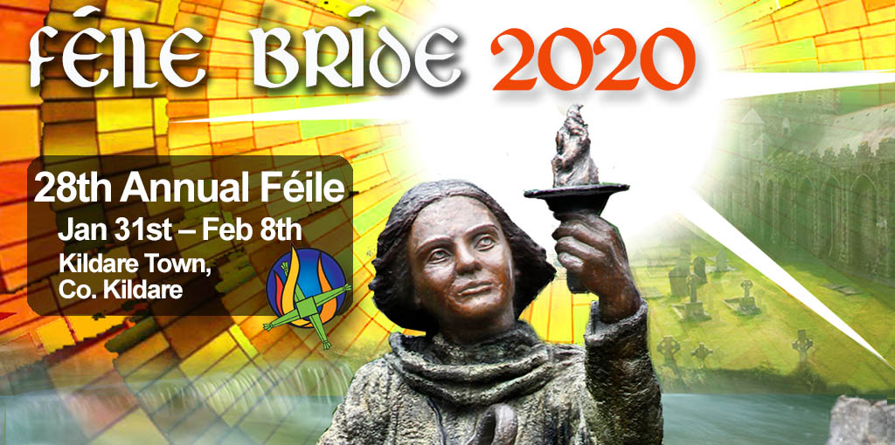

Féile Bríde, incorporates a Peace and Justice conference in collaboration with Afri – Action from Ireland, workshops, and a candle-lit ritual on Brigid’s Eve at the well. Pilgrimage and a Peace and Justice Conference are core components. For further information see [**http://solasbhride.ie/feile-bride/**](http://solasbhride.ie/feile-bride/)

**February 2nd          Presentation of the Lord / Candlemas Day**

**Toirbhirt an Linbh Íosa sa Teampall/ Lá Fhéile Muire na gCoinnle**

Today the Church celebrates the feast of the Presentation of the Lord, which occurs forty days after the birth of Jesus and is also known as Candlemas day, where the blessing and procession of candles is included in today's liturgies.

In obedience to the Old Law, the Lord Jesus, the first-born, was presented in the Temple by his Blessed Mother and his foster father. This is another 'epiphany' celebration insofar as the Christ Child is revealed as the Messiah through the canticle and words of Simeon and the testimony of Anna the prophetess. Christ is the light of the nations, hence the blessing and procession of candles on this day. In the Middle Ages this feast of the Purification of the Blessed Virgin Mary, or 'Candlemas,' was of great importance.

<https://www.catholicculture.org/culture/liturgicalyear/calendar/day.cfm?date=2020-02-02>



**February 3rd          Feast Day of St. Blaise /Lá Fhéile Naomh Bláisias**

Saint Blaise was the bishop of Sebastea and a doctor. The first known record of the saint's life comes from the medical writings of Aëtius Amidenus, where he is recorded as helping with patients suffering from objects stuck in their throat. Many of the miraculous aspects of St. Blaise's life are written of 400 years after his martyrdom in the "Acts of St. Blaise." Saint Blaise is believed to begin as a healer then, eventually, became a "physician of souls." He then retired to a cave, where he remained in prayer. People often turned to Saint Blaise for healing miracles. St. Blaise is known as the Patron of throat Illnesses. For some short, interesting videos on St. Blaise see:

<https://www.youtube.com/watch?v=3yGRtx_ITgA>  <https://www.catholic.org/saints/saint.php?saint_id=28>

**February 8th****International Day of Prayer and Awareness against Human Trafficking**

**Lá Idirnáisiunta chun aird a dhíriú ar mhangaireacht daonna agus guí ina choinne**



Pope Francis has stated, “Human Trafficking is a crime against humanity.” “It’s a disgrace that people are treated as objects, deceived, raped, often sold many times for different purposes and, in the end, killed or, in any case, physically and mentally damaged, ending up thrown away and abandoned.”

“I encourage those who work helping the men, women and children who are enslaved, exploited, abused as instruments of work or pleasure, who are often tortured and mutilated. It is my hope that government leaders may work decisively to remove the causes of this disgraceful scourge; it is a scourge unworthy of society. May each one of us feel committed to being a voice for our brothers and sisters, who have been humiliated in their dignity.”

<https://www.catholicworldreport.com/2019/04/11/pope-francis-calls-human-trafficking-a-crime-against-humanity/>

The feast day of St. Josephine Bakhita (1869 to 1947) is 8th February. The Pontifical Council for Justice and Peace and the International Union of Superiors General has designated 8th February, her feast day, as an annual day of prayer and awareness against human trafficking.

Josephine was kidnapped as a child and sold into slavery in southern Sudan and Italy. Once Josephine was freed, she became a Canossian nun and dedicated her life to sharing her testament of deliverance from slavery and comforting the poor and suffering. She was declared a Saint in 2000 and is the Patron Saint for Anti-Trafficking in the Catholic faith.

On this day Catholics all over the world are encouraged to host or attend prayer services to create greater awareness against human trafficking and for those who work to end human trafficking.. Through prayer, we not only reflect on the experiences of those that have suffered through this affront to human dignity, but also comfort, strengthen, and help empower victims and survivors.

<https://www.franciscans.ie/human-trafficking-day-of-prayer/>

<https://www.youtube.com/watch?v=HNGEnPpbT-k>

**February 11th**    **World Day of the Sick and the Feast of Our Lady of Lourdes**

**Lá Domhanda na nEaslán agus Taibhsiú na Maighdine Muire i Lourdes**

February 11th is World Day of the Sick, an observation started by Pope John Paul II as a way for believers to offer prayers for those suffering from illnesses. The day coincides with the commemoration of Our Lady of Lourdes.

People around the world take the time to pray for the sick and for those who work very hard to alleviate the sufferings of the sick on this day. Faith organisations mark this day especially to provide the sick with medicines, food, and spiritual guidance.

<https://www.awarenessdays.com/awareness-days-calendar/world-day-of-the-sick-2020/>

**World Day of the Sick** **2020:** This year’s theme is on**Hope in the Face of Suicide.**

The World Day of the Sick Seminar will take place on **Saturday, February 8th from** **9.30am to 1.00pm** in the Newtown Parish Pastoral Centre, Newtownpark Avenue, Blackrock, Co Dublin.

The World Day of the Sick Mass will take place on **Sunday 9th February** in Church of the Guardian Angels, Newtontownpark Avenue, Blackrock.

**For further information please contact – Trish Conway on M:  087 6220349.**

[**https://www.dublindiocese.ie/world-day-of-the-sick-2020/**](https://www.dublindiocese.ie/world-day-of-the-sick-2020/)

**Our Lady of Lourdes /Muire Lourdes**

Today marks the first apparition of the Blessed Virgin Mary in 1858 to fourteen-year-old Marie Bernade (St. Bernadette) Soubirous. Between February 11 and July 16, 1858, the Blessed Virgin appeared eighteen times, and showed herself to St. Bernadette in the hollow of the rock at Lourdes. On March 25, she said to the little shepherdess who was only fourteen years of age: "I am the Immaculate Conception." Since then Lourdes has become a place of pilgrimage and many cures and conversions have taken place. The message of Lourdes is a call to personal conversion, prayer, and charity.

https://www.catholicculture.org/culture/liturgicalyear/calendar/day.cfm?date=2020-02-11

**February 11th International Day of Women and Girls in Science**

**Lá Idirnáisiúnta Tiomnaithe do Mhná agus do Chailíní san Eolaíocht**

In order to achieve full and equal access to and participation in science for women and girls, and further achieve gender equality and the empowerment of women and girls, the United Nations General Assembly adopted [resolution A/RES/70/212](http://undocs.org/A/RES/70/212) declaring 11 February as the [International Day of Women and Girls in Science](http://www.womeninscienceday.org/)***.***

"On this International Day, I urge commitment to end bias, greater investments in science, technology, engineering and math education for all women and girls as well as opportunities for their careers and longer-term professional advancement so that all can benefit from their ground-breaking future contributions," UN Secretary-General, António Guterres.

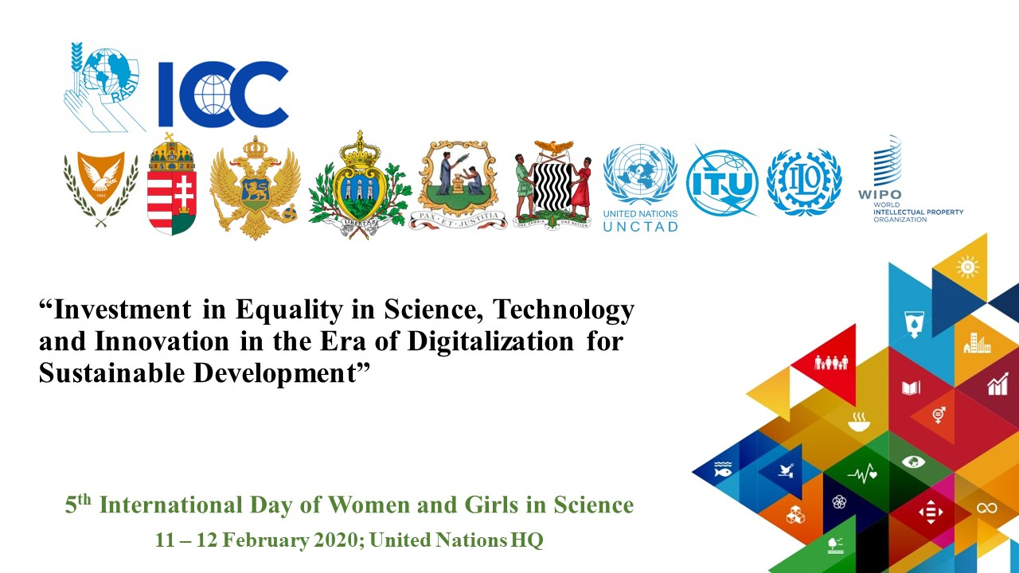

<https://www.womeninscienceday.org/>

**February 11th**        **Safer Internet Day /Sábháilteacht ar an Idirlíon**

"**Together for a better internet**"/**“Le chéile le haghaidh sábháilteachta na hIdirlíne”**



Get set for **Safer Internet Day 2020**, taking place on **Tuesday, 11 February 2020**, when - once again - we'll join forces across the globe to work "**Together for a better internet**".

Excellent resources and the latest news and articles about the campaign available at: <https://www.saferinternetday.org/web/sid/resources/gallery>

**February 14th          St. Valentine / Naomh Vailintín, Pátrún an Ghrá**

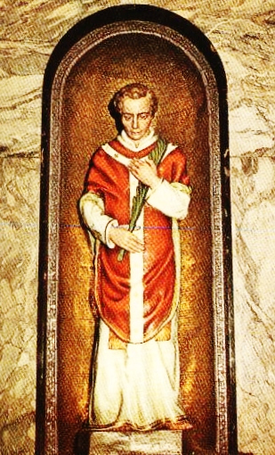

Saint Valentine, officially known as Saint Valentine of Rome, is a third-century Roman saint widely celebrated on February 14 and commonly associated with "courtly love”. Although not much of St. Valentine's life is reliably known, and whether or not the stories involve two different saints by the same name is also not officially decided, it is highly agreed that St. Valentine was martyred and then buried on the Via Flaminia to the north of Rome.

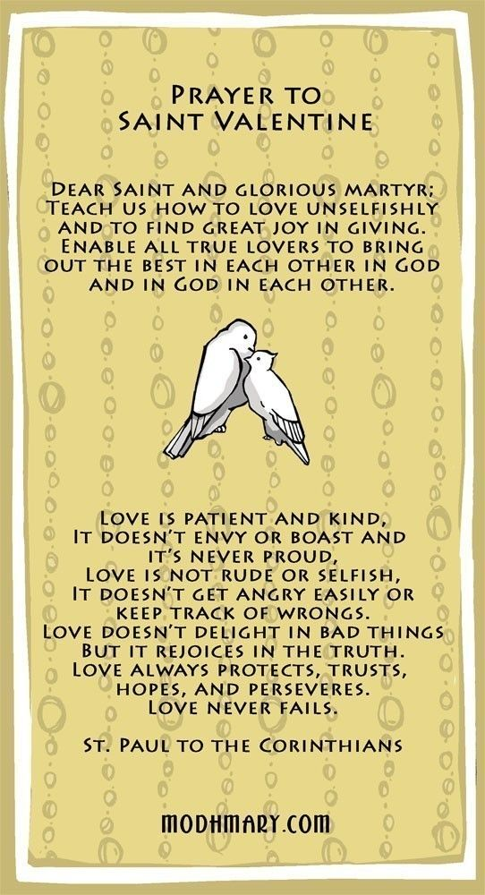

<http://www.carmelites.ie/stvalentine.html><https://www.catholic.org/saints/saint.php?saint_id=159>

<http://education.dublindiocese.ie/2012/02/21/saint-valentine/>

**February 20thWorld Day of Social Justice**

**Lá Domhanda Tiomnaithe do Cheartas Sóisialta**

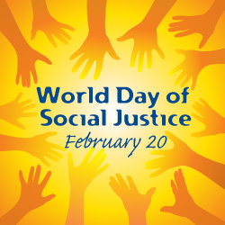

Since 2009, every 20 February has been the UN observance known as “World Day of Social Justice”. The purpose of the day is to focus on the plight of social injustice throughout the world and to press for improvements and solutions.

“Social justice” is defined, for the purpose of the observance, as including issues of poverty, unemployment, and unfair exclusion that results in economic harm or social ostracism.

On World Day of Social Justice, there are media campaigns to raise awareness of the need for better social justice both within nations and between nations. Promoting human rights, removing artificial social barriers based on race, gender, or religion, and standing up for the rights of migrants, the disabled, and the elderly are among the observance’s themes on any given year.

<http://education.dublindiocese.ie/2013/01/28/poverty/>

<http://www.un.org/en/events/socialjusticeday/background.shtml>

**Other Important Dates/Information to Note**! **/**

**Laethanta Tábhachtacha eile/ Eolas le Meabhrú!**

**1st February Re: Catholic School Week 2020/“Mary the Teacher”**

The Education Secretariat are organising a day of prayer and reflection for those who are involved in Catholic Education. This event will take place during Catholic Schools Week on:

**Saturday, 1st February 2020**

**in the Holy Cross Diocesan Centre, Clonliffe Road, Dublin D03P2E7**

The theme is “Mary the Teacher” and we have a schedule commencing at 9.30am, with breaks and a light lunch, finishing with Holy Mass celebrated by Monsignor Dan.

There will be time for prayer and reflection as well as interesting discussion and testimonies.

We have inputs on the day from school leaders and school personnel, priests and lay people. The focus is on bringing the spirit alive in school leadership with the assistance of Jesus and Mary.

This will be a fruitful day for those who attend and we invite all staff in our schools, all leaders in our schools and all members of the BOM to join us in this important initiative. Parents are also invited and are very welcome to attend.

Please reply to Karen Brady, Education Secretariat by emailing [karen.brady@dublindiocese.ie](mailto:karen.brady@dublindiocese.ie) if you and your colleagues would like to attend.

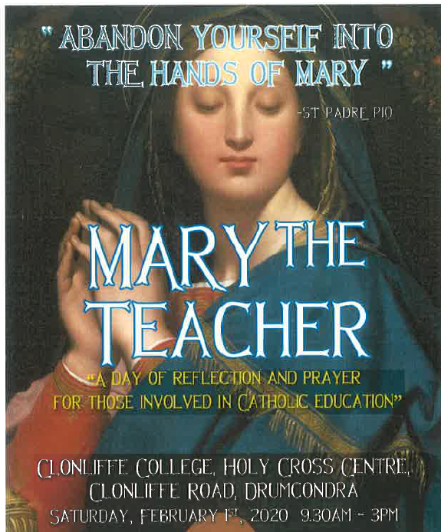

**Archdiocese of Dublin /Ard-Dheoise Bhaile Átha Cliath**

See the Archdiocese of Dublin website for information on events, which take place throughout the diocese. http://www.dublindiocese.ie/

**The Combined Catholic Parishes of Clondalkin**

Further excellent resources for February are available from Frank Brown, Parish Pastoral Worker, from the combined parishes of Clondalkin. [http://www.clondalkinparish.com](http://www.clondalkinparish.com/)​

With the feast of Don Bosco, St Brigid and St Blaise coming up here are a few resources that you can view, download, print or send onto schools, etc - https://dublindiocese-my.sharepoint.com/:f:/g/personal/frank_brown_dublindiocese_ie/EiGY1HCc4lNIm1_pQfM3U4cBLlzRA3wqwQbL5hsgbGEgDw?e=cqiyQu or from <http://www.clondalkinparish.com/?p=3865>

For Grandparents Day on the 29th Jan – Here is a simple blessing of Grandparents, suggested prayers of the faithful and prayer card that can be incorporated into a mass that day - <https://dublindiocese-my.sharepoint.com/:f:/g/personal/frank_brown_dublindiocese_ie/Eo6Rlt8P4FZKqq1NcGeCKJEB06OVUw3HDLYcRcXMW5vsaQ?e=AvxN2Y>

A suggestion for a Mass for Couples & Celebrating the Sacrament of Marriage - a suggestion to be held around Valentine’s day in your parish. All the resources (including the original files) for it - including Invitation Card, Posters, Blessing, Prayer card, Prayers of the Faithful, etc. that each parish can adapt should they chose to run with it - can be viewed & downloaded from <https://dublindiocese-my.sharepoint.com/:f:/g/personal/frank_brown_dublindiocese_ie/EuqPBTz20CRFhzpTDHLsTEgB-a0jdok3dHHcqKXbOLGpqg?e=nquiWW>

Also, were are doing a weekly 1 page reflection sheet each week – Praying the Scriptures at Home – based on the following Sunday’s Gospel that can be downloaded from - <http://www.clondalkinparish.com/?p=3519>

**The Pope John Paul II Awards**

The Pope John Paul II Award is a faith achievement award for young people between the age of 16 and 18. The Award is committed to helping young people enhance their spiritual, physical, emotional and social development through participation in school, parish and community activities. As well as the feeling of personal achievement that a participant will gain from taking part in the Award, participation will help demonstrate the young person’s commitment to a task and goal. **The Pope John Paul II Awards will be held on the 4th February 2020 in St Paul’s Church, Arran Quay**.

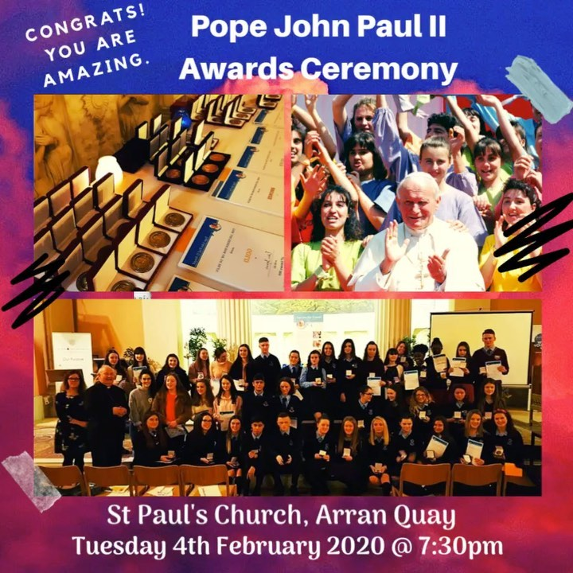

For more information email: [st.pauls@dublindiocese.ie](mailto:st.pauls@dublindiocese.ie)

**Searmanas in Onóir Bhríd Naofa, 1ú Feabhra**

*Beidh crosa Bhríde agus uisce coisricthe in úsáid.*

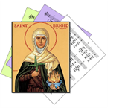

*Gabham molta Bhríde,*

*Ionúin í le hÉirinn,*

*Ionúin le gach tír í,*

*Molaimis go léir í.*

*Tig an geimhreadh dian dubh*

*’Gearradh lena ghéire;*

*Ach ar lá ’le Bríde*

*Gar dúinn earrach Éireann.*

*Lóchrann geal na Laighneach*

*’Soilsiú feadh na tíre, (Traidisiúnta, Veritas Hymnal 136)*

*Ceann ar ógha Éireann,*

*Ceann na mban ar míne.*

*“Anois teacht an earraigh, beidh ’n lá ’dul chun síneadh,*

*Is taréis na Féil’ Bríde ardóidh mé mo sheol.”*

*( Antaine Raiftearaí)*

**Cinnire:** Inniu, an chéad lá Feabhra, Lá Fhéile Bríde, Muire na nGael, Pátrún na hÉireann. Rugadh Bríd i bhFochairt láimh le Dún Dealgan sa bhliain 451, deich mbliana roimh bhás Phádraig Naofa. Taoiseach de chuid Cúige Laighean ba ea a hathair, Dúbhthach. Sclábhaí ba ea a máthair, Brocseach. Críostaí ba ea a máthair agus baisteadh Bríd ina Críostaí. Bheartaigh Bríd a bheith ina bean rialta agus bhunaigh sí mainistreacha i gCill Dara agus in áiteanna eile. Tá an-chuid scéalta i dtaobh a cineáltais do bhochtáin, d’easláin, d’ainmhithe agus i dtaobh a muinín i nDia. Tá toibreacha Bhríde ar fud na tíre agus tá a lán nósanna ag baint le Lá Fhéile Bríde. Fuair sí bás thart faoin mbliain 524.

**Beannú agus Dáileadh na gCros**

*Déantar uisce coisricthe a chroitheadh ar chrosa Bhríde agus deirtear an phaidir seo:*

**“Go raibh beannacht an Athar, an Mhic is an Spioraid Naoimh ar na crosa seo, ar na háiteanna ina bhfuil siad agus ar gach duine a fhéachann orthu.”**

*Dáiltear iad ansin agus deirtear an phaidir seo:*

**“Go dtuga lasair Bhríde spreagadh duit.**

**Go dtuga crios Bhríde slánú duit.**

**Go dtuga cruthaíocht Bhríde slí duit.”**

**Paidreacha:**

Bhí creideamh láidir ag Bríd. Chuir sí a muinín go hiomlán i nDia agus tháinig Dia i gcabhair uirthi. Guímis go muiníneach chun Dé mar a rinne Bríd.

1. A Dhia, neartaigh ár gcreideamh, ár ndóchas agus ár ngrá. A Thiarna, éist linn. **A Thiarna, bí ceansa agus éist linn.**
2. Bhí Bríd cineálta leis na bochtáin agus na heasláin. A Dhia, cabhraigh linn aithris a dhéanamh uirthi. A Thiarna, éist linn. **A Thiarna, bí ceansa agus éist linn.**
3. Bhí grá ag Bríd d’ainmhithe, d’éin agus do gach rud a chruthaigh Dia. Múin dúinn, a Dhia, conas aire a thabhairt don imshaol. A Thiarna, éist linn. **A Thiarna, bí ceansa agus éist linn.**
4. Rinne Bríd réiteach idir dhaoine. A Dhia, taispeáin dúinn conas síocháin a chothú pé áit ina mbeimid. A Thiarna, éist linn. **A Thiarna, bí ceansa agus éist linn.**
5. A Dhia, tabhair saoirse ó chogadh, ó ghorta agus ó ghéarleanúint dóibh siúd atá ag fulaingt. A Thiarna, éist linn. **A Thiarna, bí ceansa agus éist linn.**

A Dhia, bhronn tú do ghrásta go fial ar Bhríd chun do ghrá agus do thrócaire a léiriú do mhuintir na hÉireann. Beannaigh ár dtír agus líon ár gcroíthe le do ghrásta ionas go mbeimid ábalta grá Dé a léiriú agus síocháin agus aontacht a chothú pé áit ina mbeimid. Sin é ár nguí chugat trí Chríost á dTiarna. **Áiméan.**

***Duan Bhríd***

*Dearc anuas, féach mar atáimid,*

*A Naomh álainn, féach sinn.*

*Feacaimid ár nglúna id’ láthair.*

*Dearc mar mháthair ar do chlainn.*

*Cuidigh linn, a mháthair aoibhinn,*

*Bí choíche ag éisteacht linn,*

*A Naomh Bríd, a Chéile Chríosta,*

*Mar an faoileán ar an tuinn.*

*Níl aon áit ’na bhfuil na Gaeil*

*Ar an saol seo abhus, ná thall*

*Nach bhfuil grá acu’na gcroíthe*

*Ortsa, a Bhríd gheal, moch is mall.*

*Líon le grá an croí atá brúite.*

*Bain den tsúil atá fliuch, a deoir.*

*Stiúraigh, treoraigh, ardaigh sinne*

*Nó go dtagaimid id' ghlóir.*

*Ceol: Cecilia Sinnott Aistriúchán: Dubhghlas de hÍde*

**Lá Fhéile Naomh Bláisias, 3ú Feabhra**

Easpag agus mairtíreach a mhair i Sebaste san Airméin sa 4ú aois ba ea Naomh Bláisias. Tá sé sa traidisiún go raibh sé ina dhochtúir leighis sarar deineadh Easpag de agus gur leigheas sé buachaill a bhí á thachtadh. Tugtar onóir dó mar phátrún daoine a bhfuil tinneas scornaí orthu.

***************

Is comhartha é, beannú na scornach, dár gcreideamh i nDia a thugann aire dúinn agus a thugann grá do dhaoine atá tinn.

**Beannú na Scornach**

**Trí idirghuí Naomh Bláisias,**

**Easpag agus Mairtíreach,**

**go gcosnaí Dia tú ó gach éalang scornaí**

**agus ó gach tinneas eile,**

**trí Chríost ár dTiarna. Amen.**

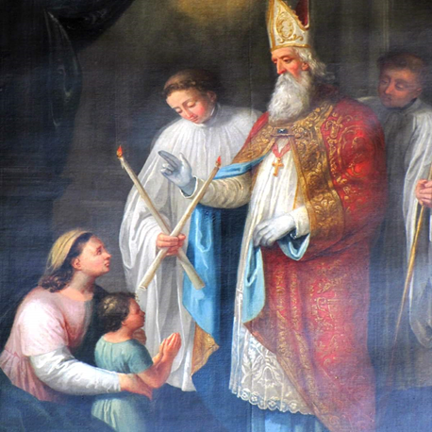

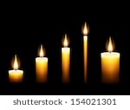



**Ceiliúradh Cairdis**

**Lá Fhéile Vailintín, Pátrún an Ghrá 14ú Feabhra**

*Coinneal chumhra, ‘croíthe’ dearga, cártaí réamh-dhéanta*

**Cinnire:** Táimid ag ceiliúradh Lá Fhéile Vailintín, Pátrún an Ghrá.

**Cérbh é Naomh Vailintín?** Sagart agus mairtíreach a cuireadh chun báis sa Róimh breis is 1,700 bliain ó shin.

**Cén fáth gur cuireadh chun báis é?** Mar thug sé a bheannacht do lánúineacha a bhí i ngrá! Ní raibh fonn ar na fir óga san am sin troid in arm an Impire Rómhánaigh, Claudius. Chuir Claudius an milleán ar na mná agus d’ordaigh sé gach pósadh agus gealltanas pósta a chur ar ceal agus bhí an bás i ndán d’aon duine a chuirfeadh ina choinne. Níor aontaigh Vailintí leis sin. Cuireadh i bpríosún é agus dícheannadh é sa Róimh ar an 14ú Feabhra 269/270 A.D.

**An bhfuil aon bhaint aige le Baile Átha Cliath?** Tá a thaisí in Eaglais na gCairmilíteach i Sráid na mBráithre Bána. Tugann lánúineacha cuairt ar an scrín ansin chun a bheannacht a iarraidh ar a bpóstaí.

**Cad is grá ann?** Seo mar a deir Naomh Pól:

“Bíonn an grá foighneach agus bíonn sé lách; ní bhíonn éad air; ní dhéanann sé maíomh ná mórtas; ní bhíonn sé mí-mhúinte ná leithleasach… Ní áil leis an éagóir ach is aoibhinn leis an mhaith. Bíonn sé lán..de chreideamh, lán de dhóchas agus lán d’fhoighne.” ( 1 Cor. 13: 4 -7)

**An duine grámhar tusa?**

An mbíonn tú foighneach.. lách.. gan éad.. gan mhaíomh.. gan a bheith mí-mhúinte.. gan a bheith leithleasach..?

An bhfuil aithne agat ar aon duine go bhfuil na tréithe sin aici/aige?

**Cinnire:** Tá cártaí Vailintín anseo, cártaí inar scríobh sibh rudaí maithe i dtaobh a chéile agus táim chun iarraidh ar Dhia iad a bheannú.

**Beannú na gCártaí**

A Dhia, cuir do bheannacht ar na cártaí seo ina gcuirimid ár ngrá do dhaoine eile in iúl mar a rinne Naomh Vailintín. Go gcuire na cártaí seo áthas, lúcháir, aoibhneas agus gliondar ar na daoine a scríobh iad agus ar na daoine a gheobhaidh iad. Sin é ár nguí chugat trí Chríost ár dTiarna. **Áiméan**

*Déantar uisce coisricthe a chroitheadh ar na cártaí.*

**Cad as a dtagann an grá?** Seo mar a deir Naomh Eoin:

“Tugaimis grá dá chéile mar gur ó Dhia an grá agus an té a thugann grá is ó Dhia a rugadh é, agus aithníonn sé Dia..mar is é Dia an Grá… Sheol sé a aonmhac sa saol le go mairimis-ne trídsean..ós fíor gur thug Dia grá dúinne nach mithid dúinne grá athabhairt dá chéile… Má thugaimid grá dá chéile maireann Dia ionainn.” (1 Eoin 4 : 7 - 12)

**Cad is fíor-ghrá ann?** Seo mar a deir Naomh Eoin:

“Ná tugaimis grá briathair ná cainte amháin, ach grá gnímh agus fírinne.”

(1 Eoin 3: 18)

**Paidreacha**

1. A Dhia ghrámhair, níl teorainn le do ghrá. Is cuma an bhfuilimid dathúil nó mí-dheas, bocht nó saibhir, óg nó aosta, tugann tú grá dúinn. Cabhraigh linn-ne aithris a dhéanamh ar do ghrá.
2. A Dia, is tú údar gach maitheasa, taispeáin dúinn conas an mhaith a aithint i ngach duine a chastar orainn.
3. A Dhia, cabhraigh linn fíor-ghrá a chleachtadh, ní le briathra amháin, ach le gníomhartha chomh maith, mar a rinne do mhac, Íosa agus Naomh Vailintín.
4. Iarraimid ort, a Dhia, do bheannacht a chur ar ár gcairdis. Cuir i gcuimhne dúinn, a Dhia, go bhfuil an grá i gcroí-lár na beatha, agus go bhfuil seirbhís do dhaoine eile i gcroí-lár an ghrá.
5. A Dhia flaithiúil, tugann tú grá dúinn gan choinníollacha. Ní chaillimid do ghrá nuair a dhéanaimid peaca agus maireann do ghrá-sa go deo. Ná lig dúinn dearmad a dhéanamh air sin choíche.

**Cinnire:** Imigí faoi shíocháin chun grá agus seirbhís a thabhairt dá chéile. **Áiméan.**

***Cairde Dílse***

*Tá cairde agat, ní gá duit bheith leat féin.*

*Bí buíoch dóibh siúd, ní gá duit bheith leat féin.*

*Tá tú láidir, ní bheidh tú i d’aonar go deo.*

*Má bhíonn sé fliuch, tugann siad foscadh duit.*

*Má bhíonn tú tinn, tugann siad faoiseamh duit.*

*Ardóidh siad do chroí, má bhíonn tú faoi bhrón.*

*Curfá*

*Cairde dílse mór-thimpeall ort,*

*Cairde dílse i gcónaí leat,*

*Cairde dílse mór-thimpeall ort go deo.*

*2*

*Má tá cairde i bhfad ó chéile*

*Bíonn siad fós i bpáirt le chéile.*

*Ní bhíonn siad riamh go brónach leo féin.*

*Bíonn siad ag smaoineamh ort,*

*Is i gcónaí ag guí duit.*

*Ní bheidh tú i d’aonar go deo.*

*Fil Uí Dhubhghaill, Finbar O’Connor, ó Beo Go Deo 8*

