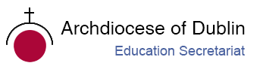

**Post-Primary Diocesan Adviser R.E. News Blog**

**December/Nollaig 2019**

Dear R.E. Teacher / Chaplain,

Welcome to the December issue of the R.E blog!  I hope you all had a great first term and are looking forward to the Christmas break! This is usually a busy month in schools and I hope the blog will help you as an educational resource in your work in schools and parishes. In addition, I would be more than happy to receive any contributions you may wish to share with fellow Chaplains and R.E. teachers or any suggestions for in-service/support days which the Diocese could provide.  We held an in-service day for Chaplains here in the *Diocesan Offices on the 29th of November* and we were delighted to welcome so many of you here for a very successful day.

School visits are well under way for this academic year, and we want to thank all those schools whom we visited for their warm welcome. We look forward to meeting many more of you in the coming months. If you would like us to visit for any reason, please contact us and we will be more than happy to arrange this with you.

As you are aware, each year, the Holy Father asks for our prayers for a specific intention each month. You are invited to answer the Holy Father's request and to join with many people worldwide in praying for this intention each month. For December the Pope’s intention is:

“**The Future of the Very Young”:**That every country take the measures necessary to prioritize the future of the very young, especially those who are suffering.

Details can be found at <http://popesprayerusa.net/popes-intentions/>

We look forward to continued collaboration with you all as we work to promote the faith of the young people in our care. May the joy of Our Saviour’s birth be with you, your families, and in your school communities this Christmastime. We wish you all many blessings.

We will continue to add resources as Gaeilge with the assistance of Sr. Mairéad Ni Bhuachalla.

Le gach dea-ghuí,

Lily Barry

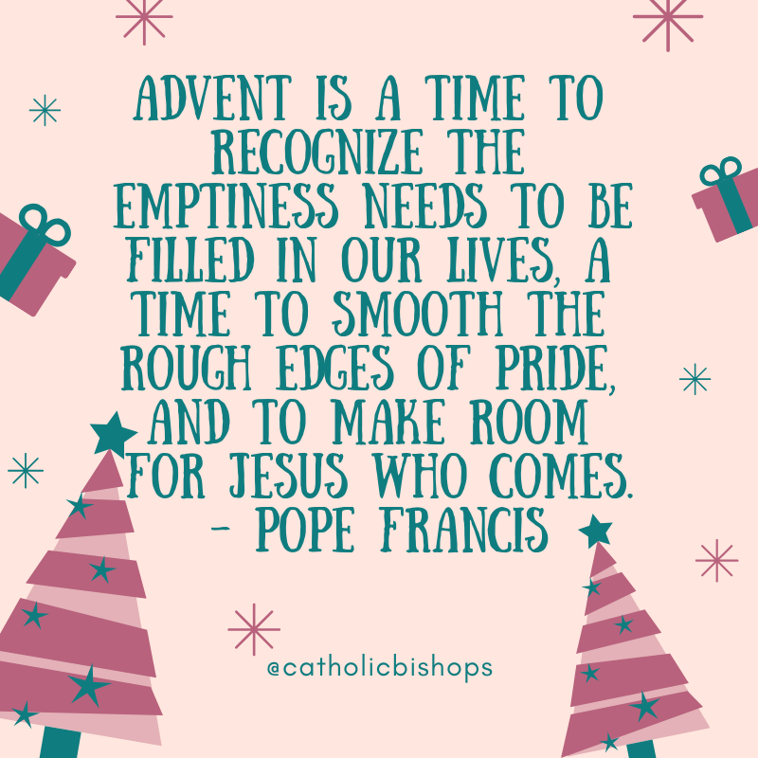

**December 1st First Sunday of Advent**

**Nollaig 1ú An Chéad Domhnach den Aidbhint**

***#LivingAdvent 2019***

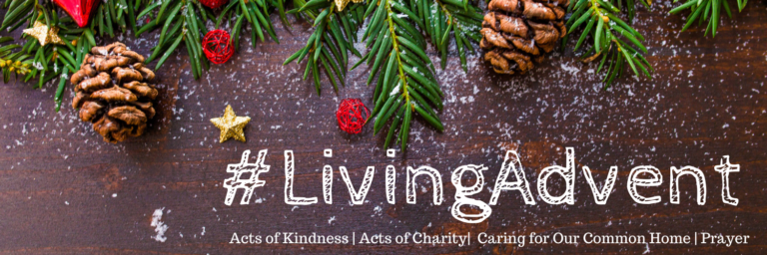

Today is the First Sunday of Advent. Advent is the season, four weeks before Christmas, in which we prepare for the coming of Christ.  The word Advent comes from the Latin word *adventus*, which means “coming”.

Advent is a time of waiting, conversion and of hope. Advent has a twofold character, for it is a time of preparation for the Solemnities of the Christmas season, in which the first coming of the Son of God to humanity is remembered, and likewise a time when, by remembrance of this, minds and hearts are led to look forward to Christ’s Second Coming at the end of time. For these two reasons Advent is a period of devout and expectant delight.

The Irish Catholic Bishop’s Conference have an excellent resource for advent. In the form of an online interactive Advent Calendar, they ask you to journey with them through the season and offer daily reflections, audio clips, readings and ideas to help you prepare and guide your students in spiritual preparation for the Lord’s coming at Christmas.

*“We are delighted to welcome you to our 2019 Advent Calendar. We hope that you can journey with us through the season of Advent. During Advent we will be sharing family prayers and suggestions for acts of kindness or charity that all of us are encouraged to undertake during the month of December. The Advent Calendar will also share tips on how families can care for our common home by having a more sustainable Christmas”.*

<https://www.catholicbishops.ie/adventcalendar/day-1-sunday-1-december-2019/>

Ideas for creating your own advent wreath and many other ideas for use in the classroom can be found at:

<http://education.dublindiocese.ie/2012/06/01/advent-resources-2/>

<https://www.catholicculture.org/ebooks/view_ebook.cfm?id=69>

**December 3rdMemorial of St. Francis Xavier**

**Nollaig 3ú Cuimhneachán ar Naomh Proinsias Xavier**

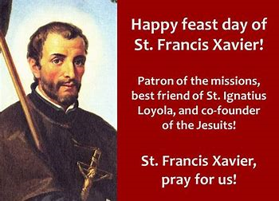

Saint Francis Xavier (1506-1552), Spanish Jesuit missionary, called the Apostle of the Indies. Born near Pamplona, on April 7, 1506, Xavier was educated at the University of Paris. In 1529, while in Paris, he met the Spanish ascetic Ignatius of Loyola. Xavier was one of the group that joined Ignatius to found the Order of Jesus. In 1537 Xavier became the first secretary of the Order. In 1542 Xavier began his work in Portuguese India. After preaching with   great success in Goa for five months, he extended his labours to southern India and Ceylon (Sri Lanka), where he converted tens of thousands of locals.   
He then led missionary work in Malacca, where he founded many Christian communities, in Japan, where he also succeeded and left behind a vigorous Christian community. In 1552 he returned to Goa with a plan to introduce Christianity into China.   
To gain entrance to that country, which was then closed to foreigners, he persuaded the Portuguese authorities to send an embassy, of which he would be a member, to the Chinese emperor. The embassy departed from Goa in the spring of 1552; it went no farther than Malacca, but Xavier continued the journey alone, arriving at a small island near Macau in August 1552. He died there December 3, 1522, after repeated vain attempts to reach the mainland. His body is enshrined in Goa, in the Church of the Good Jesus.   
A man of remarkable energy and organizational ability, Xavier ranks among the greatest missionaries of all times. Canonized in 1622. The list of his principal miracles may be found in the Bull of canonization. He was declared patron of the Orient in 1748, patron of the Faith in 1904, and with the French nun St. Teresa of Lisieux, patron of all missions in 1927. He is also the patron saint of sailors. His feast day is December 3.

All of us are called to “go and preach to all nations”—see Matthew 28:19. Our preaching is not necessarily on distant shores but to our families, our children, our husband or wife, our co-workers. And we are called to preach not with words, but by our everyday lives. Only by sacrifice, the giving up of all selfish gain, could Francis Xavier be free to bear the Good News to the world. Sacrifice is leaving yourself behind at times for a greater good, the good of prayer, the good of helping someone in need, the good of just listening to another. The greatest gift we have is our time. Francis Xavier gave his to others.

**Things to do with your students to celebrate this feast day:**

* Discuss with students what it means to be an apostle. Consider how they might imitate St. Francis Xavier in apostolic works in their own situation. Read the letter from St. Francis to St. Ignatius to get an idea of his zeal.
* Read some more about St. Francis and ideas for Celebrating the Feast of St. Francis Xavier.
* St. Francis was sent to India and Japan. Pray for the Church in these countries, and learn more about the modern Church in India and, read about the history of the Church in Japan.

<https://www.franciscanmedia.org/saint-francis-xavier/>

<https://www.catholicculture.org/culture/liturgicalyear/calendar/day.cfm?date=2019-12-03>

**December 6th  St. Nicholas of Myra**

**Nollaig 6ú Naomh Nioclás as Myra**

Not much is known about this 4th century bishop, but that does not diminish his popularity around the world, both in the East and West. It is known that Nicholas was born in Lycia in Asia Minor (modern-day Turkey) and died in 352 A.D. as the Bishop of Myra. All other stories that surround Nicholas illustrate that he practised both the spiritual and corporal works of mercy. He was generous, strove to help the poor and disadvantaged, and worked tirelessly to defend the faith. St. Nicholas provided for the poor and sick, and is the basis for the popular character of Santa Claus.

Saint Nicholas, bishop of Myra, is undoubtedly one of the most popular saints honoured in the Western world. He is primarily considered as the patron saint of children.

https://www.catholicculture.org/culture/liturgicalyear/calendar/day.cfm?date=2019-12-06

<https://www.catholic.org/saints/saint.php?saint_id=371>

**December 8th Second Sunday of Advent**

**Nollaig 8ú An Dara Domhnach den Aidbhint**

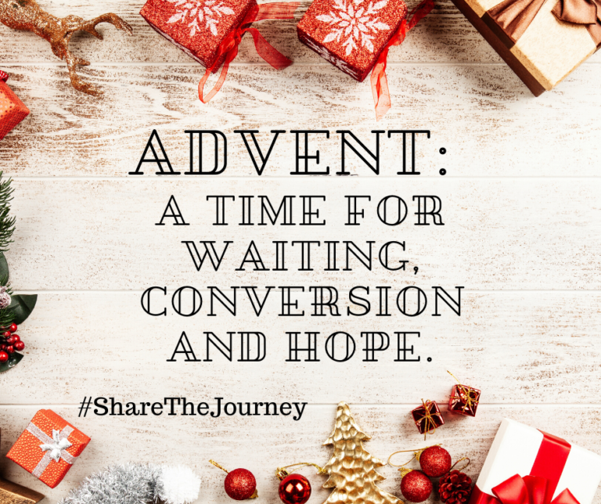

As the journey of Advent continues, as we prepare to celebrate the nativity of Christ, John the Baptist’s call to conversion sounds out in our communities. It is a pressing invitation to open our hearts and to welcome the Son of God who comes among us to make divine judgement manifest.

“Through the Gospel John the Baptist continues to speak down the centuries to each generation. His hard clear words bring health to us, the men and women of this day in which even the experience and perception of Christmas often, unfortunately, reflects materialist attitudes. The ‘voice’ of the great prophet asks us to prepare the way for the coming Lord in the deserts of today, internal and external deserts, thirsting for the water of life which is Christ.” — Benedict XVI

https://www.catholicculture.org/culture/liturgicalyear/calendar/day.cfm?date=2019-12-08

[**https://www.catholicbishops.ie/adventcalendar/**](https://www.catholicbishops.ie/adventcalendar/)

**December 9th  Solemnity of the Immaculate Conception**

**Nollaig 9ú Solúntas Ghiniúint Mhuire gan Smál**

The feast of the Immaculate Conception, which is ordinarily celebrated on the 8th of December, is superseded by the Sunday liturgy.

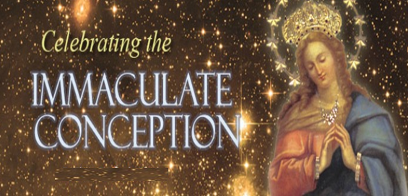

Today the Church celebrates the Solemnity of the Immaculate Conception. Through the centuries, the Church has become ever more aware that Mary, "*full of grace*" through God, was redeemed from the moment of her conception. For excellent resources to share with your students including beautiful power point presentations, see:

<https://www.catholic.org/mary/>

[http://education.dublindiocese.ie/feast-of-the-immaculate-conception-of- mary/](http://education.dublindiocese.ie/feast-of-the-immaculate-conception-of-%20mary/)

[**https://www.catholicculture.org/culture/liturgicalyear/calendar/day.cfm?date=2019-12-09**](https://www.catholicculture.org/culture/liturgicalyear/calendar/day.cfm?date=2019-12-09)

**December 10th Human Rights Day**

**Nollaig 10ú Lá Tiomanta do Chearta Daonna**

**“To deny people their human rights is to challenge their very humanity.”**

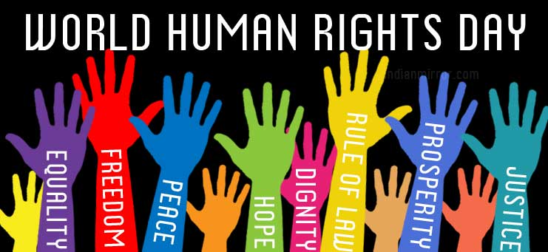

Human Rights Day is observed every year on 10 December – the day the United Nations General Assembly adopted, in 1948, the [Universal Declaration of Human Rights](http://www.un.org/en/universal-declaration-human-rights/index.html). The Universal Declaration of Human Rights, is a milestone document that proclaimed the inalienable rights, which everyone is inherently entitled to as a human being -- regardless of race, colour, religion, sex, language, political or other opinion, national or social origin, property, birth or other status. It is the most translated document in the world, available in more than [500 languages](http://www.ohchr.org/EN/UDHR/Pages/SearchByLang.aspx). Read the illustrated version of the Declaration on:

<http://www.un.org/en/events/humanrightsday/>

**December 12th** **Feast of Our Lady of Guadalupe**

**Nollaig 12ú Féile in onóir do Mhuire Guadalupe**

In 1910 Our Lady of Guadalupe was declared Patroness of Latin America, and in 1945 Pope Pius XII declared her to be the Empress of all the Americas. She appeared to an Indian convert named Juan Diego on December 9, 1531. She left a marvellous portrait of herself on the mantle of Juan Diego. This miraculous image has proved to be ageless and is kept in the shrine built in her honour, the Basilica of Our Lady of Guadalupe.

<https://www.catholicculture.org/culture/liturgicalyear/calendar/day.cfm?date=2019-12-12>

**December 14th  Memorial of St. John of the Cross**

**Nollaig 14ú Cuimhneachán in onóir d’Eoin na Croise**

St. John of the Cross (1542-1591) was born and died in Spain. In 1563 he offered himself as a lay brother to the Carmelite friars, who, however, perceiving his unusual talents, had him ordained a priest. When he was about to join the more severe Order of the Carthusians, the saintly Teresa persuaded him to remain and help her in the reform of the Carmelite Order. This reform of his order caused him such sufferings and brought him many trials. However, his sufferings served only to detach him from creatures. He had a great devotion to Our Lord's Passion and voluntarily sought out humiliations. When Our Lord asked him what reward he would ask for his labours, John answered: ***"To suffer and to be despised for Thee."*** He died of a cruel disease, embracing the crucifix. Because of his profound treatises on mystical theology Pope Pius XI proclaimed him Doctor of the Church.

https://www.catholicculture.org/culture/liturgicalyear/calendar/day.cfm?date=2019-12-14

<https://www.catholic.org/saints/saint.php?saint_id=65>

**December 15th  Third Sunday of Advent**

**Nollaig 15ú An Triú Domhnach den Aidbhint**

**"Prepare ye the way of the Lord: Make straight in the wilderness His paths; Every valley shall be exalted; Every mountain and hill shall be made low; And the crooked shall be made straight; And the rough ways plain" (Is. 40:3, 4).**

As Christmas draws near, the Church emphasizes the joy, which should be in our hearts over all that the birth of our Saviour means for us. The great joy of Christians is to see the day drawing nigh when the Lord will come again in His glory to lead them into His kingdom. **“Rejoice: the Lord is nigh.”**

Today is known as Gaudete Sunday. The term Gaudete refers to the first word of the Entrance Antiphon, “Rejoice”. Rose vestments are worn to emphasize our joy that Christmas is near, and we light the rose candle on our Advent wreath.

<https://www.catholicbishops.ie/adventcalendar/>

<http://www.catholicculture.org/culture/liturgicalyear/calendar/day.cfm?date=2018-12-16>

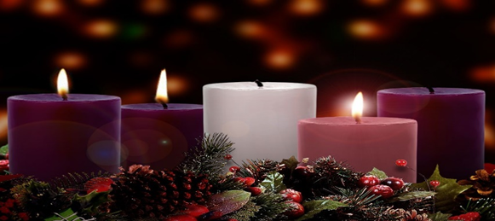

**December 22nd Fourth Sunday of Advent**

**Nollaig 22ú An Ceathrú Domhnach den Aidbhint**

**"Hail, full of grace! The Lord is with you." / “ ‘Sé do Bheatha, a Mhuire! Tá an Tiarna leat.”**

This is the last Sunday of our preparation for Christmas, the anniversary of Christ's birth. Like Joseph, we can all feel unworthy of the honour of welcoming him into our hearts and our homes. Let us try to imitate Joseph and Mary, the humblest of the humble, the kindliest of the kindly, and the greatest-ever believers in God's goodness and mercy.

<https://www.catholicculture.org/culture/liturgicalyear/calendar/day.cfm?date=2019-12-22>

**December 22nd Chanukah - Hanukkah 2019**

**Nollaig 22ú**

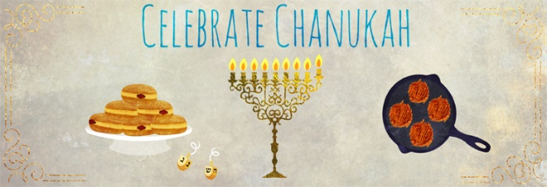

Chanukah begins Sunday night, December 2 2018 and continues through Monday, December 10 2018. Chanukah is the Jewish eight-day, wintertime “festival of lights,” celebrated with a nightly menorah lighting, special prayers and fried foods.

If you are studying Judaism with your Junior Cert class extra resources can be found at:

<https://www.chabad.org/holidays/chanukah/default_cdo/jewish/Hanukkah.htm>

<http://education.dublindiocese.ie/hanukkah/>

**Other Dates/Information (Dataí Eile/Eolas):**

We are aware that schools will close on Friday, 20th for Christmas holidays. However, please encourage your students to continue the preparation for Christmas up to Christmas Eve! ​ ​

**Frank Brown Parish Pastoral Worker from *The Combined Catholic Parishes of Clondalkin.***

Further excellent resources for Advent and Christmas are available from Frank.

“Here are a few Advent and Christmas resources that you may find useful – I have left the originals if you wish to adapt, adopt, use, lose or share” – <https://dublindiocese-my.sharepoint.com/:f:/g/personal/frank_brown_dublindiocese_ie/EjCw6RsMtQlKmzZDZcGHOFQBNfxFUHsefAw5xrG9g-petQ?e=uXEayO>

There should be something for all including, - A busy persons Advent retreat, Walking Advent with Scriptures, Family & MAD (Make a difference resources), etc. May add to these as Advent continues so keep dipping in. Have a great & hope filled Advent!! [http://www.clondalkinparish.com](http://www.clondalkinparish.com/) ​@TheCCPCDublin.

**Nutrition for the Soul / Cothú don Anam**

Excellent resources available here from Pat Murphy, including reflections and posters [**https://patsnutritionforthesoul.blogspot.com/**](https://patsnutritionforthesoul.blogspot.com/)

**Faitharts**

Faitharts is a website for those interested in the relationship between religion and the arts, especially the popular arts, and especially in relation to education. The perspective is Catholic and Irish, and its particular audience is religion teachers, but hopefully anyone with a general interest in the area will find something useful or thought provoking.

*Editor: Brendan O'Regan, teacher of English and Religion.* <http://www.faitharts.ie/advent.html>

**Christmas Voices from the Pro-Cathedral**

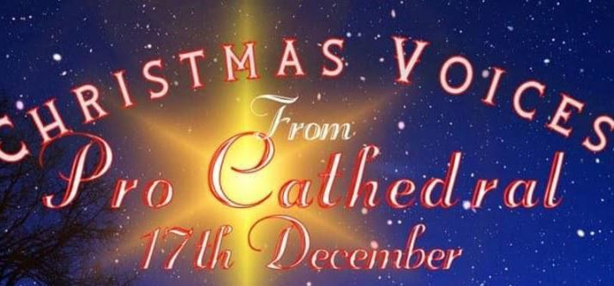

Christmas Voices is a concert in St Mary's Pro-Cathedral to raise funds for the homeless. Performers include Red Hurley, Linda Martin, Cliona Hagan, Anna Kearney, boys and girls of the Cathedral Choirs and further guests to be announced. Details - Tue, 17 December 2019 19:30. This year  
proceeds will go towards the Peter McVerry Trust and Dog's Aid. Tickets at [Eventbrite](https://www.eventbrite.ie/e/christmas-voices-from-the-pro-cathedral-tickets-81212622139).

**Videos for RE**

There has been a significant shift in recent years on the part of both Church and State and it’s reflected in the new JC specification and will impact on the NCCA review of Senior Cycle RE shortly.  
Two recently recorded interviews are likely to be helpful to teachers grappling with this question and to anyone who expects to be undertaking an interview for an RE post in the next year or two:

1. Rev. Dr. Gareth Byrne (DCU & Catholic Centre for Religious Education) explains how all students can do RE from their own perspective (which includes students who are practicing Catholics).  See <https://www.icatholic.ie/religious-education-gareth-byrne/>
2. Dr. Audrey Doyle (DCU and Le Chéile Trust) unpacks the rationale behind the recent reform of the Junior Cycle RE specification and the implications for Catholic Schools.  See <https://www.icatholic.ie/junior-cycle-re-audrey-doyle/>

**Archdiocese of Dublin / Ard-Dheoise Bhaile Átha Cliath**

See the Archdiocese of Dublin website for information on events, which take place throughout the diocese**.** [**http://www.dublindiocese.ie/**](http://www.dublindiocese.ie/)or follow the Diocese on Facebook.

[**https://www.facebook.com/DublinDiocese/photos/a.336758473023201/2786129244752766/?type=3**](https://www.facebook.com/DublinDiocese/photos/a.336758473023201/2786129244752766/?type=3)

**International Youth Conference**

The International Youth Conference is a three-night residential conference for youth (ages 16-35) taking place in Clongowes Wood College in Clane, Co. Kildare, from the 27th-30th of December and is organised by Anointing Fire Catholic Ministries. The aim is to invite all youth to experience the power and presence of God in their lives and to be strengthened and empowered by His Holy Spirit so that they can share the Good News! It includes workshops, music concert, praise and worship, Spiritual Sharing, Bible - based talks, Dramas, Holy Mass, Adoration, Confession and Healing Service - all in the company of like-minded peers. For registration and information go to [www.afcmteamireland.org](https://afcmteamireland.org/events/youth-conference/)

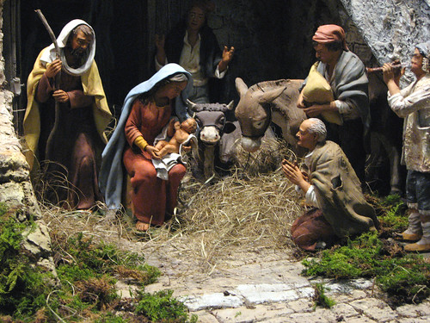

**Searmanas ag an gCró Nollag**

**Cinnire:** Tá an Nollaig buailte linn arís, séasúr speisialta den bhliain. Gabhaimis buíochas le Dia mar gur thaispeáin sé a ghrá dúinn trína mhac Íosa Críost a thabhairt dúinn mar Shlánaitheoir.

**Scéal na Nollag**

**(Bunaithe ar Lúcas 2 : 1-16)**

San am sin d’ordaigh Impire na Róimhe, Caesar Ágastas, do gach duine in Iosrael clarú ina chathair féin (chun a chinntiú go n-íocfaidís cáin!). Chuaigh Iósaf go Beithil in éineacht lena bhean chéile, Muire, a bhí ag súil le leanbh.

Nuair a shroich siad Beithil ní raibh áit dóibh sa teach ósta agus b’éigean dóibh an oíche a chaitheamh i stábla. Rugadh Íosa, mac Mhuire an oíche sin agus chuir sí ina luí i mainséar é.

Bhí aoirí ag faire a dtréada agus go tobann chonaic siad solas geal agus aingeal ó Dhia a dúirt leo gur rugadh Slánaitheoir, Críost, an Tiarna, agus go raibh sé ina luí i mainséar. In éineacht leis an aingeal bhí slua na bhFlaitheas ag canadh:

“Glóir do Dhia sna harda agus síocháin ar talamh.”

Nuair a d’imigh na haingil chuaigh na haoirí go Beithil agus fuair siad Muire agus Iósaf agus an leanbh ina luí sa mhainséar.

**An Cró Nollag**

Tá an Cró Nollag againn le beagnach ocht gcéad bliain. Naomh Proinsias as Assisi san Iodáil a chuir tús leis an gCró Nollag san Eoraip. Sa bhliain 1220 thug sé cuairt ar Bheithil agus thaitin an tslí inar ceiliúradh an Nollaig ansin go mór leis. Nuair a d’fhill sé abhaile rinne sé mainséar as uaimh. Chuir sé íomhá chloiche den leanbh Íosa isteach inti agus chuir sé ainmhithe beo timpeall uirthi. Bhí na daoine an-sásta leis an gCró Nollag agus d’fhás an nós as sin.

**Cinnire:** Tá an Cró Nollag ullamh agus tá Muire agus Iósaf ag fanacht.

Anois cuireadh an scoláire is óige sa rang an Leanbh Íosa sa mhainséar.

Canaimis : ***Oíche Chiúin***

Oíche chiúin, oíche Mhic Dé!

Cách ’na suan, dís araon,

Dís is dílse ag faire le spéis,

Naíon beag gnaoi-gheal ceannann tais caomh:

Críost ’na chodladh go séimh,

Críost ’na chodladh go séimh!

1. A Íosa, is tú mac Dé. Cabhraigh linn cur leis an ngrá atá againn dár muintir i rith na Nollag.
2. A Íosa, is tú mac Mhuire. Beannaigh gach teaghlach atá ag súil le leanbh agus beannaigh gach leanbh agus páiste.
3. A Íosa, is tú a thug dea-scéal do na bochtáin. Cabhraigh linn a bheith fial flaithiúil leo siúd nach bhfuil dóthain bia, éadaigh ná dídine acu.
4. A Íosa, leigheas tú na heasláin. Cabhraigh linn sólás a thabhairt do dhaoine atá tinn agus do dhaoine atá uaigneach.
5. A Íosa, is tú Prionsa na Síochána. Cabhraigh linn síocháin a scaipeadh sa bhaile, sa scoil agus i measc ár gcairde.
6. I rith na bliana seo romhainn go raibh deireadh le gach cogadh.

Canaimis: *Oíche chiúin, oíche Mhic Dé!*

*Aoirí ar dtús ’chuala an scéal:*

*Alleluia, aingil ag glaoch,*

*Cantain suairc i ngar is i gcéin:*

*Críost ár Slánaitheoir féin,*

*Críost ár Slánaitheoir féin!*

*Focail: Traidisiúnta*

*F. Gruber Beo go Deo 6*