Post-Primary Diocesan Adviser R.E. News Blog 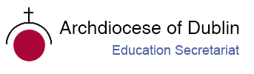
November 2019 / Mí na Samhna, Mí na Marbh

Welcome to November issue of the R.E blog! I hope you all had a lovely, restful midterm break! This month is dedicated to the faithful departed and is known as Month of the Holy Souls. You will find a number of resources below including prayer services in Irish, which could be used with your students through-out the month.
I trust the blog will continue to be useful for you as an educational resource in your work in schools and parishes. In addition, I would be more than happy to receive any contributions you may wish to share with fellow Chaplains and R.E teachers or any suggestions for in-service /support days which the Diocese could provide. This month we are delighted to invite all our Chaplains to an in-service day in the diocesan offices on the 29th of November. Letters and agendas will be sent out soon. We hope that all Chaplains can join us as we celebrate the ministry of chaplaincy and continue to support the work of chaplaincy in our schools.
As you are aware, each year, the Holy Father asks for our prayers for a specific intention each month. You are invited to answer the Holy Father's request and to join with many people worldwide in praying for this intention each month. For November the Pope’s intention is ‘Dialogue and Reconciliation in the Near East’ and details can be found at http://popesprayerusa.net/2019/10/28/november-reflection-dialogue-reconciliation-near-east/.
Please contact me if you want to include your name/school on our mailing list to receive the blog. We will continue to add resources as Gaeilge with the assistance of Sr. Mairéad Ni Bhuachalla.
Le gach dea-ghuí,
Lily Barry

Calendar of events for November:
November 1st All Saints’ Day / Féile na Naomh Uuile
November 2nd All Souls’ Day / Cuimhneachán na Marbh
November 3rd St. Martin de Porres / Naomh Máirtín de Porres
November 6th All the Saints of Ireland / Lá Fhéile Naomh na hÉireann
November 7th Diwali/Deepavali
Information on any of the above feasts/days can be found on http://education.dublindiocese.ie/category/post-primary/post-primary-blog/
November 14th St Laurence O'Toole / Lorcán Naofa Ó Tuathail
St Laurence O'Toole (Lorcán Ó Tuathail) was born in Castledermot, Co. Kildare in 1128. He became Abbot of Glendalough in 1153 and Archbishop of Dublin in 1162. He died in Normandy on November 14, 1180 and was canonised in 1225. For further information including a power point presentation, worksheets and prayers, please see: http://education.dublindiocese.ie/st-laurence-otoole/
A prayer to St. Laurence:
St. Laurence O’Toole, man of peace, you were in the middle of family and political conflict from your earliest days. Give the gift of peace and hope to all who experience the trauma of division in families, in communities and among nations. St. Laurence O’Toole, man of faith, you had the openness to accept a position of leadership in your community at an early age. Bless our young people with a spirit of generosity to offer themselves in the service of the Gospel. Amen.
https://www.catholic.org/saints/saint.php?saint_id=365

November 14th World Diabetes Day
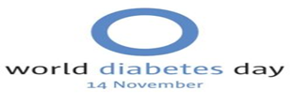
World Diabetes Day (WDD) was created in 1991 by IDF and the World Health Organization in response to growing concerns about the escalating health threat posed by diabetes.
It is marked every year on 14 November, the birthday of Sir Frederick Banting, who co-discovered insulin along with Charles Best in 1922. WDD is the world’s largest diabetes awareness campaign reaching a global audience of over 1 billion people in more than 160 countries. The campaign draws attention to issues of paramount importance to the diabetes world and keeps diabetes firmly in the public and political spotlight.
The campaign is represented by a blue circle logo that was adopted in 2007 after the passage of the UN Resolution on diabetes. The blue circle is the global symbol for diabetes awareness. It signifies the unity of the global diabetes community in response to the diabetes epidemic.
How to Observe World Diabetes Day
Wear the blue circle
The blue circle logo is a global symbol for diabetes awareness. On World Diabetes Day, wear a t-shirt, necklace or bracelet with the logo or create one yourself to make others aware of this dangerous disease and its effects.

Organize a diabetes fair
Partner with health officials to sponsor a diabetes fair at your place of work or your neighbourhood. Offer diabetes screenings, disseminate information and brochures, and provide information on what people can do to prevent type II diabetes and stay healthy.

Get tested
Symptoms of diabetes can include but aren’t limited to excessive excretion of urine, thirst, constant hunger, weight loss, vision changes and fatigue. In addition, being overweight or obese greatly increases the chances of having type II diabetes. It’s estimated 1 in 2 adults with diabetes is undiagnosed. Use World Diabetes Day as reminder to get tested if you have any risk factors or symptoms.

November 18th World Day of Remembrance / ‘Life is not a car part’
This theme ‘Life is not a car part ‘is based on Pillar 3 of the Global Plan for the Decade of Action for Road Safety – Safer vehicles. Notwithstanding global efforts to the contrary, the type of road mobility that is in place throughout the world still fosters an unbearable number of deaths, serious injuries and illnesses every year, both as the immediate consequence of road traffic crashes and through air pollution.
The World Day of Remembrance for Road Traffic Victims (WDR) is commemorated on the third Sunday of November each year – to remember the many millions killed and injured on the world’s roads, together with their families, friends and many others who are also affected. It is also a Day on which we thank the emergency services and reflect on the tremendous burden and cost of this daily continuing disaster to families, communities and countries, and on ways to halt it.

Road deaths and injuries are sudden, violent, traumatic events. Their impact is long-lasting, often permanent. Each year, millions of newly injured and bereaved people from every corner of the world are added to the countless millions who already suffer. The cumulative toll is truly tremendous.

The grief and distress experienced by this huge number of people is all the greater because many of the victims are young, because many of the crashes could and should have been prevented. Governments’ and society’s response to road death and injury and to bereaved and injured victims is often inadequate, unsympathetic, and inappropriate to a loss of life or quality of life.

This special Remembrance Day is therefore intended to respond to the great need of road crash victims for public recognition of their loss and suffering. It has also become an important tool for governments and those who work to prevent crashes or respond to the aftermath, since it offers the opportunity to demonstrate the enormous scale and impact of road deaths and injuries and the urgent need for action.
https://worlddayofremembrance.org/ https://worlddayofremembrance.org/about/themes/
November 20th Universal Children’s Day / Lá Uilíoch na Leanbh
Children are taking over and turning the world blue. Sign the petition.
United Nation’s Universal Children’s Day was established in 1954 and is celebrated on November 20th each year to promote international togetherness, awareness among children worldwide, and improving children's welfare. November 20th is an important date as it is the date in 1959 when the UN General Assembly adopted the Declaration of the Rights of the Child. It is also the date in 1989 when the UN General assembly adopted the Convention on the Rights of the Child. Since 1990, Universal Children's Day also marks the anniversary of the date that the UN General Assembly adopted both the declaration and the convention on children's rights.
Children have their rights denied every single day. We want to build a world where every child is in school and learning, safe from harm and able to fulfil their potential, and we know you do too. It's time to put children back on the agenda.
Mothers and fathers, teachers, nurses and doctors, government leaders and civil society activists, religious and community elders, corporate moguls and media professionals as well as young people and children themselves can play an important part in making Universal Children's Day relevant for their societies, communities and nations. Universal Children's Day offers each of us an inspirational entry-point to advocate, promote and celebrate children's rights, translating into dialogues and actions that will build a better world for Children.
Sign the petition and #GoBlue to call on world leaders to commit to fulfilling the rights of every child and acknowledge that these rights are non-negotiable.
https://www.unicef.org/world-childrens-day

November 21st The Presentation of Mary / Toirbhirt na Maighdine Muire
The Feast of the Presentation of Mary is celebrated in both the Eastern and Western Churches. It recalls the day in the life of the Jewish girl named Mary (Maryam) when her parents, Joachim and Anne, presented her to the Lord in the temple and dedicated her life to Him. Mary had already been chosen by God, preserved by a singular grace as a chosen vessel through whom the Incarnate Word would be given for the salvation of the whole world. However, the offering by her parents is a response to the invitation to join our free choice to God' invitation. This exercise of freedom lies at the heart of discipleship, and is the inner core of every vocation, to cooperate with grace.
Today's Feast emphasises our response to God's gifts. We remember the response of Mary's mother and father in their decision to present her in the temple for dedication to the Lord. All parents are called to imitate their response by presenting their children for Baptism.
https://www.catholicculture.org/culture/liturgicalyear/calendar/day.cfm?date=2018-11-21 https://www.catholic.org/news/hf/faith/story.php?id=43754
Venerable Nano Nagle, An Influential Educator / Nano Urramach de Nógla, Teagascóir Ceannasach
‘Justice, Peace and Integrity of Creation’
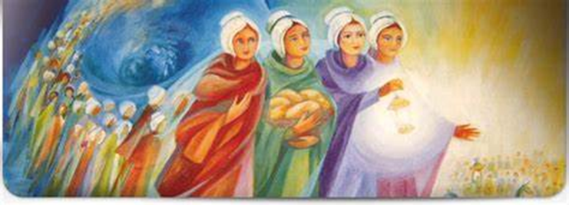The Presentation Sisters and Friends of Nano Nagle, all over the world, celebrate the Feast of the Presentation of Mary in the Temple on the 21st November each year.
If Nano Nagle were alive today she would be the kind of person to win a Nobel Prize. Before her death in 1784, Nano had opened seven schools for poor children across Cork city, founded an alms-house for poor women, and most notably, founded the Presentation Order, who continue her education and social inclusion work today. Born to a wealthy Catholic family in 1718, Honoria Nagle was given the pet name Nano by her father. The Nagle family home at Ballygriffin, near Mallow, was on the banks of the river Blackwater. Here Nano experienced an idyllic childhood with her younger siblings. The repressive Penal Laws meant that education for Catholics was not available in Ireland (unless they were willing to attend proselytising Church of Ireland schools) and Irish Catholics were forbidden from travelling to the continent to be educated. Despite this, Nano’s family had Nano educated in France. Afterward she went to Paris to live with her relations. A series of life changing events inspired Nano to devote her life to the service of the poor.
She responded in the most challenging of circumstances – educating children in secret schools when Penal Laws forbade the setting up schools for Catholics, ministering to the wretched and the dispossessed and sharing everything with them until she had scarcely enough resources for herself. Working at times through illness and often through adversity, Nano gave her ‘all’ to the poor and needy of Cork. A pioneering Spirit-led woman in every way, Nano had the foresight to set up a religious congregation, now known as the Presentation Sisters of the Blessed Virgin Mary, to ensure her legacy.
Discover #Cork discover #Nano.
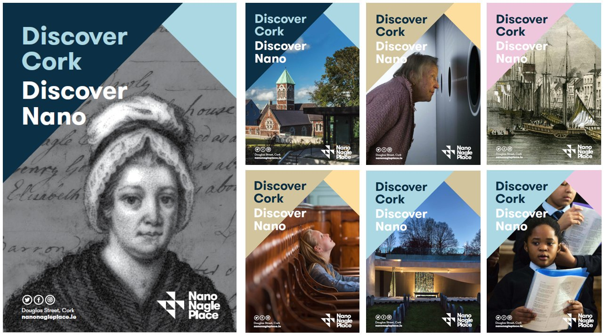The
Seven years ago the buildings of the South Presentation Convent were in a perilous position. As the area around the convent changed, the need for the school complex the site housed declined and the school closed its doors in 2006. Most of the buildings, some over 200 years old, sat empty with just a few resident sisters to maintain them. The Presentation Sisters decided to act, just as their foundress had done nearly two hundred and fifty years before. They set up a company, appointed a voluntary board, and put in place plans to redevelop ‘South Pres’ as a special place for the people of Cork City.
The heritage buildings have been lovingly regenerated, they now house educational charities and rooms are also available to let by community groups, charities and local businesses. The chapel has been turned into a heritage centre that engagingly tells the story of Nano Nagle and the city in which she worked to educate and care for the poor. It allows the visitor to explore the incredible spread of the Presentation Order, the changing lives of the sisters who have dedicated their lives to that order and the remarkable work they still carry out as educationalists and campaigners for social justice. Come and visit Nano Nagle Place, get involved and become part of our story. https://nanonagleplace.ie/
November 25th Solemnity of Our Lord Jesus Christ, King of the Universe /Sollúntas Chríost Rí na nUile
‘Yes, I am a king. I was born for this, I came into the world for this: to bear witness to the truth; and all who are on the side of truth listen to my voice.’ (John 12:37)
In 1969, Pope Paul VI gave the feast its current date on the last Sunday in the liturgical year. He also established it as a solemnity (which is of highest liturgical rank) and gave it a new title – The Solemnity of Our Lord Jesus Christ, King of the Universe.
This is a tremendous feast with which to end the liturgical year because it turns upside down all the pre-conceived ideas we have about hierarchy, kingship and what it means to be in authority. The idea of kingship as an all-powerful ruler, controller and dictator did not fit with the person and actions of Jesus. Jesus' actions made it clear that he is not that kind of king. He has not come to ‘lord’ it over people. He is not interested in an earthly type of kingdom. His kingdom is very different – it is not of this world. It is not simply that Jesus had spoken about a different place. His words and deeds presented a different way of living, one that is not about control or power but love and service. Jesus’ power comes from God and it is a power that builds people up rather than diminishes them. He does not deny that he is a king but it is not the word he would use. The only thing that matters to him is the truth and that truth is God.
http://education.dublindiocese.ie/feast-of-christ-the-king/ https://www.catholicculture.org/culture/liturgicalyear/calendar/day.cfm?date=2018-11-25

November 25th International Day for the Elimination of Violence against Women
Lá Idirnáisiúnta in aghaidh Foiréigin ar Mhná
"“Not until the half of our population represented by women and girls can live free from fear, violence and everyday insecurity, can we truly say we live in a fair and equal world." — UN Secretary-General António Guterres
Violence against women and girls is one of the most widespread, persistent and devastating human rights violations in our world today.
Gender inequality persists worldwide. Achieving gender equality and the empowerment of women and girls will require more vigorous efforts, including legal frameworks, to counter deeply rooted gender-based discrimination that often results from patriarchal attitudes and related social norms. http://www.un.org/en/events/endviolenceday/

November 27th Feast of the Miraculous Medal / Féile an Bhoinn Míorúilteach
The Motherhouse of the Daughters of Charity has been located at 140, Rue du Bac since 1815. The chapel was built by the Community and refurbished several times. In 1830 in this chapel, Mary appeared to a novice, of the Daughters of Charity, the future Saint Catherine Laboure. During one of her apparitions, she told Catherine, “Have a medal struck on this model, and everyone who wears it will receive great graces.” The model was the Virgin Mary with arms outstretched and beams of light streaming from her hands, with the inscription: “O Mary conceived, without sin, pray for us who have recourse to you.”
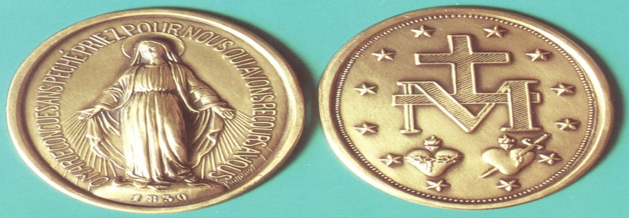
Mary left a simple message, enduring sign that she wanted to make known to us – The Medal.

Mary used the front of the medal to remind us of her active presence in our history. The inscription reveals to us Mary’s fundamental identity as the Immaculate Conception. Because she was chosen to be the Mother of Jesus, Mary was filled with grace and preserved from all stain of sin. In addition, Mary tells us that she prays to God and intercedes for each of us. The front of the medal reveals Love. Mary Immaculate with her open hands filled with light is the messenger of a God who loves us. The back of the medal reminds us of God’s loving plan for us. It describes Mary and indicates her role in the mystery of Christ. She is at the centre of the mystery of the Church: the 12 stars represent the 12 apostles chosen by Christ. The back of the medal describes the demands of Love.
“The M surmounted by the cross and the two hearts say it all”, said Catherine. They symbolize Mary’s close collaboration with Jesus even in His suffering, passion and death.
Wearing the Medal implies learning from Mary how to pray. The message of the Medal is still relevant today, as it is the message of the Gospel. The Miraculous Medal is a great gift that has been entrusted to us and is to be shared with everyone. Let us spread devotion to the Miraculous Medal.
November 30th Day of Remembrance for all Victims of Chemical Warfare
Cuimhneachán orthu siúd a cailleadh de bharr Cogaí Ceimiceacha
The history of the serious efforts to achieve chemical disarmament that culminated in the conclusion of the Chemical Weapons Convention began more than a century ago. Chemical Weapons were used on a massive scale during World War I, resulting in more than 100,000 fatalities and a million casualties.
Adopted in 1993, the Chemical Weapons Convention entered into force on 29 April 1997. It determined, “for the sake of all mankind, to exclude completely the possibility of the use of chemical weapons.”
The commemoration today, will provide an opportunity to pay tribute to the victims of chemical warfare, as well as to reaffirm the commitment of the Organization for the Prohibition of Chemical Weapons (OPCW) to the elimination of the threat of chemical weapons, thereby promoting the goals of peace, security, and multilateralism. http://www.un.org/en/events/chemwarfareday/
November 30th St. Andrew the Apostle / Féile Naomh Aindriú, Aspal
Andrew, Peter's brother, and John were the first disciples to follow the Lord. With tender delicacy the Gospel (John 1:35-42) describes their first meeting with Jesus. Andrew did not belong to the inner circle of the apostles, Peter, James and John, and the evangelists narrate nothing extraordinary about him (John 6:8); but tradition extols his great love of the Cross-and of the Saviour. https://www.catholicculture.org/culture/liturgicalyear/calendar/day.cfm?date=2018-11-30https://www.catholic.org/saints/saint.php?saint_id=109
St Andrew’s Prayer
O Glorious St. Andrew,
you were the first to recognize and follow the Son of God. With your friend, St. John, you remained with Jesus,
for your entire life, and now throughout eternity.
Just as you led your brother, St Peter, to Christ and many others after him, draw us also to Him.
Teach us how to lead them, solely out of love for Jesus and dedication to His service.
Help us to learn the lesson of the Cross and carry our daily crosses without complaint,
so that they may carry us to God the Almighty Father. Amen.
Other Dates/Information (Dataí eile/Eolas):
Archdiocese of Dublin / Ard-Dheoise Bhaile Átha Cliath
See the Archdiocese of Dublin website for information on events, which take place throughout the diocese. http://www.dublindiocese.ie/ or follow the Diocese on Facebook https://www.facebook.com/DublinDiocese/photos/a.336758473023201/2786129244752766/?type=3
Events we would love to see your Pope JPII Award participants take part in are
- Do One Thing is an initiative to help vulnerable people in our city. We aim to gather teens and young adults across the diocese to come to St. Pauls Church, Arran Quay between 5pm and 9pm on Tuesday 26th November, where we will pack boxes, hampers and bags for the variety of homeless people of our city. All the packs will go to Crosscare who will get the items to those most at risk and in need. The idea is to collect some items. Attached please find in a social media friendly graphic the suggested items for the packs.

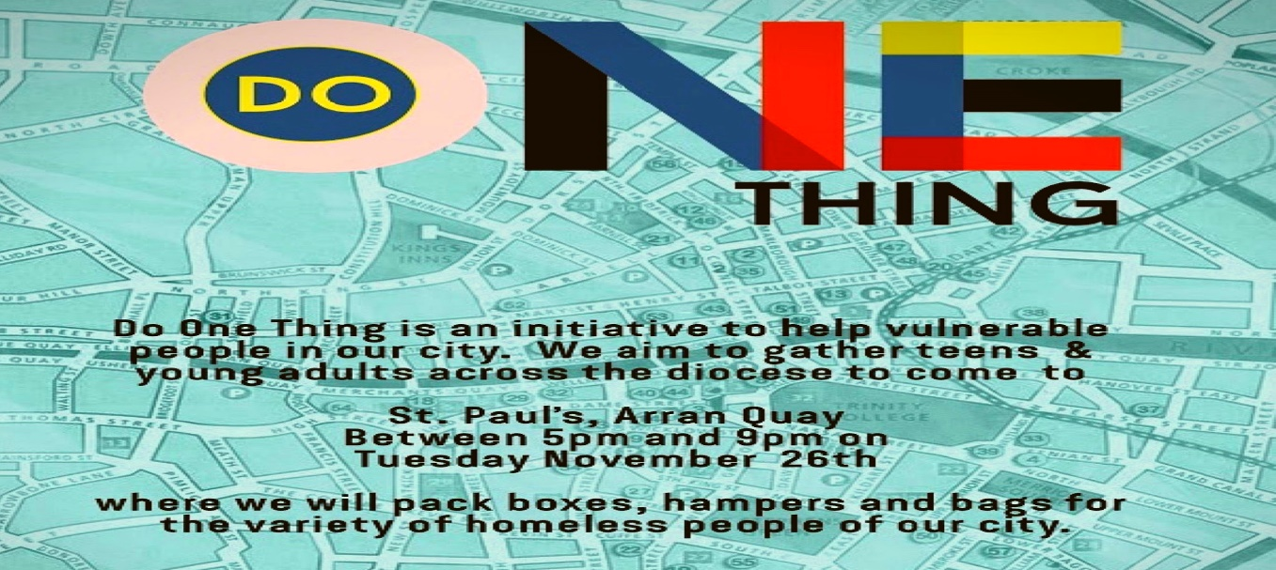
If you would like to donate for this cause, please find the list of practical items attached to this email, you can bring them to St Paul's on the following dates:
Thursday 7th November 5pm - 8pm
Monday 11th November: 7am - 10am
Wednesday 13th November 7am - 10am
Friday 15th November 5pm - 7pm
Monday 18th November 7am - 10am #community #helpingoneanother #love #youngdisciples #loveyourneighbour #doonething #theyoungchurchdublin
Please let us know if you intend to bring a group with you to our Do One Thing initiative! Email siobhan.tighe@dublindiocese.ie
Chaplaincy Day: 29th November
We would like to invite all Chaplains to attend a Chaplaincy Day which will be held in the Holy Cross Diocesan Centre, Clonliffe Road. The day will be hosted by the Archdiocese of Dublin, the Le Cheile School Trust, the Loreto Education Trust, the Jesuit Trust and the Spiritan Education Trust. The day will be an opportunity for Chaplains working in our schools to take some time out for reflection and discussion. We believe these days offer an opportunity for you to meet with other Chaplains and share best practice as well as ‘time out’ to reflect on the role of chaplaincy in our school communities. A certificate of attendance will be provided to you on the day. Please contact myself or Sr. Bernadette for further information:
lily.barry@dublindiocese.ie or bernadette.carron@dublindiocese.ie
This is a day to celebrate and acknowledge the valuable contribution Chaplains make to our schools communities, and to offer some practical guidelines for Chaplains to take away and incorporate into their ministry.
Frank Brown Parish Pastoral Worker
Excellent resources for November are available from Frank Brown Parish Pastoral Worker from The Combined Catholic Parishes of Clondalkin. http://www.clondalkinparish.com​
Nutrition for the Soul / Cothú don Anam
Excellent resources available here from Pat Murphy, including reflections and posters https://patsnutritionforthesoul.blogspot.com/
RTAI / Religion Teachers’ Association of Ireland / Cumann Múinteoirí Reiligiúin na hÉireann
Registration is now open for the RTAI workshop on the new JCRE Specification. WHEN: Saturday 23rd November from 9.30am – 1pm WHERE: Dublin West Education Centre The workshop will look at planning for, and approaches to, the new RE course. Lunch will be provided. There is no charge but please only book a place if you are fully committed to attending.
Places can be booked by emailing your name, school and Teaching Council number to jasmin.troy@gmail.com
Leaving Cert R.E Support
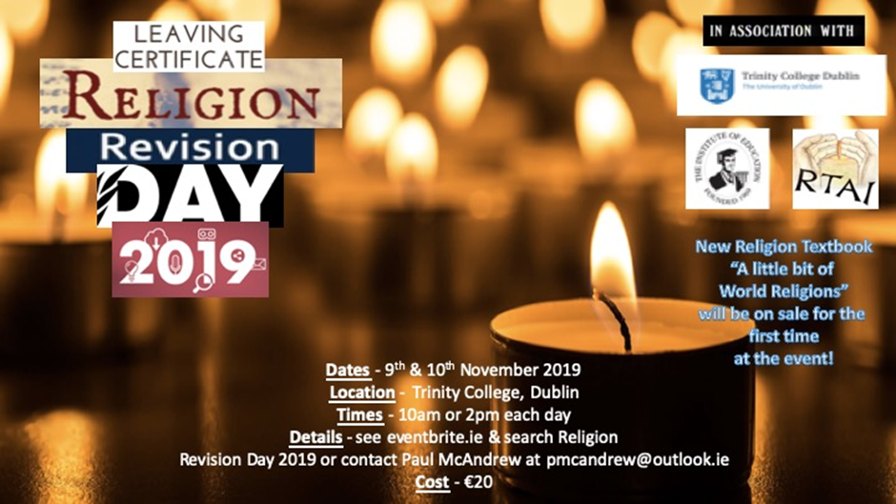
International Youth Conference
See information below for upcoming Youth Conference in December. This is a unique opportunity for the youths of Ireland to encounter the living Lord.
Conference starts at 2pm on Friday 27th December and ends on Monday 30th December at 4pm
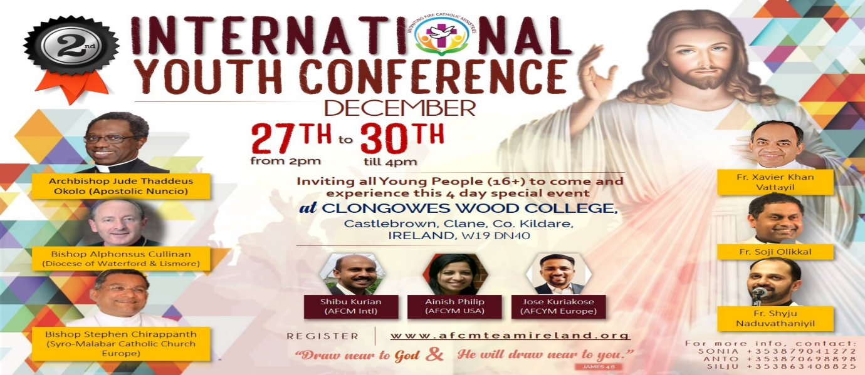
November Liturgical Resources for Catholic Schools
Preparatory Catechetical Moment – November 2019
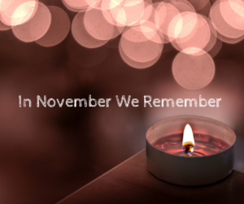
November is traditionally the month that we remember all those we have loved and are no longer with us. This November, as we remember those who have passed away, we invite Catholic primary and post-primary schools to engage with the resources we are making available as part of our preparations for Catholic Schools Week 2020. These resources aim to assist Catholic school communities with their reflections during the month of the Holy Souls as they prepare for their celebration of CSW2020, beginning on 26 January.
https://www.catholicschools.ie/catholic-schools-week-2020/
Pope Francis' encyclical, Laudato Si', is a profound invitation to everyone on the planet to care for our common home.
Download Pope Francis' Laudato Si' encyclical and find resources to reflect and respond to Laudato Si' in the light of your faith, including prayers, liturgies, a study guide and ideas for practical action, relating to climate change, the environment and sustainable development. https://cafod.org.uk/Pray/Laudato-Si-encyclical
Top 10 Things You Need to Know about Pope Francis' Laudato Si'
https://www.youtube.com/watch?v=a_lqFTYLc_4&feature=youtu.be

Acmhainn i nGaeilge
Tá na hacmhainn seo a bheadh úsáideach le haghaidh paidreoireachta faoi iamh:
- Machnamh, “Imithe as mo Radharc”
- Searmanas Paidreoireachta, “Cuimhneachán na Marbh”
- Power Point, “Samhain, Tugaimid chun Cuimhne”
Machnamh: Imithe as Mo Radharc
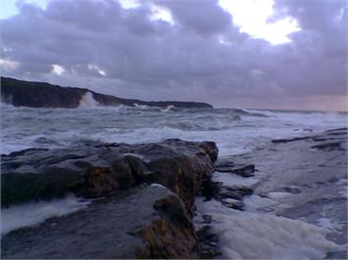
Táim im’ sheasamh cois trá.
Tá long taobh liom agus í ag spréadh amach a seolta chuig leoithne na maidne agus í ag tabhairt aghaidh ar an aigéan gorm. Tá áilleacht agus maorgacht ag baint léi. Coinním súil uirthi go dtí go mbíonn sí cosúil le dúradán scamaill bháin ag bun na spéire.
Ansin, cloisim duine taobh liom ag rá:
“Féach, tá sí imithe!” "Cá bhfuil sí imithe?” Imithe as mo radharc. Sin uile é.
Tá a crann seoil, a cabhail agus a sparra chomh mór agus a bhí siad nuair a d’fhág sí mo thaobh agus fós tá ar a cumas a lasta a iompar chuig a ceann scríbe. Is ormsa a tháinig an laghdú, ní ar an long.
Agus díreach ag an nóiméad nuair a deir duine taobh liom : “Féach tá sí imithe!”; tá súile eile ag faire amach lena teacht, agus glórtha eile ullamh chun an gháir ríméadach a thógáil: “Seo chugainn í!”Sin samhlaoid den bhás.
A Dhia na mbeo agus na marbh, a bhfuil sofheicthe agus dofheicthe, feicthe agus neamhfheicthe; beannaigh cách, i ngach áit, i ngach am; mar níl aon duine ná aon rud taobh amuigh de do ghrá mórchroíoch. Amen.
* le Henry Van Dyke, eaglaiseach, oide, file agus údar diaganta a mhair san 19ú aois.
Cuimhneachán na Marbh
Ceol: “Ag Críost an Síol” agus ceol suaimhneach
Coinnle: Ceann mór amháin, ceann beag le haghaidh gach duine, Cipíní solais, fáideoga
Bileoga: Ainmneacha na ndaoine a fuair bás
Maisiúchán: Póstaer, duilleoga
Failtiú agus Míniú
Cinnire: Tá fáilte romhaibh chuig an searmanas seo ina dtugaimid chun cuimhne daoine atá imithe ar shlí na fírinne (a fuair bás).
Tá duilleoga áille ildaite anseo ar an mbord. Tá dathanna áille, dathanna an fhómhair orthu. Tháinig siad amach san earrach agus bhí siad beag agus glas. D’fhás siad agus nuair a bhí a saol caite, d’athraigh an dath agus thit siad den chrann. Is rud nádúrtha é sin: Breith, Fás agus Bás.
Sin mar a bhíonn ag daoine freisin. Tagann siad ar an saol, beag agus óg. Fásann siad agus nuair a thagann an t-am faigheann siad bás. Is rud nádúrtha an bás, cuid de shaol an duine, cuid den phlean atá ag Dia dúinn.
Glaonn Dia abhaile orainn nuair atáimid ullamh agus is ag Dia amháin atá a fhios cathain a bhíonn an duine ullamh. Dia a thugann an bheatha dúinn, Dia a thógann ar ais í. Bronntanas sár-luachmhar ó Dhia is ea mo bheatha agus do bheatha agus níl sé de chead againn-ne, ná ag aon duine eile deireadh a chur léi.
Lasadh na gCoinnle
Táim chun an choinneal mhór a lasadh anois. Is siombail an choinneal mhór seo d’Íosa a fuair bás cosúil linne. D’éirigh sé ó mhairbh agus gheall sé do na daoine a chreideann ann go n-éireoidís ó mhairbh freisin. Tugann sé sin dóchas agus misneach dúinn.
Soiscéal
Dúirt Íosa: “Mise an tAiséirí agus an Bheatha; an té a chreideann ionamsa, fiú amháin má fhaigheann sé bás, mairfidh sé, agus gach duine a mhaireann is a chreideann ionamsa, ní bhfaighidh sé bás choíche.” (Eoin 11 : 25 – 26)
Tugaimis chun cuimhne anois na daoine a bhfuil a n-ainmneach ar na bileoga atá agaibh.
Bímis ciúin agus guímis ar son ár muintire a fuair bás..
Anois lasaigí-se an choinneal bheag ón gcoinneal mhór agus iarraigí ar Dhia na daoine atá marbh a thabhairt chun na bhFlaitheas in éineacht le hÍosa Críost.
Cuirigí an choinneal agus an bhileog leis na hainmneacha uirthi, timpeall ar an gcoinneal mhór a fhad is a bheidh ceol suaimhneach á chasadh.
Canamis:
Ag Críost an Síol, Ag Críost an síol, ag Críost an fómhar,
In iothlainn Dé go dtugtar sinn. Ag Críost an mhuir, ag Críost an t-iasc,
I líonta Dé go gcastar sinn.
Ó fhás go haois, is ó aois go bás, Do dhá láimh, a Chríost, anall tharainn.
Ó bhás go críoch, ní críoch ach ath-fhás, I bParthas na nGrást go rabhaimid.
Focail: Michael Sheehan (1916) *Ceol: Seán Ó Riada Veritas Hymnal 6
Paidir
Guímis le chéile ar son ár ngaolta, ár gcomharsana agus ár gcairde a fuair bás.
A Dhia, tabhair suaimhneas síoraí dóibh ar Neamh.
A Thiarna, éist linn. A Thiarna, bí ceansa agus éist linn.
Beannacht
Guím beannacht Dé agus coimirce Mhuire oraibh agus suaimhneas síoraí dár muintir a fuair bás.
Áiméan
* An tArdeaspag Micheál Ó Síocháin (Michael Sheehan), údar Apologetics and Catholic Doctrine, a chum an dán seo mar chomhartha comhbhróin le cairde leis a chaill iníon in aois dhá bhliain déag. D’úsáid muintir Uí Chiarghusa an dán ar chárta cuimhneacháin a n-iníne, Brídín.
Samhain-Tugaimid-chun-cuimhne.ppt
http://education.dublindiocese.ie/november-resources-as-gaeilge/

