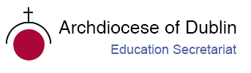

Post-Primary Diocesan Adviser R.E. News Blog
September 2019 / Meán Fómhair 2019

Dear R.E Teacher/Chaplain,
Welcome to September’s issue of the R.E blog! I hope you all had a lovely summer with plenty of opportunities to unwind, refresh and recharge! I hope the blog will continue to be useful for you as an educational resource in your work in schools and parishes. In addition, I would be more than happy to receive any contributions you may wish to share with fellow Chaplains and R.E teachers or any suggestions for in-service /support days which the Diocese could provide. We are currently working in collaboration with the Loreto Trust, Le Chéile, Spiritan Education, and Jesuit Education in order to provide an in-service day for all Chaplains working in schools. The details will follow.
Please draw your student’s attention to the Pope's monthly intentions and videos which are a wonderful resource for use in the classroom and/or assemblies. It has become the custom of Pope Francis to release a video message detailing his prayer intention for each month. The September prayer intention is ‘For protecting the oceans’.
Sr. Bernadette and I are looking forward to welcoming and launching the new 2019/20 Ember teams for schools in this academic year; we have added three new schools to our Ember programme this year and will continue to expand and include more next year. We hope to visit many of you throughout the year, and look forward to continued collaboration as we work to promote the faith of the young people in our care.
We will continue to add resources as Gaeilge with the assistance of Sr. Mairéad Ni Bhuachalla.
Le gach dea-ghuí,
Lily Barry

Pope's September prayer intention: For protecting the oceans

In his prayer intention for the month of September 2019, Pope Francis invites us to pray that "politicians, scientists and economists work together to protect the world’s seas and oceans." Oceans contain the bulk of our planet’s water supply, and also most of the immense variety of living creatures, many of them are threatened for various reasons. Creation is a project of love given by God to humanity. Our solidarity with the “common home” is born from our faith. Let us pray this month that politicians, scientists and economists work together to protect the world’s seas and oceans. https://www.vaticannews.va/en/pope/news/2019-08/pope-francis-september-2019-prayer-intention-oceans.html

September 1st Pope prays for peace ahead of 80th anniversary of World War II outbreak.
Meán Fómhair 1ú Guíonn an Pápa 80 bliain cothrom ar bhriseadh amach an Dara Cogadh Domhanda.

September 1st marks 80 years since the outbreak of the Second World War. Pope Francis reminds us that “We shall all pray for peace, so that the tragic consequences of hate – which brought only destruction, suffering, and death – may never be repeated.” The Pope also invited everyone to pray to God, so that “peace may reign in the hearts of all and in families, societies, and amongst peoples.”

September 5th The International Day of Charity

Meán Fómhair 5ú Lá Idirnáisiúnta Tiomanta don Charthanacht

“Charity can alleviate the worst effects of humanitarian crises, supplement public services in health care, education, housing and child protection.”

The International Day of Charity was originally a Hungarian civil society initiative. It was supported by the Hungarian Parliament and Government in 2011, and was instituted on September 5 to commemorate the anniversary of Mother Teresa’s death. In 2012, the UN General Assembly resolved to incorporate the Hungarian holiday and make it international. It was co-sponsored by 44 UN Member States, including Lebanon, the Dominican Republic, and the Republic of Korea. On the International Day of Charity, the emphasis is placed on enhancing visibility, organizing special events, and increasing solidarity, social responsibility, and public support. So if you’re looking for a new charity to support, or if you would like to get more involved with a specific charity, then September 5 is the perfect day to do it.

Use this day with your students to explore the idea of volunteering and why it is a valuable way of contributing to their community. Here are some ideas:
Do research on different kinds of charities. / Déan taighde ar charthanachta éagsúla.
Just as there are billions of humans on the Earth, there are billions of different problems that affect us, and some of them might not get very much attention in mainstream media. Take this opportunity to do some research, and see how many not-mainstream charities you can find. You never know—you might find your next calling.

Look for a place to volunteer. / Cuardaigh áit chun obair dheonach a dhéanamh.
Giving to charity is always a worthwhile thing to do, but you can also donate your time in addition to (or instead of) your money. Find somewhere close to home where you can put in some work and do some good in your community. This is ideal if you are in a position where you want to help others, but your current living situation makes monetary donations difficult. You can’t put a price on time spent helping others.
Why We Should Love International Day of Charity! Remind your students that:
People always need help! / Bíonn gá ag daoine le cabhair i gcónaí.
Life is hard, and for some, it’s nearly impossible. Due to circumstances beyond immediate repair, there are some people who are trapped in negative cycles that prevent them from affecting positive change on their own lives. The only reason humanity has survived as long as it has is because of our tendency to help others. All we have to do is reach out.
Sometimes we forget to reach out and help people. / Uaireanta déanaimid dearmad lámh chúnta a thairiscint.
This is understandable. The challenges we face in our daily lives can often be enough to make us short-sighted, concentrating on our own problems while ignoring those of others. While it is important not to neglect yourself in favour of others (because it’s always harder to help people when nobody is helping you), it’s also important to reach out to others and give them a hand if you’re able to give it. The International Day of Charity is the perfect time to remember that.
You might not have heard of your favourite cause yet! /B’fhéidir nár chuala tú trácht go fóill ar chúis a oirfeadh duitse.
This is the one positive side effect of the fact that the problems we face have such infinite variety. Thanks to all the different problems that can and do affect us, there’s a good chance that the cause you care about the most may not be given very much attention most of the time. On the International Day of Charity, you may discover a cause that drives you.
https://nationaltoday.com/international-day-charity/
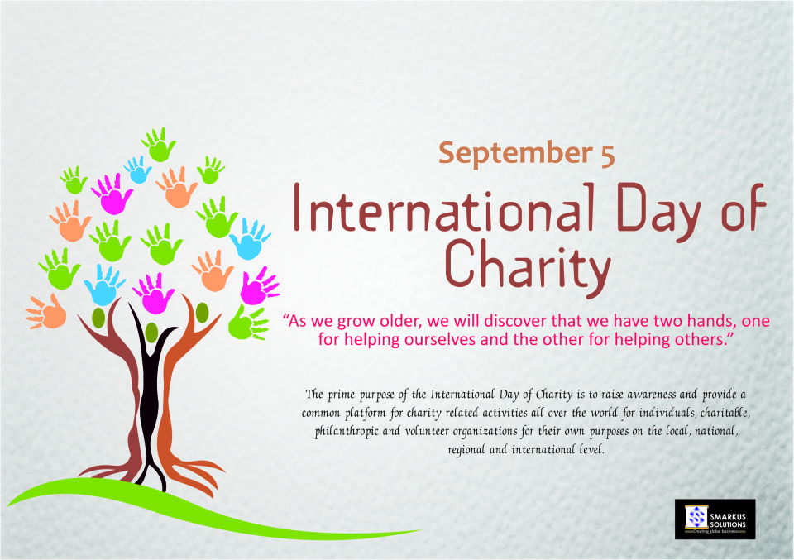

September 5th Remembering St. Teresa of Calcutta
Meán Fómhair 5ú Cuimhneachán ar Mother Theresa
“Not all of us can do great things. But we can do small things with great love.”
― Mother Teresa
Today the Missionaries of Charity and their friends will be celebrating the feast day of newly canonized St. Teresa of Calcutta. September 5th is the anniversary of her death, and at present is acknowledged as her feast day.
Mother Teresa left a testament of unshakable faith, invincible hope and extraordinary charity. Her response to Jesus' plea, "Come be My light," made her a Missionary of Charity, a "mother to the poor," a symbol of compassion to the world, and a living witness to the thirsting love of God. As a testament to her most remarkable life, Pope John Paul II permitted the opening of her Cause of Canonization. On December 20, 2002 he approved the decrees of her heroic virtues and miracles. Mother Teresa was beatified by Pope John Paul II on October 19, 2003. September 5th is established as her liturgical feast.
The General Assembly of the United Nations designated the 5th of September, the anniversary of the death of Mother Teresa, as the International Day of Charity.
https://www.un.org/en/events/charityday/background.shtml
https://www.youtube.com/watch?v=E0wwF1Emn7o https://www.catholicculture.org/culture/liturgicalyear/calendar/day.cfm?date=2019-09-05

September 8th International Literacy Day
Meán Fómhair 8ú Lá Idirnáisiúnta Tiomanta don Litearthacht
2019 Theme: Literacy and Multilingualism
International Literacy Day 2019 will focus on ‘Literacy and Multilingualism.’ Despite progress made, literacy challenges persist, distributed unevenly across countries and populations. Embracing linguistic diversity in education and literacy development is central to addressing these literacy challenges and to achieving the Sustainable Development Goals.
On the occasion of International Literacy Day 2019, the main characteristics of multilingualism in today’s globalized and digitalized world will be discussed, together with their implications for literacy in policies and practice in order to achieve greater inclusion in multilingual contexts.
https://en.unesco.org/commemorations/literacyday
https://literacyworldwide.org/meetings-events/international-literacy-day

September 8th Birth of the Blessed Virgin Mary
Meán Fómhair 8ú Saolú na Maighdine Muire
Mary was born to be the mother of the Saviour of the world, the spiritual mother of all men, and the holiest of God's creatures. Because of her Son's infinite merits, she was conceived and born immaculate and full of grace. Through her, Queen of heaven and of earth, all grace is given to men. Through her, by the will of the Trinity, the unbelieving receive the gift of faith; the afflicted are tendered the works of mercy; and the members of Christ grow in likeness of their Head. In Mary all human nature is exalted. We rejoice in her birthday, as the Church has done from the earliest times.
On Our Lady's birthday the Church celebrates the first dawning of redemption with the appearance in the world of the Saviour's mother, Mary. The Blessed Virgin occupies a unique place in the history of salvation, and she has the highest mission ever commended to any creature. We rejoice that the Mother of God is our Mother, too. Let us often call upon the Blessed Virgin as "Cause of our joy", one of the most beautiful titles in her litany.
For Pope Francis, Mary is an icon of wisdom, strength, courage and joyful hope. Her unconditional “yes” to God encourages modern believers to say “yes” to God’s call today. We must turn to Mary often, he says, for she is a mighty intercessor and a faithful companion on our spiritual journey. The writings, homilies, prayers, talks, and even tweets of Pope Francis on Mary are available in this book, “Mother Mary” and it gathers his most important and inspiring words about Mary.
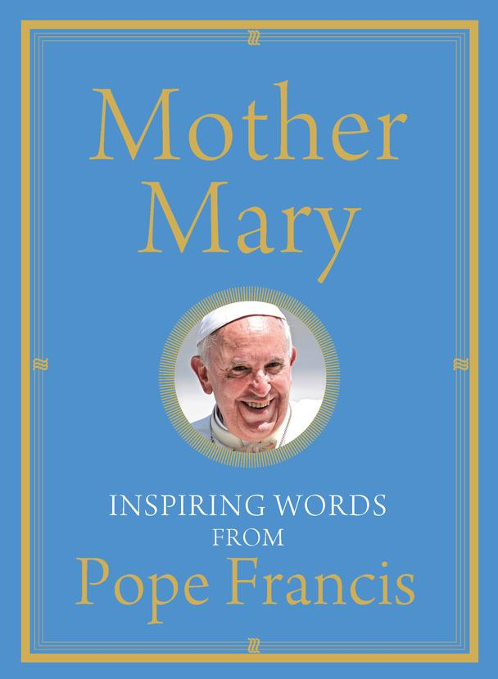
https://www.franciscanmedia.org/nativity-of-the-blessed-virgin-mary/
http://education.dublindiocese.ie/september-8th-our-ladys-birthday/
September 12th Memorial of the Most Holy Name of the Blessed Virgin Mary
Meán Fómhair 12ú Cuimhneachán ar Ainm ró- Naofa na Maighdine Beannaithe Muire.
On this day dedicated to the Holy Name of Mary let us repeat that wonderful prayer of Saint Bernard, responding to Pope Benedict XVI's invitation (Benedict XVI, address at Heiligenkreuz Abbey, September 9, 2007) to “invite everyone to become a trusting child before Mary, even as the Son of God did. Saint Bernard says, and we say with him: 'Look to the star of the sea, call upon Mary … in danger, in distress, in doubt, think of Mary, and call upon Mary. May her name never be far from your lips, or far from your heart … If you follow her, you will not stray; if you pray to her, you will not despair; if you turn your thoughts to her, you will not err. If she holds you, you will not fall; if she protects you, you need not fear; if she is your guide, you will not tire; if she is gracious to you, you will surely reach your destination”'

September 29th-30th Jewish New Year: Rosh Hashanah
Meán Fómhair 29ú - 30ú Aithbhliain na nGiúdach
Rosh Hashanah in 2019 will start on Sunday, the 29th of September and will continue for 2 days until Monday, the 30th of September. Rosh Hashanah is celebrated on the 1st and 2nd days of the Hebrew month "Tishrei". It is the only Jewish holiday which lasts for two entire days, considered as one very long day. It is the anniversary of the creation of Adam and Eve, and a day of judgment and coronation of God as king.
Rosh Hashanah observances include candle lighting in the evenings, festive meals with sweet delicacies during the night and day, prayer services that include the sounding of the ram’s horn (shofar) on both mornings, and desisting from creative work.
https://www.chabad.org/library/article_cdo/aid/4644/jewish/Rosh-Hashanah.htm

September 10th World Suicide Prevention Day/ Working Together to Prevent Suicide
Meán Fómhair 10ú Cosc ar Fhéin-ghortú
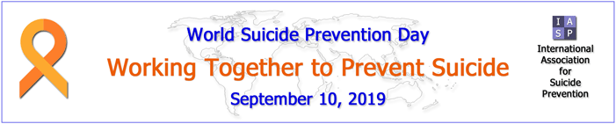
The International Association for Suicide Prevention (IASP) is dedicated to:
- preventing suicidal behaviour,
- alleviating its effects, and
- providing a forum for academics, mental health professionals, crisis workers, volunteers and suicide survivors.
Founded by the late Professor Erwin Ringel and Dr. Norman Farberow in 1960, IASP now includes professionals and volunteers from 77 countries. IASP is a Non-Governmental Organization concerned with suicide prevention.
Excellent resources available on: https://www.iasp.info/
This year IASP host their 30th world congress in Derry, Northern Ireland From the 17th-21st of September. The theme of this congress is ‘Breaking down Walls and Building Bridges,’ which denotes the concept of overcoming barriers and progressing in our shared efforts to prevent suicide. With an extensive line-up of keynote speakers and a packed conference programme, it is expected to be a very stimulating and progressive event. Full details of the conference programme are available on the website: https:// www.iasp2019.com
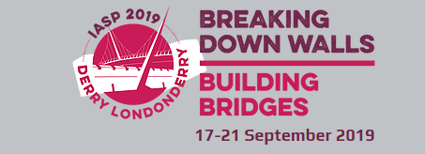
If you are feeling suicidal or know of someone who needs help, browse Help to find a crisis centre anywhere in the world. https://www.iasp.info/

September 11th 9/11 R.E. Resources
Meán Fómhair 11ú Acmhainn
It can be difficult for parents and teachers to talk about terrorism with young people, but these conversations are crucial to help future generations understand the events that shaped their world. Teach + Learn Information, context and resources exploring the attacks of 9/11, including excellent education programmes, lesson plans and interactive timelines are available at
https://www.911memorial.org/teach-learn
http://education.dublindiocese.ie/september-11th-911-r-e-resources/

September 14th Feast of the Exaltation of the Holy Cross
Meán Fómhair 14ú Féile Ghlórú na Croise Naofa
The Feast of the Exaltation of the Holy Cross, celebrated every year on September 14th, recalls three historical events: the finding of the True Cross by Saint Helena, the mother of the emperor Constantine; the dedication of churches built by Constantine on the site of the Holy Sepulchre and Mount Calvary; and the restoration of the True Cross to Jerusalem by the emperor Heraclius II. But in a deeper sense, the feast also celebrates the Holy Cross as the instrument of our salvation. This instrument of torture, designed to degrade the worst of criminals, became the life-giving tree that reversed Adam's Original Sin when he ate from the Tree of the Knowledge of Good and Evil in the Garden of Eden.
Why Do We Celebrate the Feast of the Holy Cross?
It's easy to understand that the Cross is special because Christ used it as the instrument of our salvation. But after His Resurrection, why would Christians continue to look to the Cross?
Christ Himself offered us the answer: "If any man will come after me, let him deny himself, and take up his cross daily, and follow me" (Luke 9:23). The point of taking up our own cross is not simply self-sacrifice; in doing so, we unite ourselves to the sacrifice of Christ on His Cross.
When we participate in the Mass, the Cross is there, too. The "unbloody sacrifice" offered on the altar is the re-presentation of Christ's Sacrifice on the Cross. When we receive the Sacrament of Holy Communion, we do not simply unite ourselves to Christ; we nail ourselves to the Cross, dying with Christ so that we might rise with Him.
"For the Jews require signs, and the Greeks seek after wisdom: But we preach Christ crucified, unto the Jews indeed a stumbling block, and unto the Gentiles foolishness . . . " (1 Corinthians 1:22-23).
For Christians, the Cross is the crossroads of history and the Tree of Life. Christianity without the Cross is meaningless: Only by uniting ourselves to Christ's Sacrifice on the Cross can we enter into eternal life.
https://www.learnreligions.com/feast-exaltation-of-the-holy-cross-542472
https://www.catholicculture.org/culture/liturgicalyear/calendar/day.cfm?date=2019-09-14

September 21st Matthew the Evangelist
Meán Fómhair 21ú Maitiú, Soiscéalaí
At the time that Jesus summoned him to follow Him, Matthew was a publican, that is, a tax-collector for the Romans. His profession was hateful to the Jews because it reminded them of their subjection; the publican, also, was regarded by the Pharisees as the typical sinner. St. Matthew is known to us principally as an Evangelist. He was the first to put down in writing our Lord's teaching and the account of His life. His Gospel was written in Aramaic, the language that our Lord Himself spoke. Matthew’s Gospel makes clear that Jesus is the fulfilment of everything said by the prophets in the Old Testament. His book is the first of the four Gospels in the New Testament.
The Church established St. Matthew's feast day as September 21st.
https://www.catholic.org/saints/saint.php?saint_id=84
http://www.stmatthewcr.org/parish/who-was-st-matthew/

September 21st International Day of Peace
Meán Fómhair 21ú Lá Idirnáisiúnta Tiomanta don Síocháin

Each year the International Day of Peace is observed around the world on 21 September. The General Assembly has declared this as a day devoted to strengthening the ideals of peace, both within and among all nations and peoples. This year the 2019 Theme is: “Climate Action for Peace”
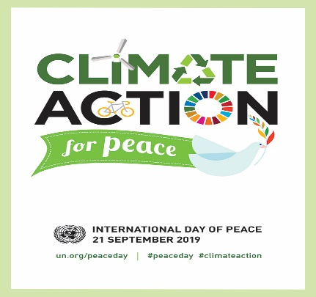

The theme draws attention to the importance of combatting climate change as a way to protect and promote peace throughout the world. What can youth do to get involved?
What can our students do to get involved?
Young people are stepping up to the challenge - close to half a million youth around the world have taken action on climate change in their homes, schools and communities. According to UNFCCC, they are key actors in raising awareness, running educational programmes, promoting sustainable lifestyles, conserving nature, supporting renewable energy, adopting environmentally-friendly practices and implementing adaptation and mitigation projects.
This year, the International Day of Peace Student Observance, to take place on 20th September 2019 at United Nations Headquarters, will provide a platform for young people to showcase the projects that they have undertaken to fight climate change and promote peace. The student observance will be held immediately following the Peace Bell Ceremony, which begins at 9 a.m. with the Secretary-General and will be webcast live at webtv.un.org.
https://www.un.org/en/events/peaceday/

September 23rd St. Padre Pio
Meán Fómhair23ú Naomh Padre Pio
"Pray, hope and don't worry."
St. Padre Pio was an Italian priest who was known for his piety and charity, as well as the gift of the stigmata, which has never been explained. Padre Pio was hearing confessions when he felt pain in his hands and feet. He noticed the stigmata, the wounds of Christ, appearing on his hands and feet. The experience was painful. Bleeding occurred. The wounds smelled of roses, and although they continued to weep, they never became infected. Doctors who later examined the stigmata were amazed at their perfectly round shape.
By 1919, word began to spread about Padre Pio's stigmata and people came from far away to examine him.
Padre Pio died on September 23, 1968. His funeral was attended by over 100,000 people. Pope John Paul II recognized Padre Pio as a saint on June 16, 2002. His feast day is September 23rd.
https://www.catholic.org/saints/saint.php?saint_id=311

September 27th Feast Day of St. Vincent de Paul
Meán Fómhair 27ú Féile Naomh Uinseann de Pól
“The poor person is a unique person of God's fashioning with an inalienable right to respect.”
(Frederic Ozanam)
Those words, spoken in 1834 by the Founder of the Society of St.Vincent de Paul, Frederic Ozanam, remain accurate in today’s world. Frederic was 20 years old when he began the Society with a number of friends in Paris on April 23, 1833. He made this statement a year later. It encompasses the spiritual ethos of the Society and its focus on working for social justice.
The Society of St. Vincent de Paul (SVP) charity is a Christian voluntary organisation, working with people experiencing poverty and disadvantage. Inspired by their principal founder, Frederic Ozanam, and patron, St. Vincent de Paul, they seek to respond to the call every Christian receives to bring the love of Christ to those in need: "I was hungry and you gave me food" (Matthew 25). No work of charity is foreign to the Society. They are involved in a diverse range of activities characterised by:
- Support and friendship/ Promoting self-sufficiency/ Working for Social Justice
Encourage staff and students to get involved!
SVP are currently helping people throughout Ireland who are struggling to provide food, heat and clothing for themselves and their families.
The Society of St Vincent de Paul helps thousands of families and individuals each year in Ireland. However, we cannot do this without your support be it through volunteering, donating to our charity shops, donating online or fundraising.
SVP provides many volunteer opportunities from visiting people in their homes by joining one our visitation conferences (local branches of SVP), to volunteering at one our second-hand Vincent’s Charity shops located around Ireland. If you are looking to volunteer with SVP and need more information, be it through volunteering at your local charity shop or through visitations contact: https://www.svp.ie/get-involved/volunteer.aspx
http://education.dublindiocese.ie/september-27th-st-vincent-de-paul/
https://www.svp.ie/about-us/history-spirituality.aspx

September 29th Feast of the Archangels
Meán Fómhair 29ú Féile na nArdaingeal

Today is the feast of St. Michael, St. Gabriel and St. Raphael which is superseded by the Sunday Liturgy.
The Feast of the Archangels is traditionally celebrated on the 29th September. The liturgy celebrates the feast of these three archangels who are venerated in the tradition of the Church. Michael (Who is like God?) was the archangel who fought against Satan and all his evil angels, defending all the friends of God. He is the protector of all humanity from the snares of the devil. Gabriel (Strength of God) announced to Zachariah the forthcoming birth of John the Baptist, and to Mary, the birth of Jesus. His greeting to the Virgin, "Hail, full of grace," is one of the most familiar and frequent prayers of the Christian people. Raphael (Medicine of God) is the archangel who took care of Tobias on his journey.
http://education.dublindiocese.ie/2012/02/21/feast-of-the-archangels/

Other Dates/Information: Dátaí eile/Eolas
Annual School Mass 2019 / Aifreann Bliaintiúil 2019
Archbishop Martin will celebrate the Votive Mass of the Holy Spirit for the opening of the school year on Tuesday 17th September at 7.30 p.m. in St. Patrick’s College Chapel, St. Patrick’s DCU Campus, Drumcondra Road Upper, Dublin 9. (Formerly St. Patrick’s Teacher Training College.)
All Principals, Teachers, Staff, Members of Boards of Management are invited to attend the Mass and a reception after mass in St. Patrick’s College, DCU Campus.
Some schools have also sent post-primary pupils and that can be accommodated if you wish. Please contact Declan Lawlor on 01 8087530 for further information.

Archdiocese of Dublin / Ard-Dheoise Bhaile Átha Cliath
See the Archdiocese of Dublin website for information on events, which take place throughout the diocese. http://www.dublindiocese.ie/
Excellent resources for September are available from Frank Brown Parish Pastoral Worker from The Combined Catholic Parishes of Clondalkin.
“As we near September and the school/college year starts back, we are inviting all parents & grandparents to make the month of September one of 30 days of prayer for our Children & Grand-children no matter what their age. I have attached the short leaflet here which gives a short suggested focus, reflection and scripture piece for each day. It’s as easy as printing out the poster & leaflet and leaving a few of the leaflets in the back of your church – or making the resource available on social media, websites, etc.”
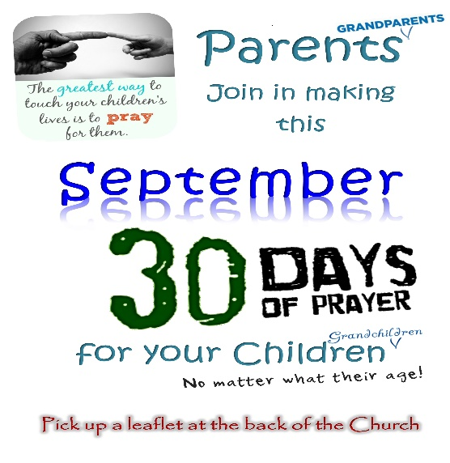

http://www.clondalkinparish.com/wordpress/wp-content/uploads/2019/08/30-Days-of-Prayer-for-your-children-Grandchildren-Gen-.pdf

Religion Teachers’ Association of Ireland
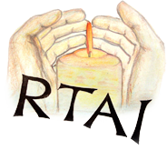
Dates for the Diary
September
14th Sept: JCRE Workshops
21st Sept: LCRE Exam Syllabus Workshop
For further details: https://www.rtai.ie/

School Chaplains' Association of Ireland /Cumann na Séiplíneach Scoile in Éirinn

Assisting Post-Primary School Chaplains in their ministry

Conference 2019
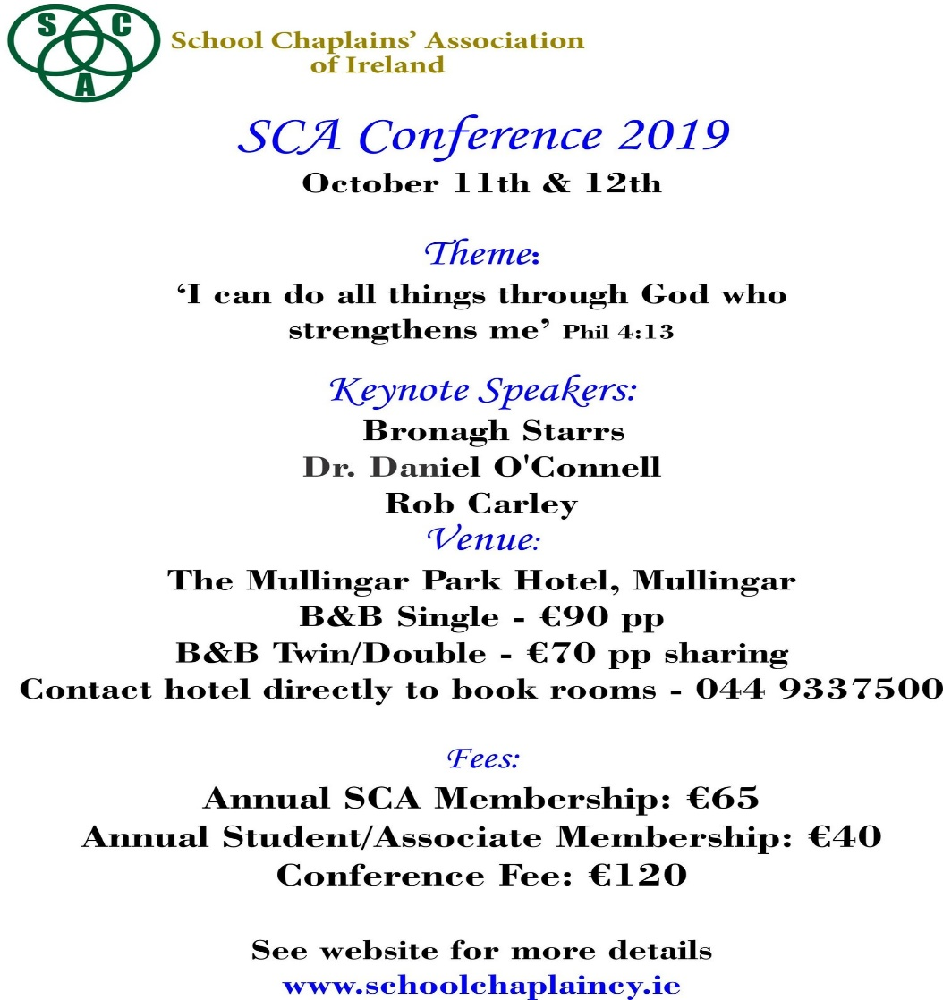
https://schoolchaplaincy.ie/

Education Conference October 24th
A special national conference is being hosted by The Irish Catholic on ‘The future of denominational education.’
The conference – hosted in the Clayton Hotel Ballsbridge in Dublin 4 – will focus on the place of faith-based education in our increasingly secular society and Catholic schools in particular. The conference will be addressed by:

- Mr Francis Campbell, Vice-Chancellor of St Mary’s University, Twickenham and a former UK Ambassador to the Holy See
- Bishop Tom Deenihan, Bishop of Meath
- Paul Barber, Director of Catholic Education Service of England and Wales
- Natalie Finnigan, Secondary Education Advisor for Archdiocese of Glasgow
- Bairbre Cahill, Columnist with The Irish Catholic

It is hoped that the invited speakers – drawing on the experience of faith-based education in other jurisdictions – will help stimulate a lively conversation that will make a contribution to the debate in Ireland.
For further information see: www.irishcatholic.com/shop or call 01-6874028 or e-mail events@irishcatholic.ie

A Teacher's Prayer / Paidir do Mhúinteoirí
Help me to be a fine teacher, to keep peace in the classroom, peace between my students and myself, to be kind and gentle to each and every one of my students.
Help me to be merciful to my students, to balance mercy and discipline in the right measure for each student, to give genuine praise as much as possible, to give constructive criticism in a manner that is palatable to my students.
Help me to remain conscientious enough to keep my lessons always interesting, to recognise what motivates each of my students, to accept my students' limitations and not hold it against them.
Help me not to judge my students too harshly, to be fair to all, to be a good role model, but most of all Lord help me to show your love to all of my students.
Amen.

Paidir do Mhúinteoirí
Cuir ar mo chumas múineadh le heagna mar cabhraímse i múnlú na haigne.
Ullmhaigh mé chun múineadh le fírinne mar cabhraímse i múnlú coinsiasa.
Spreag mé chun múineadh le fís mar cabhraímse i múnlú na todhchaí.
Cuir ar mo chumas múineadh le grá mar cabhraímse i múnlú an domhain.
“Dealróidh na saoithe mar loinnnir na spéire, agus iad siúd a theagasc an fhíréantacht do mhórán mar reanna neimhe ar feadh na síoraíochta.”
(Leabhar Dhainéil 12: 3)

Táimid go léir Bainteach lena Chéile
Póstaer ag léiriú samplaí den chruthaíocht: clocha, plandaí, ainmhithe, daoine
Cinnire: Táimid bailithe le chéile anseo chun “amharc le súile nua” ar an gcruthaíocht agus chun tuiscint níos
fearr a fháil ar an ngaolmhaireacht atá idir gach dúil bheo.
Guth 1: Léiríonn an póstaer seo éagsúlacht na cruthaíochta atá le feiceáil timpeall orainn.
Guth 2: “Fógraíonn na spéartha glóir Dé agus foilsíonn an fhirmimint saothar a lámh.” (Salm19:1)
Guth 3: “Chonaic Dia gach a ndearna sé agus, féach! bhí sé go sármhaith.”(Geineasas 1:31)
Guth 4: Mar sin tá sé de dhualgas orainn urraim a thabhairt don chruthaíocht agus an mhaitheas atá inti a aithint.
Guth 5: Bhí na daoine a scríobh cuntas faoi chruthú na cruinne i leabhar Geineasas an-bheacht nuair a
shamhlaigh siad gur chum Dia an duine daonna “de chré na talún.” (Geineasas 2:7)
Guth 6: Mar tá gach adamh carbóin inár gcorp agus gach adamh iarainn inár gcuid fola bainteach leis na réaltaí
a tháinig ón “Ollphléasc” i dtosach ama.
Guth 7: Is é an t-aer céanna ón atmaisféar a choimeádann beo sinn.
Guth 8: Nuair a scriostar gné amháin den chruthaíocht, bíonn tionchar ag an scrios sin ar gach gné eile.

Gach Uile Náisiún ar an Domhan *

Gach uile náisiún ar an domhan, mol an Tiarna a chruthaigh dúinn
An réalta is mó, an bláth is lú, Alleluia.

Moladh na Flaithis an Tiarna, Alleluia.
Gealach is réaltaí, mol an Tiarna, Alleluia.

Sléibhte faoi shneachta, mol an Tiarna, Alleluia.
Cnoic is gleannta, mol an Tiarna, Alleluia.

Duibheagán aigéin, mol an Tiarna, Alleluia.
Brádán éadrom, mol an Tiarna, Alleluia.

Leoin ag búiríl, mol an Tiarna, Alleluia.
Éin ag cantain, mol an Tiarna, Alleluia.

Ríthe is prionsaí, mol an Tiarna, Alleluia.
Óg is aosta, mol an Tiarna, Alleluia.
Kevin Mayhew
Aistrithe ag Máire Ní Mháille
Cinnire: Nuair a bhí Íosa Críost ag labhairt faoi “Ríocht Dé”, ní aonad polaitíochta a bhí i gceist, ná fiú flaitheas
Dé ar Neamh. Samhlaoid a bhí in úsáid aige chun cur in iúl conas mar a bheadh an saol nuair a bheadh
gaolmhaireacht chóir, chothrom idir dhaoine agus an t-imshaol agus i measc an chine daonna féin, de
réir mar a bhí leagtha amach ag Dia.
Guth 9: Scríobh Naomh Pól chuig na Rómhánaigh: “Is aon chorp amháin sinn i gCríost agus gach duine againn
ina mbaill dá chéile.” (Rómh. 12:5)
Guth 10: Bhí an tuiscint sin ag ár sinsear romhainn mar dúirt siad: “Is ar scáth a chéile a mhaireann na daoine,”
agus “Ní neart go cur le chéile.”
Guth 11: Tá sé de dhualgas orainn an ghaolmhaireacht seo a chothú agus a chur chun cinn mar tá síocháin ar
talamh agus todhchaí na cruinne ag brath ar ár n-iarrachtaí.
Cinnire: A Dhia, cabhraigh linn meas a bheith againn orainn féin, ar dhaoine eile, agus ar an imshaol, agus
gaolmhaireacht chóir, chothrom a chothú agus a chleachtadh pé áit ina mbeimid.

Sin é ár nguí chugat trí Chríost ár dTiarna. Áiméan.
* Tá ceol an iomainn seo ar an dlúth-dhiosca a théann le Beo go Deo 8.

