Post-Primary Diocesan Adviser R.E. News Blog 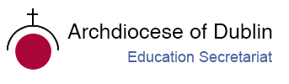
October 2019 / Deireadh Fómhair 2019

Welcome to October issue of the R.E blog! I hope you all had a great start to the new academic year! I trust the blog will continue to be useful for you as an educational resource in your work in schools and parishes. In addition, I would be more than happy to receive any contributions you may wish to share with fellow Chaplains and R.E teachers or any suggestions for in-service /support days which the Diocese could provide. Please contact me if you want to include your name/school on our mailing list to receive the blog monthly.
I drew your attention last month to the Pope’s monthly intentions and videos, which are an excellent resource for teaching and/or prayer opportunities. This month the intention is ‘A Missionary "Spring" in the Church’ and details can be found on http://popesprayerusa.net/.
Sr. Bernadette and I were privileged to launch the new 2019/20 Ember teams for 20 schools in May and September. We were also delighted to welcome a further three representatives from new schools who came to Ovoca to observe our Ember training in action, with the hope of joining us with a school team next year.
Finally, school visits have begun for this academic year, and we look forward to continued collaboration with you as we work to promote the faith of the young people in our care.
We will continue to add resources as Gaeilge with the assistance of Sr. Mairéad Ni Bhuachalla.
Le gach dea-ghuí,
Lily Barry

October / Deireadh Fómhair
The Month of the Rosary
Mí na Corónach Mhuire

How Are You Observing The Month Of The Holy Rosary?
The month of the Holy Rosary is October and this entire month is dedicated to the Rosary. The feast day of the Holy Rosary in particular is October 7th. The feast of the Rosary is held in memory of the glorious and triumphant victory at the battle of Lepanto in 1571. That battle was the most convincing military victory that proved without a doubt the great power of the Rosary.
The month of October is a good time to commit to praying the Rosary every day. The Rosary will bring great peace and holiness to your life. It is a powerful instrument for conversion. The Rosary is the best method of honouring Mary. It protects the Church from false teachings and keeps her safe from the attacks from the Enemy.
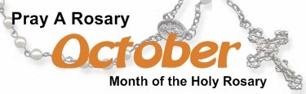

Here are some great ways to celebrate the month of the Holy Rosary...
- Pray the Rosary everyday this month. Make rosaries, have them blessed and give them away. You can teach a group of students to make rosaries of their own. You can give the rosaries they make to the elderly in nursing homes, take them to Catholic schools or your parish, or mail them to prisons. Make sure you have them blessed by a priest first!
- Print up some of our Rosary booklets and hand them out to people whether it be your own class, neighbours and friends. http://www.how-to-pray-the-rosary-everyday.com/rosary-booklets.html
- Attend Mass on October 7th, the feast of Our Lady of the Holy Rosary and on October 13th, the day of the final visit of Mary to Fatima.
For further information see:
http://www.how-to-pray-the-rosary-everyday.com/month-of-the-holy-rosary.html
https://www.thereligionteacher.com/the-month-of-the-rosary-is-october/

October
The Holy Father's Intentions for the Month of October 2019
Intinní an Phápa do Mhí Dheireadh Fómhair 2019

A Missionary "Spring" in the Church … throughout the world, let us be ‘permanently in a state of mission’. —Pope Francis, Evangelii Gaudium, §25

October 2019 provides an opportunity to take up again ‘with renewed fervour the missionary transformation of the Church’s life and pastoral activity’.
The church has a rich tradition upon which to build missionary activity. The tradition draws its strength from the person of Jesus, who through his life, death and resurrection revealed God’s gracious desire to be among people.
Jesus is at the heart of all evangelising and missionary activity. It is from Jesus that we draw our strength and inspiration. It is to Jesus that we bring our hopes for ourselves, the church and the world, and it is with Jesus that we walk from the darkness of the tomb into the light of the world. We are called to be the light, to be people of mercy, to spread the Good News.
For excellent resources and ideas for sharing Pope Francis’ message for the month of October see: https://issuu.com/catholicmission/docs/emm_parish_resource_booklet
The resource contains:
- the prayer for the Extraordinary Missionary Month: the prayer can be downloaded as a prayer card or reproduced in newsletters and bulletins during October.
- a reflection by Fr Noel Connelly SSC: ‘Mission—God’s liberating plan for the universe’. This reflection contains some questions for personal reflection and could be used as a formation tool in a meeting or as a resource for group discussion
- Pope Francis’ message for World Mission Day 2019, for individual and group use
- some tips on how to live the Missionary Month
- a reflection on saints in the Catholic tradition
- reflection sheets based on the gospels for the Sundays in October.
- a calendar that contains a short reflection or scripture text for the days of October. The text can be used as a daily reflection, or downloaded from: https://www.catholicmission.org.au/images/uploads/2019-EMM-31-Day-Calendar.pdf

October 1st
Feast Day of St. Thérèse of Lisieux
Féile Naomh Treasa as Lisieux

“Love can accomplish all things. Things that are most impossible become easy where love is at work.”

Today is the memorial of St. Thérèse of the Child Jesus and the Holy Face, more popularly known as "the Little Flower." Shining brightly among the little ones to whom the secrets of the kingdom were revealed in a most special way is Therese of the Child Jesus and the Holy Face, a professed nun of the order of Discalced Carmelites. Therese of Lisieux is a young person. She reached the maturity of holiness in the prime of youth. As such, she appears as a teacher of evangelical life, particularly effective in illumining the paths of young people, who must be the leaders and witnesses of the Gospel to the new generations. During her life Therese discovered "new lights, hidden and mysterious meanings" and received from the divine teacher that "knowledge of love" which she then expressed with particular originality in her writings. She has made the Gospel shine appealingly in our time; she had the mission of making the church, the mystical body of Christ, known and loved.
https://www.catholicculture.org/culture/library/view.cfm?recnum=232
http://education.dublindiocese.ie/october-1st-feast-day-of-st-therese-of-lisieux/ https://www.catholicculture.org/culture/liturgicalyear/calendar/day.cfm?date=2018-10-01

October 2nd
Feast of the Guardian Angels
Féile na nAingeal Coimhdeachta

‘Beside each believer stands an angel as protector and shepherd leading him to life.’ (CCC 336).
Devotion to the angels is, at base, an expression of faith in God’s enduring love and providential care extended to each person day in and day out. Angels are servants and messengers from God. "Angel" in Greek means messenger. In unseen ways, the angels help us on our earthly pilgrimage by assisting us in work and study, helping us in temptation and protecting us from physical danger. out.https://www.franciscanmedia.org/feasaint-of-the-guardian-angels/ https://www.catholicculture.org/culture/liturgicalyear/calendar/day.cfm?date=2018-10-02

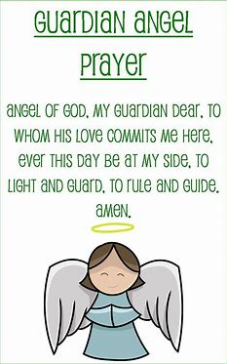

October 2nd
International Day of Non-violence: Gandhi's birthday.
Lá breithe Gandhi: Lá IdirnáisiúntaTiomanta don Fhrith – Fhoréigean

“Non-violence is the greatest force at the disposal of mankind. It is mightier than the mightiest weapon of destruction devised by the ingenuity of man.” - Mahatma Gandhi

The International Day of Non-Violence is marked on 2 October, the birthday of Mahatma Gandhi, leader of the Indian independence movement and pioneer of the philosophy and strategy of non-violence. Today we celebrate the birthday of a man who helped bring forward the notion of “non-violence,” and the tremendous impact this form of social response has had all over the world in the last century. On the International Day of Non-Violence, created by the United Nations in 2007, we look back on the influence of Indian activist Mahatma Gandhi, and how non-violent protest has evolved over the years. The UN has good reason to use the birthday of Gandhi to celebrate International Day of Non-Violence. Gandhi’s commitment to India’s independence and his methods have been the cornerstone of civil and human rights initiatives all over the world. Put simply, Gandhi saw it as completely irrational to use violence to achieve peace, but rather, “just means lead to just ends.” This is a lesson we can all take to heart. https://nationaltoday.com/international-day-non-violence/
How to Observe International Day of Non-Violence:
- Read up on Gandhi.
Gandhi was one of the world’s greatest and most influential leaders in the last century, and there’s plenty we can learn from him.
- Find or organize an event.
The UN hosts official events around the world to commemorate the resolution of 2007, but there are also innumerable events on Gandhi’s birthday dedicated to celebrating the life of the leader.
- Go for a Random Act of Kindness.

The concept of Random Acts of Kindness has taken off with the rise of social media, as the beneficiaries of RAKs often post their gratitude for the stranger online. Today, make Gandhi proud by going out of your way for a stranger, simply to brighten their day.
http://education.dublindiocese.ie/october-2nd-gandhis-birthday-international-day-of-nonviolence/

October 4th
Feast Day of St. Francis of Assisi
Féile Naomh Proinsias as Assisi

“Start by doing what's necessary; then do what's possible; and suddenly you are doing the impossible."
Francis of Assisi

Most people know Francis as a middle-ages ascetic who loved animals. The complete story is even more interesting. St Francis was born in 1181 in Assisi in Italy. In his youth, he spent money lavishly on fine clothes and having fun. He fell ill twice and then realised he was wasting precious time and that he should be serving Jesus instead.

Often he gave his clothes and money to the poor and served the sick in hospital. He felt he should do more and went around in rags while fasting. His father was disgusted with his behaviour and took his inheritance from him. St. Francis had to depend on the kindness of people for food and shelter. He begged sinners to convert and return to God. He had the great power of working miracles. He loved all creatures and the animals obeyed his commands.

Francis' final years were filled with suffering as well as humiliation. Praying to share in Christ's passion he had a vision in which he received the stigmata, the marks of the nails and the lance wound that Christ suffered, in his own body. He died on October 4, 1226 at the age of 45. Francis is considered the founder of all Franciscan orders and the patron saint of ecologists and merchants.
For further information, a full-length movie and power point presentations see the following links: https://www.youtube.com/watch?v=rG5jVcYA1aM
http://education.dublindiocese.ie/october-4th-st-francis-of-assisi/ https://www.catholic.org/saints/saint.php?saint_id=50

October 5th
St. Faustina
Naomh Faustina

“The past does not belong to me; the future is not mine; with all my soul I try to make use of the present moment.” - St. Faustina

Sister Faustina was a young, uneducated nun in a convent of the Congregation of Sisters of Our Lady of Mercy in Poland during the 1930s. She came from a poor family that struggled during the years of World War I. She had only three years of simple education, so hers were the humblest tasks in the convent, usually in the kitchen or garden. However, she received extraordinary revelations — or messages — from our Lord Jesus. Jesus asked Sr. Faustina to record these experiences, which she compiled into notebooks. These notebooks are known today as the Diary of Saint Maria Faustina Kowalska, and the words contained within are God's loving message of Divine Mercy.
Though the Divine Mercy message is not new to the teachings of the Church, Sr. Faustina's Diary sparked a great movement and a strong and significant focus on the mercy of Christ. Saint John Paul II canonized Sr. Faustina in 2000 making her the "first saint of the new millennium." Speaking of Sr. Faustina and the importance of the message contained in her Diary, the Pope called her "the great apostle of Divine Mercy in our time." Today, we continue to rely of St. Faustina as a constant reminder of the message to trust in Jesus' endless mercy, and to live life mercifully toward others. We also turn to her in prayer and request her intercession to our merciful Saviour on our behalf.
https://www.thedivinemercy.org/message/stfaustina/
https://www.catholic.org/saints/saint.php?saint_id=510

October 5th
World Teacher’s Day
Lá Domhanda Tiomanta do Mhúinteoirí

“Young Teachers: The future of the Profession.”

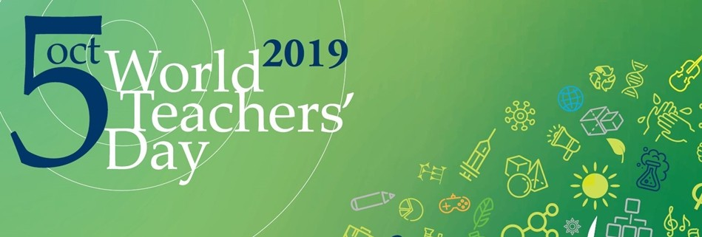
In 2019, World Teachers’ Day will celebrate teachers with the theme, “Young Teachers: The future of the Profession.” The day provides the occasion to celebrate the teaching profession worldwide, to take stock of achievements, and to address some of the issues central for attracting and keeping the brightest minds and young talents in the profession.
Why World Teachers Day is Important:
- It Celebrates Teachers
- It Highlights Current Issues
- It Applauds Progress, but Challenges Stagnation
https://nationaltoday.com/world-teachers-day/
https://en.unesco.org/commemorations/worldteachersday

October 7th
The Memorial of Our Lady of the Rosary
Cuimhneachán ar Mhuire na Corónach

"The whole purpose of the Rosary is to lead to this deep experience of Our Lady, who together with Jesus breathes the Spirit into us."

"October is the month in which Mary Most Holy, Queen of the Holy Rosary, is venerated. Pope John Paul II invited us to pray this Marian prayer, possibly every day, for peace, “so that the world can be preserved from the wicked scourge of terrorism.”
This feast, focussed on the intercessory power of our Blessed Lady, was instituted by Pope Saint Pius V in thanksgiving for the great naval victory of a Christian fleet over the Turks at Lepanto on October 7, 1571, a favour widely attributed to intense recitation of the Rosary. Pope St. Pius V and all Christians had prayed the Rosary for victory.

In modern times successive popes have urged the faithful to pray the Rosary regularly, as a form of contemplative prayer focussed on the life of Christ. It calls prayerful attention to the saving mysteries of Christ and Mary’s close association with her Son in his mission. Pope St John Paul II called the rosary a “Christocentric prayer” containing the Gospel message in its entirety. The Rosary invites us to reflect on the great mysteries of the life, death and resurrection of Jesus.
https://www.thereligionteacher.com/the-month-of-the-rosary-is-october/ http://education.dublindiocese.ie/2016/10/17/october-17-2016/

October 10th
World Mental Health Day
Lá Domhanda Tiomanta do Mheabharshláinte

World Mental Health Day 2019: focus on suicide prevention

World Mental Health Day is observed on 10th October every year, with the overall objective of raising awareness of mental health issues around the world and mobilizing efforts in support of mental health. The Day provides an opportunity for all stakeholders working on mental health issues to talk about their work, and what more needs to be done to make mental health care a reality for people worldwide. This year the campaign focus is on ‘suicide prevention’.
Every 40 seconds, someone loses their life to suicide.
Join the campaign, on 10th October, in “40 seconds of action” to raise awareness of the scale of suicide around the world and the role that each of us can play to help prevent it.

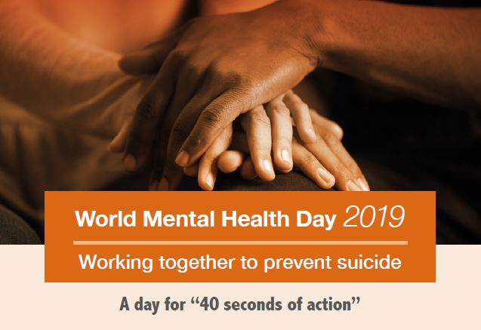
https://www.who.int/news-room/events/detail/2019/10/10/default-calendar/world-mental-health-day-2019-focus-on-suicide-prevention

October 15th
Feast Day of St. Teresa of Avila
Féile Naomh Treasa as Avila

“Prayer is an act of love. Words are not needed”. -Teresa of Avila

St. Teresa of Ávila, a sixteenth-century Spanish saint and mystic, was very aware that every Christian has a role to play in making Christ present in the world. St. Teresa (1515-1582) was born in Avila and died in Alba, Spain. When only a child of seven, she ran away from home in the hope of being martyred by the Moors; in this way, she said she could come to see God. At the age of eighteen, she joined the Carmelite Order and chose Christ as her heavenly Spouse. With the help of St. John of the Cross, she reformed most of the Carmelite convents and founded new ones. She reached the highest degree of prayer and through prayer obtained such knowledge of divine things that in 1970 Pope Paul VI named her the first woman Doctor of the Church. This was a great honour, especially for a woman of her time. She was canonized in 1622.
https://www.youtube.com/playlist?list=PLfIV99jZo_dV_c4nHlqTkJZBdORfud2Ju http://education.dublindiocese.ie/st-teresa-of-avila/ https://www.catholicculture.org/culture/liturgicalyear/calendar/day.cfm?date=2018-10-15

October 16th
UN World Food Day
Lá Domhanda na Náisiún Aontaithe atá dírithe ar Sholáthar Bia

“OUR ACTIONS ARE OUR FUTURE. HEALTHY DIETS.
FOR A # ZERO- HUNGER WORLD.”

Achieving Zero Hunger is not only about addressing hunger, but also nourishing people, while nurturing the planet. This year, World Food Day calls for action across sectors to make healthy and sustainable diets affordable and accessible to everyone. At the same time, it calls on everyone to start thinking about what we eat.
For your students:
The series of FAO Activity Books has been developed as an educational tool for youth, educators, parents and anyone who wishes to learn more about important global issues that have an impact on our future and that of our planet. They are a way to learn more about FAO’s work and important topics such as nutrition, climate change, food waste, migration, rural development, food security and the global goal to achieve Zero Hunger. These books offer young people the chance to engage with a wide variety of topics and learn about how they can take action and become part of the Zero Hunger Generation.
http://www.fao.org/world-food-day/theme/en/

October 17th
International Day for the Eradication of Poverty
Lá Idirnáisiúnta atá Tiomanta do Dhíothú Bochtaineachta

“Wherever men and women are condemned to live in extreme poverty, human rights are violated. To come together to ensure that these rights be respected is our solemn duty.”

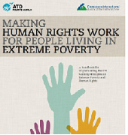

The annual United Nations International Day for the Eradication of Poverty (UN Day) 17 October is a day to express friendship and solidarity with people who have to live with poverty and social exclusion every day of the year in Ireland, Europe and around the world.
On the 17th October 1987, in the presence of 100,000 people from every socio-economic background and continent, Fr. Joseph Wresinski unveiled a commemorative stone at the Human Rights Plaza in Paris.

This message is engraved on the stone:
“Wherever men and women are condemned to live in extreme poverty, human rights are violated. To come together to ensure that these rights be respected is our solemn duty.”

Similar stones are now located in 50 cities and places around the world, including Dublin, and have become rallying points for people from all walks of life. They gather to bear witness to the most vulnerable people in the world and to make a personal commitment to join forces with them in abolishing poverty and social exclusion. In 1992, the United Nations declared October 17 “International Day for the Eradication of Poverty”.
UN Day 2019 - Commemoration Events in Ireland
Each year the Department of Employment Affairs and Social Protection supports small public awareness initiatives to promote awareness of the Day and support the work of the Irish 17 October Committee in networking with the groups responsible for the various commemorative initiatives and projects nationwide.
This funding is open to anti-poverty organisations and groups working with people experiencing poverty at national or local level. For more information see: http://www.welfare.ie/en/Pages/UN_Event.aspx
https://www.un.org/development/desa/socialperspectiveondevelopment/international-day-for-the-eradication-of-poverty-homepage/2019-2.html
http://overcomingpoverty.org/

October 18th
European Day against Human Trafficking
Lá Eorpach i gCoinne Mangaireachta Dhaonna

“Human trafficking is a crime against humanity.” - Pope Francis

This day is an opportunity to raise awareness with senior cycle students about trafficking in human beings. Trafficking is a global problem, driven by poverty, and all forms of trafficking are a gross violation of human rights. Many countries, including Ireland, have specific laws to deal with trafficking. For further information and excellent resources there are two outstanding groups working against human trafficking. They are:
- RENATE: Religious in Europe Networking Against Trafficking and Exploitation.
RENATE was established by a group of religious representing several different congregations working against human trafficking in Europe. Renate network with Talitha Kum which is the International network of sisters working against trafficking in person. Renate also collaborates with many other networks within and outside Europe. Networking is the strength of RENATE.

“Working tirelessly to rehabilitate victims, free the world of sexual and labour exploitation, slavery and forced organ harvesting.”

Pope Francis is an important supporter of the work RENATE do. For further information see: https://www.renate-europe.net/
- APT: Act to Prevent Trafficking
APT is a faith-based group working against Trafficking in Persons (TIP). The members of APT are people belonging to religious congregations or missionary societies, which are part of Ireland’s Conference of Religious Congregations and Missionaries. APT have a wide network of international contacts through colleagues working in countries from which trafficked people originate. As well as addressing the evil of human trafficking, they use their network to help victims and to work on prevention. . For further information and resources see:
https://www.aptireland.org/what-can-i-do/
https://www.aptireland.org/resources-for-spiritual-reflection/
See also Pope Francis speech on human trafficking: http://w2.vatican.va/content/francesco/en/speeches/2013/december/documents/papa-francesco_20131212_credenziali-nuovi-ambasciatori.html

October 18th
Feast of St. Luke, Evangelist
Féile Naomh Lúcás, Soiscéalaí

“What is impossible with men is possible with God”.- Luke the Evangelist

St. Luke, the inspired author of the third Gospel and of the Acts of the Apostles, was a native of Antioch in Syria and a physician, and one of the early converts from paganism. He accompanied St. Paul on a considerable part of his missionary journey. He was also his companion while in prison at Rome on two different occasions. His account of these events, contained in the Acts, is first-hand history. Luke's Gospel is, above all, the Gospel of the

Merciful Heart of Jesus. It emphasizes the fact that Christ is the salvation of all men, especially of the repentant sinner and of the lowly. A good way of introducing St. Luke to students is by presenting some fun facts and ask them to present them in the form of a mind map.
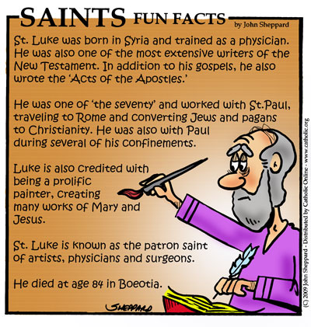
https://www.catholicculture.org/culture/liturgicalyear/calendar/day.cfm?date=2018-10-18 https://www.catholic.org/saints/saint.php?saint_id=76

October 20th
Mission Sunday
Domhnach na Misean

“Baptized and Sent: The Church of Christ on Mission in the World.”

World Mission Sunday in 2019 falls on 20 October. Instituted by Pope Pius XI in 1926, the annual day encourages prayers, cooperation and help for missions as well as reminding Christians about the fundamental missionary character of the Church and of every baptized person. The theme of this year’s observance is “Baptized and Sent: The Church of Christ on Mission in the World.”
The message of Pope Francis for this year’s World Mission Sunday, which falls on the penultimate Sunday of October every year calls for the whole Church to ‘revive her missionary awareness’.
“For the month of October 2019, I have asked that the whole Church revive her missionary awareness and commitment as we commemorate the centenary of the Apostolic Letter Maximum Illud of Pope Benedict XV (30 November 1919). Its farsighted and prophetic vision of the apostolate has made me realize once again the importance of renewing the Church’s missionary commitment and giving fresh evangelical impulse to her work of preaching and bringing to the world the salvation of Jesus Christ, who died and rose again”.

For the full text of the Pope’s message see:
https://www.vaticannews.va/en/pope/news/2019-06/pope-world-mission-day-2019-message.html
http://education.dublindiocese.ie/mission-sunday/

October 22nd
St. John Paul II
Naomh Eoin Pól 11

“I plead with you--never, ever give up on hope, never doubt, never tire, and never become discouraged. Be not afraid”. - Pope John Paul II

Today we celebrate the feast day of St. John Paul II the great defender of life and the family of our times. The Church has chosen to celebrate his feast not on the date of his death which was on April 2nd 2005 but on the anniversary of his formal installation as Universal Pontiff on October 22nd 1978.
Pope John Paul II sometimes called Saint John Paul or John Paul the Great, born Karol Józef Wojtyła; (18 May 1920 – 2 April 2005), was the head of the Catholic Church from 16 October 1978 to his death in 2005. He was the second longest-serving pope in history. As a Pole, he was the first non-Italian pope in 455 years. The last non-Italian pope was Pope Adrian VI, who died in 1523.
He is the first ever pope to visit the White House, and a mosque. He travelled more than any other pope before him, visiting many of the countries of the world. He is also famous for starting the annual World Youth Day. After he was beatified, his title was changed to Blessed John Paul II. John Paul II was canonized by Pope Francis on April 27, 2014 which means that the Polish Pope is now known as Saint John Paul II.
https://www.catholic.org/saints/saint.php?saint_id=6996

October 28th
St. Jude & St. Simon
Naomh Símón agus Naomh Iúd

Today the Church celebrates the feast of Saints. Simon and Jude whose names occur together in the Canon of the Mass and are also celebrated on the same day. Possibly this is because they both preached the Gospel in Mesopotamia and Persia where it is said they had both been sent, but in actual fact we know nothing for certain about them beyond what is told us of their being called as Apostles in the New Testament. St. Jude is the author of a short Epistle which forms part of the New Testament.
https://www.catholicculture.org/culture/liturgicalyear/calendar/day.cfm?date=2017-10-28
https://www.franciscanmedia.org/saints-simon-and-jude/

October 29th
Blessed Chiara Badano
Ciara Badano, Beannaithe

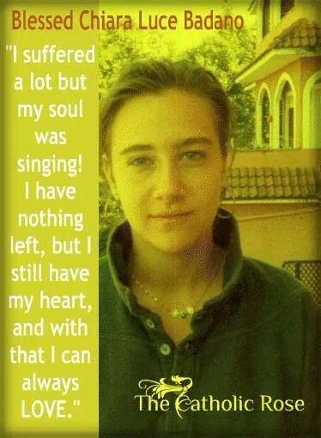

Sometimes we’d prefer that our lives be a different story than the one God seems to be writing. In our fragile existence it doesn’t take much to turn a romance into a drama, or an adventure into a tragedy. At a glance, the story of Chiara Badano—an only child conceived after 11 years of marriage, who died at 18 after a bout with a painful form of bone cancer—looks like an empty tragedy, but not from the perspective of the Divine Author.
Chiara seemed to have everything going for her as a teen. She had a loving, holy family and a rock solid faith that was nurtured by retreats and youth ministry programs. She was popular amongst her friends and was liked by boys. It’s not hard to see why. She was beautiful. Chiara loved to hang out in coffee shops. She was great at tennis, swimming and mountain climbing. Her outgoing personality and adventurous spirit made her dream of becoming a flight attendant. Chiara had a bright life ahead of her.

One day while playing tennis, Chiara experienced excruciating pain in her shoulder. Shortly afterwards she was diagnosed with osteogenic sarcoma. She watched her bright future slip away. But it’s here that the real story of her life begins—the story of heroic virtue.

This is a beautiful and inspiring story to share with your students.
Chiara Badano was a modern teenager: She liked to sing, dance, play tennis and skate, until cancer took her life at age 18, only two decades ago. Chiara was a member of the Focolare Movement, founded in Italy by Chiara Lubich in 1943.
Chiara is now Blessed Chiara Badano (the step before becoming a Saint). She was beatified on 25th September 2010. Her feast day is celebrated on 29th October. She is blessed because of the good life she led and because of a miracle that happened through her prayers. Read her story and find resources on these websites:
https://reallifecatholic.com/portfolio-item/blessed-chiara-luca-badano-pray-for-us/
https://www.catholic.org/news/hf/faith/story.php?id=38409
Or share her story with your students through a power point presentation: http://education.dublindiocese.ie/october-calendar-resources/

Other Dates/Information:

Archdiocese of Dublin / Ard-Dheoise Bhaile Átha Cliath
See the Archdiocese of Dublin website for information on events, which take place throughout the diocese. http://www.dublindiocese.ie/

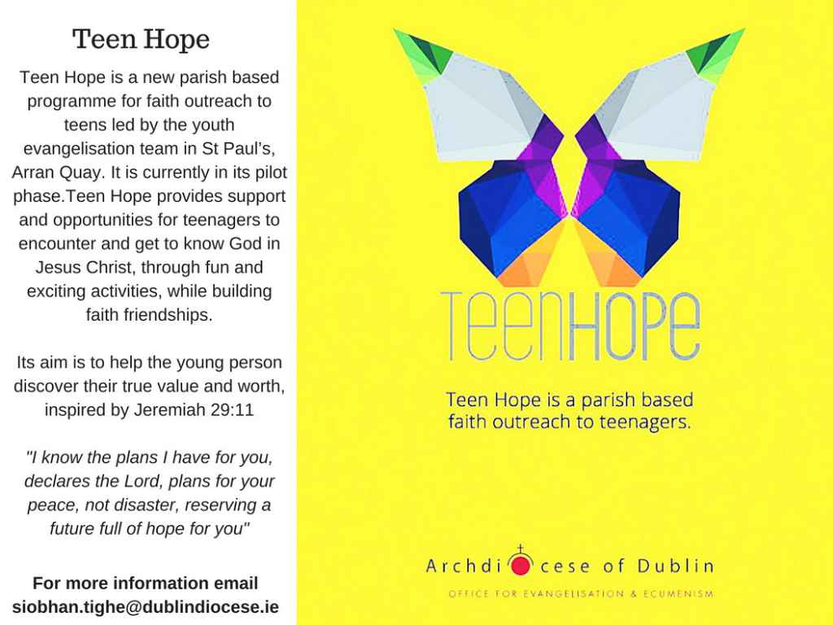

Frank Brown Parish Pastoral Worker
Further excellent resources for October are available from Frank Brown Parish Pastoral Worker from The Combined Catholic Parishes of Clondalkin. http://www.clondalkinparish.com​
Nutrition for the Soul
Excellent resources available here including reflections and posters
https://patsnutritionforthesoul.blogspot.com/

RTAI / Religion Teachers’ Association of Ireland
The Religion Teachers’ Association of Ireland [R.T.A.I.] was founded in 1992 and is the national professional association of second level teachers of Religious Education in Ireland.
“Providing support and representation for teachers of Religious Education”
For further details: https://www.rtai.ie/

SCA School Chaplains' Association of Ireland / Cumann na Séiplíneach Scoile in Éirinn
Assisting Post-Primary School Chaplains in their ministry
AGM takes place October 12-13 - Mullingar Park Hotel

Conference 2019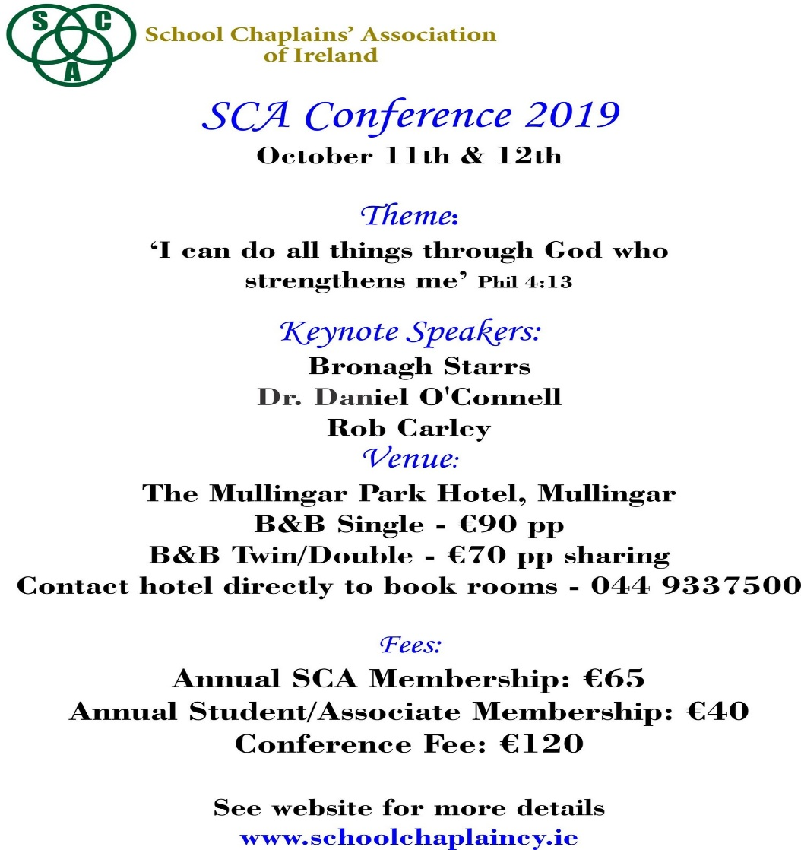

Leaving Cert R.E

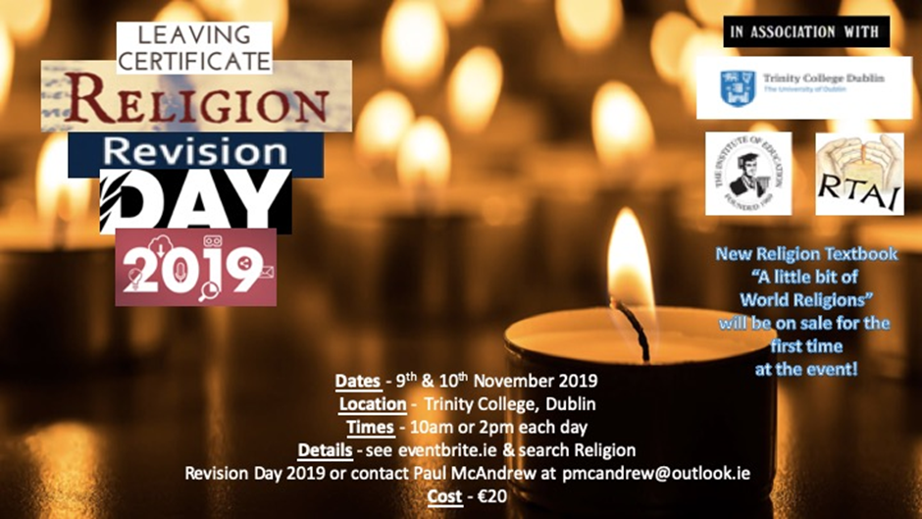

Upcoming Education Conference: Keeping Faith in Catholic Schools

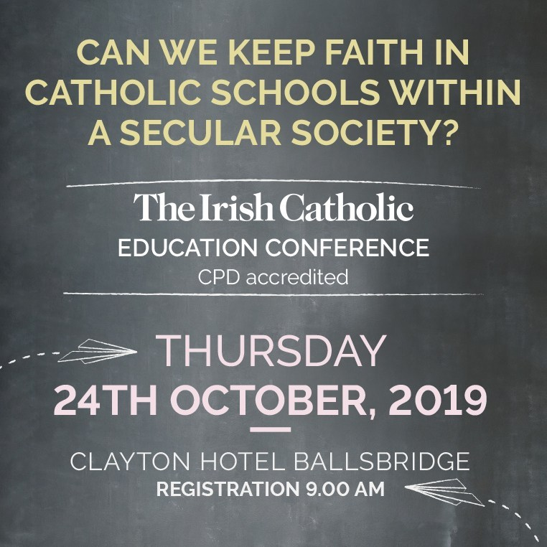

The conference – hosted in the Clayton Hotel Ballsbridge in Dublin 4 – will focus on the place of faith-based education in our increasingly secular society and Catholic schools in particular. The conference will be addressed by:

- Mr Francis Campbell, Vice-Chancellor of St Mary’s University, Twickenham and a former UK Ambassador to the Holy See
- Bishop Tom Deenihan, Bishop of Meath
- Paul Barber, Director of Catholic Education Service of England and Wales
- Natalie Finnigan, Secondary Education Advisor for Archdiocese of Glasgow
- Bairbre Cahill, Columnist with The Irish Catholic

We hope that the invited speakers – drawing on the experience of faith-based education in other jurisdictions – will help stimulate a lively conversation that will make a contribution to the debate in Ireland.
For further information contact: Ninna Jacobsen | Sales Executive The Irish Catholic
T: +353 1 5450386 | E: ninna@irishcatholic.ie | W: www.irishcatholic.com
Other Resources for teaching R.E
An excellent database of resources for religion teachers is available by contacting Marie Murphy at:
reclassresources@gmail.com or on:
https://www.facebook.com/Teaching-Religious-Education-100466933364337/

Ceiliúradh an Fhómhair

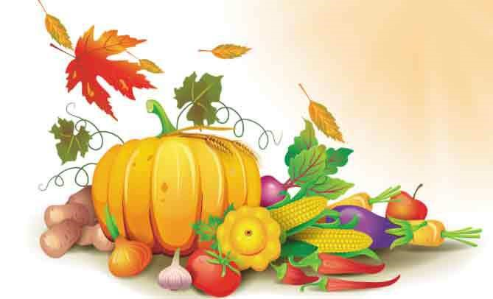

Coinneal,
Torthaí, glasraí, cruithneacht i gciseán,
dearcáin agus cnónna capaill le cur

Cinnire: Táimid bailithe le chéile anseo chun searmanas buíochais a cheiliúradh. Tá torthaí, glasraí agus cruithneacht i gciseán os ár gcomhair amach agus tá dearcáin agus cnónna capaill againn le cur.

Ithimid béilí gach lá dár saol agus téimid chuig na siopaí chun bia a cheannach, ach is fíor-annamh a chuirimid an cheist: “Cad as a dtáinig na rudaí maithe seo?”

Beidh deis againn anois machnamh a dhéanamh ar an gceist seo agus buíochas a ghábháil le Dia, údar gach maitheasa.

Guth1: Chuir ár sinir, na Ceiltigh, an cheist seo orthu féin agus is é an freagra a fuair siad ná “ón ngrian.” Gan an ghrian ní fhásfadh aon rud, ní bheadh aon bhia acu agus gheobhaidís bás.
Guth 2: Tháinig Naomh Pádraig agus mhúin sé go raibh Neach níos airde fós – Dia a chruthaigh an ghrian.
Cinnire: Lasfaimid coinneal anois in onóir Dé a thug solas na gréine dúinn agus cuirfimid na dearcáin agus na cnónna capaill sa chré.
Lastar coinneal agus cuirtear na dearcáin agus na cnónna capaill sa chré.
Guth 3: Teas na gréine agus báisteach ón spéir a chuireann plandaí ag fás agus is é Dia a chruthaíonn iad araon.

An Áit Álainn Seo
An ghrian ag scalladh anuas
tugann beocht don síol beag sa chré,
is fásann na plandaí go léir.
Cuireann siad gach rud ar fáil,
bia le hithe agus aer folláin.
Nach iontach an bronntanas dúinn é seo?

(Máirtín Ó Dubhghaill, Fran Hegarty)
(Ceol ar an dlúth-cheirnín a théann le Beo go Deo 8)

Cinnire: Dúirt an fáidh Ióéil (2: 23 – 27):
“Bíodh áthas agus gairdeas oraibh ar son an Tiarna, bhur nDia. Óir, ..chuir sé flúirse báistí anuas oraibh… Íosfaidh sibh bhur ndóthain agus beidh sibh sách. Molfaidh sibh ainm an Tiarna, bhur nDia, a chaith chomh fial sin libh… Is mise an Tiarna, bhur nDia, agus níl aon Dia eile ann ach mé.”
Guth 4: Idirthréimhse is ea an fómhar, tréimhse idir laethanta fada geala an tsamhraidh agus laethanta gairide dorcha an gheimhridh.
Guth 5: Baintear na barraí agus na torthaí a bhí ag fás i rith an tsamhraidh agus cuirtear i dtaisce iad le haghaidh an gheimhridh.
Guth 6: Bailíonn an t-iora rua agus an t-iora glas cnónna san fhómhar agus cuireann siad i dtaisce iad. Ansin déanann siad codladh geimhridh.
Cinnire: Cuireann an Bíobla i gcuimhne dúinn go bhfuil:

“tráth breithe, tráth báis,
tráth curtha síl, tráth bainte fómhair…
tráth goil, tráth gáire,
tháth caointe, tráth rince…
tráth tosta, tráth cainte.” (Cóheilit 3: 1- 7)

Canamis:
Ag Críost an Síol
Ag Críost an síol, ag Críost an fómhar,
In iothlainn Dé go dtugtar sinn.
Ag Críost an mhuir, ag Críost an t-iasc,
I líonta Dé go gcastar sinn.
Ó fhás go haois, is ó aois go bás,
Do dhá láimh, a Chríost, anall tharainn.
Ó bhás go críoch, ní críoch ach ath-fhás,
I bParthas na nGrást go rabhaimid.

(Focail: Michael Sheehan)
(Ceol: Seán Ó Riada Veritas Hymnal 6)

Guí an Phobail

- Gabhaimis buíochas le Dia a chruthaigh an domhan agus gach a bhfuil ann.

- Gabhaimis buíochas le Dia a thugann teas na gréine agus báisteach na spéire dúinn. Gan iad ní fhásfadh aon rud.

- Gabhaimis buíochas le Dia as ucht na rudaí maithe go léir atá againn.

- Guímis chun Dé ar son na ndaoine go léir a chuireann bia ar fáil dúinn: feirmeoirí, siopadóirí, cócairí, ár dtuismitheoirí…

- Guímis ar son na ndaoine atá gan bhia mar gur theip ar an bhfómhar de bharr drochaimsire nó cogaidh.

Cinnire: Gabhaimid buíochas leat-sa, a Dhia, údar gach maitheasa. Cabhraigh linn meas a bheith againn ar gach rud a chruthaigh tú agus aire a thabhairt don imshaol. Cuir i gcuimhne dúinn go bhfuil daoine eile ar an saol atá ar an ngannchuid agus cabhraigh linn bheith fial flaithiúil leo.
Sin é ár nguí chugat trí Chríost ár dTiarna. Áiméan

Duan Fhómhair

Tá an fómhar seo go haerach, céad buíochas le hÍosa,
tá eorna ina slaoda is caomh-chruithneacht thíortha;
tá cnó buí ar na craobha, is sméar ar an bhfíor-dhris,
is céad glóire don Aon-Mhac le déantar gach ní acu.

Is é sheolann na réalta, teacht gréine is taoide,
beir néalta na spéire, an ghaoth agus na síonta,
éin bheaga an aeir uile, is éisc insan mion-mhuir,
is fós chuireann féar glas chun tréada na dtíortha.

(Micheál Óg Ó Longáin, Dánta Dé, Úna Ní Ógáin, lch. 108)

