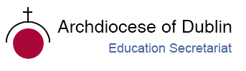

Post-Primary Diocesan Adviser R.E. News Blog
May 2019/Bealtaine 2019

Dear R.E Teacher/Chaplain,

Welcome to May’s issue of the R.E blog! I hope you are all keeping well and minding yourselves as we approach the final few weeks of exams and graduations! I hope the blog has proved useful to you and I would love to get feedback/suggestions from you so that I can continue to improve the resources I share with you. I would be more than happy to receive any contributions you may wish to share with fellow chaplains and RE teachers.
I would like to take this opportunity to say thanks to all who have welcomed me into their schools and invited me to various events through-out the year. I have been privileged to be part of many special occasions this year. I would also like to thank the Ember teams and teachers for their continued work and as they witness to their faith in our school communities.
I hope to visit many more of you in the new academic year, and look forward to continued collaboration as we work to promote the faith of the young people in our care.
We will continue to add resources as Gaeilge with the assistance of Sr. Mairéad Ni Bhuachalla.
Le gach dea-ghuí,
Lily Barry

May 1st. / Lá Bealtaine
Month of Mary the Mother of our Lord
Mí na Maighdine Muire

"God wills that all his gifts should come to us through Mary" (St. Bernard)

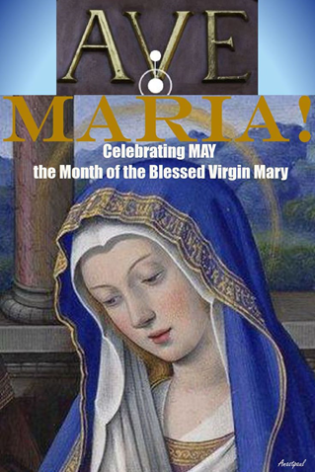

Pope Francis reminds us that serving others first, requires listening to God in prayer, so that one can give the same ‘yes’ to God’s will that Mary gave. To be at the service of others does not only mean to be ready for action. It means also to be in conversation with God with an attitude of listening, just like Mary,”
During the month of May—the month of Mary—we feel a special protection of Our Lady that extends to all the faithful. We feel a special joy that shines and illuminates our hearts expressing the universal certainty of Catholics that the indispensable patronage of our heavenly mother becomes even more tender, more loving and more full of visible mercy during her month of May.
Excellent resources on Mary can be found on the following websites:
http://education.dublindiocese.ie/may-the-month-of-mary-resources/
http://faitharts.ie/mary.html

May 1st
Feast of Saint Joseph the Worker
Naomh Iosef, Oibrí

May is the Feast of St Joseph the Worker, a day on which the Church encourages us to celebrate the value of work, and the dignity and rights of workers. "May Day" has long been dedicated to labour and the working man. It falls on the first day of the month that is dedicated to the Blessed Virgin Mary. Pope Pius XII expressed the hope that this feast would accentuate the dignity of labour and would bring a spiritual dimension to labour unions. It is eminently fitting that St. Joseph, a working man who became the foster-father of Christ and patron of the universal Church, should be honoured on this day. For more resources see:
http://education.dublindiocese.ie/2014/04/22/may-1st-feast-of-saint-joseph-the-worker/

May 3rd
Feast of Saint Philip and James, Apostles
Naomh Philib agus Naomh Séamus, Aspail

We celebrate both saints on the same day because their relics were brought to Rome together on the same day in early May. They rest there still, in the Basilica of the Holy Apostles. They are considered two of the favoured witnesses of our Beloved Jesus' Resurrection. Sts. Philip and James, bear testimony to us that their Master is truly risen from the dead, that they have seen Him, that they have touched Him, that they have conversed with Him (1 John 1: 1), during these forty days.

https://www.catholicireland.net/saintoftheday/saints-philip-and-jamesapostles/

May 3rd
World Press Freedom Day
Lá Domhanda Saoirse na Meán Cumarsáide

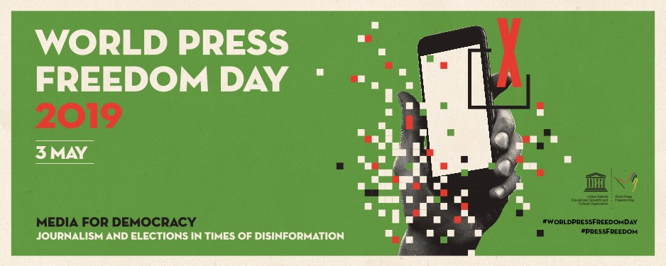

Every year, May 3rd is a date, which celebrates the fundamental principles of press freedom, to evaluate press freedom around the world, to defend the media from attacks on their independence and to pay tribute to journalists who have lost their lives in the exercise of their profession.
It serves as an occasion to inform citizens of violations of press freedom - a reminder that in dozens of countries around the world, publications are censored, fined, suspended and closed down, while journalists, editors and publishers are harassed, attacked, detained and even murdered. It is a date to encourage and develop initiatives in favour of press freedom, and to assess the state of press freedom worldwide. Furthermore, it acts as a reminder to governments of the need to respect their commitment to press freedom and is also a day of reflection among media professionals about issues of press freedom and professional ethics. Just as importantly, World Press Freedom Day is a day of support for media, which are targets for the restraint, or abolition, of press freedom. It is also a day of remembrance for those journalists who lost their lives in the pursuit of a story.
Join the global debate on press freedom around 3rd May by using #WPFD #WPFD2019 and make sure you follow and tag us on twitter @ifjglobal an Facebook /InternationalFederationofJournalists
https://en.unesco.org/commemorations/worldpressfreedomday

May 5th
Blessed Edmund Ignatius Rice
Naomh Iognáid Rís Beannaithe

“Let us do ever so little for God, we will be sure He will never forget it, nor let it pass unrewarded."

Blessed Edmund Rice, religious (1762-1844) came from Callan, County Kilkenny. After his young wife’s early death, he sold his possessions and dedicated his life to the education of the poor. To advance the work, he gathered other like-minded men who took religious vows to work for the Catholic education of boys. He is a model of patient and cheerful acceptance of the sufferings God sends, a true lay apostle and a deeply committed religious.
His Holiness John Paul II beatified Edmund Ignatius Rice on October 6, 1996, in St. Peter's Square. Speaking of Blessed Edmund Rice, the Pope stated, "Here we have an outstanding model of a true lay apostle and a deeply committed Religious. ... Today, his spiritual sons, the Christian Brothers and the Presentation Brothers, continue his mission: a mission, which he himself described in this simple and clear intention: 'Trusting in God's help, I hope to be able to educate these boys to be good Catholics and good citizens.’"

An inspirational Christian Brother of today; Br. Anthony Mark McDonnell, shared the following resources: Care of the Earth & the Story of Creation PowerPoint which may prove useful in linking the story Blessed Edmund and the work of the brothers today.

https://www.iona.edu/about/history-mission/blessed-edmund-rice.aspx

May 5th
African World Heritage Day
Lá Domhanda Oidhreacht na hAifrice

Proclaimed during the 38th session of the General Conference of UNESCO, African World Heritage Day (5th May) is an occasion to celebrate the exceptional cultural and natural heritage of the African continent. This day is also an opportunity to raise awareness, particularly among young people, of the wealth, value and need to preserve African heritage.

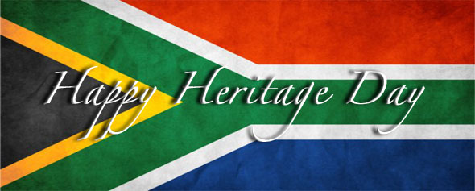

May 19th
The Festival of Wesak
Féile Wesak

For those who are teaching Buddhism as a major world religion for the Junior Cycle this might be a good opportunity to explore one of its most important festivals.
Wesak is the most important of the Buddhist festivals and is celebrated on the full moon in May. Wesak (Vesakha) is an annual holiday observed traditionally by Buddhists and sometimes informally called "Buddha's Birthday". It actually encompasses the birth, enlightenment and passing away of Gautama Buddha.
It has been written – on the first Full Moon of Taurus – the Spiritual Hierarchy creates a yearly Event – during which Divine Grace and Mercy are released with an incredible intensity – in far greater Quantities. The Wesak Festival Celebration is interlaced with the Loving and Compassionate Energies of the Lord Buddha and the Lord Jesus Christ. This Festival and Celebration is a yearly Source of Inner Strength and Rapid Spiritual Development for all Practitioners.

http://education.dublindiocese.ie/2013/05/06/buddhism-resources/
https://wesakfestival.com/

May 16th
International Day of Light
Lá Idirnáisiúnta an tSolais

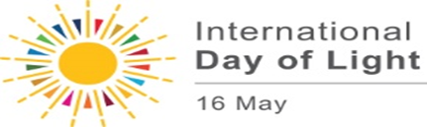
The International Day of Light is held on May 16th every year, the anniversary of the first successful operation of the laser in 1960 by physicist and engineer, Theodore Maiman. The laser is a perfect example of how a scientific discovery can yield revolutionary benefits to society in communications, healthcare and many other fields. The International Day of Light is not just about lasers and science. It also includes aspects of art, culture, entertainment – everywhere light is present in fact!
https://www.lightday.org/why-may-16

May 21st

World Day for Cultural Diversity for Dialogue and Development

Lá Domhanda le haghaidh Éagsúlacht Cultúrtha agus le haghaidh Agallaimh agus Forbartha

Three-quarters of the world’s major conflicts have a cultural dimension. Bridging the gap between cultures is urgent and necessary for peace, stability and development. Cultural diversity is a driving force of development, not only with respect to economic growth, but also as a means of leading a more fulfilling intellectual, emotional, moral and spiritual life.
The World Day for Cultural Diversity for Dialogue and Development is an occasion to promote culture and highlight the significance of its diversity as an agent of inclusion and positive change. It represents an opportunity to celebrate culture’s manifold forms, from the tangible and intangible, to creative industries, to the diversity of cultural expressions, and to reflect on how these contribute to dialogue, mutual understanding, and the social, environmental and economic vectors of sustainable development.
All are invited to join in, and promote the values of cultural diversity, dialogue and development across our globe.
http://www.unesco.org/new/en/cultural-diversity-day

May 22nd
St. Rita
Naomh Ríta

May 22nd is the feast day of St. Rita, an Augustinian nun from 14th century from Cascia, Italy. She is the patroness of impossible causes and hopeless circumstances because of her difficult and disappointing life. Through her trials, God used her in remarkable ways, not only while she lived, but now from heaven she assists those who plead for her intercession for their own seemingly impossible and hopeless circumstances.

https://www.catholic.org/saints/saint.php?saint_id=205

May 22nd
International Day for Biological Diversity
Lá Idirnáisiúnta le haghaidh Éagsúlacht Bitheolaíochta

“Our Biodiversity, Our Food, Our Health”

Biological diversity — or biodiversity — is the term given to the variety of life on Earth and the natural patterns it forms. The biodiversity we see today is the fruit of billions of years of evolution, shaped by natural processes and, increasingly, by the influence of humans. It forms the web of life of which we are an integral part and upon which we so fully depend.
Protecting biodiversity is in our self-interest. Biological resources are the pillars upon which we build civilizations. Biodiversity is the living fabric of our planet. It underpins human wellbeing in the present and in the future, and its rapid decline threatens nature and people alike. It is time to act for biodiversity! The United Nations has proclaimed May 22nd to increase understanding and awareness of biodiversity issues.

“We do not inherit the Earth from our ancestors; we borrow it from our children.”

https://www.cbd.int/idb/2019/
https://en.unesco.org/commemorations/biodiversityday

Other Dates/Information:
Dátaí Eile/ Eolas

Word on Fire Catholic Ministries is a non-profit global media apostolate that supports the work of Bishop Robert Barron and reaches millions of people to draw them into— or back to— the Catholic faith.
Word on Fire is evangelical; it proclaims Jesus Christ as the source of conversion and new life. Word on Fire is Catholic; it utilizes the tremendous resources of the Roman Catholic tradition—art, architecture, poetry, philosophy, theology, and the lives of the saints— in order to explain and interpret the event of Jesus Christ.
Word on Fire Catholic Ministries exists to draw people into the body of Christ, which is the Church, and thereby give them access to all the gifts that Jesus wants his people to enjoy. To be most effective in this mission, Word on Fire places an emphasis and urgency on the use of contemporary forms of media and innovative communication technologies.

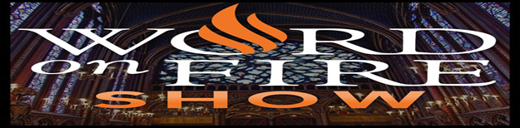

WOF 177: Thoughts on the Jordan Peterson Interview
In March 2019, Bishop Barron was interviewed by Dr. Jordan Peterson for the Jordan B. Peterson Podcast. To say the discussion was highly anticipated is an understatement. Fans of both Dr. Peterson and Bishop Barron have asked for these two great minds to meet, and their wide-ranging, nearly two-hour discussion is worth the wait.
Although the interview hasn’t been made public yet on Jordan Peterson’s channels, in this episode we discuss some of the most interesting parts of the interview.
https://wordonfireshow.com/episode177/
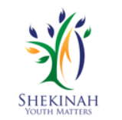Helping young people to grow in faith / Forbairt Chreidimh a Chothú san Aos Óg.

Are you a parent/teacher/chaplain or just interested in young people and their general faith development?
If so then check out www.shekinah.ie for details of the new one-year diploma course accredited by St. Patrick’s College, Maynooth. The aim of this course is to bring the Gospel message to young people in a creative, fun and reflective way. It provides transferrable skills beneficial to parents, teachers and all who work with adolescents.

Shekinah has been involved in training youth retreat facilitators for the past 15 years. We have become aware, over time, of the difficulties schools experience in taking groups out of school, due to the rising costs and the timetabling demands of freeing up teachers for pupil supervision requirements. As a result, while Leaving Certificate and Transition Year pupils may still be offered a retreat experience many children do not any longer, have the experience of a school retreat unless it is facilitated by a teacher or chaplain. This one-year Diploma course in Youth Spirituality provides teachers and chaplains, who may be interested, with a methodology, practical experience and resources for facilitating retreats in class groups within the school as well as without. The methodology and skills may also be very applicable when dealing with aspects of the ’Wellbeing’ programme in the Junior Cert curriculum.

For more information contact Jennifer Perkins at 086 8428260 or www.shekinah.ie
Graduation Resources / Acmhainn le haghaidh Bronnadh na gCéimithe

Graduation Resources are available from our website:

http://education.dublindiocese.ie/2012/06/22/graduation-resources/
http://education.dublindiocese.ie/graduation-prayer-service-2018/

Catholic Youth Ministry Ireland / Friotháil na hEaglaise Chaitilicí ar Ógra na hÉireann.

Catholic Youth Ministry Ireland Training event will take place in St. Paul’s Church, Arran Quay on Monday 13th May. Keynote Address by Erin Doughty from the Archdiocese of Birmingham. The day will also include workshops on resourcing Youth and Young Adult Ministry.
It commences with Registration at 9:30 am. Conference from 10:00am – 4:00pm. (Lunch not included) Cost €20 Per Person.
For more information – email st.pauls@dublindiocese.ie

Connect, Share and Build a Better World! / Nasc, Roinn agus Tóg Domhan Bisithe!

Xt3 is an award-winning, interactive social media platform, bringing you the latest Catholic videos, podcasts, article & more! Featuring live webcasts, youth ministry resources and Smartphone Apps for Lent and Advent, Xt3 will keep you in touch with Church news and events, the latest hot topics. Xt3 - Christ in the Third Millennium.

http://www.xt3.com/index.php?backToXt3=true

Muire, Máthair Íosa
Cinnire: Bhí sé de phribhléid ag Muire gur roghnaigh Dia í mar mháthair dá mhac, Íosa. Bhí sí páirteach i ngach sólás agus dólás ina shaol agus ba mhór an dúshlán é sin. D’éirigh léi mar chuir sí a muinín i nDia.

Lastar coinneal ag pictiúr a dó.

Guth 2: A Mhuire, cuir i gcuimhne dúinn ár muinín a chur i nDia nuair a bhíonn deacrachtaí le sárú againn
Rug Muire Mac do Dhia
Rug Muire mac do Dhia,
Íosa Críost, triath na reann;
Maireann dá éis ’na hóigh,
An bhean is dóigh do gach dall.

Buime is máthair Mhic Dé bhí,
Bean mar í ní fhaca súil;
Bean ler osclaíodh flaitheas Dé,
A mholfas mé os gach dúil.

Ní cosúil í le mnáibh,
Muire mhór, an bláth nach críon;
Ní cosúil balsam le moirt,
Le lionn goirt ní cosúil fíon.

Focail: Traidisiúnta
Ceol: Seán Óg Ó Tuama, Veritas Hymnal 71

Muire ár Máthair

Cinnire: Nuair a bhí Íosa ag fáil bháis ar an gcrois, d’iarr sé ar Mhuire a bheith mar mháthair againn-ne. Thaispeáin sí í féin do pháistí i Lourdes agus do dhaoine fásta ar Chnoc Mhuire i gCo. Mhaigh Eo, chun a chur i gcuimhne dúinn go mbíonn sí ag guí ar ár son i gcónaí.
Lastar coinneal ag pictiúr a trí.
Guímis le chéile:
A Naomh Mhuire, a Mháthair Dé, guigh orainn-ne, peacaigh anois agus ar uair ár mbáis, Áiméan.

Áivé Máiria
A Mhuire Mháthair, ’sé seo mo ghuí
go maire Íosa go deo inár gcroí.
Ave Máiria, mo ghrá Ave,
is tusa mo mháthair, is máthair Dé.

A Mhuire Mháthair, i rith mo shaoil
bí liom mar dhídean ar gach aon bhaol.
Ave Máiria, mo ghrá Ave,
is tusa mo mháthair, is máthair Dé.

A Mhuire Mháthair, tá lán de ghrás’
go raibh tú taobh liom ar uair mo bháis.
Ave Máiria, mo ghrá Ave,
is tusa mo mháthair, is máthair Dé.
Traidisiúnta
\
Céad Moladh le Muire Bheannaithe
Céad moladh le Muire bheannaithe
atá sna flaithis os cionn na naomh.
Céad moladh leatsa a bhanaltra
an Mhic sin d’fhulaing pian.
De ghnáth i ndéanamh caradais
do chaithis ar fad do shaol.
A Mhaighdean ghlégeal gheanúil
dár n-anamacha guighse féin.
Faoi mar’gheall an tAthair neamhaí dúinn
do chabhairse i dtús an tsaoil,
nuair a caitheadh Ádhamh is Éabha leis
as an ngairdín de bharr a ngnímh,
is mar gheall an tAonMhac beannaithe,
uair duitse ‘s do d’aspal caoin;
A Mhaighdean ghlórmhar cheannasach,
dár n-anamacha déanse díon.

Traidisiúnta, Veritas Hymnal, 122

