Post-Primary Diocesan Adviser R.E. News Blog
April 2019/Aibreán 2019

Dear R.E Teacher/Chaplain,

Welcome to April’s issue of the R.E blog!

As schools close on the 12th of April to the 29th for Easter holidays I will provide a shorter blog to take you through until the beginning of the holidays on the 12th.
Although Easter will have passed during the school holidays, it is not too late to re-visit some of the most important days of the Church’s liturgical year with your students! The Easter story gives us time to reflect on the message of hope and new life: Easter reminds us that when all hope appears lost the unexpected happens! Easter means to live with a sense of newness. Just as the return of spring lifts our spirits and makes us feel like the whole world is new, the Resurrection of Jesus makes “all things new.” (Rev. 21:5) Be Fearless, Be Joyful, Be Renewed: Live the Spirit of Easter!
We will continue to add resources as Gaeilge with the assistance of Sr. Mairéad Ni Bhuachalla.

Le gach dea-ghuí,

Lily Barry

April /Aibreán
A Time of New Life! / Seasúr an Úr-bheatha!

This April boasts the most solemn and sublime event of human history: the Resurrection of Jesus Christ – the Paschal mystery. Though the way to the Resurrection was the Via Crucis, the Sacrificial Lamb of God is now and forever Christ our Light, the Eternal high priest of the New Covenant. And his sorrowful mother, the Stabat Mater of Good Friday, is now the jubilant Mother of the Regina Caeli.
We, the members of Christ’s Mystical Body exult in the mystery by which we were redeemed. If in Baptism we were buried with Christ, so also will we share in his resurrection. By his death we were reborn; “by his stripes we were healed.” (Is 53:5) Easter, the epicentre of time, is the event that links time and eternity.
It is indeed “the day the Lord has made; let us be glad and rejoice in it.” (Ps 118:24)
https://www.catholicculture.org/culture/liturgicalyear/overviews/months/04.cfm

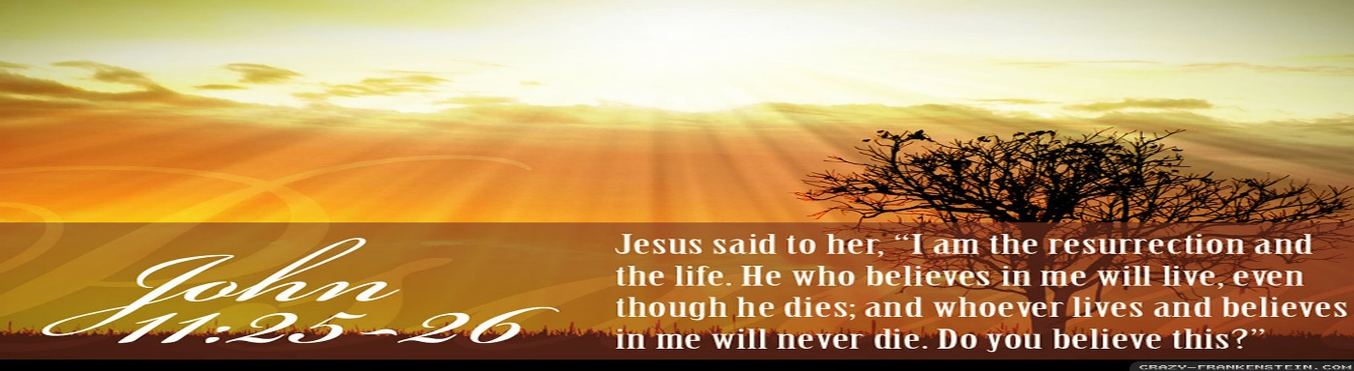

April 7th
Feast Day of St. John Baptist de La Salle / Lá Fhéile Naomh Eoin Baiste de La Salle

Special Patron of all Christian Educators

Saint Jean-Baptiste de La Salle (John Baptist de La Salle) (born 30 April 1651 in Reims; died 7 April 1719 in Saint-Yon, Rouen) was a French priest, educational reformer, and founder of an international educational movement.
He dedicated more than forty years of his life to the education of the children of the poor. In the process, he standardized educational practices throughout France, and wrote meditations on the ministry of teaching (along with catechisms, politeness texts, and other resources for teachers and students). He was to influence many other religious congregations dedicated to education that were founded in the 18th and 19th centuries.

De La Salle became involved in education little by little, without ever consciously setting out to do so. In 1679, what began as a charitable effort to establish a school for the poor in De La Salle's home town gradually became his life's work. He thereby began a new order, the Institute of the Brothers of the Christian Schools also known as the De La Salle Brothers (in the U.K. Ireland and Australasia).

Prayer to St. John Baptist de la Salle:

O God, who chose Saint John Baptist de la Salle to educate young Christians, raise up, we pray, teachers in your Church ready to devote themselves wholeheartedly to the human and Christian formation of the young. Through our Lord Jesus Christ, your Son, who lives and reigns with you in the unity of the Holy Spirit, one God, forever and ever. Amen.

For further resources and a short power point on St. John de La Salle see:
https://www.catholicculture.org/culture/liturgicalyear/calendar/day.cfm?date=2017-04-07
http://education.dublindiocese.ie/2016/03/31/saint-john-baptist-de-la-salle/
https://www.catholic.org/saints/saint.php?saint_id=153
https://www.lasalle.ie/

April 7th

Day of Remembrance of the Victims of the Rwanda Genocide / Lá Cuimhneacháin ar Íobartaigh an Ghinmhilleadh i Rwanda

The United Nations (UN) has named April 7 as the Day of Remembrance of the Victims of the Rwanda Genocide. This day commemorates the deaths of 800,000 people who were murdered during the 1994 genocide in Rwanda, central Africa.

In 1994, in the space of three months, about 800,000 Tutsis and moderate Hutus were killed in Rwanda in what came to be known as the Rwanda genocide. In 1995, the UN called for an outreach program entitled “The Rwanda Genocide and the United Nations” and “to take measures to mobilize civil society for Rwanda genocide victim remembrance and education” to help prevent future acts of genocide. The Day of Remembrance of the Victims of the Rwanda Genocide has been observed each year since 2004, 10 years after the genocide took place.
Get your students involved through educational programmes/resources or in various campaigns. Available resources/films and information available at:
https://www.un.org/en/preventgenocide/rwanda/day-of-reflection.shtml
https://en.wikipedia.org/wiki/List_of_films_about_the_Rwandan_Genocide

Other Dates/Important Notices - Dátaí Eile/Fógraí Tábhachtacha

April 6th
JCT Religious Education Symposium/Comhagallamh RE

Please see details below of the JCT Religious Education Symposium in DCU on Saturday April 6th. Register at www.jctregistration.ie

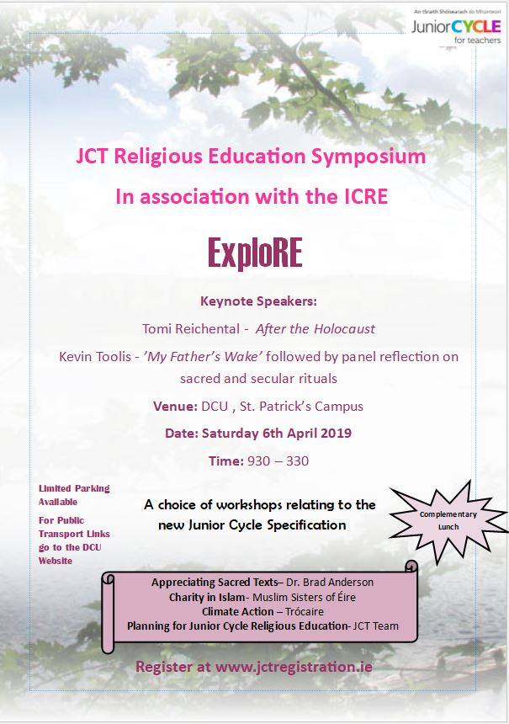

April 7th
Peter’s Passion/Páis Pheadair

Experience Peter’s Passion musical on Sunday, 7th April at 7.30pm in St. Patrick’s Church, Skerries. Performed by students and friends of Skerries Community College – “A story that begin 2000 years ago of a man who loved his friends so much that he laid down his life for them … All welcome!

Archdiocese of Dublin/Ard-Dheoise Bhaile Átha Cliath

See the Archdiocese of Dublin website for information on events, which take place throughout the diocese. http://www.dublindiocese.ie/

April 27th

Archdiocese of Dublin Pilgrimage to Knock 2019/Cuireadh do scoláirí chun taispeánadh na Maighdine Muire ar Chnoc Mhuire a cheiliúradh

Knock 1879-2019: Celebrating 140 years of our National Marian Shrine

Our Dublin Diocesan Pilgrimage to Knock, to be led by His Grace Archbishop Diarmuid Martin, will take place on Saturday, 27th April 2019.

For queries, email: knockpilgrimage@dublindiocese.ie

Trócaire: Until Love Conquers Fear 2019 Lenten Campaign/Feachtas an Charghais á reachtáil ag Trócaire chun go mbeidh an lámh in uachtar ag an ngrá thar an eagla.

Remember to continue to support Trócaire in their Lenten campaign 2019. Learn about Trócaire’s work and the United Nations Global Goals for Sustainable Development. Activities for your classroom/youth group are available from https://www.trocaire.org/getinvolved/lent

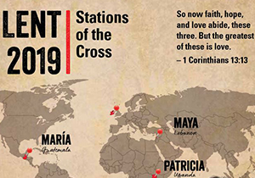

April 8th
Public Lecture: Faith Schools in a Secular Society

See attached poster for further details. (NEXT PAGE)
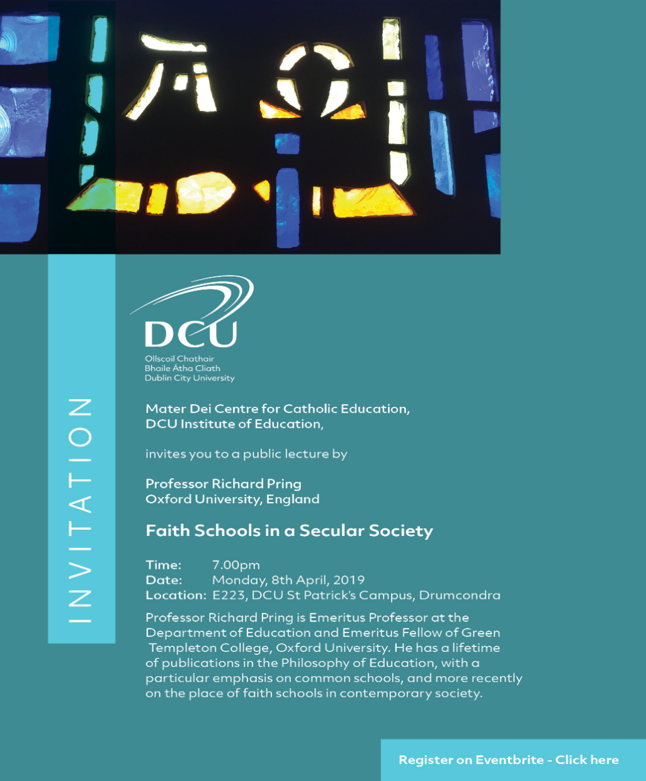

Searmanas Athmhuintearais

Socrú Síos

Suigh go compordach, do dhrom agus do cheann díreach agus do chosa ar an urlár.
Scaoil le haon teannas i do lámha, i d’aghaidh agus thart timpeall ar do bhéal agus do shúile. Scaoil le pé smaointe i do cheann a chuireann brú, nó strus, nó buairt ort.
Féach ar phictiúr éigin os do chomhair amach agus dírigh d’aire go hiomlán air. Mothóidh tú suaimhneas agus síocháin ionat féin.
Dún do shúile go séimh agus dírigh d’aire ar a bhfuil le cloisteáil timpeall ort.
Ansin scaoil le pé torann a chloiseann tú, ná bac leis, déan neamh-shuim de agus fágfaidh sin suaimhneach tú.
Éist leis an gceol, ceol suaimhneach, agus fuaimeanna ón nádúr le cloisteáil ó am go chéile.
Lig don cheol sin tú a thabhairt go háit álainn chiúin ina mbeidh sos agus saoirse, síocháin agus suaimhneas le fáil, áit a thaitníonn leat, áit ina mbíonn tú sona, sa bhaile i do sheomra féin, cois farraige, i ngairdín álainn, áit nach mbeidh aon duine ag cur isteach ort.
Scéal

Anois táim chun scéal a insint daoibh, scéal faoi dhuine a fuair bás. Nuair a casadh Dia air thug Dia cuireadh dó suí síos go compordach mar atá sibhse anois agus thaispeáin Dia fístéip dó, fístéip dá shaol iomlán. Bhí an-suim ar fad ag an duine san fhístéip ach bhí rud amháin ag cur mearbhaill air. Anseo is ansiúd bhí giotaí den téip glan agus chuir sé ceist ar Dhia cad ba chúis leis sin. D’fhreagair Dia gurbh eiseann – Dia - a ghlan amach na míreanna sin. Ansin do thuig an duine gur bhain na míreanna sin le heachtraí ina shaol ina ndearna sé rudaí go raibh náire agus aiféala air fúthu níos déanaí – an t-am a raibh sé mí-mhacánta le linn scrúdú sa scoil – an t-am a chuir sé an milleán ar dhaoine eile nuair a bhí sé féin ciontach – an t-am a bhailigh sé suim mhór airgid nuair a bhí sé mí-mhacánta agus é ag obair i mbun comhlachta ina dhuine fásta. Bhí aiféala air níos déanaí agus rinne sé aisíoc.

D’fhéach Dia air agus dúirt sé go cneasta leis: “Tá na heachtraí sin go léir glanta amach ar fad agam agus dearmad déanta agam orthu.”

Scrúdú Coinsiasa

Féach siar ar do shaol féin anois. An bhfuil aon eachtra, aon ócáid, aon rud a rinne tú go bhfuil aiféala ort anois go ndearna tú é?

Gníomh Dóláis

I do shamhlaíocht, téigh chuig na daoine go ndearna tú dochar dóibh. Abair leo go bhfuil brón ort, nach ndéanfaidh tú dochar dóibh arís, agus iarr maithiúnas orthu.
Ansin abair le Dia go bhfuil brón ort agus tabharfaidh Dia maithiúnas duit.

Abraimis le chéile:
A Dhia, gabhaim buíochas leat as ucht do ghrá dom. Tá brón orm faoi mo pheacaí go léir: nach raibh grá agam duitse ná do dhaoine eile. Cabhraigh liom mo shaol a chaitheamh ar nós Íosa agus gan peaca a dhéanamh arís.

Faoistin

Téigh chun faoistine chuig an sagart ansin. Tá an sagart in áit Íosa. Inis dó aon rud go bhfuil aiféala ort faoi. Tabharfaidh an sagart maithiúnas duit agus iarrfaidh sé ort paidir éigin a rá, nó dea-obair éigin a dhéanamh.
Tar-éis faoistine gabh do bhuíochas le Dia agus iarr ar Dhia cabhrú leat gan peaca a dhéanamh arís.

Bí, a Íosa im’ Chroíse

Bí, a Íosa im’ chroíse is im’ chuimhne gach uair,
Bí, a Íosa im’ chroíse le haithrí go luath,
Bí, a Íosa im’ chroíse le dúthracht go buan,
Is a Íosa, a Dhia dhílis, ná scar choíche uaim.

Is é Íosa mo ríse, mo chara is mo ghrá,
Is é Íosa mo dhídean ar pheaca is ar bhás,
Is é Íosa mo aoibhneas, mo sheasamh de ghnáth,
Is a Íosa, a Dhia dhílis, ná scar liom go bráth.

Bí, a Íosa, go síoraí im’ chroí is im’ bhéal,
Bí, a Íosa, go síoraí im’ thuiscint is im’ mhéin,
Bí, a Íosa, go síoraí im’ mheabhair mar léann,
Is a Íosa, a Dhia dhílis, ná fág mé liom féin.

Traidisiúnta, Veritas Hymnal 31

A Íosa, a Aonmhic an Athar

A Íosa, a Aonmhic an Athar is a Uain,
Thug fíorfhuil do chroí ghil dár gceannach go crua,
Bí im dhíon-sa, bí im choimhdeacht, bí im aice gach uair,
Más luí dom, más suí dom, más seasamh, más suan.

Ó ísligh mo dhíoltas is m’fhearg is m’fhuath,
Is díbir na smaointe mallaithe uaim;
Lig braon beag ded’ NaoimhSpiorad beannaithe anuas
A scaoilfeas an croí seo ’tá ina charraig le cruas.

Tabhair tionscnamh dom’ ghníomhartha i d’ ainm go buan,
Is críochnaigh le fíorcheart de ghnáth mo uaill,
Go bhfaighinnse teacht saor ó gach cealg is cluain,
A Rí Mhic, is go bhfaighinnse a bheith ag amharc ort suas.

Cathal Buí Mac Giolla Ghunna, Veritas Hymnal 55

A Íosa, Glan mo Chroíse

A Íosa, glan mo chroíse go gléghlan gach lá;
A Íosa, cuir m’intinn faoi léirsmacht do ghrá.

Déan mo smaointe go fíorghlan agus briathra mo bhéil;
Is a Thiarna, a Dhia dhílis, stiúraigh choíche mo shaol.

Traidisiúnta, Veritas Hymnal 79

