April 1st 2019

As we move now into the Theme of Holy Week and Easter we might think of the teacher reflection taken from second class, Theme 7, programme.

“The power of the Resurrection reminds our culture that grace is always more powerful and effective than sin and evil”.
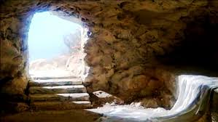
(Irish Catholic Catechism for Adults, p. 106)

