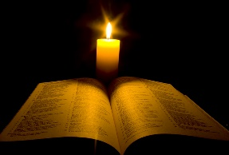
For the attention of all staff!
We are taking time to update our knowledge for the teaching of RE by listening to input, sharing and asking questions. The topic chosen is the following;
“The Person of Jesus and key people of faith in the Bible”.
Cost: Your time – no cash, no cheques, no plastic cards
Venue: Holy Cross College, Clonliffe Rd, Dublin D03P2E7
Date: March 13th 2019 Time: 7pm-9pm
Input will be given by Fr John Littleton and Fr Peter O’Kane from The Priory Institute, Tallaght
“Christ’s Resurrection is not an event of the past; it contains a vital power which has permeated this world. Where all seems to be dead, signs of the Resurrection suddenly spring up. It is an irresistible force. Often it seems that God does not exist: all around us we see persistent injustice, evil, indifference and cruelty. But it is also true that in the midst of darkness something new always springs to life and sooner or later produces fruit”.
(Pope Francis, Evangelii Gaudium)
If you can come, great!
Reply to beatrice.reilly@dublindiocese.ie to confirm your attendance by Wednesday, March 6th 2019
Please print this flyer and bring to the attention of your staff. Thanking you.

