Welcome back after the break

A thought from 2nd class, Theme 5, Teacher Reflection
“Forgiveness is the fragrance the violet sheds on the heel that has crushed it”. (Mark Twain)
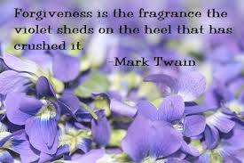

And from 1st class, Theme 5, Teacher Reflection
“There is no saint without a past, no sinner without a future”.
(St Augustine of Hippo)
