Monday, 11th February 2019

Today is the Feast of Our Lady of Lourdes and the day we bring to mind all who are sick in the world.
On 11th February 1858 Our Lady appeared to 14-year-old Bernadette Soubirous in a town in France. Bernadette was with her nine-year old sister and a friend, collecting firewood at a stream near Massabielle outside Lourdes. Her sister and friend had taken off their shoes to wade across a stream and Bernadette got left behind. Suddenly she heard the noise of a rush of wind and saw a beautiful young woman in a niche in the rock, dressed in a white robe. She smiled silently and called to Bernadette, who went down on her knees, took out her Rosary from her pocket and began to pray. The Lady also had a Rosary, but she allowed Bernadette to recite the decade and joined in only at the Glory be. When the Rosary ended, the Lady disappeared.
When the other girls came back, they saw Bernadette still kneeling. They thought she was trying to escape gathering timber and began to give out to her. At first Bernadette said nothing, but on the way home she could not hold her secret. And so her secret spread and today Lourdes is a place of pilgrimage where many come to pray and especially the sick come to ask for inner peace, healing and strength.
Today we pray especially for all who are sick, those whom we know and those who may have no one to pray for them. Perhaps today schools might light up their virtual candles in the Grow in Love online prayer space for all who are unwell at this time.
Our Lady of Lourdes, pray for us

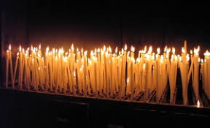

Srs. Maureen, Anne and Edel

