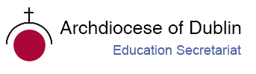

Post-Primary Diocesan Adviser R.E. News Blog
February 2019

Dear R.E Teacher/Chaplain,

Welcome to February’s issue of the R.E blog. This month’s blog continues with a calendar of events for February with a selection of resources linked to important dates from international justice, peace and environmental calendars as well as important dates/feast days from religious calendars. There is also a variety of further resources on this website http://education.dublindiocese.ie/post-primary/ under classroom and general resources.

We will also continue to add resources as Gaeilge with the assistance of Sr. Mairéad Ni Bhuachalla. This month we include three prayer services as Gaeilge, which you can use with your students to mark the important feast days of lá Fhéile Bríde, lá Fhéile Naomh Bláisias agus Naomh Vailintín.

We would encourage you to download the blog and share it with other teachers in your school. If you would like to be added to our mailing list, please let us know. Finally, if there is any way we can help/assist you in your work as Religious Educators, please feel free to contact us with any queries at lily.barry@dublindiocese.ie / bernadette.carron@dublindiocese.ie May you continue to be guided by the Holy Spirit in the work you do with young people.

Le gach dea-ghuí,

Lily Barry,
Post-Primary Diocesan Adviser.

January 27th-3rd February Catholic Schools Week 2019
Seachtain na Scoileanna Caitliceacha
‘Catholic Schools: Celebrating the Work of Our Own Catholic School’

Catholic Schools Week 2019 will run in the same format as previous years from 27th January to 3rd February 2019. As in previous years, each day of Catholic Schools Week 2019 has a theme and a correlating resource for each class group.

Each year Catholic Schools Week provides Catholic school communities with an important opportunity to celebrate ‘who they are’ and ‘what they do’. Catholic Schools Week 2019 aims to achieve this in a more meaningful way by placing each local Catholic school at the centre our celebrations. This year the theme for Catholic Schools Week 2019 is ‘Catholic Schools: Celebrating the Work of Our Own Catholic School’ and we invite Catholic schools to reflect on and celebrate the relationship that exists between home, school and parish through participation in two catechetical moments.

All resources are available as Gaeilge. All resources are accessible via www.catholicschools.ie.
February 1st St. Brigid’s Day
Lá Fhéile Bríde

Lá Fhéile Bhride faoi mhaise agat! Happy St. Brigid’s Day.

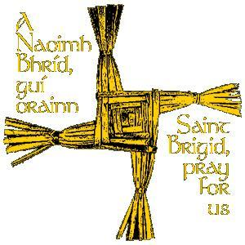
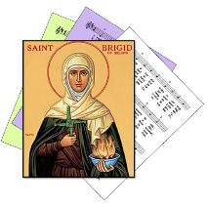

Brigid is one of the great saints of Ireland. Irish people have prayed to her for many hundreds of years. St. Brigid was Abbess of the monastery at Cill Dara (the Church of the Oak in the 6th century. Tradition tells us that as Brigid explained the passion and death of Christ to the dying pagan chieftain she took some rushes from the floor of the bothán and fashioned a cross. The Old Irish custom of placing a St. Brigid’s cross over the doors of dwelling houses and animal shelters thus began. People believed that in so doing Brigid would look after their households and stock and that full and plenty would be theirs in the year ahead. Later the custom of sprinkling the cross with holy water and invoking the following blessing began: “May the Father, Son, Holy Spirit and St. Brigid bless this cross and all who look upon it.” People ask her blessing on themselves, their families and their work. They use her name in prayer. "Brid agus Muire dhuit" was one old Irish blessing. For further resources and a short video on how to make St. Brigid’s day crosses see:
http://education.dublindiocese.ie/2012/02/21/ppsaintbrigid/
https://www.icatholic.ie/how-to-make-st-brigid-cross/

For a short video of her story, see https://www.catholic.org/saints/saint.php?saint_id=453

We have included a prayer service as Gaeilge at the end of this blog.

Aifreann na Féile Bríde:
Déanfar Aifreann na Féile Bríde a cheiliúradh in Áras Chonnradh na Gaeilge, Corrán Grattan, Inse Chóir, Baile Átha Cliath 8, Aoine 1ú Feabhra @ 8p.m i.n. Beidh oíche caidrimh ina dhiaidh. Beidh fáilte roimh chách.

February 2nd Presentation of the Lord / Candlemas Day
Toirbhirt an Linbh Íosa sa Teampall/ Lá Fhéile Muire na gCoinnle
Today the Church celebrates the feast of the Presentation of the Lord, which occurs forty days after the birth of Jesus and is also known as Candlemas day, where the blessing and procession of candles is included in today's liturgies.

"In obedience to the Old Law, the Lord Jesus, the first-born, was presented in the Temple by his Blessed Mother and his foster father. This is another 'epiphany' celebration insofar as the Christ Child is revealed as the Messiah through the canticle and words of Simeon and the testimony of Anna the prophetess. Christ is the light of the nations, hence the blessing and procession of candles on this day. In the Middle Ages this feast of the Purification of the Blessed Virgin Mary, or 'Candlemas,' was of great importance.
https://www.catholicculture.org/culture/liturgicalyear/calendar/day.cfm?date=2019-02-02

February 3rd Feast Day of St. Blaise
Lá Fhéile Naomh Bláisias
Saint Blaise was the bishop of Sebastea and a doctor. The first known record of the saint's life comes from the medical writings of Aëtius Amidenus, where he is recorded as helping with patients suffering from objects stuck in their throat. Many of the miraculous aspects of St. Blaise's life are written of 400 years after his martyrdom in the "Acts of St. Blaise." Saint Blaise is believed to begin as a healer then, eventually, became a "physician of souls." He then retired to a cave, where he remained in prayer. People often turned to Saint Blaise for healing miracles. St. Blaise is known as the Patron of throat Illnesses. For some short, interesting videos on St. Blaise see: https://www.youtube.com/watch?v=3yGRtx_ITgA
https://www.catholic.org/saints/saint.php?saint_id=28

We have included a prayer service as Gaeilge at the end of this blog.

February 5th Safer Internet Day /Sábháilteacht ar an Idirlíon
"Together for a better internet"/“Le chéile le haghaidh sábháilteachta na hIdirlíne”
This year's Safer Internet Day (SID) celebrations will take place on Tuesday, 5 February 2019. The campaign's slogan, "Together for a better internet", is a call to action for all stakeholders to join together and play their part in creating a better internet for everyone, and especially for younger users.

Excellent resources and the latest news and articles about the campaign available at:
https://www.saferinternetday.org/ Some ideas for your students!
- Youth – Get involved in Safer Internet Day 2019!
- Support the #SID2019 campaign on Twibbon
- 10 ways to get involved in Safer Internet Day 2019 (Ireland)

https://www.betterinternetforkids.eu/web/portal/practice/awareness/detail?articleId=3986850

February 8th International Day of Prayer and Awareness against Human Trafficking
Lá Idirnáisiunta chun aird a dhíriú ar mhangaireacht daonna agus guí ina choinne
The feast day of St. Josephine Bakhita (1869 to 1947) is 8th February. She was kidnapped as a child and sold into slavery in southern Sudan and Italy. Once Josephine was freed, she became a Canossian nun and dedicated her life to sharing her testament of deliverance from slavery and comforting the poor and suffering. She was declared a Saint in 2000 and is the Patron Saint for Anti-Trafficking in the Catholic faith.

The Pontifical Council for Justice and Peace and the International Union of Superiors General has designated 8th February, her feast day, as an annual day of prayer and awareness against human trafficking. On that day Catholics all over the world are encouraged to host or attend prayer services to create greater awareness against human trafficking and for those who work to end human trafficking.. Through prayer, we not only reflect on the experiences of those that have suffered through this affront to human dignity, but also comfort, strengthen, and help empower victims and survivors.

Pope Francis has stated, “Human Trafficking is a crime against humanity.” “It’s a disgrace that people are treated as objects, deceived, raped, often sold many times for different purposes and, in the end, killed or, in any case, physically and mentally damaged, ending up thrown away and abandoned.”

“I encourage those who work helping the men, women and children who are enslaved, exploited, abused as instruments of work or pleasure, who are often tortured and mutilated. It is my hope that government leaders may work decisively to remove the causes of this disgraceful scourge; it is a scourge unworthy of society. May each one of us feel committed to being a voice for our brothers and sisters, who have been humiliated in their dignity”
https://www.franciscans.ie/human-trafficking-day-of-prayer/
https://www.youtube.com/watch?v=HNGEnPpbT-k

February 11th World Day of the Sick and the Feast of Our Lady of Lourdes
Lá Domhanda na nEaslán agus Taibhsiú na Maighdine Muire i Lourdes
February 11 is World Day of the Sick, an observation started by Pope John Paul II as a way for believers to offer prayers for those suffering from illnesses. The day coincides with the commemoration of Our Lady of Lourdes.

People around the world take the time to pray for the sick and for those who work very hard to alleviate the sufferings of the sick on this day. Faith organisations mark this day especially to provide the sick with medicines, food, and spiritual guidance.
https://www.awarenessdays.com/awareness-days-calendar/world-day-of-the-sick-2019/
The World Day of the Sick 2019 conference will take place on 9 February 2019 in All Hallows, Drumcondra (9:30am to 1.00pm) on the topic Community struggle with addiction – A Pastoral response. Booking forms are available at https://www.dublindiocese.ie/world-day-of-the-sick/
Mass for World Day of the Sick will be held on 10 February 2019 in Corpus Christi 3.00pm

Our Lady of Lourdes /Muire Lourdes
Today marks the first apparition of the Blessed Virgin Mary in 1858 to fourteen-year-old Marie Bernade (St. Bernadette) Soubirous. Between February 11 and July 16, 1858, the Blessed Virgin appeared eighteen times, and showed herself to St. Bernadette in the hollow of the rock at Lourdes. On March 25, she said to the little shepherdess who was only fourteen years of age: "I am the Immaculate Conception." Since then Lourdes has become a place of pilgrimage and many cures and conversions have taken place. The message of Lourdes is a call to personal conversion, prayer, and charity.
https://www.catholicculture.org/culture/liturgicalyear/calendar/day.cfm?date=2019-02-11

February 11th International Day of Women and Girls in Science
Lá Idirnáisiúnta Tiomnaithe do Mhná agus do Chailíní san Eolaíocht
"We need to encourage and support girls and women achieve their full potential as scientific researchers and innovators." — UN Secretary-General, António Guterres
Science and gender equality are both vital for the achievement of the internationally agreed development goals, including the 2030 Agenda for Sustainable Development. Over the past 15 years, the global community has made a lot of effort in inspiring and engaging women and girls in science. Unfortunately, women and girls continued to be excluded from participating fully in science. According to a study conducted in 14 countries, the probability for female students of graduating with a Bachelor’s degree, Master’s degree and Doctor’s degree in science-related field are 18%, 8% and 2% respectively, while the percentages of male students are 37%, 18% and 6%.

In order to achieve full and equal access to and participation in science for women and girls, and further achieve gender equality and the empowerment of women and girls, the United Nations General Assembly adopted resolution A/RES/70/212 declaring 11 February as the International Day of Women and Girls in Science.
http://www.un.org/en/events/women-and-girls-in-science-day/

February 14th St. Valentine
Naomh Vailintín, Pátrún an Ghrá

Saint Valentine, officially known as Saint Valentine of Rome, is a third-century Roman saint widely celebrated on February 14 and commonly associated with "courtly love”.

Shrine of St Valentine, Whitefriar Street Church, Dublin.

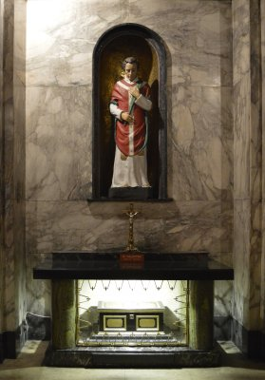
Throughout the centuries since Valentine received martyrdom there have been various basilicas, churches and monasteries built over the site of his grave. Many restorations and reconstructions took place at the site, therefore over the years. In the early 1800s such work was taking place and the remains of Valentine were discovered along with a small vessel tinged with his blood and some other artefacts.

In 1835 an Irish Carmelite by the name of John Spratt was visiting Rome. He was well known in Ireland for his skills as a preacher and also for his work among the poor and destitute in Dublin’s Liberties area. He was also responsible for the building of the new church to Our Lady of Mount Carmel at Whitefriar Street. While he was in Rome he was asked to preach at the famous Jesuit Church in the city, the Gesu. Apparently, his fame as a preacher had gone before him, no doubt brought by some Jesuits who had been in Dublin. The elite of Rome flocked to hear him and he received many tokens of esteem from the doyens of the Church. One such token came from Pope Gregory XVI (1831-1846) and were the remains of Saint Valentine.

On November 10, 1836, the Reliquary containing the remains arrived in Dublin and were brought in solemn procession to Whitefriar Street Church where they were received by Archbishop Murray of Dublin. With the death of Fr Spratt interest in the relics died away and they went into storage. During a major renovation in the church in the 1950s/60s they were returned to prominence with an altar and shrine being constructed to house them and enable them to be venerated. The statue was carved by Irene Broe and depicts the saint in the red vestments of a martyr and holding a crocus in his hand.

Today, the Shrine is visited throughout the year by couples who come to pray to Valentine and to ask him to watch over them in their lives together. The feast day of the saint on February 14 is a very popular one and many couples come to the Eucharistic celebrations that day which also includes a Blessing of Rings for those about to be married. On the feast day, the Reliquary is removed from beneath the side-altar and is placed before the high altar in the church and there venerated at the Masses. At the 11.00am and 3.15pm Masses, there are special sermons and also a short ceremony for the Blessing of Rings for those about to be married.
http://www.carmelites.ie/stvalentine.html
https://www.catholic.org/saints/saint.php?saint_id=159
http://education.dublindiocese.ie/2012/02/21/saint-valentine/
We have included a prayer service as Gaeilge at the end of this blog.

February 20th World Day of Social Justice
Lá Domhanda Tiomnaithe do Cheartas Sóisialta
The United Nations' (UN) World Day of Social Justice is annually observed on February 20th to encourage people to look at how social justice affects poverty eradication. It also focuses on the goal of achieving full employment and support for social integration.

Social justice is an underlying principle for peaceful and prosperous coexistence within and among nations. We uphold the principles of social justice when we promote gender equality or the rights of indigenous peoples and migrants. We advance social justice when we remove barriers that people face because of gender, age, race, ethnicity, religion, culture or disability. For excellent resources to use with students, see:
http://education.dublindiocese.ie/2013/01/28/poverty/
http://www.un.org/en/events/socialjusticeday/background.shtml

Other Important Dates/Information to Note!
/Laethanta Tábhachtacha eile/ Eolas le Meabhrú!

February 2nd “Mary, Lift Our Spirits!”
A one-day conference on Mary will take place in DCU All Hallows Campus, Drumcondra, on Saturday 2nd February 2019. Details below.

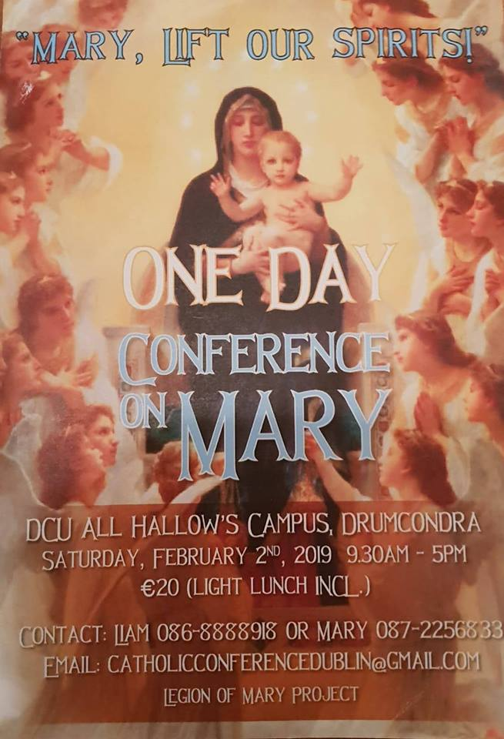
Our Lady Brings Us to Jesus:
Reflections for the feast of Our Lady of Lourdes.
A serious conversation is never a personal accomplishment, an achievement that we might savour with some satisfaction. In a very pure sense, it is an entirely a gift of God when a soul returns to a friendship with him or discovers his real presence for the first time in life.

But there is another truth behind conversions that is often less noted. It may also be that the Virgin Mary always has her eyes on a soul that undergoes any form of conversion. She is the mother of conversions and often in a very direct manner. She asked Saint Bernadette many times in the apparitions at Lourdes to pray for the conversion of sinners. Bernadette recounts that each time Mary made this request, the young seer asked our Lady what she meant by these words. And each time, in reply, Mary only smiled at her. There is a mystery in that smile of Mary. Did she smile at the zeal of Bernadette’s desire to get it right and fulfil the request properly? Or perhaps Mary smiled in knowing already that this girl in the years to come would offer much in sacrifice and self-giving for the conversions of many souls.

As in all the apparitions of Our Lady, the passage reminds us that conversions occur because prayer and sacrifice have been placed in the heart of Mary for the sake of souls. The personal experience we might have in every serious conversion of being drawn to our Lord has hidden within it the presence of Mary and these intersessions. Mary wanting a soul for her Son because her own love for that soul is strong, is one reason behind every conversion.
Fr. Donald Haggerty. Magnifiicat February 2019, Vol.9, No.4
The Combined Catholic Parishes of Clondalkin
Further excellent resources for February are available from Frank Brown, Parish Pastoral Worker, from the combined parishes of Clondalkin. Free to use, lose, adapt, adopt or share. Hope these are useful and take what you need, like or find useful.
You can download them from https://1drv.ms/f/s!AtJiw53tHyZ_gf8xBAgJ_TlcwJGN9A

Archdiocese of Dublin /Ard-Dheoise Bhaile Átha Cliath
See the Archdiocese of Dublin website for information on events, which take place throughout the diocese including updates from the WYD in Panama 2019.
http://www.dublindiocese.ie/

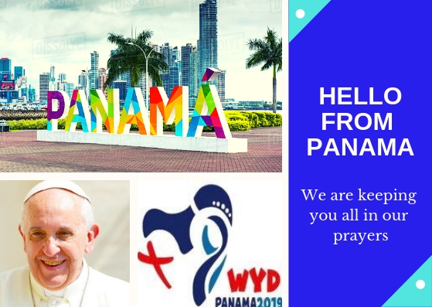

John Paul II Awards 2019 /Gradam Eoin Pól 2019
The Pope John Paul II Award was created to commemorate the late Pope John Paul II who was so committed to young people and who had such belief and confidence in them. The Award enables participants to take an active part in the life of their Church – in the life of their community and society. It enables young people become more aware of the teaching and role of the Catholic Church in the world and to engage at a deep level with Christ. The Award is committed to helping young people enhance their spiritual, physical, emotional and social development through participation in school, parish and community activities. As well as the feeling of personal achievement that a participant will gain from taking part in the Award, participation will help demonstrate the young person’s commitment to a task and goal. The JPII Awards will take place on Tuesday 12th February in St Paul's Church, Arran Quay [Smithfield] at 7:30pm.

Emmanuel 2019 at the Helix/ Emmanuel san Helix
70 Second Level Schools from all over the Archdiocese will participate in the renowned Emmanuel concert series this year, where hundreds of teenagers take part in a live concert in the Helix over four nights. Monday 25/Tuesday 26/ Wednesday 27 and Thursday 28 of February at 7.30pm each evening. Come along and as a choir / music group to listen to young people praising God with energy in this unique event. A list of participating schools is available www.litmus@dublindiocese.ie Tickets available from www.thehelix.ie 01 7007000

Searmanas in Onóir Bhríd Naofa, 1ú Feabhra

Beidh crosa Bhríde agus uisce coisricthe in úsáid.

Gabham molta Bhríde,
Ionúin í le hÉirinn,
Ionúin le gach tír í,
Molaimis go léir í.

Tig an geimhreadh dian dubh
’Gearradh lena ghéire;
Ach ar lá ’le Bríde
Gar dúinn earrach Éireann.

Lóchrann geal na Laighneach
’Soilsiú feadh na tíre, (Traidisiúnta, Veritas Hymnal 136)
Ceann ar ógha Éireann,
Ceann na mban ar míne.

“Anois teacht an earraigh, beidh ’n lá ’dul chun síneadh,
Is taréis na Féil’ Bríde ardóidh mé mo sheol.”

( Antaine Raiftearaí)

Cinnire: Inniu, an chéad lá Feabhra, Lá Fhéile Bríde, Muire na nGael, Pátrún na hÉireann. Rugadh Bríd i bhFochairt láimh le Dún Dealgan sa bhliain 451, deich mbliana roimh bhás Phádraig Naofa. Taoiseach de chuid Cúige Laighean ba ea a hathair, Dúbhthach. Sclábhaí ba ea a máthair, Brocseach. Críostaí ba ea a máthair agus baisteadh Bríd ina Críostaí. Bheartaigh Bríd a bheith ina bean rialta agus bhunaigh sí mainistreacha i gCill Dara agus in áiteanna eile. Tá an-chuid scéalta i dtaobh a cineáltais do bhochtáin, d’easláin, d’ainmhithe agus i dtaobh a muinín i nDia. Tá toibreacha Bhríde ar fud na tíre agus tá a lán nósanna ag baint le Lá Fhéile Bríde. Fuair sí bás thart faoin mbliain 524.

Beannú agus Dáileadh na gCros

Déantar uisce coisricthe a chroitheadh ar chrosa Bhríde agus deirtear an phaidir seo:

“Go raibh beannacht an Athar, an Mhic is an Spioraid Naoimh ar na crosa seo, ar na háiteanna ina bhfuil siad agus ar gach duine a fhéachann orthu.”

Dáiltear iad ansin agus deirtear an phaidir seo:

“Go dtuga lasair Bhríde spreagadh duit.
Go dtuga crios Bhríde slánú duit.
Go dtuga cruthaíocht Bhríde slí duit.”
Paidreacha:

Bhí creideamh láidir ag Bríd. Chuir sí a muinín go hiomlán i nDia agus tháinig Dia i gcabhair uirthi. Guímis go muiníneach chun Dé mar a rinne Bríd.

- A Dhia, neartaigh ár gcreideamh, ár ndóchas agus ár ngrá. A Thiarna, éist linn. A Thiarna, bí ceansa agus éist linn.

- Bhí Bríd cineálta leis na bochtáin agus na heasláin. A Dhia, cabhraigh linn aithris a dhéanamh uirthi. A Thiarna, éist linn. A Thiarna, bí ceansa agus éist linn.

- Bhí grá ag Bríd d’ainmhithe, d’éin agus do gach rud a chruthaigh Dia. Múin dúinn, a Dhia, conas aire a thabhairt don imshaol. A Thiarna, éist linn. A Thiarna, bí ceansa agus éist linn.

- Rinne Bríd réiteach idir dhaoine. A Dhia, taispeáin dúinn conas síocháin a chothú pé áit ina mbeimid. A Thiarna, éist linn. A Thiarna, bí ceansa agus éist linn.

- A Dhia, tabhair saoirse ó chogadh, ó ghorta agus ó ghéarleanúint dóibh siúd atá ag fulaingt. A Thiarna, éist linn. A Thiarna, bí ceansa agus éist linn.

A Dhia, bhronn tú do ghrásta go fial ar Bhríd chun do ghrá agus do thrócaire a léiriú do mhuintir na hÉireann. Beannaigh ár dtír agus líon ár gcroíthe le do ghrásta ionas go mbeimid ábalta grá Dé a léiriú agus síocháin agus aontacht a chothú pé áit ina mbeimid. Sin é ár nguí chugat trí Chríost á dTiarna. Áiméan.

Duan Bhríde

Dearc anuas, féach mar atáimid,
A Naomh álainn, féach sinn.
Feacaimid ár nglúna id’ láthair.
Dearc mar mháthair ar do chlainn.
Cuidigh linn, a mháthair aoibhinn,
Bí choíche ag éisteacht linn,
A Naomh Bríd, a Chéile Chríosta,
Mar an faoileán ar an tuinn.

Níl aon áit ’na bhfuil na Gaeil
Ar an saol seo abhus, ná thall
Nach bhfuil grá acu’na gcroíthe
Ortsa, a Bhríd gheal, moch is mall.
Líon le grá an croí atá brúite.
Bain den tsúil atá fliuch, a deoir.
Stiúraigh, treoraigh, ardaigh sinne
Nó go dtagaimid id' ghlóir.

Ceol: Cecilia Sinnott Aistriúchán: Dubhghlas de hÍde

Lá Fhéile Naomh Bláisias, 3ú Feabhra

Easpag agus mairtíreach a mhair i Sebaste san Airméin sa 4ú aois ba ea Naomh Bláisias. Tá sé sa traidisiún go raibh sé ina dhochtúir leighis sarar deineadh Easpag de agus gur leigheas sé buachaill a bhí á thachtadh. Tugtar onóir dó mar phátrún daoine a bhfuil tinneas scornaí orthu.

***************

Is comhartha é, beannú na scornach, dár gcreideamh i nDia a thugann aire dúinn agus a thugann grá do dhaoine atá tinn.

Beannú na Scornach

Trí idirghuí Naomh Bláisias,

Easpag agus Mairtíreach,

go gcosnaí Dia tú ó gach éalang scornaí

agus ó gach tinneas eile,

trí Chríost ár dTiarna. Amen.

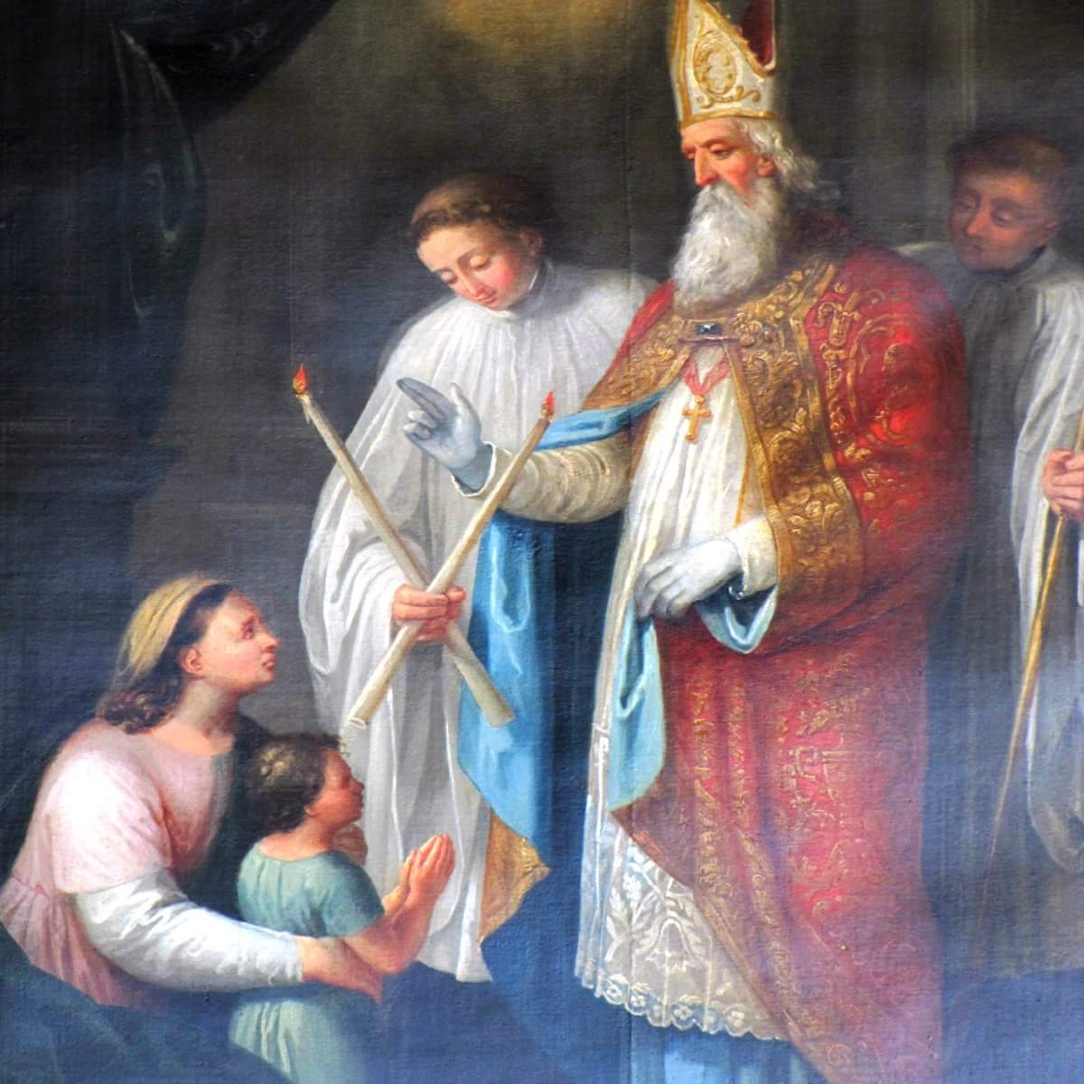

Ceiliúradh Cairdis

Lá Fhéile Vailintín, Pátrún an Ghrá 14ú Feabhra

Coinneal chumhra, ‘croíthe’ dearga, cártaí réamh-dhéanta

Cinnire: Táimid ag ceiliúradh Lá Fhéile Vailintín, Pátrún an Ghrá.

Cérbh é Naomh Vailintín? Sagart agus mairtíreach a cuireadh chun báis sa Róimh breis is 1,700 bliain ó shin.

Cén fáth gur cuireadh chun báis é? Mar thug sé a bheannacht do lánúineacha a bhí i ngrá! Ní raibh fonn ar na fir óga san am sin troid in arm an Impire Rómhánaigh, Claudius. Chuir Claudius an milleán ar na mná agus d’ordaigh sé gach pósadh agus gealltanas pósta a chur ar ceal agus bhí an bás i ndán d’aon duine a chuirfeadh ina choinne. Níor aontaigh Vailintí leis sin. Cuireadh i bpríosún é agus dícheannadh é sa Róimh ar an 14ú Feabhra 269/270 A.D.

An bhfuil aon bhaint aige le Baile Átha Cliath? Tá a thaisí in Eaglais na gCairmilíteach i Sráid na mBráithre Bána. Tugann lánúineacha cuairt ar an scrín ansin chun a bheannacht a iarraidh ar a bpóstaí.

Cad is grá ann? Seo mar a deir Naomh Pól:
“Bíonn an grá foighneach agus bíonn sé lách; ní bhíonn éad air; ní dhéanann sé maíomh ná mórtas; ní bhíonn sé mí-mhúinte ná leithleasach… Ní áil leis an éagóir ach is aoibhinn leis an mhaith. Bíonn sé lán..de chreideamh, lán de dhóchas agus lán d’fhoighne.” ( 1 Cor. 13: 4 -7)

An duine grámhar tusa?
An mbíonn tú foighneach.. lách.. gan éad.. gan mhaíomh.. gan a bheith mí-mhúinte.. gan a bheith leithleasach..?
An bhfuil aithne agat ar aon duine go bhfuil na tréithe sin aici/aige?

Cinnire: Tá cártaí Vailintín anseo, cártaí inar scríobh sibh rudaí maithe i dtaobh a chéile agus táim chun iarraidh ar Dhia iad a bheannú.

Beannú na gCártaí

A Dhia, cuir do bheannacht ar na cártaí seo ina gcuirimid ár ngrá do dhaoine eile in iúl mar a rinne Naomh Vailintín. Go gcuire na cártaí seo áthas, lúcháir, aoibhneas agus gliondar ar na daoine a scríobh iad agus ar na daoine a gheobhaidh iad. Sin é ár nguí chugat trí Chríost ár dTiarna. Áiméan

Déantar uisce coisricthe a chroitheadh ar na cártaí.

Cad as a dtagann an grá? Seo mar a deir Naomh Eoin:
“Tugaimis grá dá chéile mar gur ó Dhia an grá agus an té a thugann grá is ó Dhia a rugadh é, agus aithníonn sé Dia..mar is é Dia an Grá… Sheol sé a aonmhac sa saol le go mairimis-ne trídsean..ós fíor gur thug Dia grá dúinne nach mithid dúinne grá athabhairt dá chéile… Má thugaimid grá dá chéile maireann Dia ionainn.” (1 Eoin 4 : 7 - 12)

Cad is fíor-ghrá ann? Seo mar a deir Naomh Eoin:
“Ná tugaimis grá briathair ná cainte amháin, ach grá gnímh agus fírinne.”
(1 Eoin 3: 18)

Paidreacha

- A Dhia ghrámhair, níl teorainn le do ghrá. Is cuma an bhfuilimid dathúil nó mí-dheas, bocht nó saibhir, óg nó aosta, tugann tú grá dúinn. Cabhraigh linn-ne aithris a dhéanamh ar do ghrá.

- A Dia, is tú údar gach maitheasa, taispeáin dúinn conas an mhaith a aithint i ngach duine a chastar orainn.

- A Dhia, cabhraigh linn fíor-ghrá a chleachtadh, ní le briathra amháin, ach le gníomhartha chomh maith, mar a rinne do mhac, Íosa agus Naomh Vailintín.

- Iarraimid ort, a Dhia, do bheannacht a chur ar ár gcairdis. Cuir i gcuimhne dúinn, a Dhia, go bhfuil an grá i gcroí-lár na beatha, agus go bhfuil seirbhís do dhaoine eile i gcroí-lár an ghrá.

- A Dhia flaithiúil, tugann tú grá dúinn gan choinníollacha. Ní chaillimid do ghrá nuair a dhéanaimid peaca agus maireann do ghrá-sa go deo. Ná lig dúinn dearmad a dhéanamh air sin choíche.

Cinnire: Imigí faoi shíocháin chun grá agus seirbhís a thabhairt dá chéile. Áiméan.

Cairde Dílse

Tá cairde agat, ní gá duit bheith leat féin.
Bí buíoch dóibh siúd, ní gá duit bheith leat féin.
Tá tú láidir, ní bheidh tú i d’aonar go deo.
Má bhíonn sé fliuch, tugann siad foscadh duit.
Má bhíonn tú tinn, tugann siad faoiseamh duit.
Ardóidh siad do chroí, má bhíonn tú faoi bhrón.

Curfá

Cairde dílse mór-thimpeall ort,
Cairde dílse i gcónaí leat,
Cairde dílse mór-thimpeall ort go deo.

2
Má tá cairde i bhfad ó chéile
Bíonn siad fós i bpáirt le chéile.
Ní bhíonn siad riamh go brónach leo féin.
Bíonn siad ag smaoineamh ort,
Is i gcónaí ag guí duit.
Ní bheidh tú i d’aonar go deo.

Fil Uí Dhubhghaill, Finbar O’Connor, ó Beo Go Deo 8

