Post-Primary Diocesan Adviser R.E. News Blog
December/Nollaig 2018

Dear R.E. Teacher / Chaplain,

Welcome to December issue of the R.E blog! I hope you all had a great first term and are looking forward to the Christmas break! This is a busy month and I hope the blog will continue to be useful for you as an educational resource in your work in schools and parishes. In addition, I would be more than happy to receive any contributions you may wish to share with fellow Chaplains and R.E. teachers or any suggestions for in-service /support days which the Diocese could provide. We have a day for Chaplains here in the Diocesan Offices on the 6th of December and are looking forward to welcoming all those who work in the Chaplaincy area.

School visits are well under way for this academic year, and we want to thank all those schools whom we visited for their warm welcome. We look forward to meeting many more of you in the coming months. If you would like us to visit for any reason, please contact us and we will be more than happy to arrange this with you.

We look forward to continued collaboration with you all as we work to promote the faith of the young people in our care. May the joy of Our Saviours birth be with you, your families, and your schools this Christmas time. We wish you all many blessings.

We will continue to add resources as Gaeilge with the assistance of Sr. Mairéad Ni Bhuachalla.

Le gach dea-ghuí,

Lily Barry

November 30th First Sunday of Advent
“It is the beautiful task of Advent to awaken in all of us memories of goodness and thus to open doors of hope”, (Pope Benedict XVI)
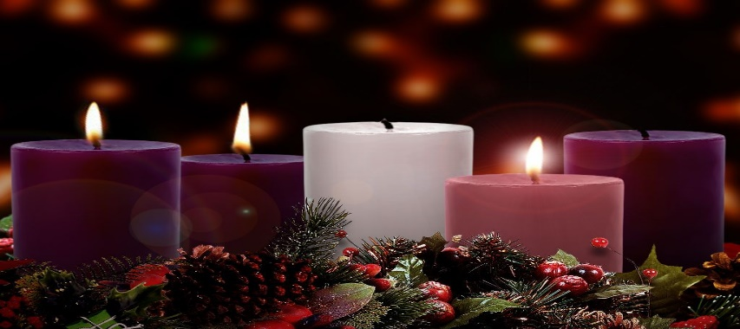
Today the Church celebrates the First Sunday of Advent. This is the beginning of a new liturgical year. The Advent liturgy opens with that great yearning cry of the prophets of Israel to the Messiah and Redeemer whose advent they awaited. "Come!" In the Mass of this Sunday, the whole work of redemption is set before us, from its preparation in Israel's expectancy and its effect on our present lives down to its final fulfilment. The Church, in preparing us to celebrate at Christmas the birth of Our Lord and Saviour, Jesus Christ.
To help your students prepare see the following ideas for creating your own advent wreath and many other ideas for use in the classroom:

http://education.dublindiocese.ie/2018/11/26/primary-november-blog-2/
http://education.dublindiocese.ie/2012/06/01/advent-resources-2/https://www.catholicculture.org/ebooks/view_ebook.cfm?id=69

December 2nd Chanukah - Hanukkah 2018

Chanukah begins Sunday night, December 2 2018 and continues through Monday, December 10 2018. Chanukah is the Jewish eight-day, wintertime “festival of lights,” celebrated with a nightly menorah lighting, special prayers and fried foods.
If you are studying Judaism with your Junior Cert class extra resources can be found at:

https://www.chabad.org/holidays/chanukah/default_cdo/jewish/Hanukkah.htm
http://education.dublindiocese.ie/hanukkah/

December 3rd Memorial of St. Francis Xavier
St. Francis Xavier one of the Church’s most illustrious missionaries, came from a noble Basque family in Spain. He studied at the University of Paris, where he taught philosophy.

Jesus asked, “What profit would there be for one to gain the whole world and forfeit his life?” (Matthew 16:26a). These words were spoken to a young teacher of philosophy who had a highly promising career in academics, with success and a life of prestige and honour before him.

Francis Xavier, 24 at the time, and living and teaching in Paris, did not heed these words at once. They came from a good friend, Ignatius of Loyola, whose tireless persuasion finally won the young man to Christ. Francis then made the spiritual exercises under the direction of Ignatius, and in 1534, joined his little community, the infant Society of Jesus. Together at Montmartre they vowed poverty, chastity, obedience, and apostolic service according to the directions of the Pope.

https://www.franciscanmedia.org/saint-francis-xavier/ http://www.catholicculture.org/culture/liturgicalyear/calendar/day.cfm?date=2018-12-03

December 6th St. Nicholas of Myra
Not much is known about this 4th century bishop, but that does not diminish his popularity around the world, both in the East and West. It is known that Nicholas was born in Lycia in Asia Minor (modern-day Turkey) and died in 352 A.D. as the Bishop of Myra. All other stories that surround Nicholas illustrate that he practiced both the spiritual and corporal works of mercy. He was generous, strove to help the poor and disadvantaged, and worked tirelessly to defend the faith. St. Nicholas provided for the poor and sick, and is the basis for the popular character of Santa Claus.

Saint Nicholas, bishop of Myra, is undoubtedly one of the most popular saints honoured in the Western world. He is primarily considered as the patron saint of children.

http://www.catholicculture.org/culture/liturgicalyear/calendar/day.cfm?date=2018-12-06 https://www.catholic.org/saints/saint.php?saint_id=371

December 8th Solemnity of the Immaculate Conception
"The most Blessed Virgin Mary was, from the first moment of her conception, by a singular grace and privilege of almighty God and by virtue of the merits of Jesus Christ, Saviour of the human race, preserved immune from all stain of original sin." — Catechism of the Catholic Church

Today the Church celebrates the Solemnity of the Immaculate Conception. Through the centuries, the Church has become ever more aware that Mary, "full of grace" through God, was redeemed from the moment of her conception. For excellent resources to share with your students including beautiful power point presentations, see:

https://www.catholic.org/mary/
http://education.dublindiocese.ie/feast-of-the-immaculate-conception-of- mary/
https://www.catholicculture.org/culture/liturgicalyear/calendar/day.cfm?date=2017-12-08

December 9th Second Sunday of Advent
As the journey of Advent continues, as we prepare to celebrate the nativity of Christ, John the Baptist’s call to conversion sounds out in our communities. It is a pressing invitation to open our hearts and to welcome the Son of God who comes among us to make divine judgement manifest.
“Through the Gospel John the Baptist continues to speak down the centuries to each generation. His hard clear words bring health to us, the men and women of this day in which even the experience and perception of Christmas often, unfortunately, reflects materialist attitudes. The ‘voice’ of the great prophet asks us to prepare the way for the coming Lord in the deserts of today, internal and external deserts, thirsting for the water of life which is Christ.” — Benedict XVI

http://www.catholicculture.org/culture/liturgicalyear/calendar/day.cfm?date=2018-12-09

December 10th Human Rights Day
The Universal Declaration of Human Rights turns 70!
Let's stand up for equality, justice and human dignity.

Human Rights Day is observed every year on 10 December – the day the United Nations General Assembly adopted, in 1948, the Universal Declaration of Human Rights. This year, Human Rights Day marks the 70th anniversary of the Universal Declaration of Human Rights, a milestone document that proclaimed the inalienable rights, which everyone is inherently entitled to as a human being -- regardless of race, colour, religion, sex, language, political or other opinion, national or social origin, property, birth or other status. It is the most translated document in the world, available in more than 500 languages.
http://www.un.org/en/events/humanrightsday/

December 14th Memorial of St. John of the Cross
St. John of the Cross (1542-1591) was born and died in Spain. In 1563 he offered himself as a lay brother to the Carmelite friars, who, however, perceiving his unusual talents, had him ordained a priest. When he was about to join the more severe Order of the Carthusians, the saintly Teresa persuaded him to remain and help her in the reform of the Carmelite Order. This reform of his order caused him such sufferings and brought him many trials. However, his sufferings served only to detach him from creatures. He had a great devotion to Our Lord's Passion and voluntarily sought out humiliations. When Our Lord asked him what reward he would ask for his labours, John answered: "To suffer and to be despised for Thee." He died of a cruel disease, embracing the crucifix. Because of his profound treatises on mystical theology Pope Pius XI proclaimed him Doctor of the Church.
https://www.catholicculture.org/culture/liturgicalyear/calendar/day.cfm?date=2018-12-14 https://www.catholic.org/saints/saint.php?saint_id=65

December 16th Third Sunday of Advent
Today is known as Gaudete Sunday. The term Gaudete refers to the first word of the Entrance Antiphon, “Rejoice”. Rose vestments are worn to emphasize our joy that Christmas is near, and we light the rose candle on our Advent wreath.
“Rejoice: the Lord is nigh.” As Christmas draws near, the Church emphasizes the joy, which should be in our hearts over all that the birth of our Saviour means for us. The great joy of Christians is to see the day drawing nigh when the Lord will come again in His glory to lead them into His kingdom.
http://www.catholicculture.org/culture/liturgicalyear/calendar/day.cfm?date=2018-12-16

Other Dates/Information (Dataí Eile/Eolas):

We are aware that schools will close on Friday, 21st for Christmas holidays. Therefore, the blog takes us up to the final week of teaching and the 3rd Sunday of advent. Please encourage your students to continue the preparation for Christmas up to Christmas Eve! ​ ​

Further excellent resources for Advent and Christmas are available from Frank Brown Parish Pastoral Worker from The Combined Catholic Parishes of Clondalkin. http://www.clondalkinparish.com ​@TheCCPCDublin.

There are a number of liturgies & resources including:
- ​​Something Different for Advent - a series of 1 page (2 sided) reflections & Bookmarks for each week of Advent
- Praying Advent - A busy person's retreat - A booklet that can be printed and given out
- Family Prayer card
- Walking Advent through Scripture - A Scripture a day Advent calendar
- A few 'Make A Difference' (MAD) resources
- The Christmas Doorstep Challenge
- Family New Year’s Resolutions, etc.,
Hope these are useful and take what you need, like or find useful:
https://1drv.ms/f/s!AtJiw53tHyZ_gftBViKu9Vs3nFhN_w

Archdiocese of Dublin/Ard-Dheoise Bhaile Átha Cliath

See the Archdiocese of Dublin website for information on events, which take place throughout the diocese including the WYD in Panama 2019. Also, please see attached poster on WYD Panama in Dublin! We would love to see as many schools bring their students to this wonderful event and to join with all those who are in Panama celebrating WYD 2019.
http://www.dublindiocese.ie/

