Dear Principals and Teachers,
We would like to draw your attention to downloadable material now available on the Grow in Love site, under “Professional Development”. These materials may be of value in relation to the preparation of the following sacraments.
- First Reconciliation
- First Holy Communion
- Confirmation
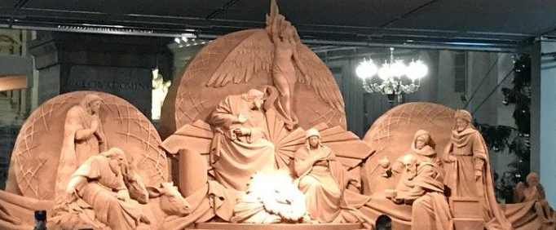

This year’s Sand Nativity scene in Rome’s St. Peter’s Square was inaugurated during an impressive ceremony that included Christmas carols, folk dances and band music.

The sand sculpture of the Nativity scene is a gift of the Italian seaside resort town of Jesolo, north of Venice, and the Patriarchate of Venice. Over 700 tons of sand from the beach of Jesolo was compacted to create the 16-meter wide and 5-meter tall Nativity sculpture covering 25 square meters.
(extract and photo from CatholicNews.ie)

A very Happy Christmas to all,
Maureen, Anne and Edel

