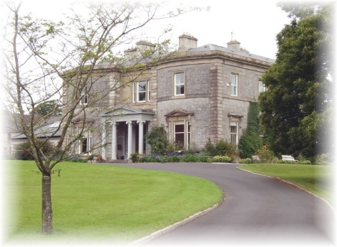Presentation Sisters,
Mount St. Anne’s Retreat and Conference Centre,

Killenard, Portarlington, Co. Laois
057-8626153
email: msannes@eircom.net

Faith Development Co-ordinator
Job Description

Title: Faith Development Co-ordinator

Location: Mount St. Anne’s Retreat & Conference Centre, Killenard,
Portarlington, Co. Laois.

Contract: 12-month fixed term contract

Salary: iro €30,000

Reports to: CEO-Programme Director

Background to the Job:

The Presentation Sisters are a Catholic international religious congregation founded in 1775. They have a long tradition and commitment to faith development in the Catholic tradition. Mount St. Anne’s Centre has a steady programme of retreats for both primary and secondary school students as well as adults throughout the academic year. As well as having its own Visitor Centre, Mount St Anne’s is also interested in exploring and developing pilgrimage and spiritual tourism.

Main Purpose of the Job:

The main purpose of the Retreat Team Leader is to coordinate, plan and deliver, with other members of the team, retreats for school students and others as required. The successful candidate will also be involved in the development of Mount St Anne’s Visitor Centre and will be key to progressing our interest in pilgrimage and spiritual tourism.

Main Duties and Responsibilities of the Position:

Leadership and Planning:

- To draw up a programme for both children and youth retreats. This will be done in collaboration with the occasional retreat team members and overseen by the CEO.

- To co-ordinate the work and scheduling of the existing retreat team members and lead the Retreat Team in the delivery of retreats.

- To evaluate and review, with the CEO, the programmes delivered with the retreat team members regularly and to amend programmes accordingly and to ensure that participants are given the opportunity to evaluate their experience of retreat.

- To take initiative and to be innovative in bringing forward new ideas and activities to promote our Visitor Centre and the development of pilgrimage and spiritual tourism.

Day to Day:

- Design and offer retreats, workshops, reflective days and events to both adult and youth groups.

- Maximise the use of the facilities of the centre for the promotion and delivery of faith development.

Communications:

- Contribute to Mount St Anne’s newsletters, e-newsletters and web updates, etc. as appropriate.

Training:

- Identify training opportunities for the retreat team.

- Alert Management to training needs where they occur.

- Take opportunities offered by Management for training.

Networking and Capacity Building:

- Network with schools, parishes and groups in the catchment area of the Centre and beyond to inform them of the facilities and resources which the Centre offers.

The Person:

The successful candidate will be skilled in faith formation and faith development, possess excellent facilitation skills, and be able to engage with a wide range of groups.

S/he will have an excellent knowledge of the Catholic faith development field and be able to network with groups, schools, parishes and other organisations. S/he will have a positive attitude with regard to his/her own faith and practice.

S/he will be highly motivated and will be a self starter. An appreciation of the Presentation ethos, the social teaching of the Church and of current innovation and development in the field of faith development is desirable.

S/he will be a leader of people with the ability to bring out the best in others and to encourage the maximisation of their skills.

The successful candidate will have most of the following skills and experience:

- A relevant third level qualification in Theology, Catechetics or a similar faith formation programme.
- Knowledge of Irish Catholic Church policy and direction on catechesis and retreat giving.
- An ability to organise liturgies and events for children, teenagers, young and older adults.
- Demonstrated experience of designing, leading and delivering faith events, workshops and of facilitating groups.
- Ability to engage in planning processes with others.
- Experience in leading a team.
- Experience of building networks including the use of new social medias.
- Demonstrated leadership, organisational and planning skills.
- Excellent interpersonal skills, ability to communicate effectively with a wide range of people.
- Full clean driving licence and access to a car.

Expectations:

Flexibility in relation to working hours is essential. There will be some unsocial hours, evening and weekend work and travel involved for which time in lieu will apply.

The person appointed will undergo the Garda Vetting Process of the Presentation Sisters.

Application:

To apply for this post, email or post the following:

- Your CV, including the names of 2 referees, one of whom must be your most recent employer.

- A letter outlining your suitability for the post.

to CEO-Programme Director at the above address or email ceo.mountstannes@gmail.com

Closing Date: June 18th 2018

Interviews will be held at Mount St Anne’s on June 28th 2018

