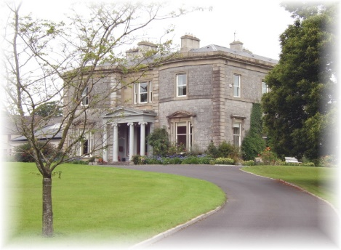
Mount St. Anne’s Retreat and Conference Centre,

Killenard, Portarlington, Co. Laois
057-8626153

Faith Development Co-ordinator

The main purpose of the Co-ordinator is twofold:
- To co-ordinate, plan and deliver, with occasional members of the team, retreats for school students ranging from pre-Confirmation to Leaving Certificate age.
- To assist in the further development of Mount St Anne’s Heart Aflame Visitor Centre and our broader interest in heritage/pilgrimage/spiritual tourism.

The person appointed will be a key member of the Mount St. Anne’s staff. The successful candidate will be interested and skilled in Catholic faith formation and faith development. A background in education will be an advantage. A background/interest in pilgrimage/spiritual tourism is desirable.

The appointment will be fulltime with necessary flexibility in hours/days worked. The salary will be in the region of €30,000 depending on experience.

To apply for this position, email or post the following:

- Your CV, including the names of 2 referees, one of whom must be your most recent employer.

- A letter outlining your interest in and suitability for the post to CEO
Programme Director at ceo.mountstannes@gmail.com or to the above address.

Closing Date: June 18th 2018

Interviews will be held at Mount St Anne’s on June 28th

