The Papal Flag

[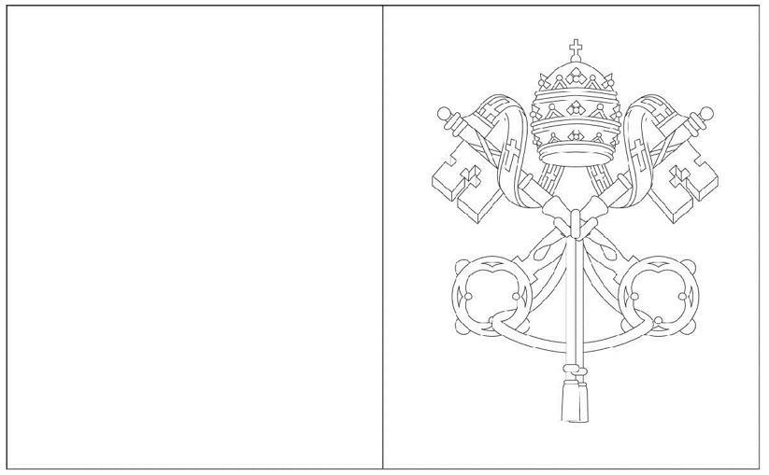](https://www.google.ie/url?sa=i&rct=j&q=&esrc=s&source=images&cd=&cad=rja&uact=8&ved=2ahUKEwjqi-K2l4LaAhVjDMAKHRMJC9wQjRx6BAgAEAU&url=https://search.aol.com/aol/imageDetails?q%3Dprayer%2Bflags%26imgty%3Dlinedrawing%26width%3D140%26s_it%3DimageDetails%26v_t%3Dwebmail-searchbox%26imgsz%3Dlarge%26fr2%3Dp:s,v:i&psig=AOvVaw2zO58dhDnHrpDh3E0sMHnr&ust=1521885308339383)