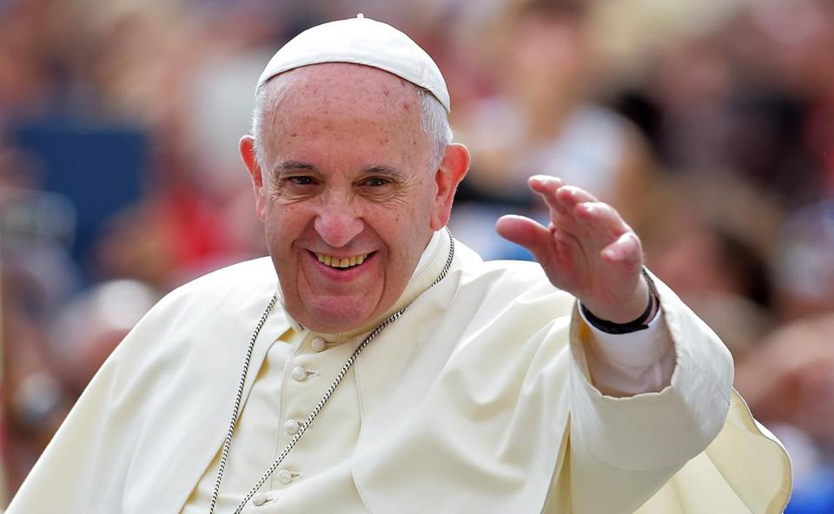
Why don’t you…

Colour in the Papal Flag in the Papal Colours.
Research the symbols on the Papal Flag.
Take note of when the Papal Flag is raised in the church in your parish or other parishes.
Decorate your school in preparation for visit of Pope Francis during the World Meeting of Families in August, 2018.
Register with your family for the World Meeting of Families.
Make plans to go to see Pope Francis with your family.

