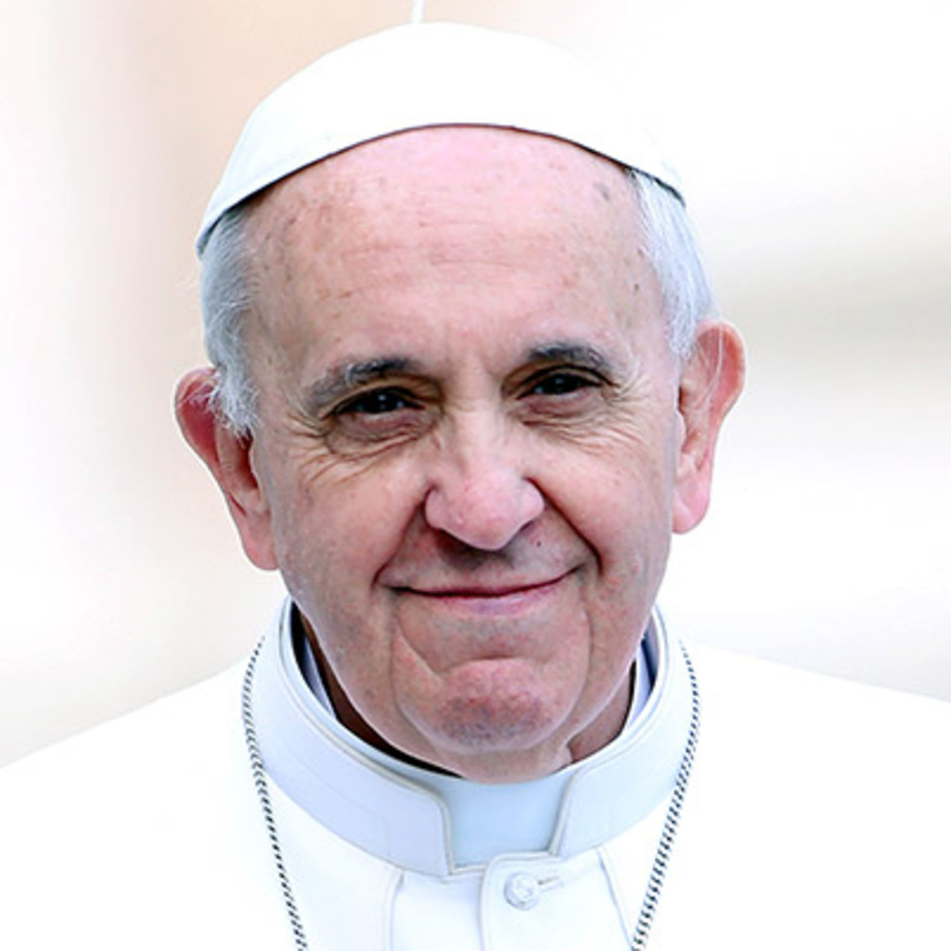

**Pope Francis**

**Dublin, Ireland**

**25-26 August 2018**