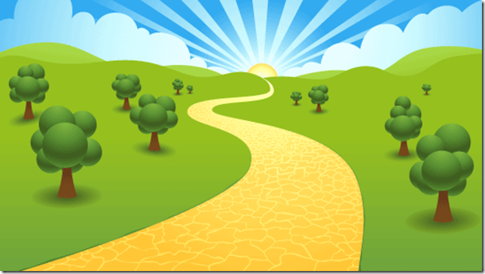
PLAN AND UNDERTAKE A LOCAL PILGRIMAGE (from Grow in Love, 4th Class,p.337)
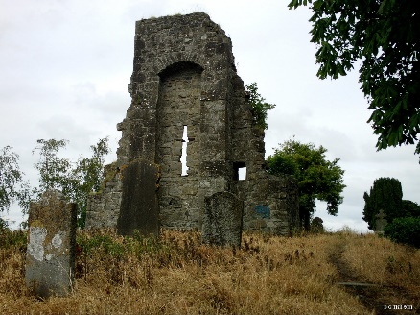 | Invite the children to identify local places of pilgrimage, such as a holy well, a mountain, a Celtic cross, a church or cathedral. Ask them to choose one of these places that they would like to visit and to research it in preparation for a class visit to the site.
Divide up the tasks. One group of children could work together to (1) find out about and record the history of their chosen pilgrimage site; (2) identify the person to whom it is dedicated and record a few facts about them; and (3) find and record any prayers or rituals associated with the  site. |  | 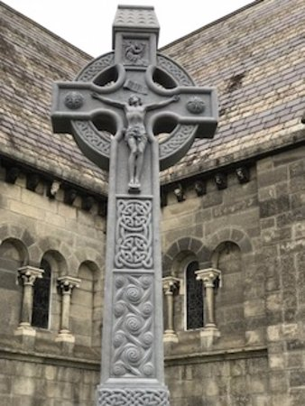
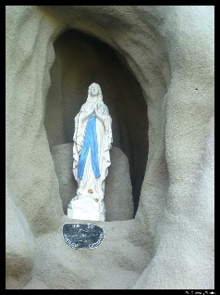 | Another group of children could compile a programme for the pilgrimage, while others could write a prayer to use during the pilgrimage
If possible, you might like to invite someone from the locality who is familiar with the site to join you and the children on a short pilgrimage. |  | 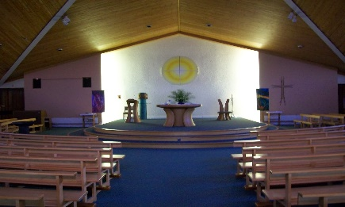
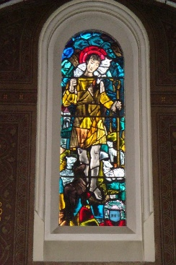 | Afterwards, have the children record their reflections about the pilgrimage, e.g. what they saw, the prayers they said, the people they met, what they thought about the experience, what they learned about why this place might have been chosen as a pilgrimage site, etc.

