The Sunday Message – Third Sunday of Easter – The Road to Emmaus
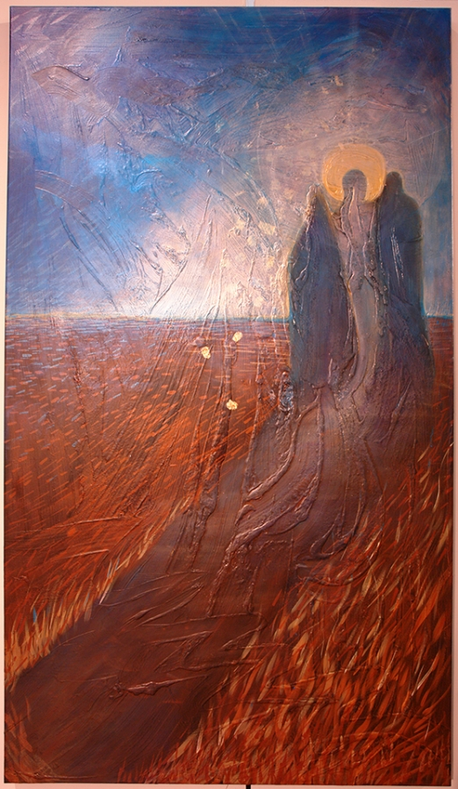
How can we encounter Jesus today?
Luke is writing his gospel for the second generation of Christians who did not know Jesus in his lifetime. He uses this beautiful and well-written narrative to address this question which applies just as much to ourselves as to the community of his time. The answer he gives is that we can encounter the Risen Lord, and we do this through the sacrament of the Eucharist.
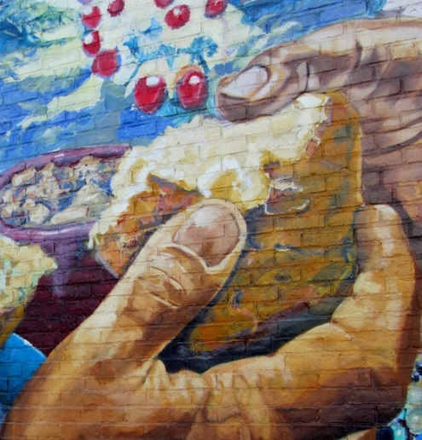
The two disciples, Cleopas and another who might be his wife, are walking away from Jerusalem. For Luke, Jerusalem is the focal point of redemption; it is the place where God’s plan will come to its fulfillment. But the Easter mystery is not yet complete: Pentecost has not occurred, the Spirit is yet to come. So the despondent pair are walking away from salvation. They are bewildered: they cannot make sense of what happened to Jesus, because they are aware of only part of the story. All they can give the mysterious stranger is an account of the facts. What the risen Jesus supplies is the key to Jesus’ passion and crucifixion – the will of God as expressed in the Jewish scriptures. Throughout the gospel there has been a constant theme that this had to happen: “Was it not ordained?” He asks them.
When they are at table, Jesus performs the Eucharistic action of taking bread, blessing God, breaking the bread and giving it to them. As he explained the scriptures to them they had begun to experience a burning feeling, perhaps of love, which culminated in their eyes being (figuratively) opened and they realise that they are in the presence of the risen Lord, that what the women had reported was really true. Nothing had changed except their perception of the person in front of them, but in that very sense everything had changed. They return rejoicing to Jerusalem and rejoin the others, who confirm their experience with word of the appearance to Simon, the leader of the disciples.
We should perhaps note that the final line of the story should read: “how he had made himself known to them in the breaking of bread”. In the bible, God or the risen Jesus make themselves known to people: human beings do not discover God.
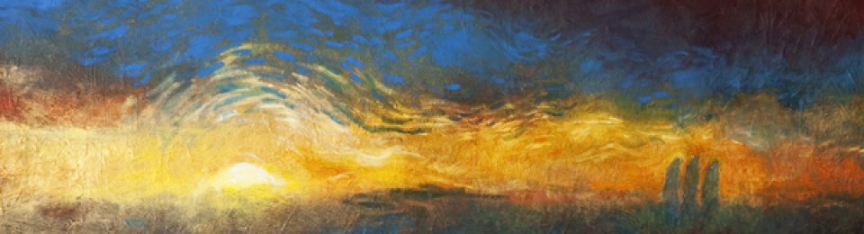
Reflect
Our ideas of Gospel scenes are often coloured by pictures we have looked at. Traditional visual presentations of the Emmaus episode show Jesus with two male disciples, but there is nothing in the original text to say that this must be the case. The remark about foolish men can just as well be rendered foolish people. One of the women mentioned at the crucifixion in John’s Gospel is Mary the wife of Clopas, so the suggestion of the two on the way to Emmaus being Cleopas and his wife is not impossible. In his Gospel, Luke has given a prominent place to women and mentioned them as companions of Jesus in his travels.
In the books of Acts (Ch 8), Luke gives a complementary story about the Ethiopian official, and there we find the same elements, the Jewish scriptures, the details about the suffering Jesus and a sacramental encounter, this time baptism. So how do we encounter the risen Lord today? In the sacraments. In the Mass we celebrate the liturgy of the Word and the liturgy of the Eucharist and when we come together the Lord is present among us. The lesson of Emmaus is that the Lord is present: we do not need to see him.

Commentary by Fr. Anthony Cassidy C.Ss.R.

