May the Beauty of God Surprise Us
May the beauty of God surprise us.
May the presence of God guide us.
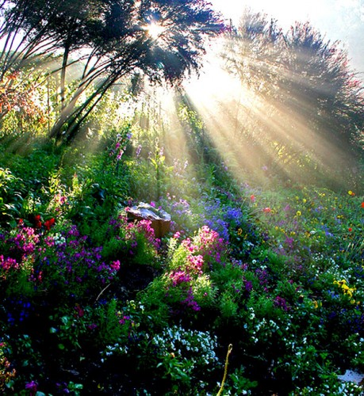
May the Word of God inspire us.
May the dream of God enfold us.
May the passion of God love us.
May the wisdom of God instruct us.
May the call of God invite us.
May the healing of God hold us.
May the wonder of God humble us.
May the love of God renew us.
May the compassion of God strengthen us.
May the forgiveness of God reconcile us.
May the mercy of God mould us.
May the friendship of God bless us.
May the truth of God challenge us.
May the peace of God surround us
And may we delight in ‘God-with-us’ (Emmanuel) always.
Amen.

