The meaning and importance for Christians of believing in the Holy Spirit

Learning outcomes

By the end of this lesson you should be able to:

• describe the meaning of term the Holy Spirit
• give your own opinion, with reasons, about the Holy Spirit
• explain why the belief in the Holy Spirit is important to Christians
• evaluate the importance of the belief in the Holy Spirit for Christians.

The meaning for Christians of believing in the Holy Spirit

Christians believe that the Holy Spirit is the third person of the Trinity. All
parts of the Trinity are equal as they are all one.This means that as God he is worshipped by Christians.

The Holy Spirit communicates with creation, showing God’s presence throughout the universe.

In the Old Testament, the Spirit of God is called ‘ruah’ which means breath i.e. a presence that is felt not seen.

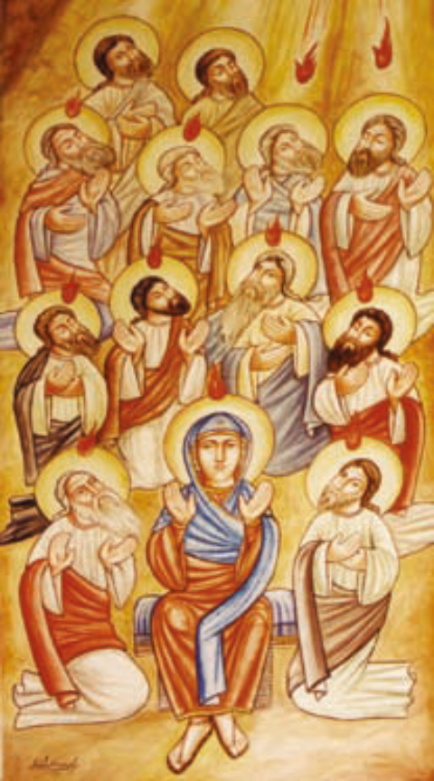
Christians believe that the Holy Spirit inspired the Bible writers and guided them in revealing the nature and purpose of God.

After the Resurrection, Jesus promised to stay with his followers. After Jesus ascended to Heaven the Holy Spirit continued to guide and inspire Christians

Christians believe that the Holy Spirit continues to guide the Church in the work of preserving the teachings of the Apostles, (Apostolic Tradition), and when developing new teachings.

It is through the power of the Spirit that all Christians are in communion with Christ through the sacraments.

Through the power of the Spirit God strengthens and empowers Christians today.

Look at the picture. What does this picture show?

The symbols of the Holy Spirit

These are some of the different symbols used to help Christians understand what the
Holy Spirit is like.
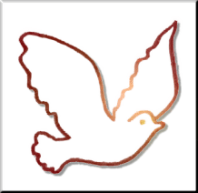
The Holy Spirit brings new life to people, in the same way as a dove descended from Heaven when Jesus was baptised.

The Holy Spirit brings peace, as the returning dove Noah sent from the Ark held an olive branch, showing that the flood had receded and God was once again at peace with the world.


Fire was used to show the presence of God. God spoke to Moses out of a burning bush.

It is a symbol of purifi cation. Metals were placed in a fi re to purify them. The Holy Spirit cleanses people of their sins.


We know that wind is there – we can feel it and see its effect on things, but cannot see it.

The symbol of wind is therefore used to describe God’s power and presence in the world.

Activity
1 Design a stained glass window for a church on the theme of the Holy Spirit.
Now explain either in writing, or to the rest of the group, how your window shows what the Holy Spirit means to Christians.
“As soon as Jesus was baptized, he went up out of the water. At that moment heaven was opened, and he saw the Spirit of God descending like a dove and alighting on him.”
Matthew 3:16
The Holy Spirit in the Bible

‘The Holy Spirit described as wind’ (John 3:8)
‘The baptism of Jesus’ (Luke 3:21–22)
‘The fruits of The Holy Spirit’ (Galatians 5:22–23)
‘The different gifts of the Holy Spirit’ (I Corinthians 12: 4–11)

Activity

- Fill in the information in the boxes on the next page in your exercise book – Title: ‘The work of the Holy Spirit’
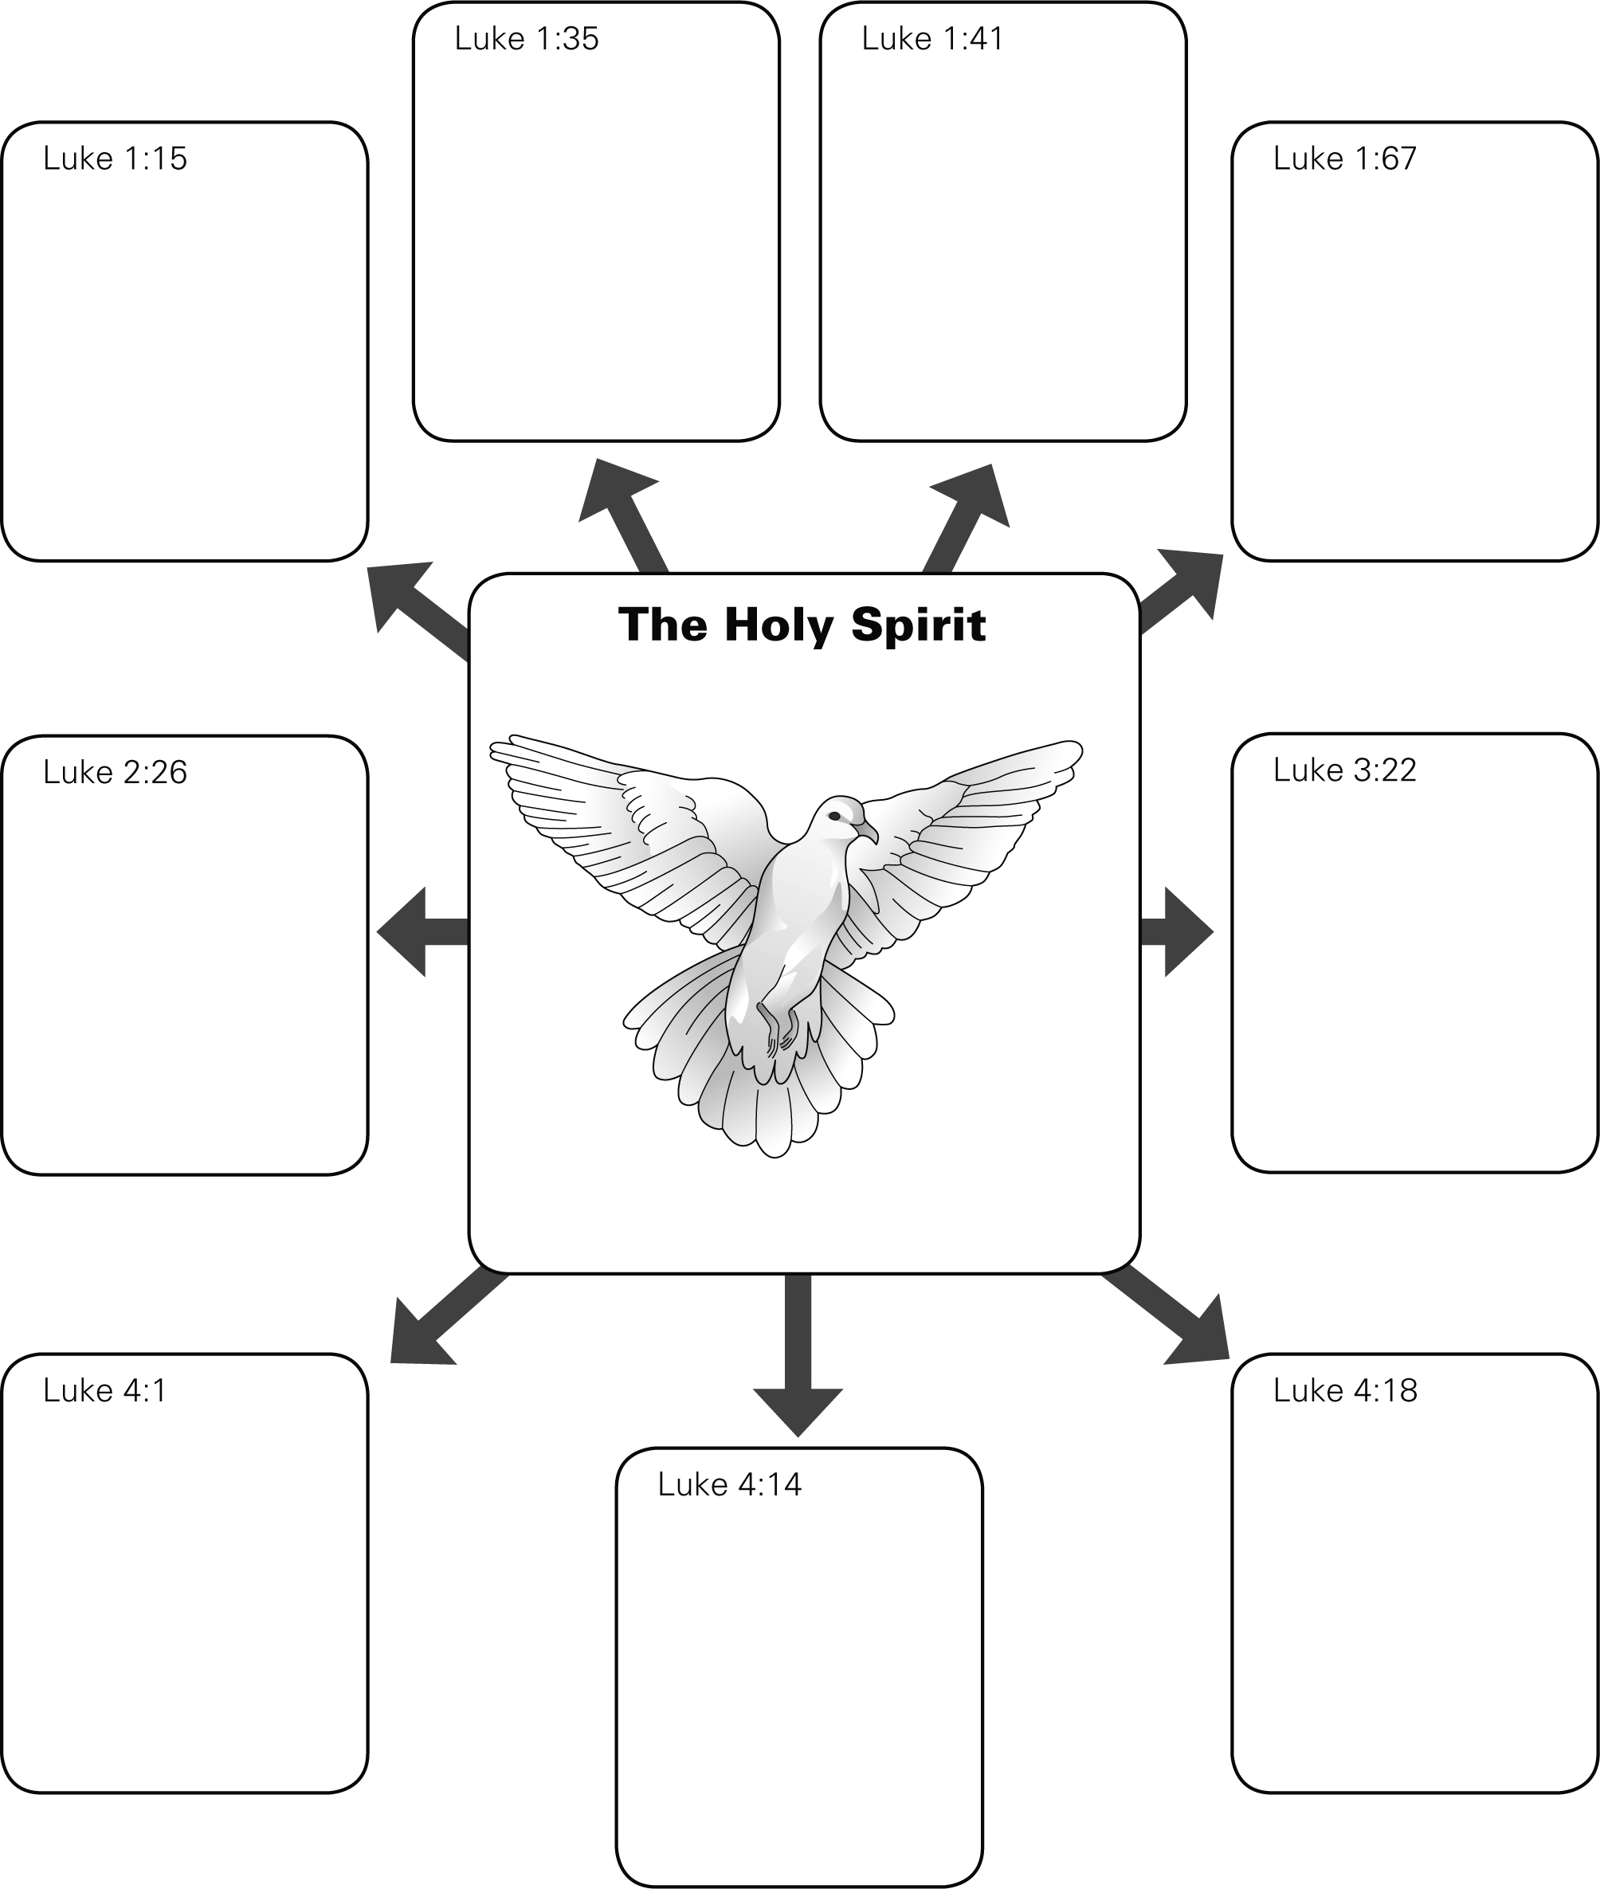

Why is the Holy Spirit important for Christians?
“All of them were filled with the Holy Spirit and began to speak in other tongues as the Spirit enabled them.
Acts 2:4
Christians believe that the Holy Spirit works to change us and make us better people. Through the sacraments of baptism and reconciliation, it purifies people from sin and so enables them to have a relationship with God and have eternal life.

The qualities we develop are called Fruits of the Spirit, such as love, kindness, faithfulness, and self-control.

The Holy Spirit gives people different gifts. All are different but equal, just as parts of the body each have a certain function, but depend on each other to work effectively.

It is through the Holy Spirit that God is with people today.

Christians see the Holy Spirit as the comforter, the guide, the counsellor and the inspirer. Therefore people are able to live their Christian vocations fully.

The Holy Spirit inspires the teachings of the Church. So Catholics believe that the Church is directly linked to God and therefore they must follow its teachings.

The Holy Spirit guides the Church in choosing its leaders, i.e. the election of the Pope.

The Holy Spirit today
In the Bible
Through prayer
In the lives of
people such as
Mother Teresa
Through the Church’s
Traditions and teachings
Through the
Sacraments such as
baptism
Some Christians believe that the Holy Spirit is received through healing and the ability to speak in tongues
How is the Holy Spirit found today?

Activities
For discussion
3 ‘The Holy Spirit is active in the world today’. Do you agree? Give reasons for your
opinion. Give reasons why some people might disagree with you.

4 Explain what it means for Christians to believe in the Holy Spirit.

