 |  | Statistics 2021 - 2022  Catholic Primary Schools |  |  |  | 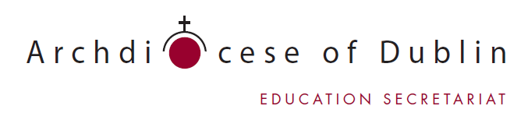
 | 1 |  |  | School Details
School name:

School address:

School roll number:

School e-mail address:

Principal email address:

Tel. No.: School website:

Parish:

 | 2 |  |  | School Category
Tick one box below.  Parochial  Convent / Monastery  Private |  |  |  |  | Tick one box below.  Infants  Junior (Inf. – 2nd)  Senior (2nd – 6th)  Senior (3rd – 6th)  All streams (Inf. – 6th) |  | Tick one box below.  Boys  Girls  Co-Ed.
Additional classes (e.g. special class / unit for children with autism). Please specify:
 | 3 |  |  | School Personnel

Chairperson of Board of Management:
Principal:
Deputy Principal:
R.E. Representative:
Chaplain’s name and address:

4 |  | Numbers

Number of pupils
Number of teachers (including principal)
Number of permanent classrooms in the school
Number used as classrooms
Number of classrooms used as Learning Support/Resource Rooms
Number of classrooms used for other school purposes. Please list purpose:
- __________________________________________
- __________________________________________
- __________________________________________
- __________________________________________

Number used for other than school use
Empty classrooms

Number of prefab classrooms in school use
Number used for other than school use

5 |  | School Day

Opening Time |  |  | Morning Break
Closing Time |  |  | Lunch Break

6 |  | Teacher and Class Details

Please submit a list to include:
- The names of all class teachers, the class level being taught and the number of pupils in each class.
- Names of SEN teachers, HSCL, Language Support teachers

Return this form with your list of teachers by 23rd October 2020 to
Beatrice Reilly by email to statistics@dublindiocese.ie

School: |  |  | Roll No.:
No. | Teacher/SNA | Class |  | No. of Pupils

Use additional pages if necessary.

