ECUMENICAL WORSHIP SERVICE

Week of Prayer for Christian Unity 2017

Order of Service

Reconciliation – The love of Christ compels us

(2 Corinthians 5:14-20)

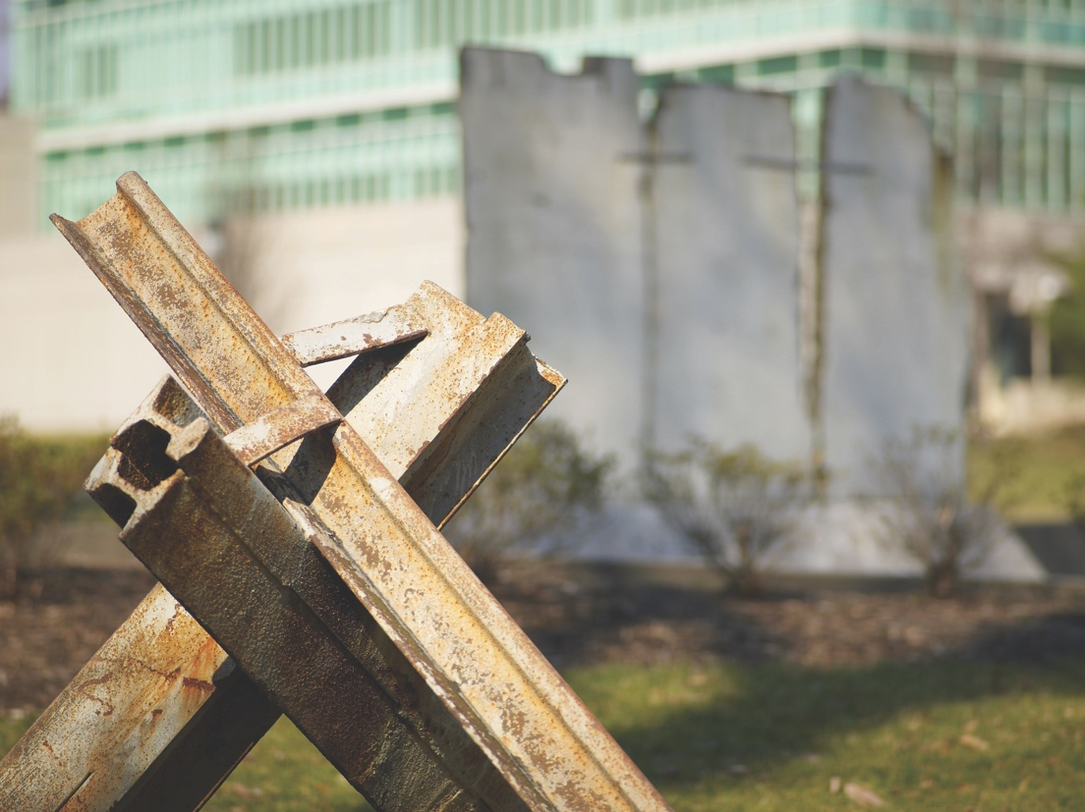

© Churches Together in Britain and Ireland
Photo: United States government work

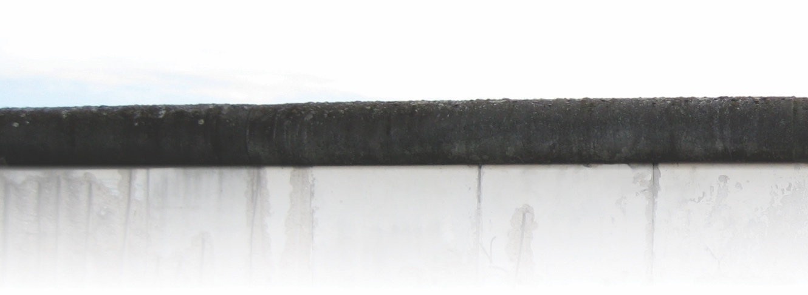

GATHERING

A hymn is sung while a Bible or Lectionary is brought forward in a procession.

Either

Leader In the name of the Father and of the Son and of the Holy Spirit.

All Amen.

Or

Leader In the name of God, Creator, Redeemer and Sustainer.

All Amen.

Leader Grace and peace to you from God, who has reconciled us to himself through Christ.
2
Crossing barriers

This year many Christians will be commemorating the anniversary of the Reformation in Germany. As Luther discovered himself reconciled to Christ by faith, we remember that God has reconciled us through Jesus Christ whose love compels us to be ministers
of reconciliation.

CONFESSING

Leader The Church always needs to grow closer to Jesus, for as we grow in
love for Jesus we grow in love for each other. But as we have sought
to do this we have instead grown apart and become divided. Mindful that Jesus himself prayed that we may all be one, that the world might believe, let us confess our sins and seek healing for the wounds we have inflicted on each other as a result of our division.

A period of silence follows.

We acknowledge before God that we have failed to be his living stones and have built walls of division.

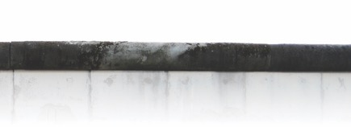

Before each of the following petitions a member of the congregation brings a stone forward, from different parts of the church to build a wall and makes the relevant plea for forgiveness.

Reader 1 This stone is ‘lack of love’.
Gracious God,
the love of Christ compels us to seek forgiveness for whenever we have failed to love.

Reader 2 This stone is ‘hate and contempt’.
Gracious God,
the love of Christ compels us to seek forgiveness for our hate and
contempt for one another.

Reader 3 This stone is ‘false accusation.’
Gracious God,
the love of Christ compels us to seek forgiveness for denouncing and falsely accusing one another.

A Kyrie or another short invocation is sung.

Reader 4 This stone is ‘discrimination’.
Gracious God,
the love of Christ compels us to seek forgiveness for all forms of
prejudice and discrimination against one another.

Reader 5 This stone is ‘persecution’.
Gracious God,
the love of Christ compels us to seek forgiveness for persecuting and torturing one another.

Reader 6 This stone is ‘broken communion’.
Gracious God,
the love of Christ compels us to seek forgiveness for perpetuating broken communion among our churches.
Week of Prayer for Christian Unity

3

A Kyrie or another short invocation is sung.
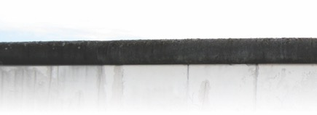

Reader 7 This stone is ‘intolerance’.
Crossing barriers

4
Gracious God,
the love of Christ compels us to seek forgiveness for acts of religious intolerance in history and today.

Reader 8 This stone is ‘religious wars and conflicts’.
Gracious God,
the love of Christ compels us to seek forgiveness for all wars and conflicts that we have waged against one another
in his name.

Reader 9 This stone is ‘division’.
Gracious God,
the love of Christ compels us to seek forgiveness for living our Christian lives divided from one another and astray from our common calling for the healing of all creation.

A Kyrie or another short invocation is sung.

Reader 10 This stone is ‘abuse of power’.
Gracious God,
the love of Christ compels us to seek forgiveness for our abuse
of power.

Reader 11 This stone is ‘isolation’.
Gracious God,
the love of Christ compels us to seek forgiveness for the times when we have isolated ourselves from our Christian sisters and brothers and from the communities in which we live.

Reader 12 This stone is ‘pride’.
Gracious God,
the love of Christ compels us to seek forgiveness for our pride.

All Lord, our God,
look upon this wall that we have built,
which separates us from you and from one another.
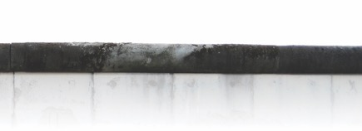

Forgive us our sins and heal us.
Help us to overcome all walls of division
and make us one in you. Amen.

The following words from Ezekiel and the Peace may be spoken here
or after the Readings and Sermon.

Leader May God give you a new heart and a new spirit
remove your heart of stone
give you a new heart of flesh
put a new Spirit within you
so that you may walk in God’s ways and love
God’s commandments.
(Based on Ezekiel 36:25-27)

THE PEACE

Leader Christ is our peace, he has made us one and has broken down in his flesh the dividing wall of hostility. (Eph. 2.14)

The peace of the Lord be with you always.

All And also with you.

A sign of peace is exchanged.

A hymn or song is sung or a piece of meditative music is played.

HEARING
Epistle
2 Corinthians 5:14-20

For the love of Christ urges us on, because we are convinced that one has died for all; therefore all have died. And he died for all, so that those who live might live no longer for themselves, but for him who died and was raised for them. From now on, therefore,
Week of Prayer for Christian Unity

5

we regard no one from a human point of view; even though we once knew Christ from a human point of view, we know him no longer in that way. So if anyone is in Christ, there is a new creation: everything old has passed away; see, everything has become new! All this is from God, who reconciled us to himself through Christ, and has given us the ministry of reconciliation; that is, in Christ God was reconciling the world to himself, not counting their trespasses against them, and entrusting the message of reconciliation to us. So we are ambassadors for Christ, since God is making his appeal through us; we entreat you on behalf of Christ, be reconciled to God.

Responsorial Psalm: 18:26-32 (may be sung)

I love you, Lord, my strength.

You are loving with those who love you:
but the cunning you outdo in cunning.
For you save a humble people
but humble the eyes that are proud. R./

You, O Lord, are my lamp,
my God who lightens my darkness.
With you I can break through any barrier,
with my God I can scale any wall. R./

As for God, his ways are perfect;
the word of the Lord, purest gold.
He indeed is the shield
of all who make him their refuge. R./

For who is God but the Lord?
Who is a rock but our God?
the God who girds me with strength
and makes the path safe before me. R./

Alleluia (sung)
Crossing barriers

6
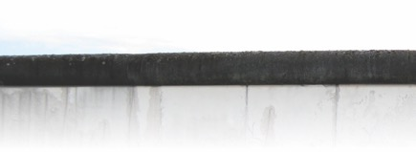
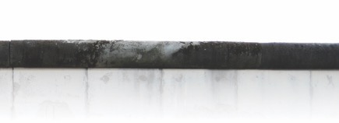
Gospel Reading
Luke 15:11-32

Jesus said, “There was a man who had two sons. The younger of them said to his father, ‘Father, give me the share of the property that will belong to me.’ So he divided his property between them. A few days later the younger son gathered all he had and travelled to a distant country, and there he squandered his property in dissolute living. When he had spent everything, a severe famine took place throughout that country, and he began to be in need. So he went and hired himself out to one of the citizens of that country, who sent him to his fields to feed the pigs. He would gladly have filled himself with the pods that the pigs were eating; and no one gave him anything. But when he came to himself he said, ‘How many of my father’s hired hands have bread enough and to spare, but here I am dying of hunger! I will get up and go to my father, and I will say to him, “Father, I have sinned against heaven and before you; I am no longer worthy to be called your son; treat me like one of your hired hands.” ’ So he set off and went to his father. But while he was still far off, his father saw him and was filled with compassion; he ran and put his arms around him and kissed him. Then the son said to him, ‘Father, I have sinned against heaven and before you; I am no longer worthy to be called your son. ’ But the father said to his slaves, ‘Quickly, bring out a robe—the best one—and put it on him; put a ring on his finger and sandals on his feet. And get the fatted calf and kill it, and let us eat and celebrate; for this son of mine was dead and is alive again; he was lost and is found!’ And they began to celebrate. Now his elder son was in the field; and when he came and approached the house, he heard music and dancing. He called one of the slaves and asked what was going on. He replied, ‘Your brother has come, and your father has killed the fatted calf, because he has got him back safe and sound.’ Then he became angry and refused to go in. His father came out and began to plead with him. But he answered his father, ‘Listen! For all these years I have been working like a slave for you, and I have never disobeyed your command; yet you have never given me even a young goat so that I might celebrate with my friends. But when this son of yours came back, who has devoured your property with prostitutes; you killed the fatted calf for him!’ Then the father said to him, ‘Son, you are always with me, and all that is mine is yours. But we had to celebrate and rejoice, because this brother of yours was dead and has come to life; he was lost and has been found.’”

Alleluia (sung)
Week of Prayer for Christian Unity

75

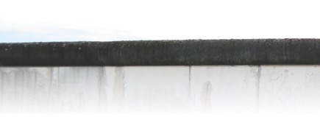
SERMON

CREED

We believe in one God,
the Father, the Almighty,
maker of heaven and earth,
of all that is, seen and unseen.
We believe in one Lord, Jesus Christ,
the only Son of God,
eternally begotten of the Father,
God from God, Light from Light,
true God from true God,
begotten, not made,
of one Being with the Father;
through him all things were made.
For us and for our salvation
he came down from heaven,
was incarnate of the Holy Spirit and the Virgin Mary
and became truly human.
For our sake he was crucified under Pontius Pilate;
he suffered death and was buried.
On the third day he rose again
in accordance with the Scriptures;
he ascended into heaven
and is seated at the right hand of the Father.
He will come again in glory to judge the living and the dead,
and his kingdom will have no end.
We believe in the Holy Spirit, the Lord, the giver of life,
who proceeds from the Father [and the Son],
Crossing barriers

8
who with the Father and the Son is worshiped and glorified,
who has spoken through the prophets.
We believe in one holy catholic and apostolic Church.
We acknowledge one baptism for the forgiveness of sins.
We look for the resurrection of the dead,
and the life of the world to come. Amen.

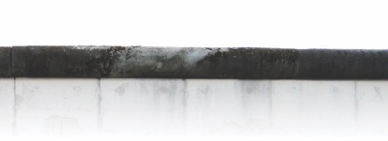

If the words from Ezekiel and the Peace were not used earlier, they should be included here.

Leader May God give you a new heart and a new spirit
remove your heart of stone
give you a new heart of flesh
put a new Spirit within you
so that you may walk in God’s ways and love God’s commandments.

(Based on Ezekiel 36:25-27)

THE PEACE

Leader Christ is our peace, he has made us one and has broken down in his flesh the dividing wall of hostility. (Eph. 2.14)

The peace of the Lord be with you always.

All And also with you.

A sign of peace is exchanged.

RESPONDING

Leader All that divides us from God died with Christ on the cross.
As we are again one with him, we commit ourselves,
in the power of his Spirit,
to break down our divisions and become one with each other,
so that Christ’s name be glorified, the kingdom come and God’s
will be done.

A song of reconciliation or hymn of the glory of the cross while the wall is dismantled and formed in the shape of a cross.

INTERCESSORY PRAYERS

After each petition, a person lights a candle from a central source of light (for example a Paschal candle). Remain standing around the cross.
Week of Prayer for Christian Unity

95
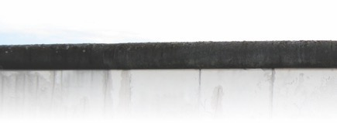

Reader 1 Almighty God,
you sent your son Jesus Christ to reconcile the world to yourself.
We praise you because through your Gospel,
in all parts of the earth a community of love has been
gathered together,
and that in every place your servants call upon your name.
May your Spirit awaken in every community a hunger and
thirst for unity.

Lord, in your mercy,

All Hear our prayer (Spoken/Sung response)

Reader 2 Gracious God,
we pray for our churches. Fill them with all truth and peace.
Where faith is corrupt, purify it;
where people go astray, redirect them;
where they fail to proclaim your Gospel, reform them;
where they witness to what is right, strengthen them;
where they are in need, provide for them;
and where they are divided, reunite them.

Lord, in your mercy,

All Hear our prayer (Spoken/Sung response)

Reader 3 Creator God,
you made us in your own image and redeemed us through Jesus Christ your Son.
Look with compassion on the whole human family;
take away the arrogance and hatred that infect our hearts;
break down the walls that separate us, and unite us in bonds of love.
Even through our weaknesses, work to accomplish your purposes
on earth,
so that every people and nation may serve you in harmony around your heavenly throne.

Lord, in your mercy,
Crossing barriers

10

All Hear our prayer (Spoken/Sung response)

Reader 4 Holy Spirit, Giver of Life,
we are created to become whole in you
and to share this life on earth with our brothers and sisters.
Awaken in each of us your compassion and love.
Give us strength and courage to work for justice in
our neighbourhoods,
to create peace within our families,
to comfort the sick and the dying,
and to share all we have with those who are in need.
For the transformation of every human heart, we pray:

Lord, in your mercy,

All Hear our prayer (Spoken/Sung response)

THE LORD´S PRAYER

The Lord’s Prayer is said or sung in the form most appropriate to your context.

SENDING

A Hymn is sung

The assistants spread the candlelight throughout the congregation until each person has a lighted candle.

Leader Jesus is the light of the world, a light that darkness cannot overcome.
Carry his light into the world, into the dark places where fighting, discord and division impede our united witness.
May Christ´s light effect reconciliation in our thoughts, words
and deeds.

Week of Prayer for Christian Unity

115

BLESSING

Leader We call out to you, most merciful God:
Bless and encourage all those who seek reconciliation
so they may know and proclaim your mighty deeds of love.
We ask this in the name of Jesus Christ, your son, our Lord.

All Amen

Either

Leader May the blessing of Almighty God,
the Father, and the Son, and the Holy Spirit
be upon you and remain with you always.

All Amen

Or

Leader May the blessing of Almighty God,
Creator, Redeemer and Sustainer
be upon you and remain with you always.

All Amen

Leader Go in Peace to love and serve the Lord.

All Thanks be to God.

An organ voluntary or other suitable music is played, during which a retiring collection is taken.

Bible verses from the New Revised Standard Version Bible: Anglicized Edition, copyright 1989, 1995, Division of Christian Education of the National Council of the Churches of Christ in the United States of America. Used by permission.
Crossing barriers

12
All rights reserved.
Berlin wall: Jeff Keyzer (www.flickr.com/photos/mightyohm/3860393026/)

