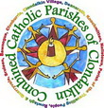
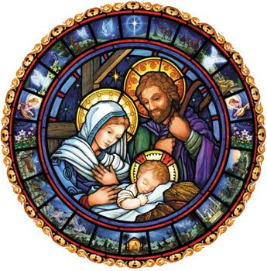
A Prayerful, Magical & Joyful Family Advent & Christmas
Ideas this Advent for Families

Dear Parents,
During the 4 weeks just before Christmas, Catholics traditionally celebrate Advent, the season of waiting for the birth of Jesus. Even though shops are already filled with Christmas decorations and music, this is a time we hold back a little, so that our celebration of the true Christmas Season, which begins December 24th and lasts until the Baptism of the Lord on the Sunday after Epiphany (6th Jan), can be more beautiful and meaningful.

Advent can be a time to build magical memories for our children, even without Christmas parties, decorations and lights because it has its own beautiful symbols and traditions. Here are some ideas for how you can establish lasting family traditions and spiritual practices related to Advent and Christmas. Don’t feel like you have to do them all – and do bring your own!!

- SHOP MORE MINDFULLY – Focus your gift shopping on the people, not the things, and try not to get caught up in the rush to make things “perfect.” Take time to enjoy the season and savour the preparations. Encourage your children to put aside at least a small amount of your gift spending for items to be donated to the poor. Above all, try to see Advent as a special time to prepare for Christmas, not to celebrate it - yet.
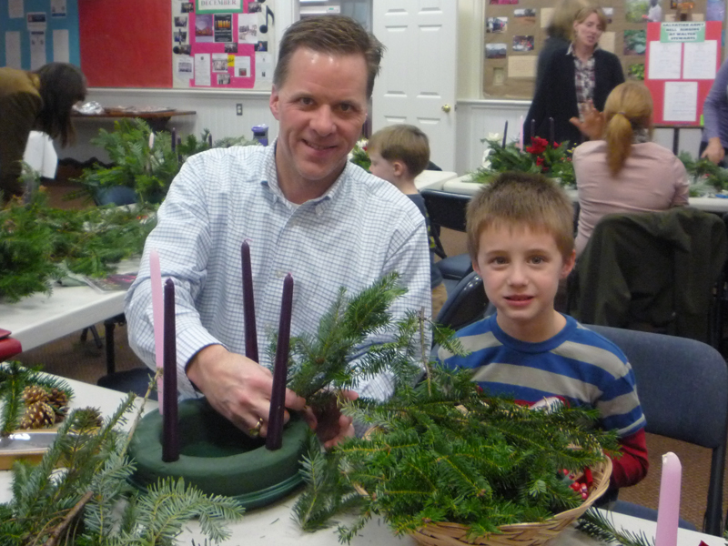
- ADVENT WREATH –Purchase or make (http://www.instructables.com/id/Make-an-Advent-Wreath-for-Your-Family/) a simple evergreen wreath and four candles, traditionally three purple and one pink (lit on the third week) or, you can use four white or four purple candles. Decorate the wreath with purple and blue ribbons or small ornaments. Stars are especially good. Place it in the middle of your table. Beginning on the Saturday night before the First Sunday of Advent, dim the lights and light the first purple candle, using the prayer “Lord our God, we praise you for your Son, Jesus Christ: he is Emmanuel, the hope of the peoples, he is the wisdom that teaches and guides us, he is the Saviour of every nation. Lord God, let your blessing come upon our family as we light the candles of this wreath. May the wreath and its light be a sign of Christ’s promise to bring us peace, hope, joy & love and may we be examples of His peace, hope, joy & love to all that we meet this Advent. Lord come among us; bring your light quickly, do not delay. We ask this through Christ our Lord. Amen.”
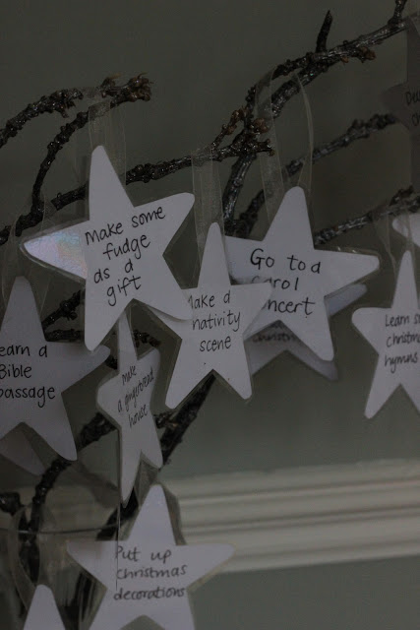
Then during Advent, light that candle every evening at dinnertime, adding another candle each Saturday night until all four are lit. Be sure to eat by candlelight. Your children will love this because it makes Advent meals special. Older children can take turns lighting the candles. Pray around the wreath each night for the needs of your family, neighbourhood and the world before blessing your food.
- ADVENT IMAGINATION/ACTIVITY TREE - First sit down and talk about Christmas and what you would all like to do as a family and individually. Some may be very keen to mention hot chocolate, sweets, cakes and presents (no surprise!). You may want to make sure to include parish services, singing carols and learning Bible passages together, to keep the Biblical & preparatory focus. You may also want to include old fashioned traditions and lots of crafting and baking. Between you, you will come up with lots of ideas, but choose 24 & do- one for each day of December! Make 24 star shapes and write one of your ideas on each. To do this you could draw around a star shape cookie cutter onto white card, cut them out (if you have time you could laminate them!) and stick a loop of ribbon on the back of each one with sticky tape! Paint a tree branch with a tiny bit of silver glitter paint and hang the activity stars onto it & be ready to choose one for each day in December.
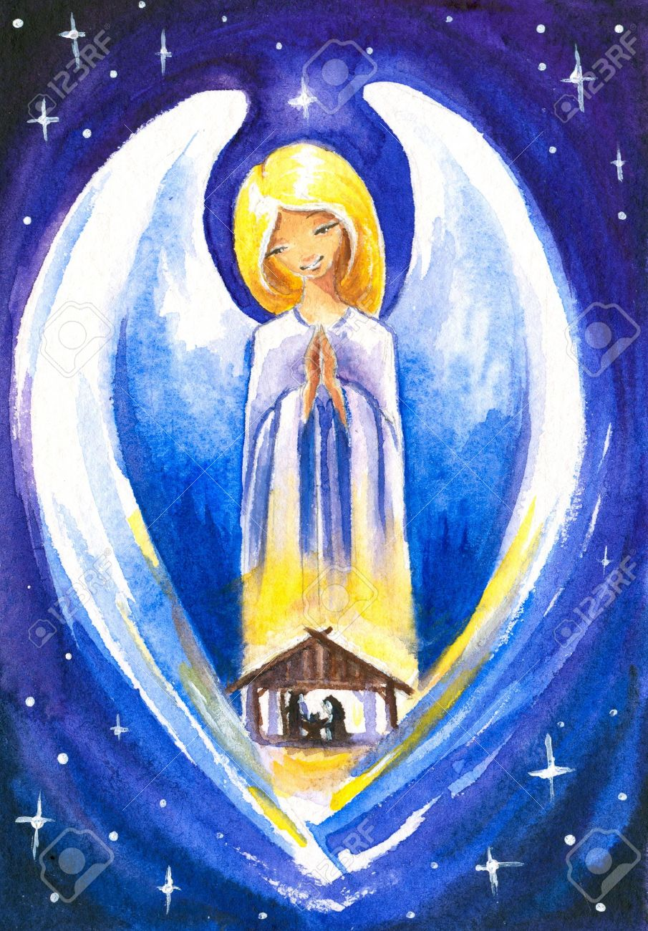
- JOURNEY TO BETHLEHEM –Sometime in the early weeks of December, set up your family Nativity scene, but start with just the empty stable with the empty manger in it. Put the figures of Mary, Joseph and the donkey on the other side of the room, and move them closer to the stable each evening, having them “arrive” just before Christmas Eve. Children can take turns moving the figures. If you use real straw in your stable, you can have each child add a stick of straw every day as well. (Some families encourage that each straw might represent each good deed done.) On Christmas Eve, as the sun goes down, add the baby Jesus figure to the manger, then the angels and shepherds. Be sure not to add the Three Kings just yet – they are still on their way!!
- ST. NICHOLAS, ST. LUCY – Celebrate the Advent Saints. On the night of December 5th have your children leave one shoe outside their bedroom door. After they are asleep, the shoes will be filled with small treats for them to find in the morning – little gifts from St. Nicholas. For December 13th, make a crown-shaped coffee cake or traditional cat-shaped buns to celebrate St. Lucy and her martyrdom. More suggestions here: http://www.wikihow.com/Celebrate-St.-Lucia-Day
- Go to Mass on the FEAST OF THE IMMACULATE CONCEPTION, December 8. It’s a holy day of obligation and it always falls during Advent. Make sure your children understand what this Feast day means – This little colouring sheet may help - http://www.catholicicing.com/explain-immaculate-conception-to-kids/
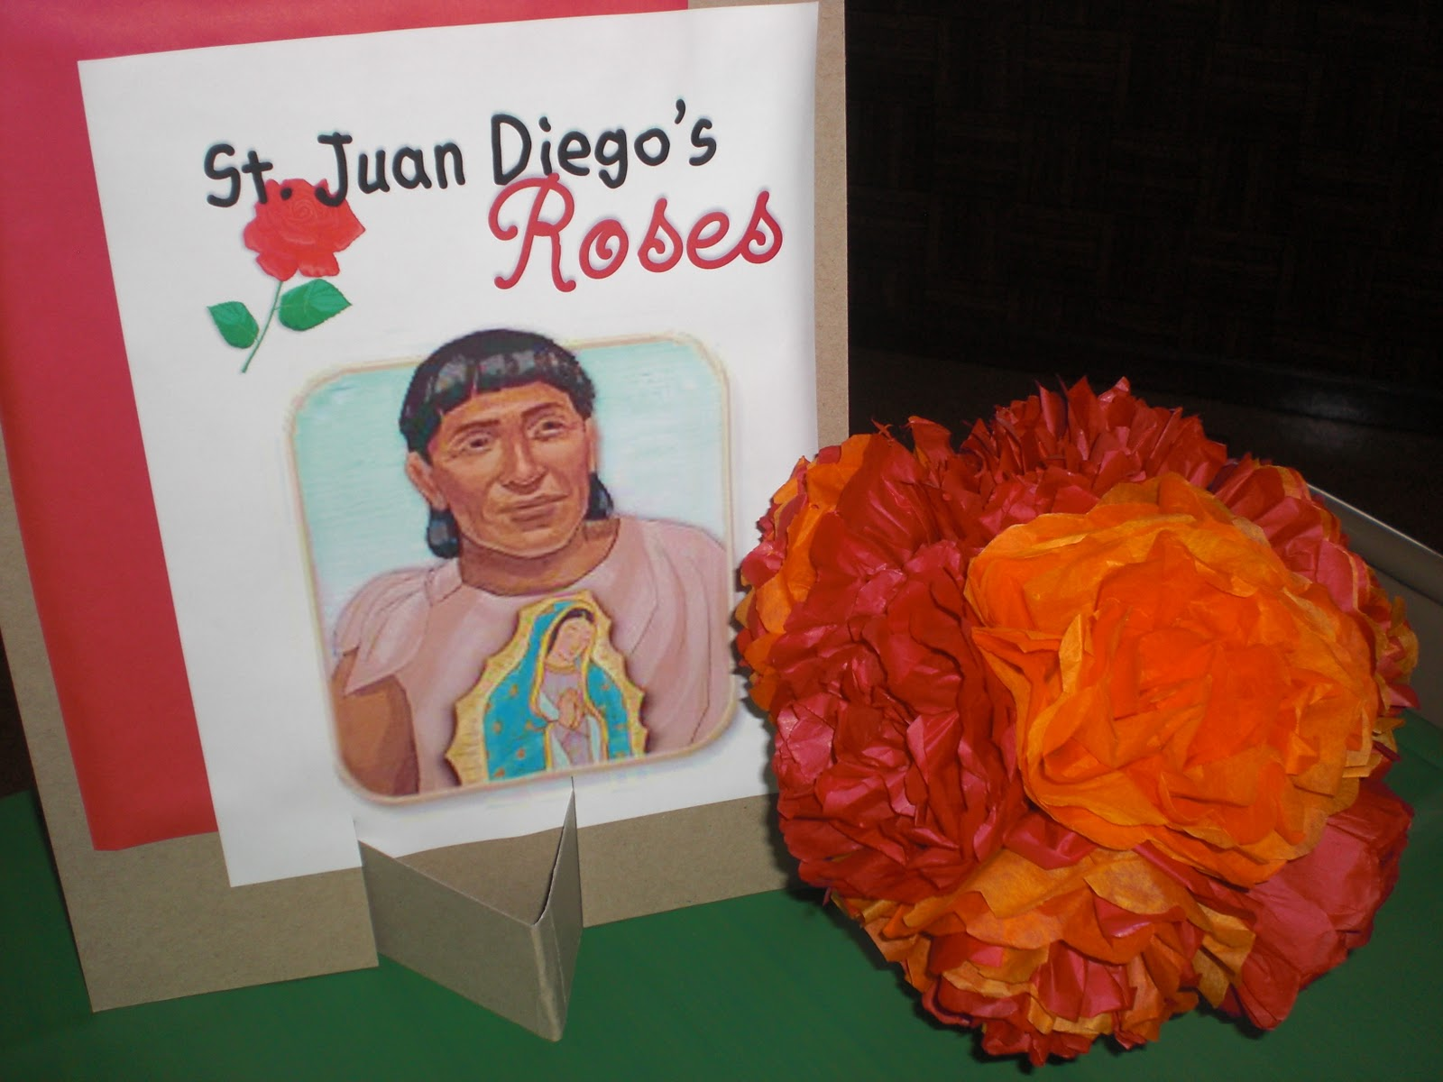
- Celebrate the feast of OUR LADY OF GUADALUPE (Dec 12) or ST JUAN DIEGO (Dec 9) by eating Mexican food for dinner. There are lots of ways to celebrate these days (http://www.catholicicing.com/juan-diego-and-our-lady-of-guadalupe/ ), but you have to cook dinner anyway, right? May as well be enchiladas! If you have a statue of our Lady of Guadalupe, set her on the table as a centrepiece.
- JESSE TREE CRAFTS –If you and your children love hands-on crafts, a simple Jesse Tree, celebrating the important ancestors of Jesus, is a great idea to make Advent special. There are many patterns for ornaments on the internet. You can find some of them here: https://www.pinterest.com/jdonliturgy/advent-resources-crafts-for-classrooms-families/ or www.myjessetree.com
- Watch a few FAMILY CHRISTMAS MOVIES together that show the message of Christmas. There are loads of great films - Franco Zeffirelli’s Jesus of Nazareth, The Greatest Story Ever Told, The classic “Peanuts” special “A Charlie Brown Christmas”, It’s a Wonderful Life, A Muppet Christmas Carol, The Santa Clause, How the Grinch Stole Christmas, … And many more
- MAKE YOUR CHRISTMAS TREE LIGHTING SPECIAL –Wait at least a little bit into December before putting up your tree –and consider putting it up in stages. After all, if you celebrate Christmas as it is intended, you will have at least 12 days after to keep the tree up, so there is plenty of time to enjoy it. First, just put up the tree, maybe a night or two later, add the lights (but don’t turn on yet). Next, add the ornaments. When the tree is complete and your family has time to be together, light the tree and use The Blessing of a Christmas Tree prayer – “Loving God, bless our Christmas tree, this sign of life and freshness and perseverance in our home. It stands as a reminder that you are born anew in us each day. Bless our family and friends as we celebrate this joyous season. Keep us safe in our travels, kind in our conversations, and gracious in our giving and receiving. We ask you this in confidence, because we know you love us. Amen”
- SING ADVENT SONGS – Hold the Christmas music until later in the month. If your family loves carols, try listening to or singing traditional Advent songs: “Creator of the Stars of Night,” “O Come, O Come Emmanuel” (especially beginning December 17th), “People Look East,” “O Come, Divine Messiah,” and “Soon and Very Soon” are some great choices – Have look at http://catholic-resources.org/Lectionary/Seasons-Advent-Christmas.htm for more suggestions
- JOURNEY OF THE THREE KINGS – On Christmas Eve, after the star has appeared over the stable, the Three Kings can begin their journey to meet baby Jesus. Place them across the room, toward the east side of your Nativity scene and move them closer each day, having them arrive on Epiphany (traditionally January 6th). As with the Holy Family, children can take turns moving the figures each evening until the Kings arrive.
- TAKING DOWN THE TREE AND DECORATIONS – Many families do this after Epiphany is celebrated in church, or wait until the next Sunday, the Baptism of the Lord. In some European traditions, the tree remains until “Little Christmas” on February 2 (Candlemas Day) No matter which date you choose, make this a special family time – with everyone helping as they are able. Play the last of the Christmas music – and be sure to serve hot chocolate and cookies afterwards and share the best memories of the season you have just celebrated together!!

There are loads of other activities & ideas for your children & families eg: http://looktohimandberadiant.blogspot.ie/2012_11_01_archive.html

Wishing you and your family a beautiful Advent and Christmas season!
Blessings from all in the Combined Catholic Parishes of Clondalkin

