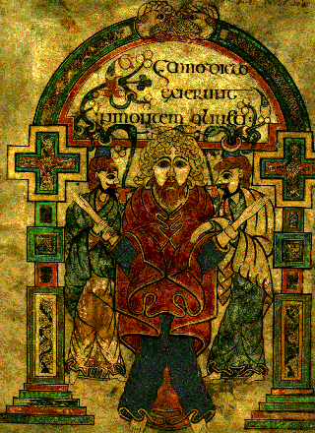
The Shield of
St. Patrick
Attributed to St. Patrick
Paraphrased by
Cecil Frances Alexander

I bind unto myself today the strong name of the Trinity, by invocation of the same, the Three in One, the One in Three.

I bind this day to me forever by power of faith Christ's incarnation, his baptism in the Jordan River, his death on the cross for my salvation; his bursting from the spiced tomb, his rising up the heavenly way, his coming at the day of doom I bind unto myself today.

I bind unto myself today the power of God to hold and lead, His eye to watch, His might to stay, His ear to harken to my need, the wisdom of my God to teach, His hand to guide, His shield to ward, the Word of God to give me speech, His heavenly host to be my guard.
Christ be with me, Christ within me,
Christ behind me, Christ before me,
Christ beside me, Christ to win me;
Christ to comfort and restore me;
Christ beneath me, Christ above me,
Christ in quiet, Christ in danger,
Christ in hearts of all that love me,
Christ in mouth of friend and stranger.

I bind unto myself the name, the strong name of the Trinity, by invocation of the same, the Three in One, and One in Three,
of whom all nature hath creation, eternal Father, Spirit, Word; praise to the God of my salvation, salvation is of Christ the Lord!
