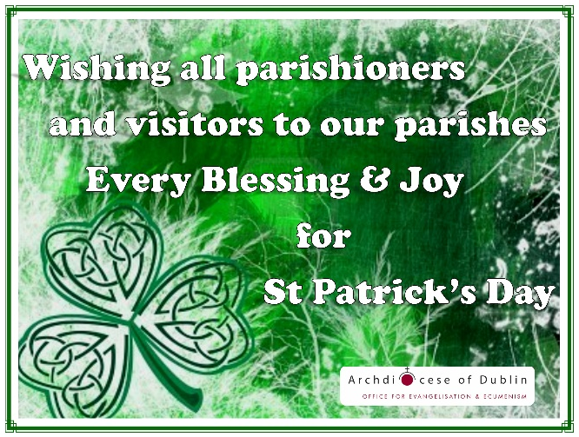
St. Patrick
A Brief History
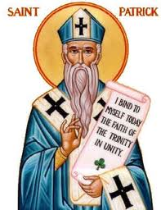
The colour green, a shamrock, St. Patrick’s Day parades? All of these things have become associated with our celebration of St. Patrick’s Day every March… But why?

One of Christianity’s best known figures – Saint Patrick – was born in Britain to a wealthy family near the end of the fourth century. At the age of sixteen, Patrick was taken prisoner by a group of Irish raiders. He was carried away to Ireland where he was held captive for more than six years. During his time as a slave, Patrick worked as a shepherd, attending the flocks of his master. Alone and homesick, Patrick prayed many times a day while in the pastures with the sheep.

In Patrick’s work, “Confessio”, he wrote, “the love of God and His fear increased in me more and more, and the faith grew in me, and the spirit was aroused, so that, in a single day, I have said as many as a hundred prayers, and in the night nearly the same, so that whilst in the woods and on the mountain, even before the dawn, I was roused to prayer and felt no hurt from it, whether there was snow or ice or rain; nor was there any slothfulness in me such as I see now, because the spirit was then fervent within me.”

While a slave in Ireland, Patrick learned the Celtic language and became familiar with the culture. After six years of living as a slave, he escaped from his master and set sail on a ship to Britain. Patrick was reunited with friends and family. However, things were different for Patrick when he returned. Patrick had a new desire in his heart and that was to devote himself to the service of God.

Patrick joined St. Martin’s monastery at Tours, learning the Christian life, which would help prepare him for his future ministry amongst the Irish. After years of learning and growing in faith, Patrick and his companions set sail to Ireland in the summer months of 433. Upon his arrival, Patrick went to his former master to pay the price of ransom as well as to impart to him the blessings of God but by the time he had arrived, his master had set fire to his own mansion and treasures, even casting himself upon the flame.

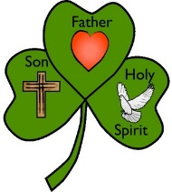
Patrick evangelized in Ireland for many years. It wasn’t easy as St. Patrick endured trials and persecutions from those who opposed the Christian faith. In his “Confessio”, he tells of the numerous times he and his missionary companions were captured. But through these hardships, St. Patrick prevailed and remained steadfast in the faith, sharing the Gospel throughout Ireland.

St. Patrick used the shamrock, a three-leaf clover, to explain the difficult understanding of the Holy Trinity to the pre-Christian Irish. To this day, the shamrock is a well-known symbol of Ireland.

St. Patrick founded many churches in Ireland and continued looking after them until his death on March 17, 493. Every year, on March 17, millions of people celebrate this annual feast day that celebrates St. Patrick, a patron of Ireland. In Ireland, March 17 is a national holiday as they remember the life and work of Saint Patrick.

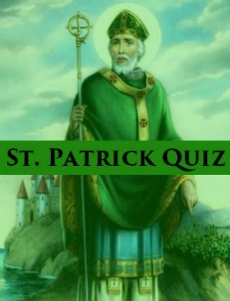
1. Where was St. Patrick born?

2. What significant event happened to St. Patrick when he was 16?

3. As a slave, what was St. Patrick’s job?

4. While in Ireland, what language did St. Patrick learn?

5. While alone in the fields tending to the sheep, what did St. Patrick do frequently?

6. After returning to his family, what new desire did St. Patrick have?

7. In what year did St. Patrick and his companions travel to Ireland as Missionaries?

8. What happened when St. Patrick tried to return to his former slave owner?

9. What did St. Patrick use the shamrock for?

10. What did St. Patrick establish in Ireland?

11. On what day is St. Patrick’s Day celebrated each year?

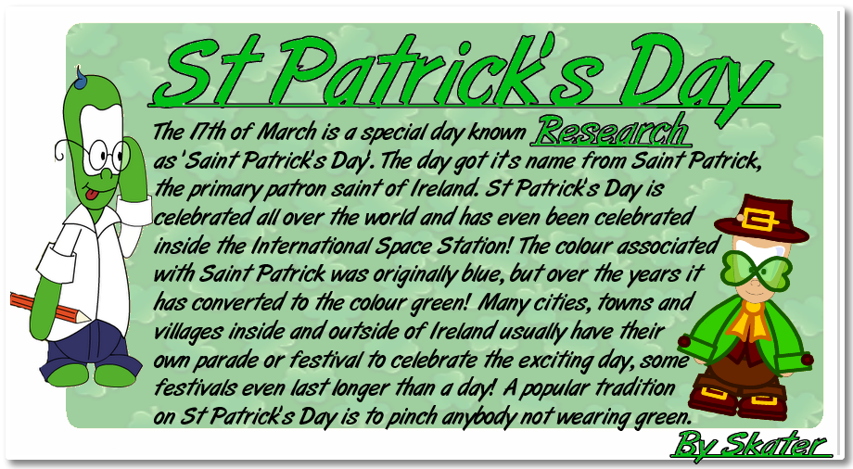
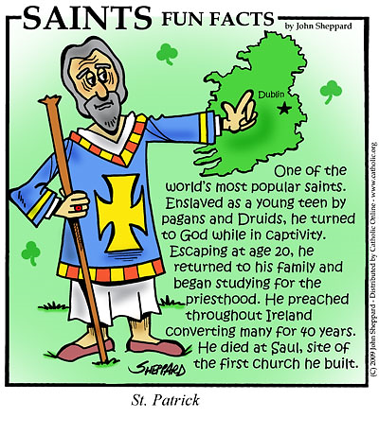

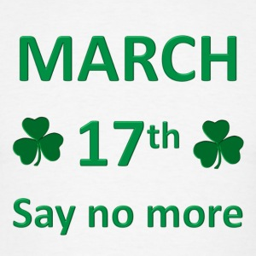
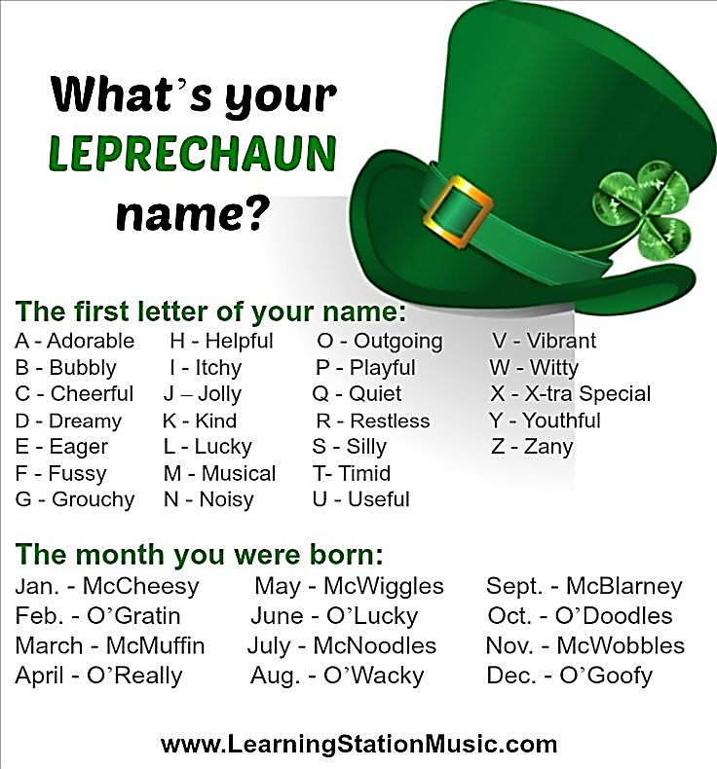
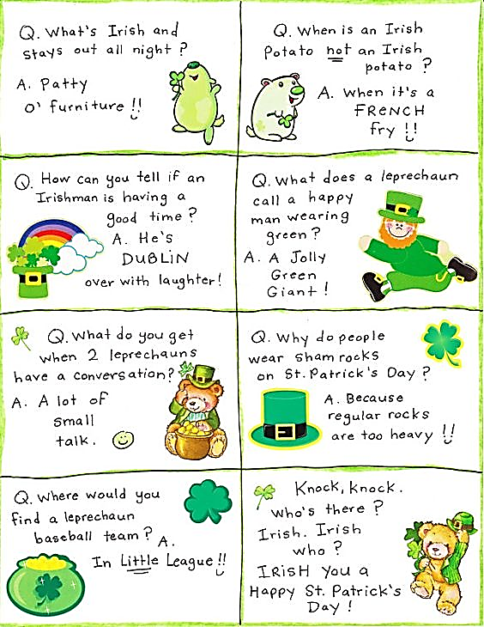
Some Irish Humour
- Saint Patrick’s real name is Maewyn Succat. Try saying that five times, fast! After becoming a priest, Maewyn adopted the name “Patrick” which means “well-born” in Latin. If you really want to test the breadth of your friends’ knowledge, wish them a “Happy Maewyn Succat Day” and wait for their response. If they give you a high five, you know you’re both equally as informed!
- The first Saint Patrick’s Day parade was not in Ireland, but in Boston. - If there’s one thing you should know about Boston,USA, it’s that everyone will claim that they are part Irish at some point or another, even if they’re not. No one knows why Bostonians and the Irish have such a strong emotional bond. Maybe it’s the mass of people that immigrated there after the Great Potato Famine. It’s important to note that Bostonians claim to have hosted the first St. Paddy’s Day Parade, long before the Irish realized that that was their job.
- Chicago dyes their main river green to celebrate the holiday. Using a mixture of vegetable dye and other compounds, the city of Chicago dyes their main river green every year to commemorate the Irish holiday.
- There are 10,000 three-leaf clovers for every 4-leaf clover. The luck of finding a four-leaf clover is not exaggerated. Next time you find one (if you find one), spray it with hair-spray, stick it in a laminated folder and frame it on your wall with the caption “Thank
God” beneath it because you may never find
another one in your entire life!!

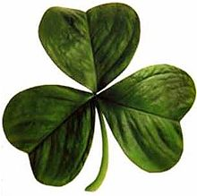
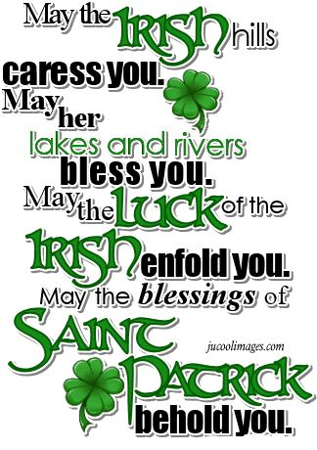
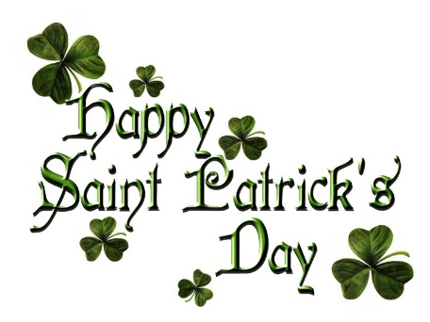
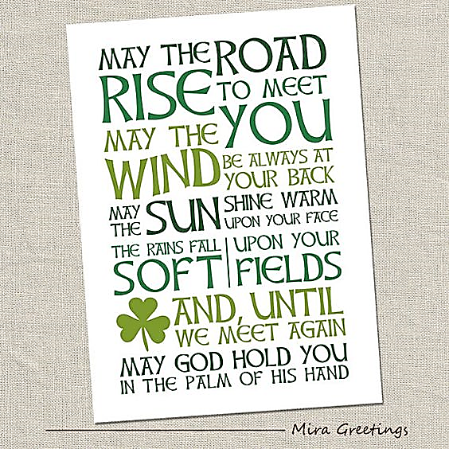
Prayers, Blessing s & Sayings for S t Patrick’s Day
The Shield of St. Patrick
Attributed to St. Patrick

I bind unto myself today the strong name of the Trinity, by invocation of the same, the Three in One, the One in Three.

I bind unto myself today the power of God to hold and lead, His eye to watch, His might to stay, His ear to harken to my need, the wisdom of my God to teach, His hand to guide, His shield to ward, the Word of God to give me speech, His heavenly host to be my guard.

Christ be with me, Christ within me,
Christ behind me, Christ before me,
Christ beside me, Christ to win me;
Christ to comfort and restore me;
Christ beneath me, Christ above me,
Christ in quiet, Christ in danger,
Christ in hearts of all that love me,
Christ in mouth of friend and stranger.

I bind unto myself the name, the strong name of the Trinity, by invocation of the same, the Three in One, and One in Three, of whom all nature hath creation, eternal Father, Spirit, Word; praise to the God of my salvation, salvation is of Christ the Lord!

