Useful Websites for the R.E. Classroom
- www.visuwords.com
The blurb on the website reads: Not your grandad’s dictionary; a modern dictionary for a modern world. Visuwords represents language visually.

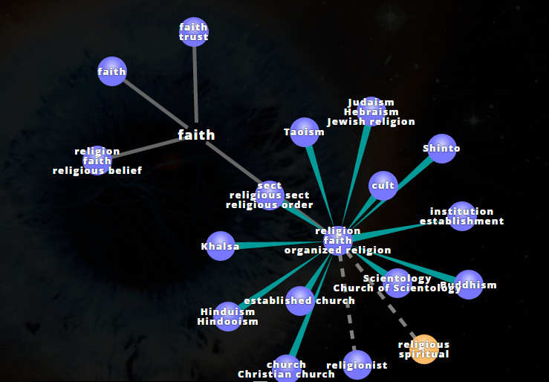

- www.instagrok.com
Instagrok is a search engine, created specifically for use in the classroom with students; only educational, safe and age appropriate material will be retrieved when a key word or phrase is searched. Perfect for use with students when completing research for projects, etc.
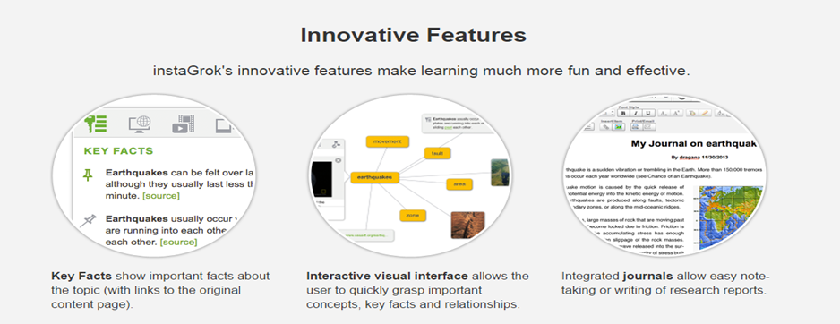
- www.bibledex.com
Bibledex.com offers students a modern way of exploring our ancient sacred text. Each book of the Bible is presented as a short YouTube clip where a scripture expert relates the story in narrative form. It would be ideal for use with students as an introduction to the synoptic gospels or for Senior students take a look at:
The Book of Tobit: http://www.bibledex.com/videos/tobit.html. This Bible story holds a wealth of potential when exploring:

- Life, Family, Faith in God
- Coping with challenges
- Material Possessions vs Values/Beliefs

- www.padlet.com & www.poplet.com
Padlet allows you to present your class tasks in an interesting way; log onto http://www.freetech4teachers.com/2013/09/video-how-to-create-padlet-wall-for.html#.VCQLv_ldVHQ for a demonstration on how to use this website.
See http://padlet.com/educationdublin/DioceseAdSample to view this sample:
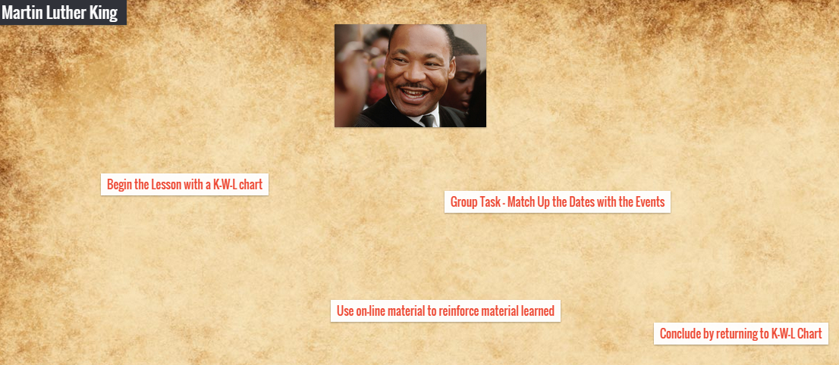
Popplet.com is similar, offering you another way to present lesson content:
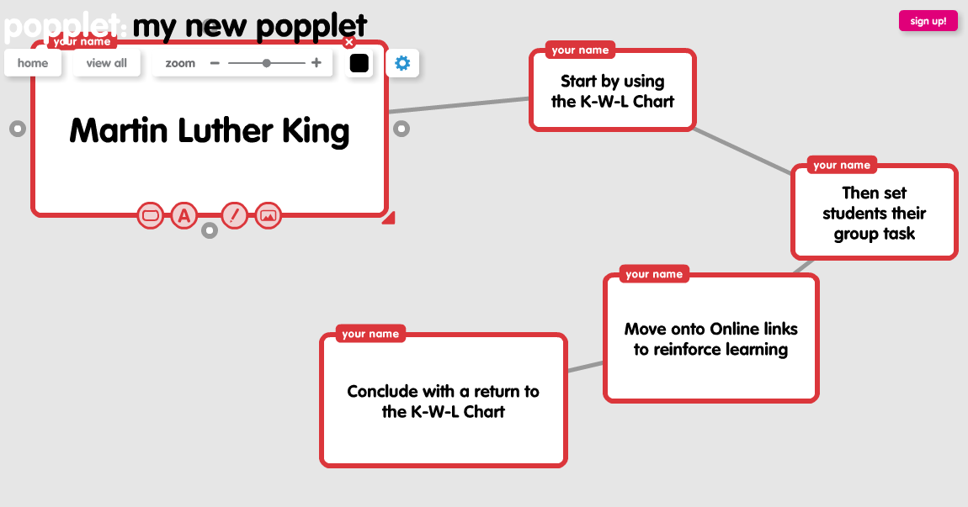
The layout is easy for students to present their tasks – such mind mapping activities – too!

- www.socrative.com
Fun and effective formative assessment; this tool allows teachers to engage students in the classroom using any form of tablet/device. Through the use of real-time questioning, result aggregation, and visualization, teachers have instant insight into levels of understanding, allowing better use of class time, while creating an environment which fosters collaboration and encourages the group to grow as a community of learners.
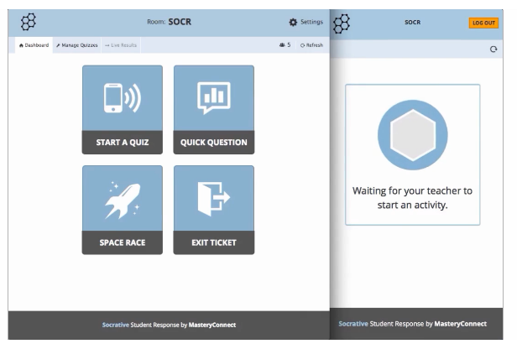
- www.blendspace.com
Blendspace is an online tool that allows you to collect content for your students to view in one place. Pictures, videos, articles, websites, and Google docs are just some of the items you can share in a Blendspace. It is simple to use and easy for students to navigate; can be used for one lesson, or cover an entire unit.
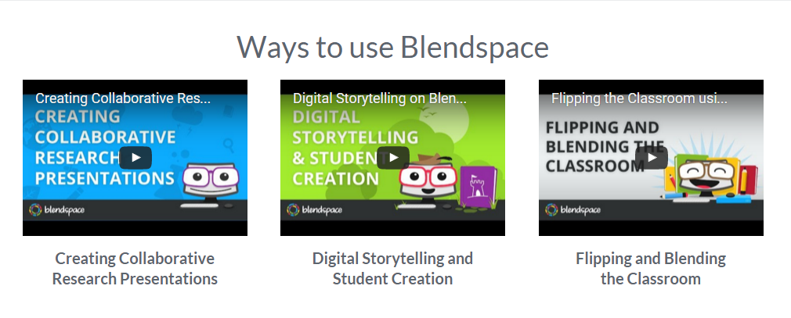
- www.whycare.ie
This website has been created by the Jesuit Centre for Faith and Justice; a non-profit organisation working on behalf of those suffering injustice or disadvantage in society. The website’s video: Why Care: Learning About Social Justice, is a great way to introduce students to the mission at the heart of their work.
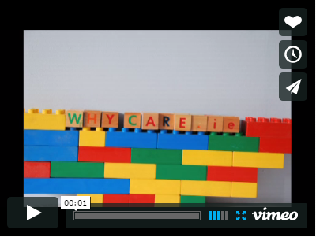
http://www.whycare.ie/index.php/47-work/working-youth-organisations/201-why-care-video
- www.kahoot.com
Kahoot.com is a great website where you can upload quiz questions in advance. Students can then work in pairs/teams to answer the questions and the website generates/tabulates their scores along the way so they can see how they’re doing; similar to a scoreboard at a Table Quiz.
- www.classdojo.com
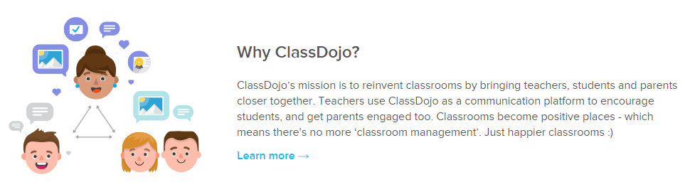

- www.webwise.ie
This website has been created for teachers and parents; to promote internet safety. The information is frequently updated to offer advice regarding websites and apps (those most popular with teens in particular), how to maximise the use of your IT equipment, etc. Several teacher resources available for download.

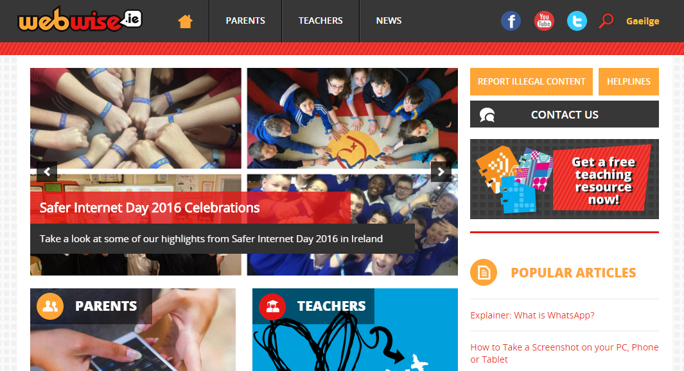

- www.censusatschool.ie
CensusAtSchool - an International Children's Census. Collecting and disseminating real data for use by teachers and pupils in data-handling, ICT and across the curriculum for teaching and learning.
CensusAtSchool is a non-profit making project funded by organisations interested in promoting good use of statistics and data handling.
Ireland became involved in CensusAtSchool in 2009 when the NCCA, the CSO and the NCTE collaborated to set-up the Irish website.

- www.govote.at
Log onto Mentimeter.com to sign up to this free service, ideal for use with students in your classroom. Govote.at allows you to engage your students in a quick, fun and interactive method of formative assessment.
