Imagine a world without judgement, condemnation, and full of forgiveness.
This is the hope of Pope Francis, who has proclaimed a Holy Year of Mercy for the whole Church.
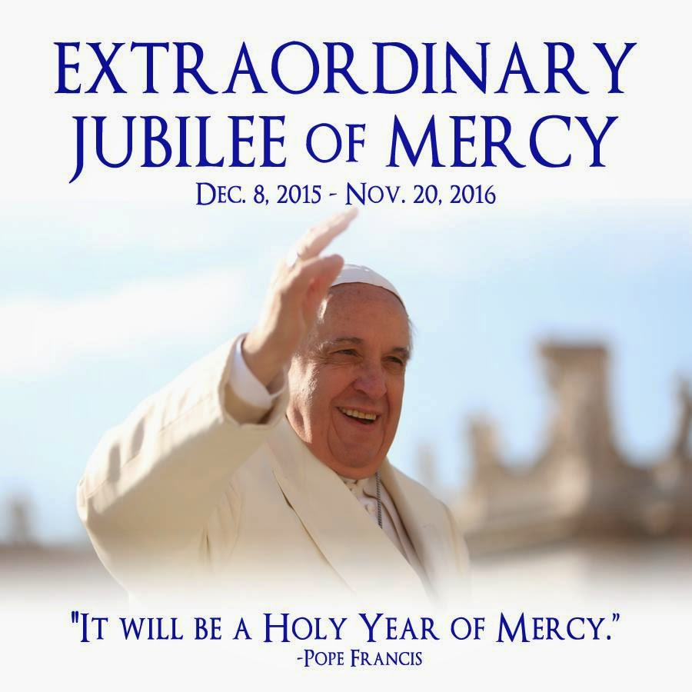
Pope Francis announced a jubilee year, a very special event in the Catholic Church, called the Holy Year of Mercy. A jubilee year is called by the church to receive a blessing and pardon from God; this jubilee year begins on December 8, 2015 and will close on November 20, 2016, the feast of Christ the King. The Holy Year of Mercy celebrates being a witness of mercy and invites us all to follow the example of God as merciful, forgiving and loving followers.
Mercy is acts of love by which we care for the bodily and spiritual needs of others. Being merciful frequently includes forgiveness of others, just as God the Father demonstrates forgiveness of our sins through love.
Did You Know?
The Catholic Church only calls jubilee years every 25 or 50 years. Jubilee years have existed since the year 1300. Extraordinary jubilee years are even rarer but are called from time to time for similar celebrations.
For PCLs/Principals:
Make a plan to teach students about being merciful. Discuss with colleagues and designate a day that your parish or school can celebrate a Day of Mercy. On this day, coordinate a series of activities for students to participate in. You may choose to have students go on a community service field trip, create “I forgive you” cards for friends, or perform a play to act out a parable of forgiveness for your community. Dedicate the day to teaching others about mercy and the importance of being merciful to one another.

For the Catechist/R.E. Teacher/Chaplain:
Document your students’ actions of mercy by creating a calendar. At the end of each day, take 5 minutes to write down the actions taken by members of your class to be witnesses of mercy during that day. At the end of the term, write a letter to Pope Francis summarizing the mercy demonstrated by the students in your class.
For Parents:
Teach your child the meaning of mercy. Sit down with your child and tell him or her about a time that you were truly sorry for what you did; explain that God forgives us for our sins and welcomes us into his arms of love when we seek forgiveness. Brainstorm ways to seek God’s forgiveness. You may want to say a prayer, reach out and make amends to those affected, or simply discuss what could be done better next time. Explain to your child that God always forgives and demonstrates mercy when we express remorse.
For the community:
To celebrate the jubilee year, create a Mercy Tree in the hallway of your school or parish. As the year progresses, ask community members to look for students, catechists, and staff members to model mercy. As merciful actions are observed, community members can write each act of mercy on a leaf. Watch your Mercy Tree bloom as the Holy Year of Mercy progresses!
What does Scripture teach us about mercy?
Luke teaches us to “Be merciful, just as your Father
is merciful.” (Luke 6:36)
The Parable of the Lost Sheep (Luke 15:1–7)
shows us the mercy of God.
James teaches us that mercy triumphs over judgement.
Matthew teaches us “Blessed are the merciful for they will be shown mercy.” (Matthew 5:7)

