THE EIGHT BEATITUDES OF JESUS

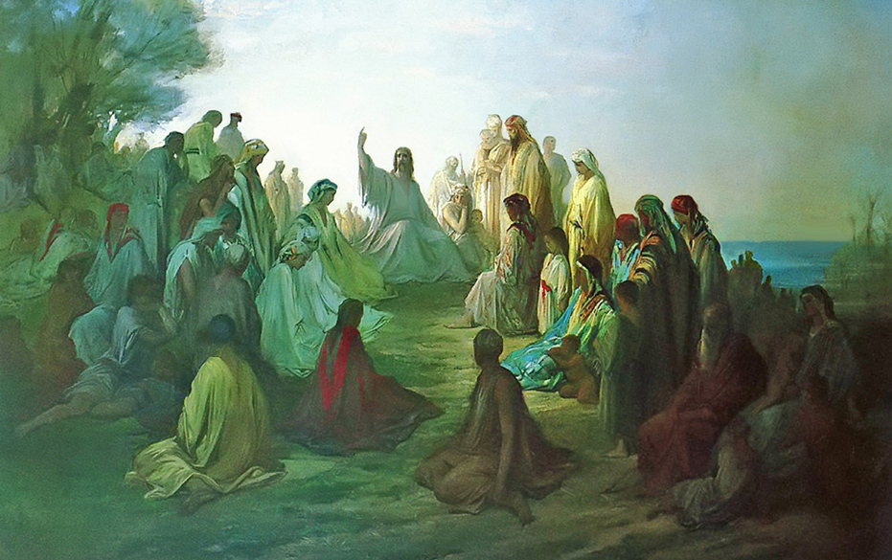
Jesus Christ gave us the eight Beatitudes in the Sermon on the Mount, recorded for all posterity in the Gospel of Matthew, the first Book of the New Testament of the Bible. Matthew's Gospel was directed to an audience steeped in Hebrew tradition. The Gospel of Matthew stressed that Jesus is the Christ or Messiah foretold in Hebrew Scripture, our Old Testament, and that the Kingdom of the Lord is the Kingdom of God in Heaven. Jesus offers us a way of life that promises eternity in the Kingdom of Heaven.
The teachings of Jesus of Nazareth were simple but unique and innovative at the time of his life on earth. He began teaching about 30 AD during the ruthless Roman occupation of Palestine. At the time there were four major groups in the Jewish religion, the Pharisees, Sadducees, Essenes, and the Zealots, all of whom presented a different viewpoint to the Jewish people. The Pharisees demanded strict observance of the Mosaic law expressed in the Torah, but also accepted the oral tradition of Jewish customs and rituals. The Sadducees were mainly from the priestly families and strictly accepted the Law of Moses but rejected oral tradition. The Pharisees, unlike the Sadducees, believed in the resurrection of the dead. The monastic Essenes awaited a Messiah that would establish a Kingdom on earth and free the Israelites from oppression. The Zealots were a militant Jewish group who wanted freedom for their homeland, and were centered in Galilee; one of the Twelve Apostles was Simon the Zealot.
The Ten Commandments, given to Moses on Mount Sinai in the Old Testament Book of Exodus, related a series of "Thou shalt not" phrases, wrong doings one must avoid in daily life on earth.
In contrast, the message of Jesus is one of humility, charity, and brotherly love. He teaches transformation of the inner person. Jesus presents the Beatitudes in a positive sense, virtues in life which will ultimately lead to reward. Love becomes the motivation for the Christian. All of the Beatitudes have an eschatological meaning, that is, they promise us salvation; not in this world, but in the next. The Beatitudes initiate one of the main themes of Matthew's Gospel; that the Kingdom so long awaited in the Old Testament is not of this world, but of the next, the Kingdom of Heaven.
While the Beatitudes of Jesus provide a way of life that promises salvation, they also provide peace in the midst of our trials and tribulations on this earth.
An early contemplation on the Beatitudes came from St. Gregory of Nyssa, a mystic who lived in Cappadocia in Asia Minor around 380 AD. He described the Beatitudes this way:
"Beatitude is a possession of all things held to be good,
from which nothing is absent that a good desire may want.
Perhaps the meaning of beatitude may become clearer to us
if it is compared with its opposite.
Now the opposite of beatitude is misery.
Misery means being afflicted unwillingly with painful sufferings."
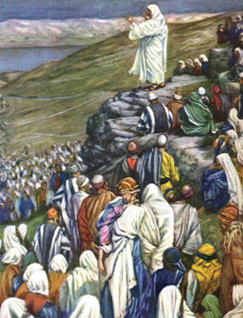

THE EIGHT BEATITUDES OF JESUS

"Blessed are the poor in spirit,
for theirs is the kingdom of heaven.
Blessed are they who mourn,
for they shall be comforted.
Blessed are the meek,
for they shall inherit the earth.
Blessed are they who hunger and thirst for righteousness,
for they shall be satisfied.
Blessed are the merciful,
for they shall obtain mercy.
Blessed are the pure of heart,
for they shall see God.
Blessed are the peacemakers,
for they shall be called children of God.
Blessed are they who are persecuted for the sake of righteousness,
for theirs is the kingdom of heaven."

Gospel of Matthew 5:3-10

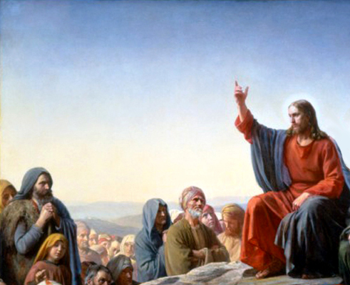
ON THE BEATITUDES
"Blessed are the poor in spirit, for theirs is the kingdom of heaven."
"Poor in spirit" means to be humble. Humility is the realization that all your gifts and blessings come from the grace of God. To have poverty of spirit means to be completely empty and open to the Word of God. When we are an empty cup and devoid of pride, we are humble. Humility brings openness and an inner peace, allowing one to do the will of God. He who humbles himself is able to accept our frail nature, to repent, and to allow the grace of God to lead us to Conversion.
It is pride, the opposite of humility, that brings misery. For pride brings anger and the seeking of revenge, especially when one is offended. If every man were humble and poor in spirit, there would be no war!
"Blessed are they who mourn, for they shall be comforted."
If we are humble and appreciate that all of our gifts and blessings come from God, we grow in love and gratitude for Jesus Christ our Saviour. But this can only produce mourning and regret over our own sins and the sins of this world, for we have hurt the one who has been so good to us. One also mourns for the suffering of others.
St. Gregory describes another reason to mourn: the more one ascends in meditation of Divine Truth, Beauty, and Goodness, and then realize the poverty of human nature, man can only be left in sorrow. When one contemplates that we were made in the image and likeness of God and lived in Paradise, the Garden of Eden, and compare that to our present state after the Fall, one can only mourn our present condition. But the sentence continues that they shall be comforted, by the Comforter, the Holy Spirit, and hopefully one day in the Kingdom of Heaven.
Mourning in this context is called a blessing, because mourning our fallen nature creates in us a desire to improve ourselves and to do what is right!
"Blessed are the meek, for they shall inherit the earth."
St. Gregory of Nyssa taught that the Beatitudes build one upon another. A humble person becomes meek, or becomes gentle and kind, and exhibits a docility of spirit, even in the face of adversity and hardship. A person that is meek is one that exhibits self-control. St. Augustine advises us to be meek in the face of the Lord, and not resist but be obedient to him. Obedience and submission to the will of God are certainly not in vogue these days, but they will bring one peace in this world and in the next.
"Blessed are they who hunger and thirst for righteousness, for they shall be satisfied."
Justice and righteousness in the New Covenant indicate the fulfilment of God's will in your heart and soul. It is not mere observance of the law (Matthew 5:20), but rather an expression of brotherly love (I John 3:10). A continuous desire for justice and moral perfection will lead one to a fulfilment of that desire - a transition and conversion to holiness. This is true for all the virtues - if you hunger and thirst for temperance, you will head towards the goal you have in mind. St. Augustine called the Beatitudes the ideal for every Christian life! In his discourse on the Lord's Sermon on the Mount, he noted the correspondence of the seven gifts of the Holy Spirit and their necessity in fulfilling the Beatitudes. For example, one must have the gift of fortitude so one may be courageous in seeking social justice.
"Blessed are the merciful, for they shall obtain mercy."
Mercy is the loving disposition towards those who suffer distress. Love, compassion, and forgiveness towards one's neighbour will bring peace in your relationships. We say in the Lord's Prayer: Forgive us our trespasses, as we forgive those who trespass against us. As we are merciful to others, so our Heavenly Father will be merciful with us! Jesus reminds us that whatever "you did to the least of my brethren, you did it to me (Matthew 25:31-46)." St. Paul calls for the obedience of faith in the beginning and end of his Letter to the Romans (1:5, 16:25-27). The following are ways to be merciful to your neighbour as well as to living our faith in Christ.
Works of Mercy
1 Feed the Hungry/Give drink to the thirsty
2 Clothe the naked
3 Shelter the homeless
4 Comfort the imprisoned
5 Visit the sick
6 Honour the dead
7 Evangelise those who are open to God’s voice
8 Counsel the doubtful
9 Comfort the sorrowful
10 Be patient with those in error
11 Forgive offenses
12 Pray for the living and the dead

"Blessed are the pure of heart, for they shall see God."
Moses (Exodus 33:20), John 1:18, and Paul (I Timothy 6:16) all say that no one can see God here on earth! But Jesus says the pure of heart shall see God! To be pure of heart means to be free of all selfish intentions and self-seeking desires. What a beautiful goal! How many times have any of us performed an act perfectly free of any personal gain? Such an act is pure love. An act of pure and selfless giving brings happiness to all.
"Blessed are the peacemakers, for they shall be called children of God."
Peacemakers not only live peaceful lives but also try to bring peace and friendship to others, and to preserve peace between God and man. St. Gregory of Nyssa calls a peacemaker a man who brings peace to another; but one cannot give another what one does not possess oneself. Hence the Lord wants you first to be yourself filled with the blessings of peace and then to communicate it to those who have need of it. By imitating God's love of man, the peacemakers become children of God.
"Blessed are they who are persecuted for the sake of righteousness,
for theirs is the Kingdom of Heaven."
The biblical passage continues to elaborate: "Blessed are you when men revile you and persecute you and utter all kinds of evil against you falsely on my account. Rejoice and be glad, for your reward is great in heaven, for so men persecuted the prophets who were before you" (Matthew 5:11-12). Jesus said many times that those who follow Him will be persecuted. "If they persecute me, they will persecute you" (John 15:20-21).
Stephen, Peter and Paul, nearly all of the Apostles, and many Christians in the Roman era suffered martyrdom. Oppressive governments and endless conflicts in the last one hundred years, such as World Wars I and II, and the Middle East wars in Iraq, Egypt, and Syria have seen their share of martyrs, such as Maximilian Kolbe, Dietrich Bonhoeffer, Latin American martyrs, and Middle East Christians. St. Maximilian Kolbe offered his life in place of a stranger at the Auschwitz death camps on August 14, 1941. Franz Jaegerstaetter, a Catholic Austrian refused to join the German army when conscripted during WWII. He was beheaded on August 9, 1943. Dietrich Bonhoeffer was a Lutheran pastor who was hanged on April 9, 1945 for condemning the leadership of Hitler in Nazi Germany. The Central American Martyrs include the 38 recognized martyrs of La Cristiada, the Cristero War from 1926 to 1929, when the Mexican government persecuted priests of the Catholic Church, such as St. Christopher Magallanes, St. Toribio Romo Gonzalez, and the 14 year old martyr Blessed Jose Luis Sanchez del Rio. Another Central American martyr was Oscar Romero, Archbishop of San Salvador, who was assassinated while saying Mass at Divine Providence Hospital on March 24, 1980 for speaking out against government human rights violations.
As in the time of Jesus of Nazareth (Matthew 2:23) and the early Christian Church (Acts 24:5), a Christian in the Middle East today is still called a Nazarene or in Arabic Nasrani or plural Nasara. Middle Eastern Christians have suffered severe persecution since the crises in Iraq and Syria. At least 58 Christians were slaughtered during Sunday Mass at Our Lady of Salvation Syriac Eastern Catholic Church in Baghdad on October 31, 2010. Sixty thousand Christians in Mosul have been displaced from their homes, and over one million Christians have fled Iraq since the beginning of the Iraq War in 2003. It is estimated that the present turmoil in Syria has resulted in over 700,000 Christian refugees escaping to Jordan, Lebanon, and other Middle Eastern countries….
… Blessed are they who are persecuted for the sake of righteousness,
for theirs is the Kingdom of Heaven.

