A LIGHT FOR MISSIONARIES

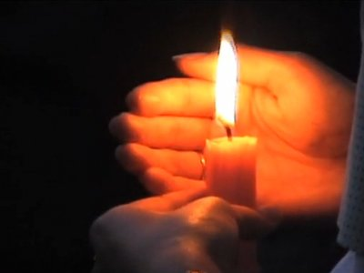

Just as the light of a candle burns brightly, may Your love burn brightly forever in the hearts of missionaries.

I ask you, Lord, to grant them wisdom and courage and guide them as they bear witness to You.

Protect them through difficult times and keep them always in the palm of Your hand. Amen.

