Veni Sancti Spiritus – Come Holy Spirit

For you did not receive the spirit of slavery
to fall back into fear, but you have received the spirit of kinship. When we cry, “Abba! Father!” it is the Spirit himself bearing witness with our spirit that we are children of God.

Saint Paul, in his letter to the Romans 8: 15 – 16

Breathe in me, O Holy Spirit

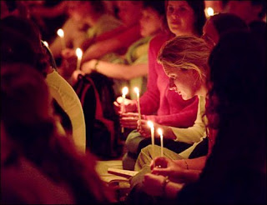
Breathe in me, O Holy Spirit,
that my thoughts may all be holy.
Act in me, O Holy Spirit,
that my work, too, may be holy.
Draw my heart, O Holy Spirit,
that I may love but what is holy.
Strengthen me, O Holy Spirit,
to defend all that is holy.
Guard me, then, O Holy Spirit, Young people at prayer in Taize
that I may always be holy.
Amen.
SAINT AUGUSTINE OF HIPPO

Prayer is a gift of the Holy Spirit, that makes us into men and women of hope, and prayer enables us to keep the world open to God.
POPE BENEDICT XVI
Unusual Invocations to the Holy Spirit
Holy Spirit – source of truth,
Breathe of God – giver of life!
Surprise me in the midst of daily life.
Go with me even into my plans.
Transform me in my understanding.
Fill me with all your gifts.
Immerse me to make me clean.
Awaken my talents to work in me.
Work in me that I may grow less self-centred.
Ignite your charism that I may witness to you.
Overtake me when I flee.
Gather me up when I wander aimlessly.
Urge me on when I start to flag.
Give me wings when I work creatively.
Hasten to me when I seek you.
Walk beside me when I am pensive.
Enlighten me when I do not understand.
Break me open when I freeze.
Pour into me when I am hesitant.
Burn within me when I grow cold.
Overwhelm me when I become complacent.
Flood through me when I am empty.
Fill me with joy when I am sad.
Embrace me when I am lonely.
Pray in me when I cannot find the words.
Console me when I am abandoned.
Heal me when I am sick.
Hold me when I fall.
Shelter me when I am defenceless.
Seize me when I burn with longing.
Rejoice in me when I love you.

