The Pilgrim Path of Life
Our walk with God
is never a lonely walk,
it is a family occasion,
if taken in the company
of God's children.
If we lag behind,
there are those who will turn
and offer words of encouragement,
hold out a hand and offer assistance
over stiles and other obstacles,
share refreshment,
help us from our knees
when we stumble.

PILGRIM PATH

Each Day of Our Lives We Walk on Hallowed Ground

Today…
Take Time
Be Attentive
Be Aware
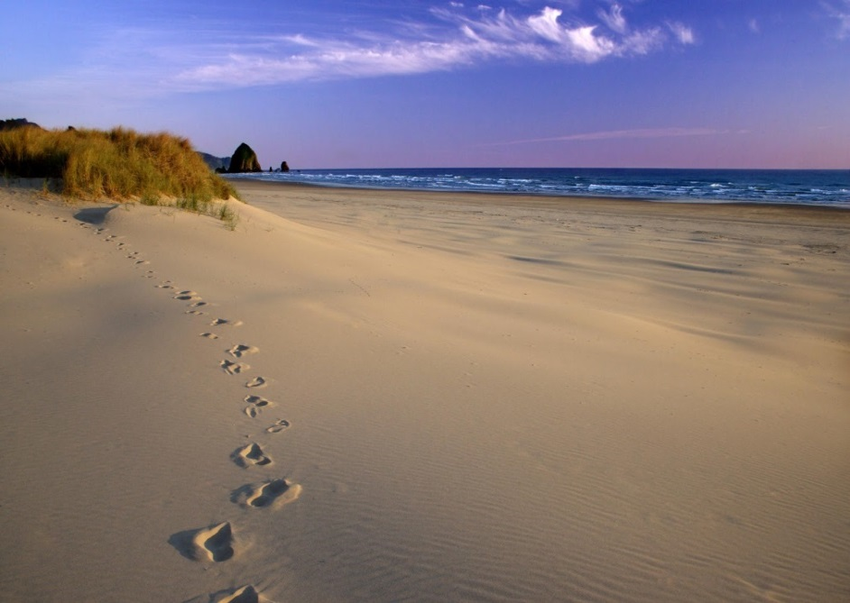
This is what Yahweh asks of you : only this,

To act justly,
to love tenderly
and to walk humbly with your God.
Micah 6:8
Shoes
Protect your feet along the way…
Leave marks where you have travelled…
Listen to the sound of your shoes
as you tread the way…

Then he said, ‘Come no closer!
Remove the sandals from your
Feet, for the place you on which you are
Standing is holy ground.’ Ex 3:5
Rest and reflect
Rest awhile
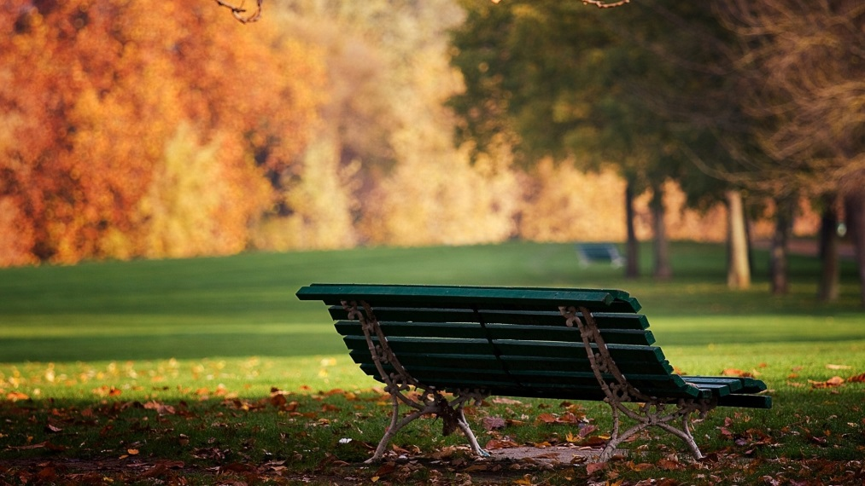
Listen to the unsung song in your heart
Thank God for the tapestry of your life

The Lord went before them in a pillar of cloud by day, To lead them along the way, and in a pillar of fire by night, to give them light, so that they might travel by day and by night. Ex 13:21
The word – tree of light
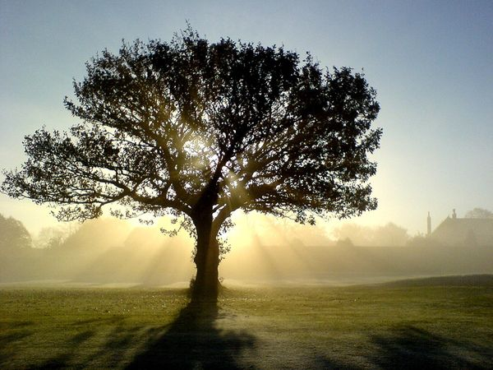
Choose a ‘flame’ from the Tree of Light
Words… Conversation… Story-telling…
Chitter chatter…
What sacred story lights your path?
In the beginning was the Word, and the Word was with God, and the Word was God. Jn 1:1
Baggage
Imagine a bag on your back…
Carrying too much?
Unresolved issues?
Weighed down by clutter?

Take nothing for your journey, no staff, nor bread,
nor bag, nor money – not even an extra tunic.
Lk 9:3
Stones
The path may be stony…
… strewn with rocks
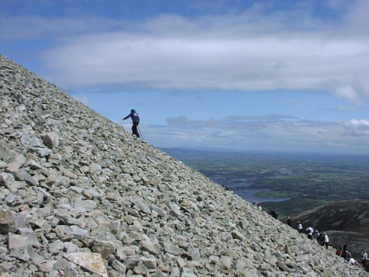
Obstacles too great to overcome?
Or Stepping stones to new possibilities?

If God sends you down a stony path,
May He give you strong shoes.
Plants/flowers
Who or what feeds you?
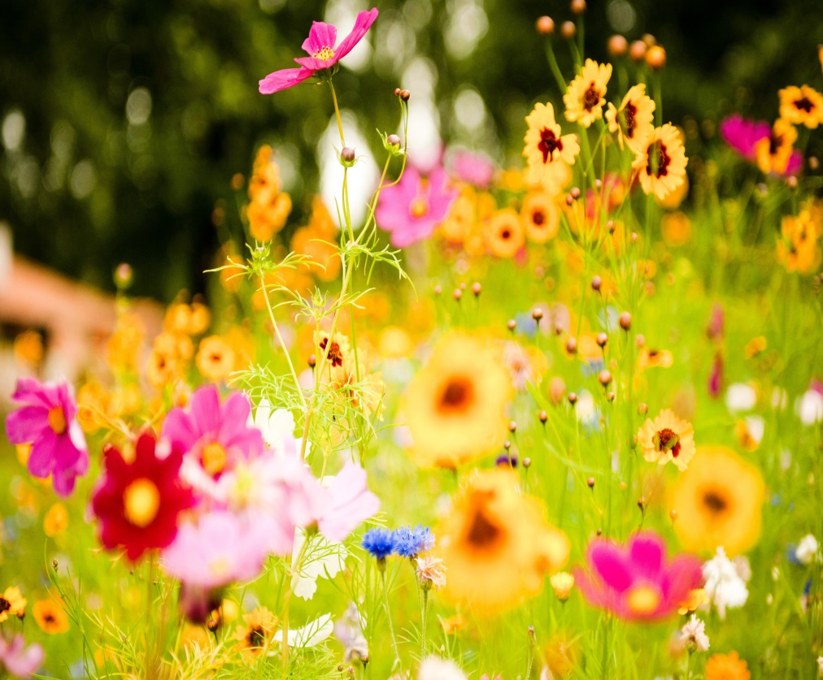

Look at the birds of the air; they neither sow nor reap nor gather into barns, and your heavenly Father feeds them. Are you not of more value than they? Mt 6:26

