The Legion of Mary

The Legion of Mary is the largest organisation of lay people in the Catholic Church with over 3 million active members in almost every country in the world. It was founded in Dublin in 1921 by Frank Duff who wanted lay Catholics to understand that they too had a very important role to play in the ‘apostolate’ of the Church. The apostolate is any action undertaken to promote the gospel in the world.
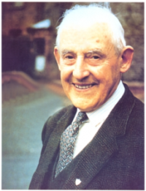
Members meet once a week to pray and to give an account of the apostolic work that they have undertaken. This work may include visiting the elderly and the sick, visiting prisons, going door to door to talk to people about their religion, promoting religious newspapers, magazines and various other religious links on social media. Under the guidance of a spiritual director, usually a priest, they plan the activities for the following week. The individual members also commit themselves to saying the prayers of the Legion.
Frank Duff was one of the few lay people at the Second Vatican Council where he received great praise for his work of promoting the lay apostolate. He died in 1980, aged 91, and in 1996 the Archdiocese of Dublin introduced the cause Frank Duff 1889 – 1980 for his canonisation, that is the means by which he can be declared a saint in the Catholic Church.
Encouraging others to do the same, Frank tried to see ‘Christ in every person [we] meet’. This is why he set up the hostels for homeless men, women and children. All work for the Legion is done on behalf of Our Lady and each member tries to be ‘her arms and feet in assisting others’.
For more information about the Legion of Mary and its work here in Dublin log onto:
legionofmaryd7.com/mstar.htm and legionofmaryd7.com/regina.htm
Donations are always welcome, should you consider fundraising to support the work of the Legion.
Check out Deus Et Patria on Facebook to learn about activities related to the Legion of Mary
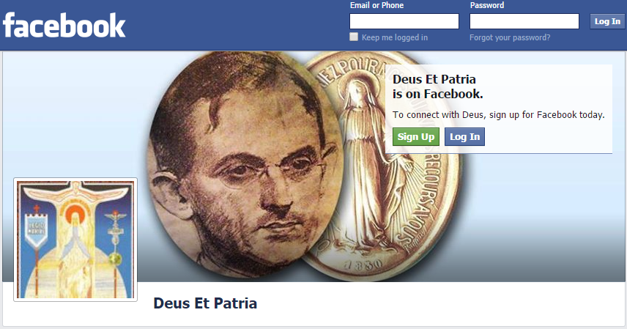

For example, this youth event is coming up later this month. The tag line “If Mary were but known” is a famous phrase, often used by Frank Duff.
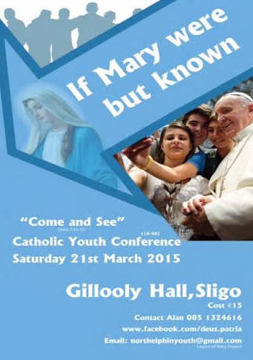

Extract from Exploring Faith S.Goan and T. Ryan (Celtic Press, 2004)p. 28 used with authors’ permission

