Mary, you said Yes
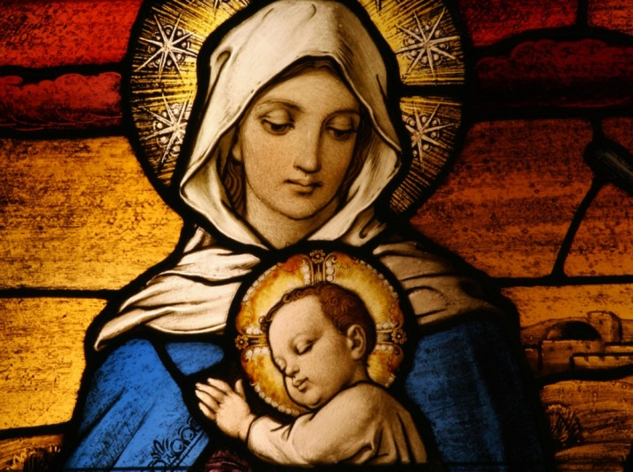
Mary, Mother of the Yes,
You listened to Jesus and
Know the sound of his voice
And the beating of his heart.
You Morning Star, speak to us about him
And tell us how you follow him
On the way of faith.

Mary, you lived in Nazareth
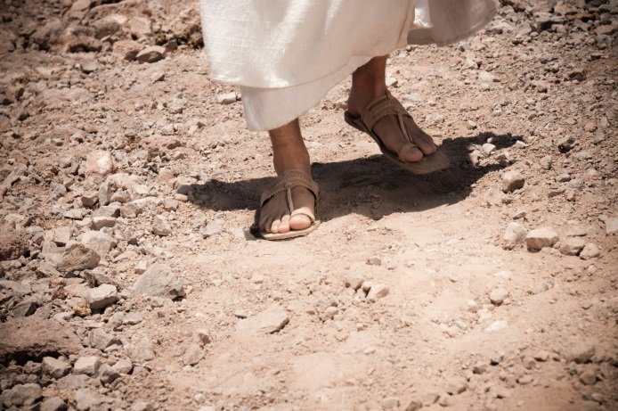
Together with Jesus.
Imprint on our lives your feelings,
Your docility, your silence,
That listens and,
In truly free decisions,
Brings the Word to blossoming.

Mary, tell us about Jesus,
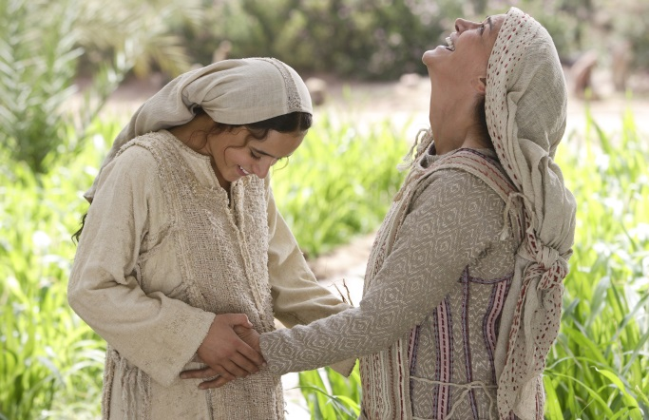
So that our faith in its freshness
May shine from our eyes
And warm the hearts of those we meet,
Just as you did when you went to visit Elizabeth
And she, old as she was,
Rejoiced with you over the gift of life.
Mary, Virgin of the Magnificat,
Help us to bring joy into the world
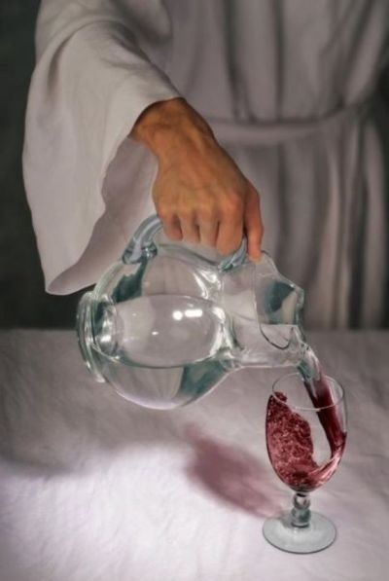
And, as you did in Cana,
Encourage all young people
Engaged in the service of their brethren,
To do only what Jesus tells them.
Mary, turn your gaze upon young people,
So that they may become a fruitful soil
Of the Church.

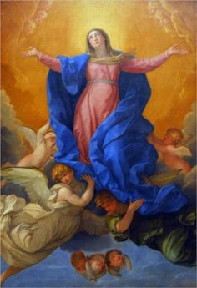
Pray that Jesus, who died and rose again,
May be reborn in us and transform us,
In a night full of light, fully filled by him.
Mary, Mother of God and gate of heaven,
Help us to lift up our gaze.
We want to see Jesus; to speak with him;
To proclaim his love to all.

POPE BENEDICT XVI

