Saint Patrick’s “Breastplate” Prayer
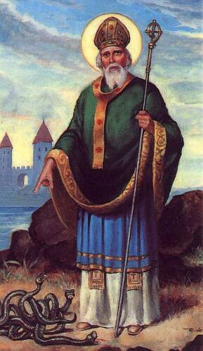
I bind unto myself today
The strong Name of the Trinity,
By invocation of the same,
The Three in One and One in Three.

I bind unto myself today
The power of God to hold and lead,
His eye to watch, His might to stay,
His ear to hearken to my need.
The wisdom of my God to teach,
His hand to guide, His shield to ward,
The Word of God to give me speech,
His heavenly host to be my guard.

Christ be with me, Christ within me,
Christ behind me, Christ before me,
Christ beside me, Christ to win me,
Christ to comfort and restore me.
Christ beneath me, Christ above me,
Christ in quiet, Christ in danger,
Christ in hearts of all that love me,
Christ in mouth of friend and stranger.

I bind unto myself today
The strong Name of the Trinity,
By invocation of the same,
The Three in One and One in Three.
Of Whom all nature hath creation,
Eternal Father, Spirit, Word:
Praise to the Lord of my salvation,
Salvation is of Christ the Lord.
Quotations from the Five Sunday Gospels
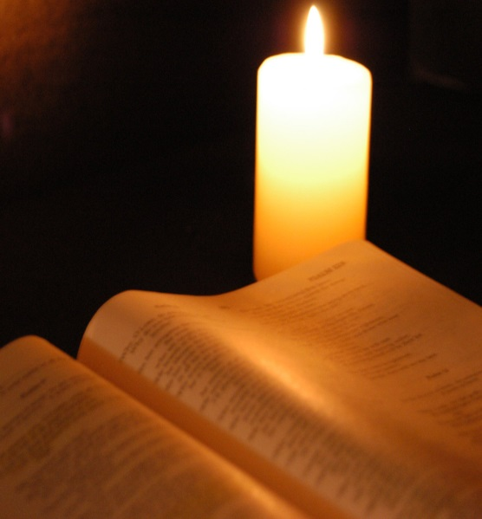
Sunday March 9th
“One does not live on bread alone”
^{Matthew 4:4}
Sunday March 16th
^{“This is my Son, the Beloved;}
he enjoys my favour. Listen to him”
^{Matthew 17:5}

Sunday March 23rd
“Those who drink of the water that I will give them will never be thirsty.
The water that I will give will become in them a spring of water gushing up to eternal life”
^{John 4:14}

Sunday March 30th
^{“I am the Light of the World”}
^{John 9:5}

Sunday April 6th
“I am the resurrection and the life, if anyone
believes in me, even though he dies he will live,
and whoever lives and believes in me will never die”
^{John 11:25}

Denise Levertov (1923 – 1997)
“Beginners”
We have only begun
To imagine the fullness of life.
How could we tire of hope?
---so much is in bud.
How can desire fail?
---we have only begun
to imagine justice and mercy,
only begun to envision
how it might be
to live as siblings with beast and flower,
not as oppressors…

Not yet, not yet---
there is too much broken
that must be mended…
We have only begun to know
the power that is in us if we would join
our solitudes in the communion of struggle.
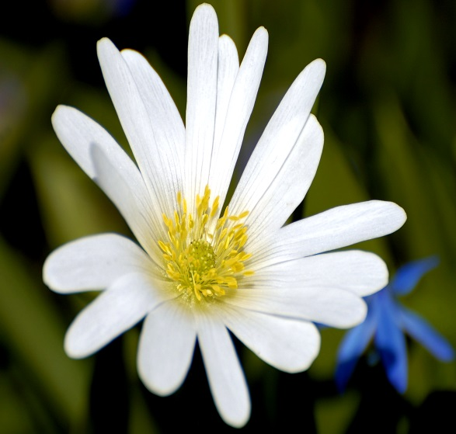
So much is unfolding that must
complete its gesture,
so much is in bud.

Gethsemane
The grass never sleeps.
Or the roses.
Nor does the lily have a secret eye that shuts until morning.
Jesus said, wait with me. But the disciples slept.
The cricket has such splendid fringe on its feet,
and it sings, have you noticed, with its whole body,
and heaven knows if it ever sleeps.
Jesus said, wait with me. And maybe the stars did,
maybe the wind wound itself into a silver tree,
and didn’t move,
maybe the lake far away,
where once he walked as on a blue pavement,
lay still and waited, wild awake.
Oh the dear bodies, slumped and eye-shut, that could not
keep the vigil, how they must have wept,
so utterly human, knowing this too,
must be part of the story.

Mary Oliver
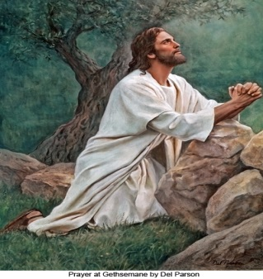
Reflection
For those who set out again with Christ
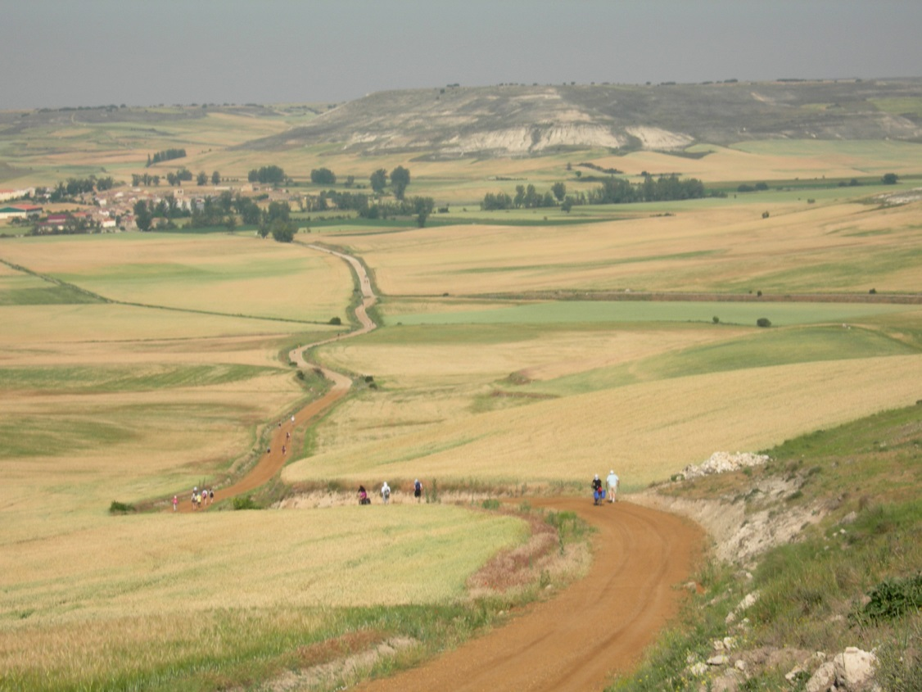
and travelled on the pilgrim road with him,
there came a new understanding
that all pilgrims
are wounded and wounding creatures
and need constant healing
and forgiveness.
And the source of this healing
and forgiveness is the Lamb
who takes away
the sins of the world
and gives us peace.
With this understanding
there came a new compassion.
And with the compassion
came a realisation
that we are not knights or gallant crusaders
riding up to the doors of heaven.
Ah! No! we are but humble pilgrims supporting one another
along the road trod by Him
who was hurt but who never wounded
except for healing.
And the Spirit will lead us to the portals of heaven
on whose doors are written large:
“Welcome home, and forgiveness
To all who, in turn, have forgiven others”
Good Friday Reflection
They arrived at the appointed place
where He who bore all crosses stood,
welcoming saint and sinner with open arms.
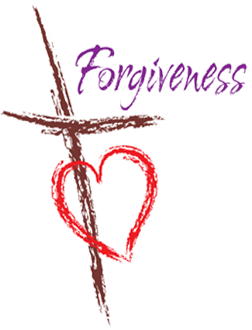
He lifted the burden from each one’s shoulder
and placed it in a circle around the Cross,
which He for us had borne.
They sat around in silence,
and as his gaze looked with love into each heart
they knew instinctively that He knew and understood
the weight and burden of the cross they carried.
He spoke in tongues but no sound came,
yet each one heard his words within the heart,
which changed the weight and texture of the cross they carried.
He then raised his hands and gave a blessing.
Then He gave a strange direction and a choice;
Whoever wished could exchange their cross for his,
or for the cross of those who had caused them pain,
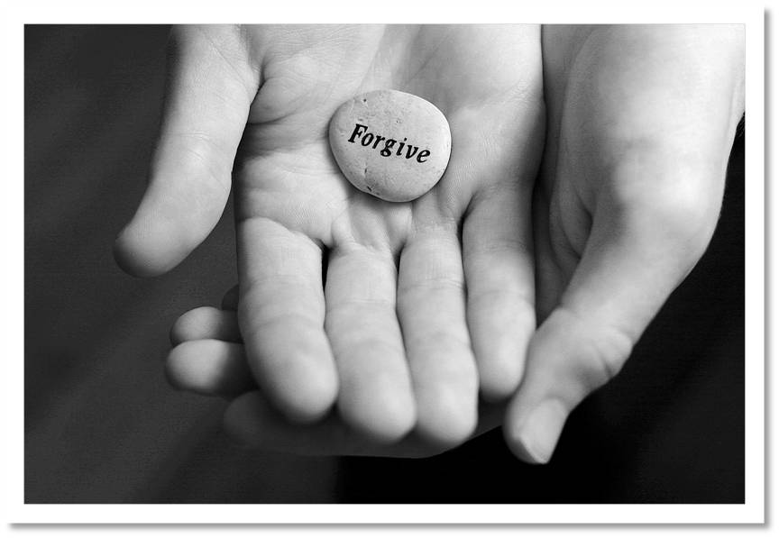
or they could embrace their own,
now transformed with compassionate love.
And if they were to travel further with him
in the peace and joy they now experienced,
they must allow his compassion to flow,
which forgave the other
and sought forgiveness for themselves.
Strange as it may seem
none of them exchanged their crosses of this
and few if any took the crosses of their afflictors.
Those who did left them down again
for they realised that they were heavy,
that their own crosses
fitted their own shoulders best
for the rest of their journey home.

Frank Fahey

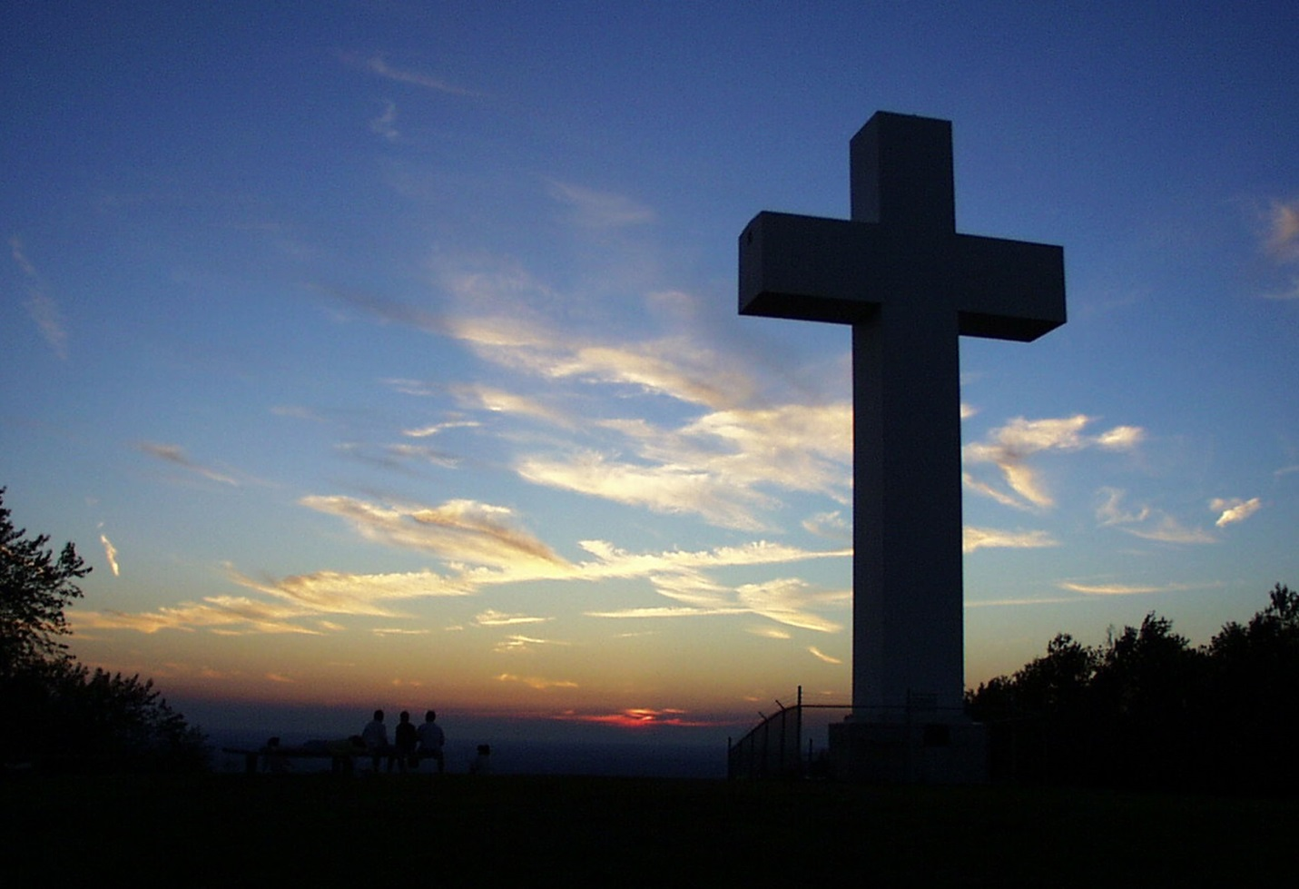

Reflection

Whatever happens to me in Life
I must believe that somewhere
in the mess or madness of it all,
there is a sacred potential –
a possibility for wondrous redemption
in the embracing of all that is.
For in the unfolding of my journey,
in all its soaring delight
and crushing pain,
I may be sure that God is there –
always ahead, behind, below and above,
encompassing all that befalls me
in a circle of deep compassion.
And there,
Above the darkness
that wraps me round
the bright wings of the Dove
hover and beat
in gentle healing love
and invitation to
New Rising.

Edwina Gately

The Good

The good are vulnerable
As any bird in flight,
They do not think of safety,
Are blind to possible extinction
And when most vulnerable
Are most themselves.
The good are real as the sun,
Are best perceived through clouds
Of casual corruption
That cannot kill the luminous sufficiency
That shines on city, sea and wilderness,
Fastidiously revealing
One man to another,
Who yet will not accept
Responsibilities of light.
The good incline to praise,
To have the knack of seeing that
The best is not destroyed
Although forever threatened.
The good go naked in all weathers,
And by their nakedness rebuke
The small protective sanities
That hide men from themselves.

The good are difficult to see
Though open, rare, destructible;
Always, they retain a kind of youth,
The vulnerable grace
Of any bird in flight,
Content to be itself,
Accomplished master
and potential victim,
accepting what the earth or sky intends.
I think I know one.

By Brendan Kennelly
1967

“In your light we see light”
Psalm 36
Jesus standing before the Samaritan woman
becomes the mirror in which she sees not only the face of
God but her own true face.

In the gospels, all the people who encountered Jesus only
by hearsay, by what somebody else believed about him,
by what they’d been told, by what they hoped to get out of him:
all those people left. They still leave today.
The ones that remained – and still remain –
are the ones who have met him in the moment:
in the instantaneous, mutual recognition of hearts
and in the ultimate energy that is always pouring forth
from this encounter.
It is indeed the wellspring.

Cynthia Bourgeanet

Lent
Lent can be more than a time of fasting; it can be a season of feasting.
We can choose this Lent, to fast from certain things and to feast on others. It is a season in which we can:
- Fast from emphasis on differences; feast on the unity of life
- Fast from apparent darkness; feast on the reality of light
- Fast from thoughts of illness; feast on the healing power of God
- Fast from words that pollute; feast on phrases that purify
- Fast from discontent; feast on gratitude
- Fast from pessimism; feast on optimism
- Fast from worry; feast on divine order
- Fast from complaining; feast on appreciation
- Fast from negatives; feast on affirmatives
- Fast from unrelenting pressures; feast on unceasing prayer
- Fast from hostility; feast on non-resistance
- Fast from bitterness; feast on forgiveness
- Fast from self-concern; feast on compassion for others
- Fast from personal anxiety; feast on eternal truth
- Fast from discouragements; feast on hope
- Fast from facts that depress; feast on verities that uplift
- Fast from lethargy; feast on enthusiasm
- Fast from thoughts that weaken; feast on promises that inspire
- Fast from shadows of sorrow; feast on the sunlight of sincerity
- Fast from idle gossip; feast on purposeful silence
- Fast from judging others; feast on the Christ dwelling in them

From a Benedictine source

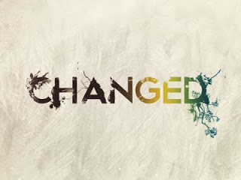

The Lantern

Take down your lantern from its niche and go out!
You may not rest in firelight certainties
Secure from drifting fog of doubt and fear.
You may not build yourself confining walls
And say: “Thus far, and thus, and thus far shall I walk,
And these things shall I do, and mothering more.”
Go out! For need calls loudly
in the winding lanes
And you must seek Christ there.
You pilgrim heart
Shall urge you still one pace beyond,
And love shall be your lantern flame.

Sister Raphael Considine, 1977

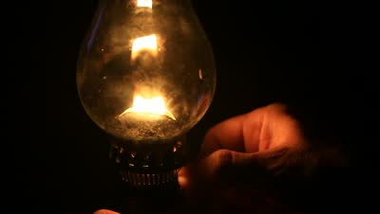
Resurrection

To believe in resurrection
is to believe in someone who acts
in us and for us
with immense power,
capable of bringing life from death
and of making old become new,
orientating us to a future
of huge dimensions.

To believe in resurrection
is to believe that no limit,
no barrier,
no difficulty,
nothing in this world,
will be able to kill the life and hope
which is born in God’s people.

Carlos Mesters CEBI Brazil

