Before setting out…
You will be asked to contemplate on certain aspects of Pilgrimage along the Path and reminders to reflect will be given along the way. These reflections seek to distinguish the ‘Pilgrim’ from the ‘Tourist’.
At this point, consider the following as ways in which you can make your journey more meaningful:
Faith: Light a candle as a symbol of your faith before setting out. On the path, offer a prayer each time as you a cross a boundary. (i.e. a stile, a fence, a gateway)
Penance: No complaining! If you stumble and wind up in a mucky puddle, say “Thanks be to God”
Community: No ‘cliques’. Include the ‘stranger’ in your group or better still, why not walk the path with someone you have rarely/never spoken to?… who knows what God may tell you, as He speaks to you through another’s heart.
Change of Heart: Follow some part of the journey reflecting in quiet time. Respect others who choose to do so. What is the Lord suggesting you must change about yourself?
Celebration: Share your food, your Joy, your Love and your Care.

As the Prayer on the overleaf speaks of journey, perhaps it may serve as a good starting point. It might be worth taking a second look at during rest stops along the way.

Saint Patrick’s “Breastplate” Prayer
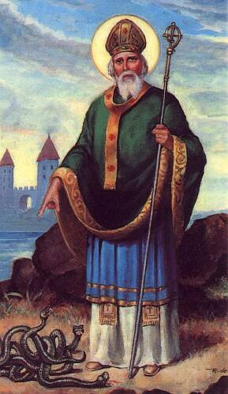
I bind unto myself today
The strong Name of the Trinity,
By invocation of the same,
The Three in One and One in Three.

I bind unto myself today
The power of God to hold and lead,
His eye to watch, His might to stay,
His ear to hearken to my need.
The wisdom of my God to teach,
His hand to guide, His shield to ward,
The Word of God to give me speech,
His heavenly host to be my guard.

Christ be with me, Christ within me,
Christ behind me, Christ before me,
Christ beside me, Christ to win me,
Christ to comfort and restore me.
Christ beneath me, Christ above me,
Christ in quiet, Christ in danger,
Christ in hearts of all that love me,
Christ in mouth of friend and stranger.

I bind unto myself today
The strong Name of the Trinity,
By invocation of the same,
The Three in One and One in Three.
Of Whom all nature hath creation,
Eternal Father, Spirit, Word:
Praise to the Lord of my salvation,
Salvation is of Christ the Lord.

