Prayer to St. Laurence O’Toole
St. Laurence O’Toole, man of peace,
You were in the middle of family and political
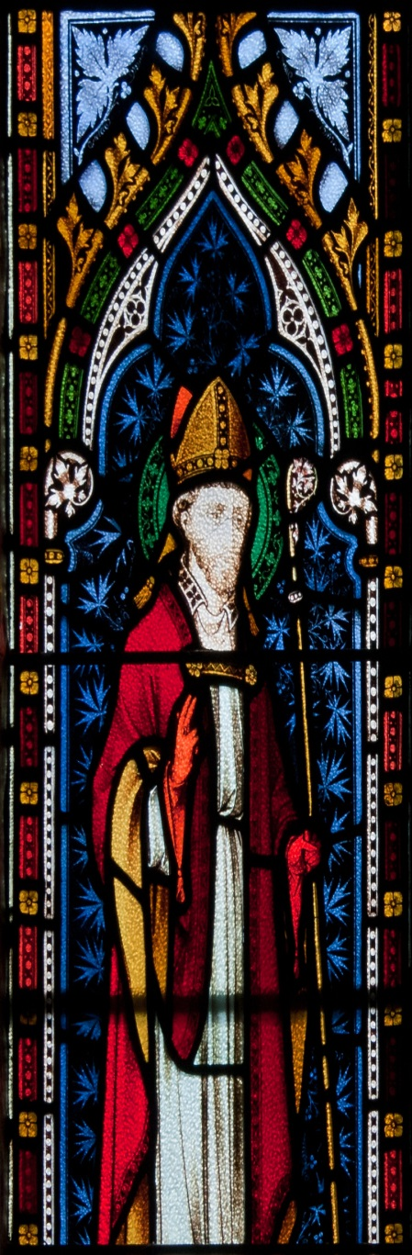
conflict from your earliest days. Give the gift
of peace and hope to all who experience the
trauma of division in families, in communities
and among nations.

St. Laurence O’Toole, man of prayer,
you recognized the call to serve the Lord
in a particular way at Glendalough. Give the
gift of perseverance to all who are discerning
their Christian vocation at this time.

St. Laurence O’Toole, man of faith,
you had the openness to accept a position of
leadership in your community at an early age.
Bless our young people with a spirit of
generosity to offer themselves in the service
of the Gospel.

St. Laurence O’Toole, man of prayer,
you inspired people by your commitment to
the spiritual life and the recitation of the
Prayer of the Church. Fill us with that desire
to pray in communion with each other
throughout each day.

St. Laurence O’Toole, man of faith,
you opened your heart and your doors to
those who were poor. Increase our awareness
of those in need and inspire us to act with
justice and charity at all times.

St. Laurence O’Toole, man of prayer,
you were respected for your commitment to
your Church and to your country. Grant us
the grace to live in this world while always
reflecting the eternal values of the kingdom.

St. Laurence O’Toole, man of peace,
you gave your last ounce of energy in the
cause of peace. Give us the gift of tirelessness
as we try to live as instruments of Christ’s
peace, love and tolerance.

