**In November, We Remember**

One way to invite students to remember those who have died is to create a Tree of Remembrance in the school.

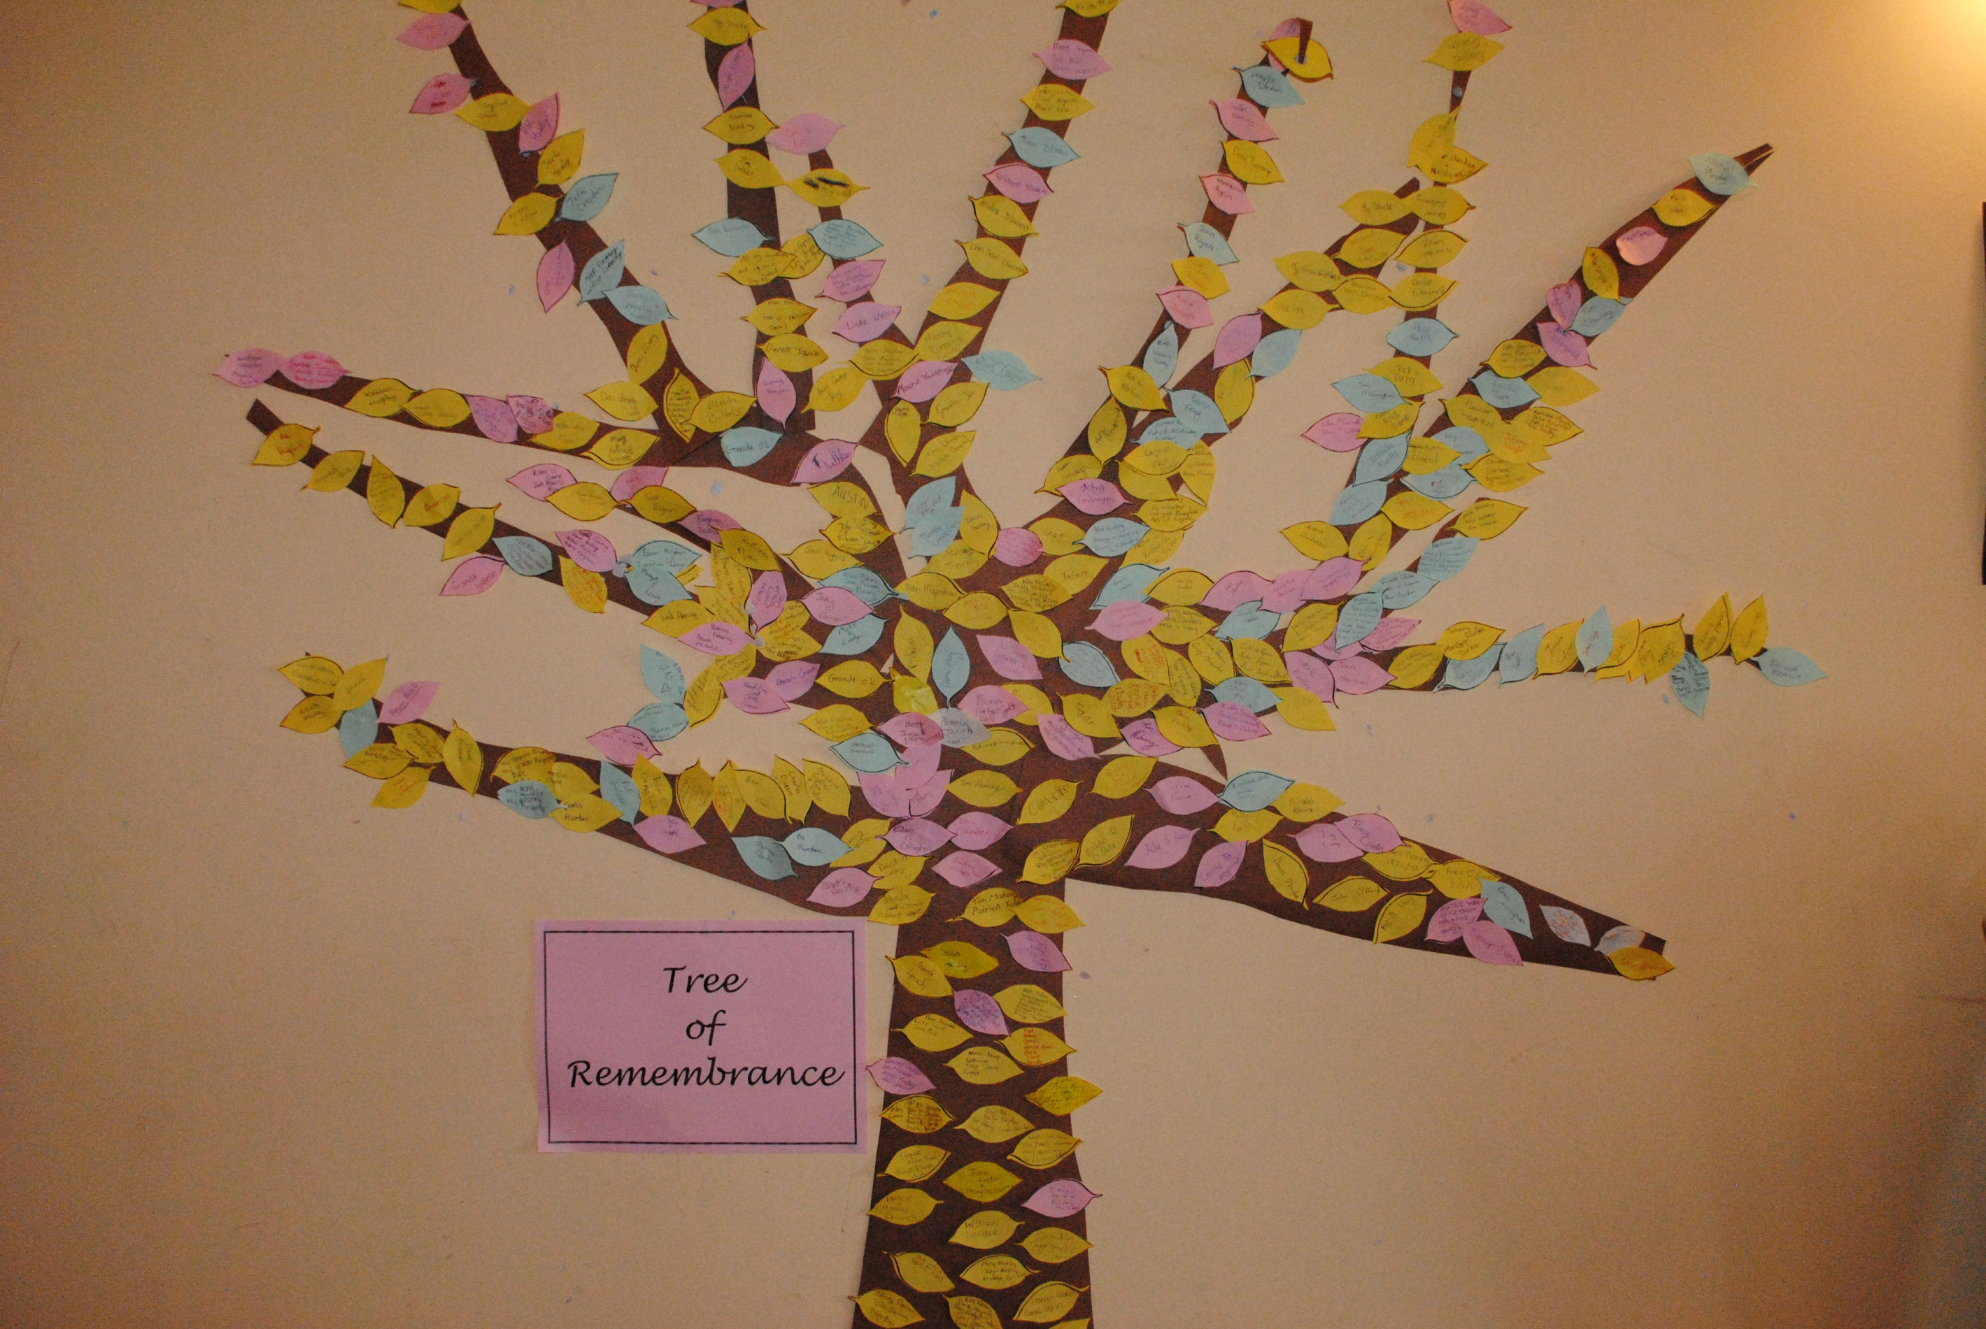

**This picture was taken in Scoil Phobail Sliabh Luachra, Rathmore**

Invite students to remember and write the names of those who have died e.g. family members, friends and neighbours into the leaf template below. (You could photocopy the template onto a coloured sheet in advance.)Then assemble on Tree of Remembrance.

Idea: Why not use a real Branch for your Tree of Remembrance and then this tree could change to a Jesse Tree during Advent. At Christmas you could add lights.

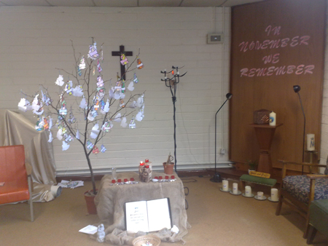

**This picture was downloaded from google, (Ballyroan)**

