November Remembrance

Book of Remembrance

Start by inviting all RE teachers to invite their students to write the name of the people that have died that they wish to remember in the book of Remembrance. This could be done as part of a prayer service or with gentle music playing in the background. If there is a mass or prayer service for those who have died during November a prayer might be included to pray for those named by students in the book of remembrance.
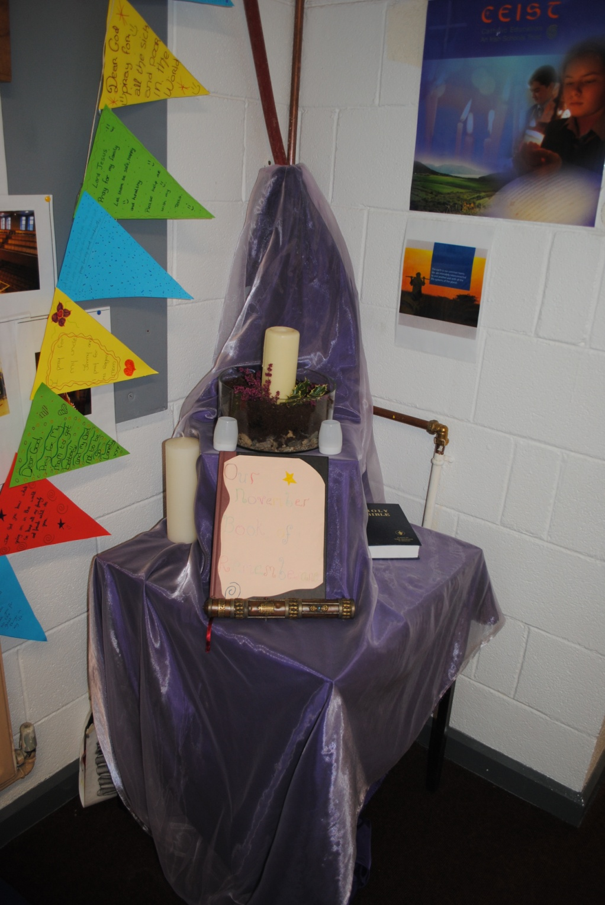
This picture was taken in Presentation Secondary School Milltown.

