Gospel Reading: Fourth Sunday of Lent, March 30th 2014
Jesus Heals the Blind Man
John 9:1-41 (Shorter version 9:1, 6-9, 13-17, 34-38)
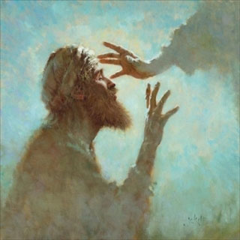
This is a story of a man who was enlightened by Jesus and who came to have faith in him; what saved him was the fact that he had no problem admitting to his blindness.
This blind man in fact saw more than the religious leaders of his day; he saw the goodness of Jesus and had more faith in him than they had. The Pharisees had perfect physical eyesight, yet Jesus refers to them as being blind. They were spiritually blind, but they refused to acknowledge that fact, and seek the help that he was offering them.
There are, as Jesus illustrates here, many forms of blindness, besides that of the physical kind; the kind of blindness that can darken and warp the hearts and minds of all of us. Here are some of them:
Selfishness that blinds us to the need of others
Snobbery that blinds us to the dignity and equal rights of our brothers and sisters
Pride that blinds us to our own faults
Prejudice that blinds us to the truth
Love of material wealth that blinds us to spiritual values (Father Kevin Lyons)

Jesus My Guiding Light
Oh Jesus you are a bright flame before me; you are a guiding star above me – you are the light and love I see in others’ eyes. Keep me in a love that is tender, a love that is true, a love that is strong, today, tomorrow and always. Amen. (JPN)

