New Year's Resolutions: The Pope Francis List
This post on Rappler by Paterno Esmaquel II is an amazing overview of Pope Francis' primary concerns. “He preaches against gossip, reminds us to finish our meals, and even tells us not to fear marriage. Described as the “world's parish priest,” Pope Francis goes beyond abstract theology, and gives us advice we can use daily. What lessons from him can we bring into 2017?”
Rappler compiles 10 of the Pope's most memorable quotes in the form of New Year's resolutions. This is the Pope Francis list.
1. Don't gossip. It's one of our hobbies. For Francis, it's also one of the most evil activities.
The Catholic leader denounces gossip as “murder.” He feels so strongly about it that in
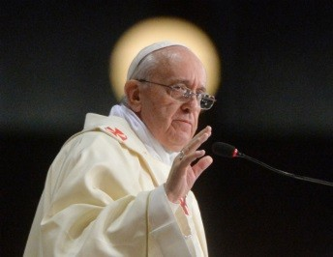less than a year as pontiff, Francis has preached against gossip in at least 6 different instances. He says when we gossip, we “are doing what Judas did,” and “begin to tear the other person to pieces. Every time we judge our brother in our hearts or worse when we speak badly of them with others, we are murdering Christians,” Francis says. “There is no such thing as innocent slander.”

- 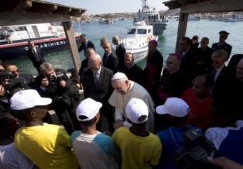Finish your meals. No leftovers, please. Named after a 12th-century saint who lived in poverty, Francis slams a “culture of waste” that neglects the plight of the hungry. The Pope says: “We should all remember... that throwing food away is like stealing from the tables of the poor, the hungry! I encourage everyone to reflect on the problem of thrown away and wasted food to identify ways and means that, by seriously addressing this issue, are a vehicle of solidarity and sharing with the needy.”

- Make time for others. Tending to 1.2 billion members, Francis seems too busy for
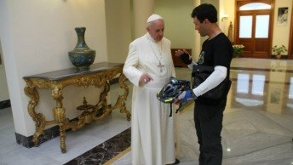anything else. That is, until he calls up strangers. Or entertains a random biker. Or sends a handwritten letter to a Jesuit he has never met. The Jesuit who got the letter, Fr James Martin, says “If the Pope can find time to be kind to others, if he can pause to say thank you, if he can take a moment make someone feel appreciated, then so can I. So can we.”

- 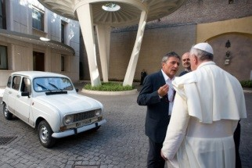Choose the 'more humble' purchase. The Pope preaches against materialism. “Certainly, possessions, money, and power can give a momentary thrill, the illusion of being happy, but they end up possessing us and making us always want to have more, never satisfied. ‘Put on Christ’ in your life, place your trust in him, and you will never be disappointed!”

- Meet the poor 'in the flesh.' “It is not enough to mediate this commitment through
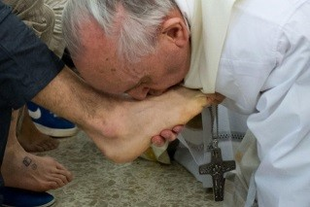institutions, which obviously help because they have a multiplying effect, but that is not enough. They do not excuse us from our establishing personal contact with the needy. The sick must be cared for, even when we find them repulsive and repugnant. Those in prison must be visited. Charity that does not change the situation of the poor isn't enough.”

- 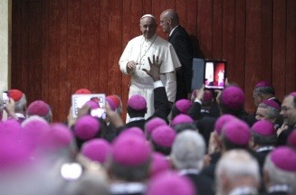Stop judging others. In the same way he denounces gossip, Francis condemns prejudice. He reminds “intolerant” Catholics, for one, to respect atheists. “If we, each doing our own part, if we do good to others, if we meet there, doing good, and we go slowly, gently, little by little, we will make that culture of encounter: we need that so much. We must meet one another doing good.”

- Befriend those who disagree. “When leaders in various fields ask me for advice, my response is always the same: dialogue, dialogue, dialogue. It is the only way for individuals, families, and societies to grow, the only way for the life of peoples to
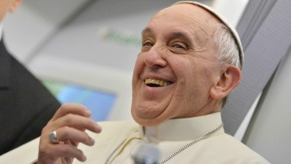progress, along with the culture of encounter, a culture in which all have something good to give and all can receive something good in return. Others always have something to give me, if we know how to approach them in a spirit of openness and without prejudice.”

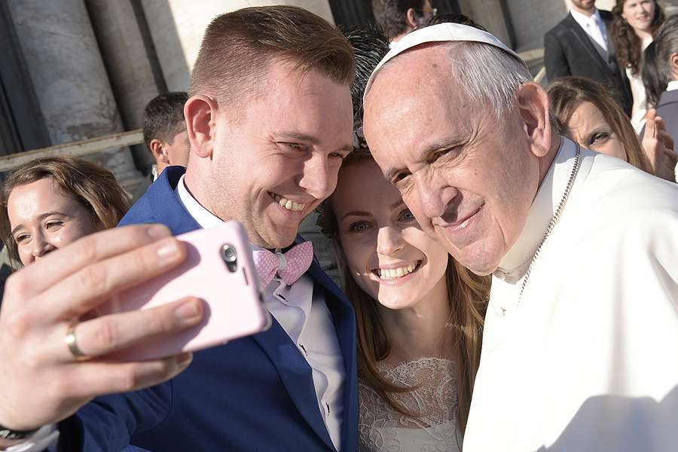
8. Make commitments, such as marriage. The Pope says: “Today, there are those who say that marriage is out of fashion; in a culture of relativism and the ephemeral, many preach the importance of ‘enjoying’ the moment. They say that it is not worth making a life-long commitment, making a definitive decision, ‘forever,’ because we do not know what tomorrow will bring. I ask you, instead, to be revolutionaries, to swim against the tide; yes, I am asking you to rebel against this culture that sees everything as temporary and that ultimately believes that you are incapable of responsibility, that you are incapable of true love. I have confidence in you and I pray for you. Have the courage ‘to swim against the tide.’ Have the courage to be happy.”

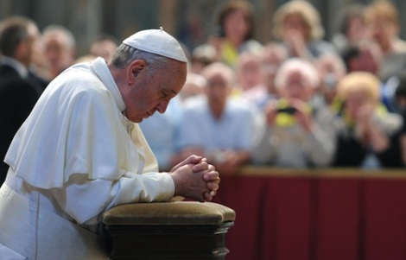
9. Make it a habit to 'ask the Lord.' “Dear young people,” he says, “some of you may not yet know what you will do with your lives. Ask the Lord, and he will show you the way. The young Samuel kept hearing the voice of the Lord who was calling him, but he did not understand or know what to say, yet with the help of the priest Eli, in the end he answered: 'Speak, Lord, for I am listening' (cf. 1 Sam 3:1- 10). You too can ask the Lord: What do you want me to do? What path am I to follow?”

10. Be happy. The true Christian, says the Pope, exudes great joy. He says keeping this joy to ourselves “will make us sick in the end. Sometimes these melancholy Christians' faces have more in common with pickled peppers than the joy of having a beautiful life.” Francis says, “The Christian sings with joy, and walks, and carries this joy." This joy, he reminds us, should translate to love of neighbour.

