Prayer Service to mark the Feast of the Epiphany
January 6, 2016
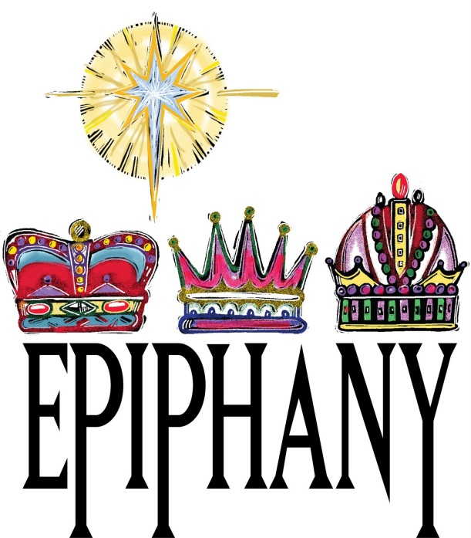
*Suggestions for Sacred Space: The Bible open on Matthew 2:1 – 12, the crib including the wise men, a star and lighting candle. A final suggestion is to include open gift boxes (see picture). These boxes remind us of the gifts offered to the infant Jesus by the wise men long ago, they could also symbolise the gifts we offer Christ; our love, our kindness, our willingness to follow the path He shows before us, our friendship to others as we begin a new term and a new year.
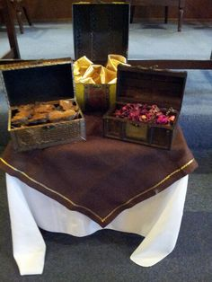

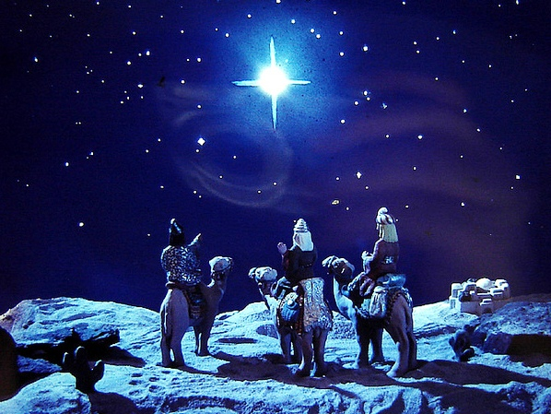
Leader: Welcome everyone, we gather today to celebrate the feast of the Epiphany. This feast commemorates the final guests who travelled many miles to greet the baby Jesus in the stable in Bethlehem. The Gospel describes these visitors as the Magi or the wise men, who followed a star across the desert to pay homage to the baby Jesus. Tradition tells us that their names were Caspar, Melchior and Balthassar. The men were astrologers who were looking for the star that would lead them to the promised Messiah as prophesied in the Book of Micah.
*You will see the open boxes in our sacred space; these three boxes symbolise the gifts of gold, frankincense and myrrh which the wise men brought with them to offer to Jesus in Bethlehem; according to the Gospel story, these gifts were very meaningful.
Reader One: Gold was a precious and expensive gift; the wise men offered this in homage to the Kingship of Jesus, as a symbol of their hearts offering love.
Reader Two: Frankincense was a sweet perfume, often burned in the temple to worship God. The wise men offered this in homage to the Divinity of Jesus and as a symbol of their minds offering wonder and awe.
Reader Three: Myrrh was used to keep things fresh and would later be used by the women to anoint Jesus’ body when he died. The wise men offered this in homage to the Humanity of Jesus and as a symbol of their bodies offering to worship and serve.
Leader: Let us look at these open boxes in our sacred space, and reflect for a moment as we gather here today. What gifts can we offer to Jesus? [Pause] We pray that God will open our hearts to love, worship and serve His Son, as the Magi once did. Let us listen to the story of how they found the Holy Family by following a star:

Now when Jesus was born in Bethlehem of Judea in the days of Herod the king, behold, wise men from the East came to Jerusalem, saying, “Where is he who has been born king of the Jews? For we have seen his star in the East, and have come to worship him.” Matthew 2:1–2, RSV

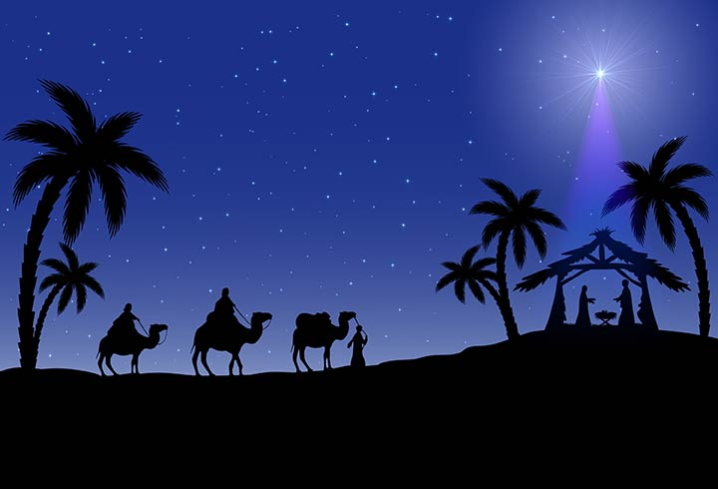
Gospel Reading: Matthew 2:1-12 [Good News Bible]
Visitors from the East

Jesus was born in the town of Bethlehem in Judea, during the time when Herod was king. Soon afterwards, some men who studied the stars came from the east to Jerusalem and asked, “Where is the baby born to be the king of the Jews? We saw his star when it came up in the east, and we have come to worship him.”
When King Herod heard about this, he was very upset, and so was everyone else in Jerusalem. He called together all the chief priests and the teachers of the Law and asked them, “Where will the Messiah be born?”
“In the town of Bethlehem in Judea,” they answered. “For this is what the prophet wrote: ‘Bethlehem in the land of Judah, you are by no means the least of the leading cities of Judah; for from you will come a leader who will guide my people Israel.’ ”
So Herod called the visitors from the east to a secret meeting and found out from them the exact time the star had appeared. Then he sent them to Bethlehem with these instructions: “Go and make a careful search for the child, and when you find him, let me know, so that I too may go and worship him.”
And so they left, and on their way they saw the same star they had seen in the east. When they saw it, how happy they were, what joy was theirs! It went ahead of them until it stopped over the place where the child was.
They went into the house, and when they saw the child with his mother Mary, they knelt down and worshipped him. They brought out their gifts of gold, frankincense and myrrh and presented them to him.
Then they returned to their own country by another road, since God had warned them in a dream not to go back to Herod.
The Gospel of the Lord
All: Praise to you, Lord Jesus Christ
Reader 1: The wise men were brave. They left their home and their families without being sure of the way. [Pause]
Let us consider those who have embarked on journeys in more recent times; the people who have left their homes in Syria, like the Magi, uncertain of what the road ahead may bring. May God guide them and bring them to a place where they know lasting peace and safe lodgings.
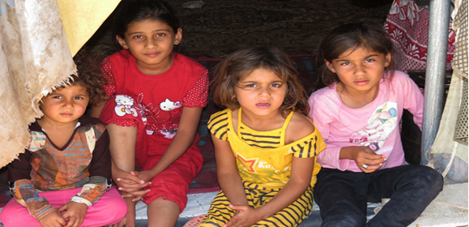
Syrian Refugee Children in Lebanon (Trόcaire Image)

Reader 2: Having met Mary, Joseph and the baby Jesus, the wise men returned home. They returned to tell the good news about the new leader to their families and friends. [Pause]
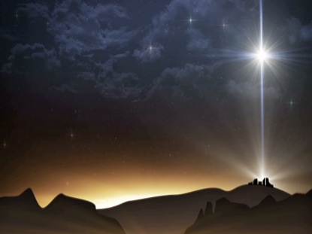
The story of the birth of Jesus reminds us of the Good News that God is always with us. Let us remember this in a very special way today as we begin a new year and a new term together. The response to each prayer is, ‘God is with us.’

God is with us

Reader 3: As we return after our Christmas celebrations.
All: God is with us.
Reader 4: As we begin a new year.
All: God is with us.
Reader 5: As we keep the spirit of Christmas alive in our heart.
All: God is with us.
Reader 6: We remember those for whom Christmas has not been a happy time. For those who have been effected by the recent flooding, for those who are homeless, for those who are suffering bereavement and those who are worried for whatever reason, we ask God to be with them as we pray:
All: Our Father/Ár nÁthair

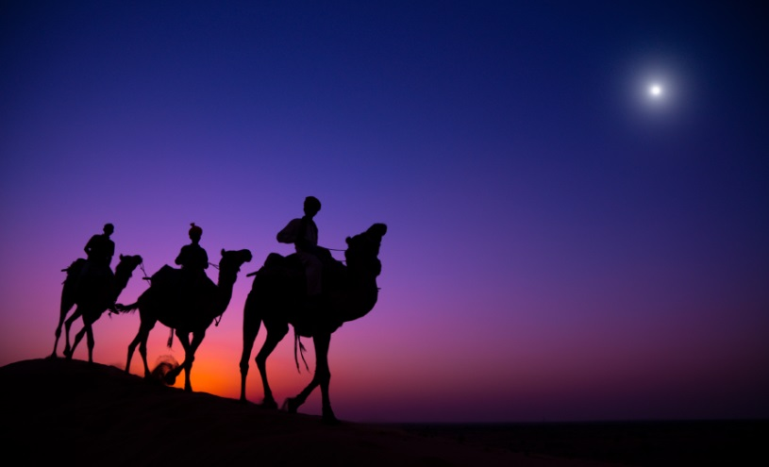
Closing Prayer
Leader:
Lord our God, we thank you that you have come to this earth, born in a humble stable in Bethlehem. Allow your light to shine out again and again, among those who hear your Gospel, among those with sincere hearts, whether or not they are Christians. May they come to know your light and peace in Jesus Christ. May your light shine for us and may you appear to us ever more clearly. Remember all who call to you. Remember your people. May your people gather and become a light in your name, serving you wherever they go.
We ask this through Jesus Christ, our Lord.
Amen.
This prayer service is an adaptation of The Feast of the Epiphany Resources shared on the Irish Conference of Catholic Bishops website. You can view the full and original document by downloading the following PDF:
http://www.catholicbishops.ie/wp-content/uploads/2013/08/Feast-of-the-Epiphany.pdf

Commentary for the Readings on the Feast of the Epiphany: (Optional)
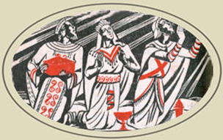
"There came Magi from the East to Jerusalem, saying, 'Where is the newly born King of the Jews?...We have seen His star in the East and have come to worship Him'" (Gospel).
Epiphany means "an apparition, or manifestation" of God becoming visible to all the world; Jews & Gentiles (non-Jews) alike. Today Jesus manifests a new “kingdom”, to which the star-light of “faith” guides all wise men & women (Prayer).
The First reading [Isaiah 60:1-6] is a revealing picture of the "darkness" of the Jewish Old Testament; a prophecy also of the "brightness" of Christ shining in a world where men may now "see."
The Gospel tells of the faith of the "Magi" divinely guided by the "star"; how this faith manifested itself in action by their seeking instruction from God's priests, by paying the greatest respect to Jesus by bowing low and offering their best treasures before the baby Jesus in Mary's arms:
A truly great Feast! "Arise, be enlightened."
— Excerpted from My Sunday Missal, (Confraternity of the Precious Blood)

