HARVEST MASS
Introduction
Our Mass today is about harvest and we reflect on how fortunate we are to have so many wonderful gifts from God, and we think about those who do not have as much as we have.
Penitential Rite
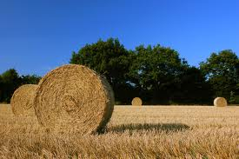
Let us confess our forgetfulness of the needs of the poor, and repent of the ways in which we waste the resources of the world.
God has blessed us,
but still God’s children go hungry.
Lord, have mercy.
Lord, have mercy.
God has blessed us,
but still the poor cry out for justice.
Christ, have mercy.
Christ, have mercy.
God has blessed us,
but still we see inequality and oppression in the earth.
Lord, have mercy.
Lord, have mercy.
May God almighty have mercy on us, forgive us our sins, and bring us to life everlasting. Amen

Opening Prayer
God of life and love,
we offer you our thanks and praise in this season of Harvest.
We thank you that you are Creator and Provider,
the source of all goodness.
We thank you for the sunshine and the rain,
for the land and the soil.
We thank you for the miracle of fertility and growth,
for the rhythm of nature and life.
We thank you for crops and livestock, farmers and growers.
We thank you for our calling to be co-creators with you
and we pray especially for all who share with you
in the task of growing and supplying the food we eat.
God of life and love,
we offer you our thanks and praise. Amen.

First Reading 2 Corinthians 9:6-15
Do not forget: thin sowing means thin reaping; the more you sow, the more you reap. Each one should give what he has decided in his own mind, not grudgingly or because he is made to, for God loves a cheerful giver. And there is no limit to the blessings which God can send you – he will make sure that you will always have all you need for yourselves in every possible circumstance, and still have something to spare for all sorts of good works. As scripture says: He was free in almsgiving, and gave to the poor: his good deeds will never be forgotten. The one who provides seed for the sower and bread for food will provide you with all the seed you want and make the harvest of your good deeds a larger one, and made richer in every way, you will be able to do all the generous things which through us, are the cause of thanksgiving to God. For doing this holy service is not only supplying all the needs of the saints, but it is also increasing the amount of thanksgiving that God receives. By offering this service, you show them what you are, and that makes them give glory to God for the way you accept and profess the Gospel of Christ, and for your sympathetic generosity to them and to all. And their prayers for you, too, show how they are drawn to you on account of all the grace that God has given you. Thanks be to God for his inexpressible gift.
The Word of the Lord. Thanks be to God.
Gospel Matthew 6:24-34
You cannot be the slave both of God and of money. That is why I am telling you not to worry about your life and what you are to eat, nor about your body and how you are to clothe it. Surely life means more than food, and the body more than clothing! Look at the birds in the sky. They do not sow or reap or gather into barns; yet your heavenly Father feeds them. Are you not worth more than they are? Can any of you for all his worrying, add one single cubit to his span of life? And why worry about clothing? Think of the flowers growing in the fields; they never have to work or spin; yet I assure you that not even Solomon in all his regalia was robed like one of these. Now if that is how God clothes the grass in the field which is here today and thrown into the furnace tomorrow, will he not much more look after you, you men of little faith? So do not worry; do not say, ‘What are we to eat? What are we to drink? How are we to be clothed? ‘ It is the pagans who set their hearts on all these things. Your heavenly Father knows you need them all. Set your hearts on his kingdom first, and on his righteousness, and all these other things will be given you as well. So do not worry about tomorrow: tomorrow will take care of itself. Each day has enough trouble of its own.
The Gospel of the Lord. Praise to you, Lord Jesus Christ.

Prayers of the Faithful
As we pray this Mass, let us make our intentions to God:

Loving God, through your love for the earth and its fruits, help us to redeem the harm we have done to our planet so that future generations may not go hungry; Lord, hear us.

Christ Jesus, You come to us in the breaking of bread that we may celebrate our oneness with the whole community of life and give our lives in service. Help us to live more simply, that others may simply live; Lord, hear us.

Creator God, help us to love and care for the produce of land, sea and sky, recognising it all as your gifts to be cherished, protected and shared; Lord, hear us.
The Presentation of Creation
(To consist of a parade of gifts with students representing various aspects of harvest and nature)
• Earth – (e.g. some soil presented as a treasure)
• Plants – (home grown vegetables, home-made bread)
• Seasons – (four students each dressed to represent one of the seasons)
• Fish and birds - (e.g. dancing representations of fish and birds)
• Creatures of the earth (pets)
• Human Beings – (a deliberately diverse group of students by age, ethnicity, etc., dressed in traditional costume)
Each one presents themselves in turn and is asked by the leader ‘What is this?’
To which they reply, each in turn
• We are the earth – and the soil that makes for life
• We are the plants – which bring forth such beauty and goodness
• We are the seasons - which make up the cycle of life
• We are the fish and birds – which dance in freedom and are fed by the gracious hand of God
• We are creatures of the earth – who share our planet
• We are human beings – made to praise the Creator of all things
Communion Reflection
"My sisters the birds, much are you beholden to God your Creator, and always and in every place should you praise him. He has given you the freedom to fly wherever you wish and he has clothed you so fully. Moreover he preserved your kind in the ark of Noah so that you might not die out. Again, you are beholden to him for the very air that he has given to you. Furthermore, you do not sow nor reap yet God feeds you and gives you rivers and fountains from which you drink, He gives you mountains and valleys as places of refuge and the tall trees in which to build your nests. Because you do not know how to sew or spin, God clothes you and your young: you can see how much God loves you in that he gives you so much. Guard yourselves therefore my sisters the birds from the sin of ingratitude and be ever mindful to give praise to God."
From The Little Flowers of St. Francis.

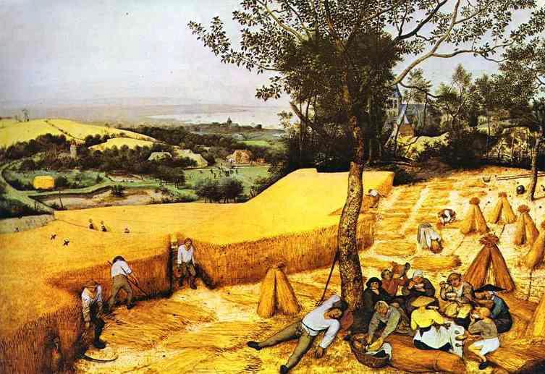
Concluding Prayer
We bless you,
God of Seed and Harvest
And we bless each other
That the beauty of this world
And the love that created it
Might be expressed through our lives
And be a blessing to others
Now and always
AMEN

