Feast of the Holy Rosary

The feast of the Holy Rosary was established by Saint Pius V on the anniversary of the naval victory won by the Christian fleet at Lepanto, October 7, 1571. The victory was attributed to the help of the holy Mother of God whose aid was invoked through praying the Rosary.
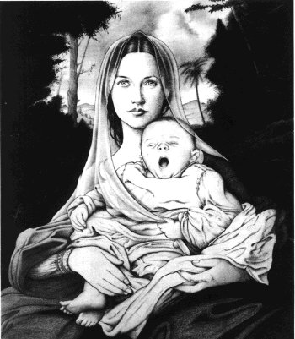
On September 30, 2001, after the morning Mass opening the Synod of Bishops, Pope John Paul II asked people to pray the Rosary. Here is his message:
"October is the month in which Mary Most Holy, Queen of the Holy Rosary, is venerated. Within the current international context, I invite all -- individuals, families, communities -- to pray this Marian prayer, possibly every day, for peace, so that the world can be preserved from the wicked scourge of terrorism.
"We cannot forget that Jews, Christians and Muslims adore God as the only God. The three religions, therefore, have the vocation of unity and peace. May God allow the Church's faithful to be agents of peace, in the front line of the search for justice and the prohibition of violence. May the Virgin Mary, Queen of Peace, intercede for all humanity, so that hate and death never have the last word!"
- “The Rosary is a way of contemplating the face of Christ seeing him - we may say - with the eyes of Mary. I wish to suggest the recitation of the Rosary to individuals, families and Christian communities.
- I wish once again to entrust the great cause of peace to the praying of the Rosary. We are facing an international situation that is full of tensions, at times threatening to explode. In some parts of the world, where the confrontation is harsher - I think particularly of the suffering land of Christ

How to Pray the Rosary
Looking at the cross, we hold it while we make the sign of the cross and pray the Apostles' Creed which is a summary of all the things we believe as Catholics.

On this separate bead, we pray an Our Father, the prayer that Jesus taught us.
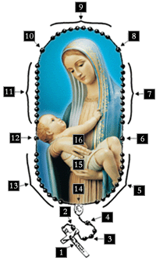
On each of the next three beads, we pray the Hail Mary.

On this separate bead, we announce the first mystery. (e.g.. Joyful) We reflect on what happened to Jesus at this time and we think about what it means in our lives today. We pray the Our Father.

We pray one Hail Mary on each of the next 10 beads. Then we pray the Glory Be.

On this separate bead, we announce the second mystery, reflect, and pray the Our Father.
We pray one Hail Mary on each of the next ten beads. Then we pray the Glory Be.

On this separate bead, we announce the third mystery, reflect, and pray the Our Father.

We pray one Hail Mary on each of the next ten beads. Then we pray the Glory Be.

On this separate bead, we announce the fourth mystery, reflect, and pray the Our Father.

We pray one Hail Mary on each of the next ten beads. Then we pray the Glory Be.

On this separate bead, we announce the fifth mystery, reflect, and pray the Our Father.

We pray one Hail Mary on each of the next ten beads. Then we pray the Glory Be.

We have now reached the end of the Rosary. On the medal that connects the beads we pray the Hail Holy Queen.

Why beads?
In the Old Testament when the extended family came together to pray, they would say the prayers that they had learned in the synagogue. These prayers were called the Psalms. There are 150 Psalms. Since most of the people at that time could not read, what they did was to collect 150 stones into a leather bag, one for each Psalm. When it came time to pray they would take out a stone and try to remember as much as the Psalm prayer as they could: “The Lord is my Shepherd. He leads me to green pastures…”
If they could not remember the words to the Psalm they would simply rub the stone and Think Good Thoughts. They would use the stone as something that would draw them into a spirit of prayer.

In the early centuries of monasticism, Christian Monks used the same method to keep track of their prayers. They, too, prayed the Psalms and used 150 stones or beads, which they treaded together. Some just tied knots in a rope that they wore around their waist.
At some point the monks decided that they wanted to pray together, so they began saying common prayers on each bead. The “Our Father,” which they said 150 times, was probably the first such common prayer for the beads. But while they were saying the prayers out loud, they were encouraged to think of from scripture. What events from the life of Jesus related to their life and times? Their meditation on the Psalms was giving way to a meditation on the life and mysteries of Jesus.
Over time, as devotion to the Blessed Mother increased, the Our Father that was said in common was replaced by a devotional, scripture-based prayer to the Blessed Virgin, ‘Hail Mary, full of grace…”
There are many ways parents and teachers can introduce and teach the praying of the Rosary to children. Most children like to hold the Rosary in their hands, finger the beads, look at the cross; so often times it is best to begin by giving each child a Rosary to hold onto and to become familiar with the Rosary.

