Easter Crossword

Across  1 The Roman official who tried Jesus and sentenced him (7,6)  3 The day we remember Jesus' last meal with his disciples (6,8)  5 The Garden in which Jesus was arrested (10)  9 ? Tuesday, the day before Lent begins (6)  10 On which animal did Jesus ride into Jerusalem? (6)  11 The first day of Holy Week (4,6)  Down  1 People waved branches from which tree to greet Jesus? (4)  2 The disciple who betrayed Jesus (5)  4 The first day of Lent (3,9)  5 The day Jesus was arrested and put to death (4,6)  6 The last week of Lent (4,4)  7 An Easter symbol (3) | 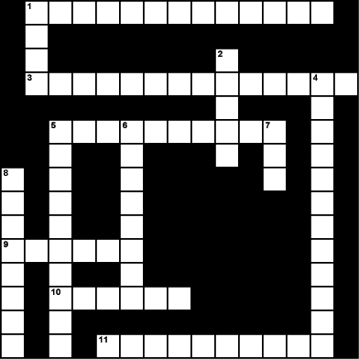  8 The religious ceremony Jesus came to Jerusalem to celebrate (8)

Easter Bingo

Ascension | Passover
Easter | Eggs
Thomas | Bunny
Stations | Crucifixion
Cross | Washing of the Feet
Last Supper | Vigil
Mary Magdalene | Jews
Tomb | Soldiers
Good Friday | Judas
Holy Saturday | Calvary
Apostles | Nails
Pontius Pilate | Our Lady
Shroud of Turin | Trial
Vinegar | Peter
Silver | Barrabas
Romans | Simon
Gethsemane | Crown of thorns
Palm Sunday | 3 O’Clock
Joseph of Arimathea | Unleavened Bread
Hell | Galilee
Emmaus | Jerusalem
Nazareth | Pharisees
Heaven | Resurrection

